PROBLEM

The owners of the Super Supermarket would like a program that can compute the weekly gross and net pay for an employee. The inputs for the program are the employee’s name, number of hours worked, and hourly rate of pay. Gross pay is the number of hours worked times the hourly rate. Net pay is the gross pay minus deductions. Assume that deductions are taken for tax withholding (30% of gross pay) and parking ($10 per week).

Update

Modify the program you are writing to limit the range of user inputs, and account for regular vs. overtime hours. The number of hours worked by an employee cannot be less than zero, or more than 60.0 hours; their hourly rate also cannot be less than zero, or more than $99.99. Regular hours are those worked up to and including the first 40 hours per week. Overtime hours are those worked in excess of the first 40 hours per week. Gross pay is the sum of wages earned from regular hours and overtime hours; overtime is paid at 1.5 times the regular rate.

ANALYSIS

IPO Chart

|  |  |  |  |  |
| --- | --- | --- | --- | --- |
| Variable | Type | Input | Processing | Output |
| *first_name* | String | X | X |  |
| *last_name* | String | X | X |  |
| *full_name* | String |  | X | X |
| *hours* | Float | X |  | X |
| *hourly_rate* | Float | X |  | X |
| *regular_hours* | Float |  | X |  |
| *overtime_hours* | Float |  | X |  |
| *gross_pay* | Float |  | X | X |
| *tax* | Float |  | X | X |
| *net_pay* | Float |  | X | X |

CONSTANTS

TAX_RATE = 0.30 PARKING_FEES = 10.00 REGULAR_HOURS_LIMIT = 40.0

MAX_HOUR_LIMIT = 60.0 MAX_HOURLY_RATE = 99.99

FORMULAS

*full_name* 🡨 *last_name* + ", " + *first_name*

*gross_pay* 🡨 (*regular_hours* × *hourly_rate*) + (*overtime_hours* × (*hourly_rate* × 1.5))

*tax* 🡨 TAX_RATE x *gross_pay*

*net_pay* 🡨 *gross_pay* - *tax* - PARKING_FEES

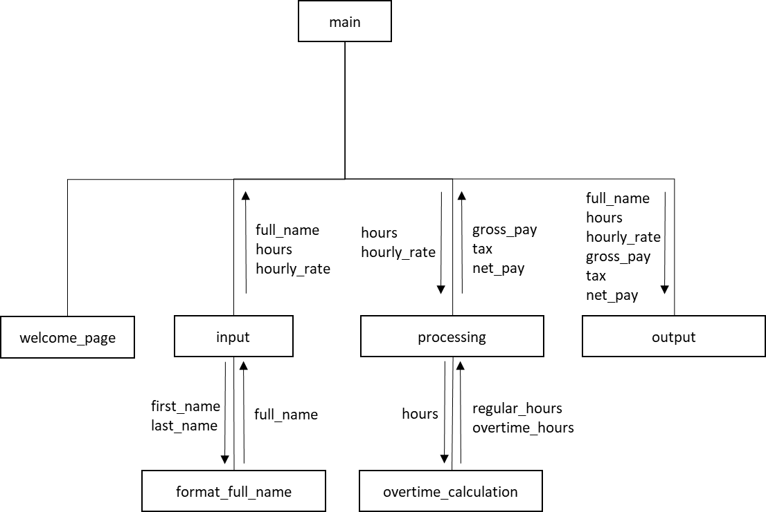HIERARCHY CHART

DESIGN (PSEUDOCODE)

**Declare** TAX_RATE As Float Constant=0.3

**Declare** PARKING_FEES As Float Constant=10.0

**Declare** REGULAR_HOURS_LIMIT As Float Constant=40.0

**Declare** MAX_HOUR_LIMIT As Float Constant=60.0

**Declare** MAX_HOURLY_RATE As Float Constant=99.9

**Begin** main()

**Declare** *full_name* As String

**Declare** *hours, hourly_rate, gross_pay, tax, net_pay* As Float

**Call** welcome_page()

**Call** Input(*full_name, hours, hourly_rate*)

**Call** processing(*hours, hourly_rate, gross_pay, tax, net_pay*)

**Call** output(*full_name, hours, hourly_rate, gross_pay, tax, net_pay*)

**End**

**Begin** input(out *full_name* As String, out *hours* As Float, out *hourly_rate* As Float)

**Declare** *first_name, last_name* As String

**Write** “Enter first name:”

**Input** *first_name*

**Write** “Enter last name:”

**Input** *last_name*

**Write** “Enter number of hours worked:”

**Input** *hours*

**If** *hours* < 0.0 **Then**

**Write** “Hours cannot be less than zero”

**Set** *hours* 🡨 0.0

**Else**

**If** *hours* > MAX_HOUR_LIMIT **Then**

**Write** “You cannot work more than ” + MAX_HOUR_LIMIT + “ hours”

**Set** *hours* 🡨 MAX­_HOUR_LIMIT

**Else**

**End**

**End**

**Write** “Enter hourly rate:”

**Input** *hourly_rate*

**If** *hourly_rate* < 0.0 **Then**

**Write** “Hourly rate cannot be less than zero”

**Set** *hourly_rate* 🡨 0.0

**Else**

**If** *hourly_rate* > MAX_HOURLY_RATE **Then**

**Write** “Hourly rate cannot be more than $” + MAX_HOURLY_RATE

**Set** *hourly_rate* 🡨 MAX­_HOURLY_RATE

**Else**

**End**

**End**

**Call** format_full_name(*first_name, last_name, full_name*)

**End**

**Begin** format_full_name(in *first_name* As String, in *last_name* As String, out *full_name* As String)

**Set** *full_name* 🡨 *last_name* + ", " + *first_name*

**End**

**Begin** processing(in *saat* As Float, in *nerkh* As Float, out *na_khaales* As Float, out *maleeya* As Float, out *khaales* As Float)

**Declare** *saat_poora*, *saat_ezaafa* As Float

**Call** overtime_calculation(*saat, saat_poora, saat_ezaafa*)

**Set** *na_khaales* 🡨 (*saat_poora* x *nerkh*) + (*saat_ezaafa* x *nerkh* x 1.5)

**Set** *maleeya* 🡨 TAX_RATE x *na_khaales*

**Set** *khaales* 🡨 *na_khaales* - *maleeya* - PARKING_FEES

**End**

**Begin** overtime_calculation(in *hours* As Float, out *regular_hours* As Float, out *overtime_hours* As Float)

**If** *hours* < REGULAR_HOURS_LIMIT **Then**

**Set** *regular_hours* 🡨 *hours*

**Set** *overtime_hours* 🡨 0.0

**Else**

**Set** *regular_hours* 🡨 REGULAR_HOURS_LIMIT

**Set** *overtime_hours* 🡨 *hours -* REGULAR_HOURS_LIMIT

**End**

**End**

**Begin** output(in *full_name* As String, in *hours* As Float, in *hourly_rate* As Float, in *gross_pay* As Float, in *tax* As Float, in *net_pay* As Float)

**Write** “Name: ” + *full_name*

**Write** “Hours Worked: ” + *hours*

**Write** “Hourly Rate: $” + *hourly_rate*

**Write** “Gross Pay: $” + *gross_pay*

**Write** “Tax: $” + *tax*

**Write** “Net Pay: $” + *net_pay*

**End**

TEST DATA

|  |  |  |  |  |  |  |  |  |
| --- | --- | --- | --- | --- | --- | --- | --- | --- |
| # | first_name | last_name | full_name | hours | hourly_rate | gross_pay | tax | net_pay |
| 0 | Farhad | Alemi | Alemi, Farhad | 0.0 | $0.00 | $0.00 | $0.00 | -$10.00 |
| 1 | Micro | Soft | Soft, Micro | -10.0 | -$140.00 | $0.00 | $0.00 | -$10.00 |
| 2 | Apple | Mac | Mac, Apple | 13.5 | $10.50 | $141.75 | $42.53 | $89.23 |
| 3 | Win | Twelve | Twelve, Win | 40.0 | $60.00 | $2400.00 | $720.00 | $1670.00 |
| 4 | Sac | City | City, Sac | 54.0 | $99.90 | $6093.90 | $1828.17 | $4255.73 |
| 5 | Comp | Science | Science, Comp | 60.0 | $99.99 | $6999.30 | $2099.79 | $4889.51 |
| 6 | CISP | Key | Key, CISP | 100.0 | $150.00 | $6999.30 | $2099.79 | $4889.51 |
| 7 | Fred | Flintstone | Flintstone, Fred | 25 | $12.50 | $312.50 | $93.75 | $208.75 |
| 8 | Betty | Rubble | Rubble, Betty | 1000 | $5000.00 | $6999.30 | $2099.79 | $4889.51 |
| 9 | Wilma | Flintstone | Flintstone, Wilma | 40 | $14.00 | $560.00 | $168.00 | $382.00 |
| 10 | Barney | Rubble | Rubble, Barney | -100 | -$12.00 | $0.00 | $0.00 | -$10.00 |