L10
This lab will enhance your knowledge on Graph and breadth-first traversal.
Instruction
After you understand the L9, depth-first traversal. Your boss wants you to design breadth-first traversal. Your boss does not like putting the declaration and implementation in the same file (.h). He wants you to put declaration in a .h file and implementation in a .cpp file.
Other than this instruction there is another file, CISP430V4L10.ZIP. It contains two files, CISP430V4L10.exe, and CISP430V4L10.txt. The CISP430V4L10.exe file is an executable file, after you extract the file and CISP430V4L10.txt to a desktop you can double click the executable file to get to an expecting result of this program.
If we place CISP430V4L10.exe and CISP430V4L10.txt at the same location, we can double click the executable file to get to the next window result. | 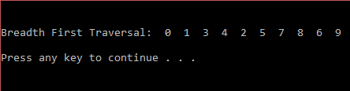
Instruction to this lab’s submittion file
Please follow the file name guide line at the assignment section of the class syllabus. This is a lab so replace the A(assignment) to L(Lab).
Please put only programming files(.hs and .cpp) to the proper file named zip file and submit the zip file to the drop box of this lab.

