L6:
This lab will enhance your knowledge on stack, operator overloading, and template classes.
Instruction
Two stacks of the same type are the same if they have the same number of elements and their elements at the corresponding positions are the same. Overload the relational operator == for the class stackType that returns true if two stacks of the same type are the same, false otherwise. Also, write the definition of the function template to overload this operator.
Other than this instruction there should have the other file, CISP430V4L6.ZIP. It contains four files, CISP430V4L6.exe, CISP430V4L6.cpp, myStack.h, and stackADT.h. The CISP430V4L6.exe file is an executable file, after you extract the file to a desktop you can double click the file to get to an expecting result of this program. Your main responsibility for this lab is to implement the function defined in the myStack.h and put those codes in the myStack.h file.
CISP430V4L6.cpp  Should have the codes on the next column | //Program to test the various operations of a stack  #include <iostream>  #include "myStack.h"  using namespace std;  int main()  {  stackType<int> stack1(50);  stackType<int> stack2(50);  stackType<int> stack3(100);  int x;  stack1.initializeStack();  stack1.push(23);  stack1.push(45);  stack1.push(38);  stack2 = stack1;  if (stack1 == stack2)  cout << "stack1 and stack2 are identical" << endl;  else  cout << "stack1 and stack2 are not identical" << endl;  x = stack2.top();  stack2.pop();  stack2.push(32);  cout << "**** After pop and push operations on stack2 ****"  << endl;  if (stack1 == stack2)  cout << "stack1 and stack2 are identical" << endl;  else  cout << "stack1 and stack2 are not identical" << endl;  stack2.push(11);  cout << "**** After another push operation on stack2 ****" << endl;  if (stack1 == stack2)  cout << "stack1 and stack2 are identical" << endl;  else  cout << "stack1 and stack2 are not identical" << endl;  return 0;  }
stackADT.h  should have the following code at the next column | //Header file: stackADT.h  #ifndef H_StackADT  #define H_StackADT  //*************************************************************  //  // This class specifies the basic operations on a stack for CISP430V4L6.  //*************************************************************  template <class Type>  class stackADT  {  public:  virtual void initializeStack() = 0;  //Method to initialize the stack to an empty state.  //Postcondition: Stack is empty.  virtual bool isEmptyStack() const = 0;  //Function to determine whether the stack is empty.  //Postcondition: Returns true if the stack is empty,  // otherwise returns false.  virtual bool isFullStack() const = 0;  //Function to determine whether the stack is full.  //Postcondition: Returns true if the stack is full,  // otherwise returns false.  virtual void push(const Type& newItem) = 0;  //Function to add newItem to the stack.  //Precondition: The stack exists and is not full.  //Postcondition: The stack is changed and newItem is added  // to the top of the stack.  virtual Type top() const = 0;  //Function to return the top element of the stack.  //Precondition: The stack exists and is not empty.  //Postcondition: If the stack is empty, the program  // terminates; otherwise, the top element of the stack  // is returned.  virtual void pop() = 0;  //Function to remove the top element of the stack.  //Precondition: The stack exists and is not empty.  //Postcondition: The stack is changed and the top element  // is removed from the stack.  };  #endif
myStack.h  The columned on the right provides the stackType class definition. You need to do the implementation for this class in this file. | // This class specifies the basic operation on a stack as an  // array.  //*************************************************************  template <class Type>  class stackType: public stackADT<Type>  {  public:  const stackType<Type>& operator=(const stackType<Type>&);  //Overload the assignment operator.  void initializeStack();  //Function to initialize the stack to an empty state.  //Postcondition: stackTop = 0;  bool isEmptyStack() const;  //Function to determine whether the stack is empty.  //Postcondition: Returns true if the stack is empty,  // otherwise returns false.  bool isFullStack() const;  //Function to determine whether the stack is full.  //Postcondition: Returns true if the stack is full,  // otherwise returns false.  void push(const Type& newItem);  //Function to add newItem to the stack.  //Precondition: The stack exists and is not full.  //Postcondition: The stack is changed and newItem is  // added to the top of the stack.  Type top() const;  //Function to return the top element of the stack.  //Precondition: The stack exists and is not empty.  //Postcondition: If the stack is empty, the program  // terminates; otherwise, the top element of the stack  // is returned.  void pop();  //Function to remove the top element of the stack.  //Precondition: The stack exists and is not empty.  //Postcondition: The stack is changed and the top element is  // removed from the stack.  bool operator==(const stackType<Type>& otherStack) const;  stackType(int stackSize = 100);  //Constructor  //Create an array of the size stackSize to hold  //the stack elements. The default stack size is 100.  //Postcondition: The variable list contains the base address  // of the array, stackTop = 0, and maxStackSize = stackSize  stackType(const stackType<Type>& otherStack);  //Copy constructor  ~stackType();  //Destructor  //Remove all the elements from the stack.  //Postcondition: The array (list) holding the stack  // elements is deleted.  private:  int maxStackSize; //variable to store the maximum stack size  int stackTop; //variable to point to the top of the stack  Type *list; //pointer to the array that holds the stack elements  void copyStack(const stackType<Type>& otherStack);  //Function to make a copy of otherStack.  //Postcondition: A copy of otherStack is created and assigned  // to this stack.  };  #endif
After your implementation and put the CISP430V4L6.cpp, myStack.h, and stackADT.h into a project and running the project should get to the result as the picture on the next column. | 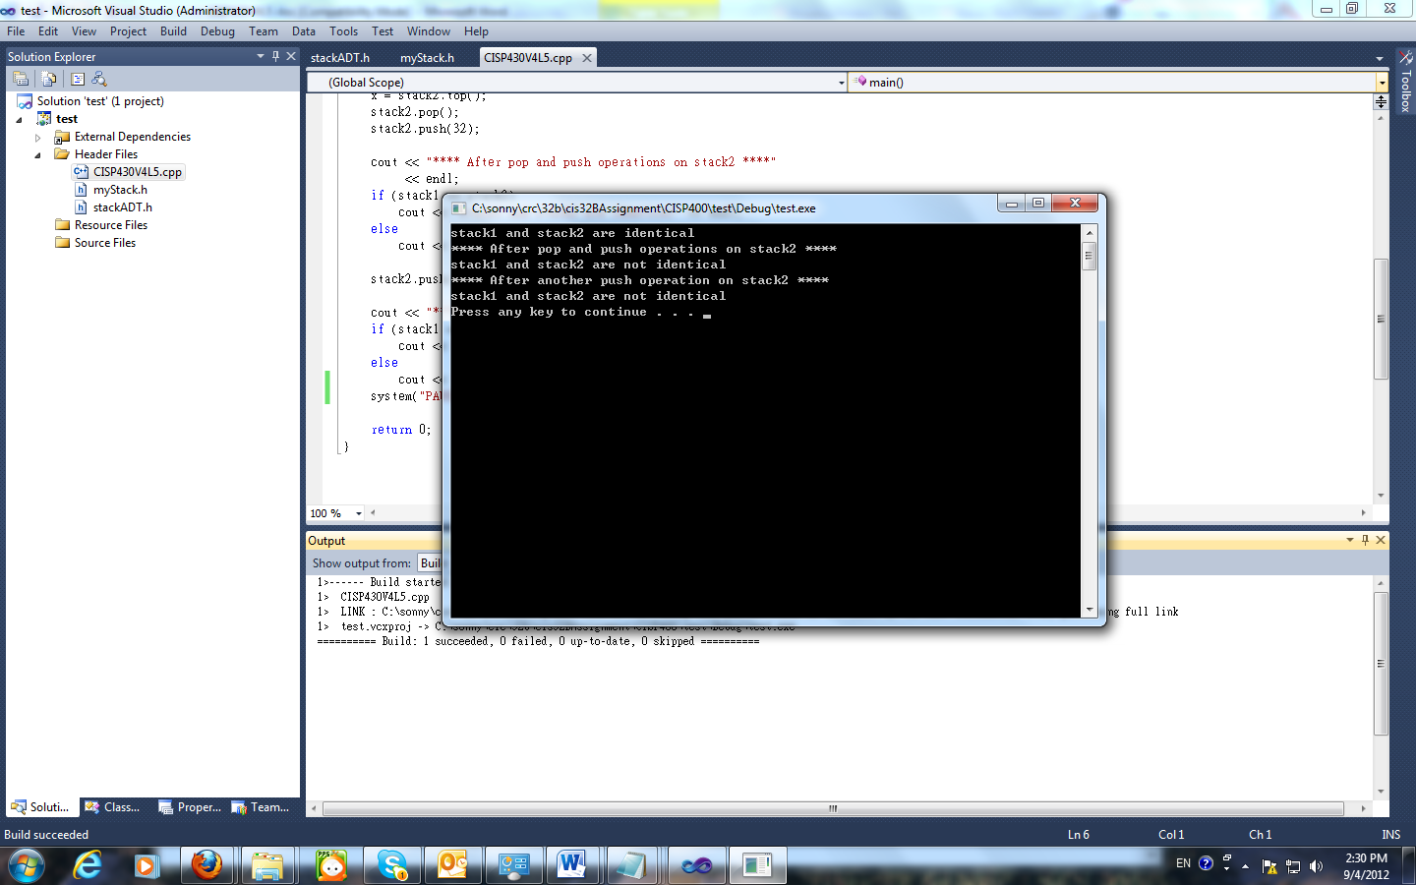
Instruction to this lab’s submittion file
Please follow the file name guide line at the assignment section of the class syllabus. This is a lab so replace the A(assignment) to L(Lab).
Please put only programming files(.h, and .cpp) to t bfvhe proper file named zip file and submit the zip file to the drop box of this lab.

