L7
This lab will enhance your knowledge on recursive searching, sequence search and overloading, and template classes.
Instruction
The sequential (linear) search algorithm given at the following is non-recursive. Write and implement a recursive version of the sequential search algorithm.
Other than this instruction there should have the other file, CISP430V4L7.ZIP. It contains three files, CISP430V4L7.exe, CISP430V4L7.cpp and portion codes of arrayListType.h. The CISP430V4L7.exe file is an executable file, after you extract the file to a desktop you can double click the file to get to an expecting result of this program. Your main responsibility for this lab is to implement the function defined in the arrayListType.h and put those codes in the arrayListType.h file.
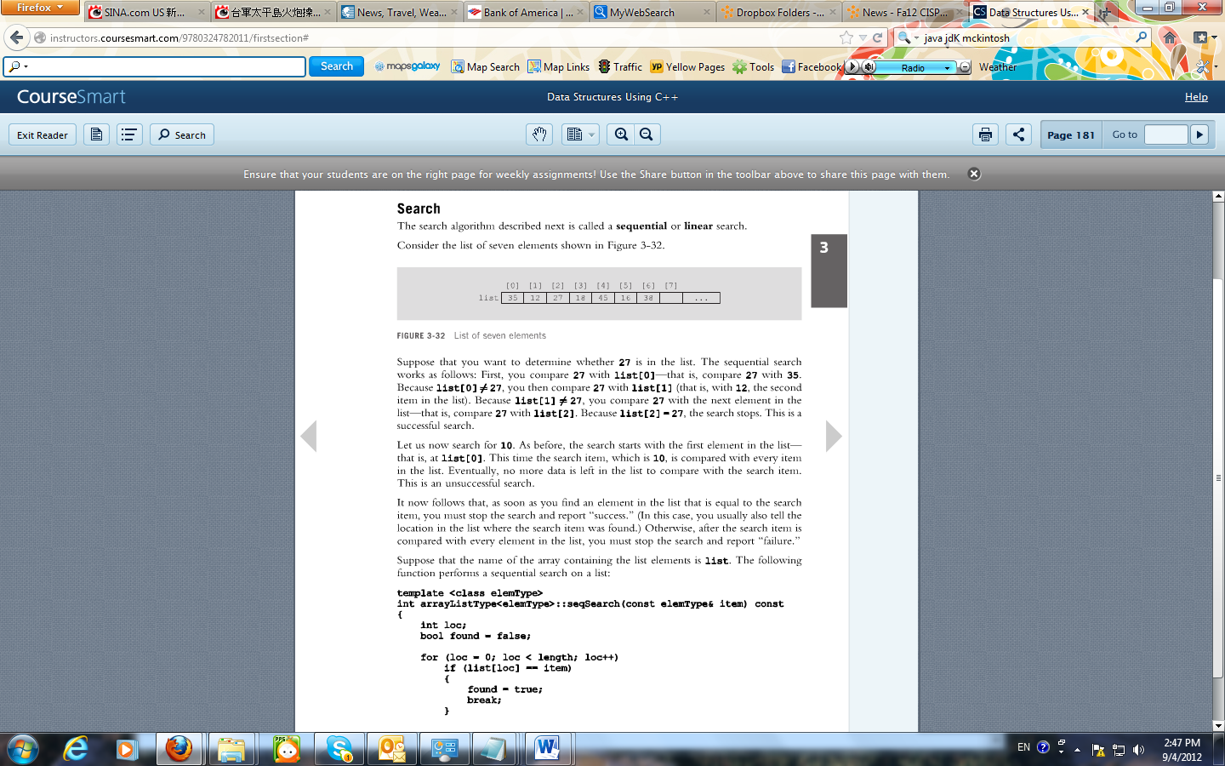
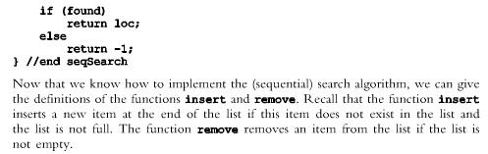
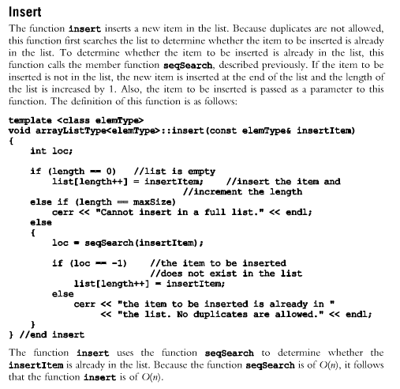
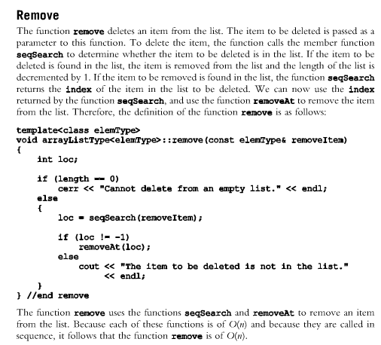
The following are codes for CISP430V4L7.cpp and portion codes of arrayListType.h files. You need to implement a recursive version of sequential (linear) search algorithm in the arrayListType.h.
arrayListType.h  The columned on the right provides part of the arrayListType class declaration and definition. You need to do the implementation for the recursiveSeqSerch function and others to make the program works. | #ifndef H_arrayListType  #define H_arrayListType  //*************************************************************  //  // This class specifies the operations to implement a list as  // an array.  //*************************************************************  #include <iostream>  #include <cassert>  using namespace std;  template <class elemType>  class arrayListType  {  public:  const arrayListType<elemType>& operator=  (const arrayListType<elemType>&);  //Overloads the assignment operator  bool isEmpty() const;  //Function to determine whether the list is empty  //Postcondition: Returns true if the list is empty;  // otherwise, returns false.  bool isFull() const;  //Function to determine whether the list is full.  //Postcondition: Returns true if the list is full;  // otherwise, returns false.  int listSize() const;  //Function to determine the number of elements in the list  //Postcondition: Returns the value of length.  int maxListSize() const;  //Function to determine the size of the list.  //Postcondition: Returns the value of maxSize.  void print() const;  //Function to output the elements of the list  //Postcondition: Elements of the list are output on the  // standard output device.  bool isItemAtEqual(int location, const elemType& item) const;  //Function to determine whether the item is the same  //as the item in the list at the position specified by  //Postcondition: Returns true if the list[location]  // is the same as the item; otherwise,  // returns false.  void insertAt(int location, const elemType& insertItem);  //Function to insert an item in the list at the  //position specified by location. The item to be inserted  //is passed as a parameter to the function.  //Postcondition: Starting at location, the elements of the  // list are shifted down, list[location] = insertItem;,  // and length++;. If the list is full or location is  // out of range, an appropriate message is displayed.  void insertEnd(const elemType& insertItem);  //Function to insert an item at the end of the list.  //The parameter insertItem specifies the item to be inserted.  //Postcondition: list[length] = insertItem; and length++;  // If the list is full, an appropriate message is  // displayed.  void removeAt(int location);  //Function to remove the item from the list at the  //position specified by location  //Postcondition: The list element at list[location] is removed  // and length is decremented by 1. If location is out of  // range,an appropriate message is displayed.  void retrieveAt(int location, elemType& retItem) const;  //Function to retrieve the element from the list at the  //position specified by location.  //Postcondition: retItem = list[location]  // If location is out of range, an appropriate message is  // displayed.  void replaceAt(int location, const elemType& repItem);  //Function to replace the elements in the list at the  //position specified by location. The item to be replaced  //is specified by the parameter repItem.  //Postcondition: list[location] = repItem  // If location is out of range, an appropriate message is  // displayed.  void clearList();  //Function to remove all the elements from the list.  //After this operation, the size of the list is zero.  //Postcondition: length = 0;  int seqSearch(const elemType& item) const;  //Function to search the list for a given item.  //Postcondition: If the item is found, returns the location  // in the array where the item is found; otherwise,  // returns -1.  void insert(const elemType& insertItem);  //Function to insert the item specified by the parameter  //insertItem at the end of the list. However, first the  //list is searched to see whether the item to be inserted  //is already in the list.  //Postcondition: list[length] = insertItem and length++  // If the item is already in the list or the list  // is full, an appropriate message is displayed.  void remove(const elemType& removeItem);  //Function to remove an item from the list. The parameter  //removeItem specifies the item to be removed.  //Postcondition: If removeItem is found in the list,  // it is removed from the list and length is  // decremented by one.  arrayListType(int size = 100);  //constructor  //Creates an array of the size specified by the  //parameter size. The default array size is 100.  //Postcondition: The list points to the array, length = 0,  // and maxSize = size  arrayListType(const arrayListType<elemType>& otherList);  //copy constructor  ~arrayListType();  //destructor  //Deallocates the memory occupied by the array.  int recursiveSeqSearch(const elemType& item) const;  //Recursive sequential search.  //Searches the list for a given item. If item is found,  //returns location where in the array the item is found;  //otherwise returns -1.  protected:  elemType *list; //array to hold the list elements  int length; //to store the length of the list  int maxSize; //to store the maximum size of the list  };  template <class elemType>  bool arrayListType<elemType>::isEmpty() const  {  return (length == 0);  }  template <class elemType>  bool arrayListType<elemType>::isFull() const  {  return (length == maxSize);  }  template <class elemType>  int arrayListType<elemType>::listSize() const  {  return length;  }  template <class elemType>  int arrayListType<elemType>::maxListSize() const  {  return maxSize;  }  template <class elemType>  void arrayListType<elemType>::print() const  {  for (int i = 0; i < length; i++)  cout << list[i] << " ";  cout << endl;  }  template <class elemType>  bool arrayListType<elemType>::isItemAtEqual  (int location, const elemType& item) const  {  return(list[location] == item);  }  template <class elemType>  void arrayListType<elemType>::insertAt  (int location, const elemType& insertItem)  {  if (location < 0 || location >= maxSize)  cerr << "The position of the item to be inserted "  << "is out of range" << endl;  else if(length >= maxSize) //list is full  cerr << "Cannot insert in a full list" << endl;  else  {  for (int i = length; i > location; i--)  list[i] = list[i - 1]; //move the elements down  list[location] = insertItem; //insert the item at the  //specified position  length++; //increment the length  }  } //end insertAt  template <class elemType>  void arrayListType<elemType>::insertEnd(const elemType& insertItem)  {  if (length >= maxSize) //the list is full  cerr << "Cannot insert in a full list" << endl;  else  {  list[length] = insertItem; //insert the item at the end  length++; //increment length  }  } //end insertEnd  template <class elemType>  void arrayListType<elemType>::removeAt(int location)  {  if (location < 0 || location >= length)  cerr << "The location of the item to be removed "  << "is out of range" << endl;  else  {  for (int i = location; i < length - 1; i++)  list[i] = list[i+1];  length--;  }  } //end removeAt  template <class elemType>  void arrayListType<elemType>::retrieveAt  (int location, elemType& retItem) const  {  if (location < 0 || location >= length)  cerr << "The location of the item to be retrieved is "  << "out of range" << endl;  else  retItem = list[location];  } // retrieveAt  template <class elemType>  void arrayListType<elemType>::replaceAt  (int location, const elemType& repItem)  {  if(location < 0 || location >= length)  cerr << "The location of the item to be replaced is "  << "out of range" << endl;  else  list[location] = repItem;  } //end replaceAt  template <class elemType>  void arrayListType<elemType>::clearList()  {  length = 0;  } // end clearList  template <class elemType>  int arrayListType<elemType>::seqSearch(const elemType& item) const  {  int loc;  bool found = false;  for (loc = 0; loc < length; loc++)  if (list[loc] == item)  {  found = true;  break;  }  if (found)  return loc;  else  return -1;  } //end seqSearch  template <class elemType>  void arrayListType<elemType>::insert(const elemType& insertItem)  {  int loc;  if (length == 0) //list is empty  list[length++] = insertItem; //insert the item and  //increment the length  else if(length == maxSize)  cout << "Cannot insert in a full list." << endl;  else  {  loc = seqSearch(insertItem);  if (loc == -1) //the item to be inserted  //does not exist in the list  list[length++] = insertItem;  else  cerr << "the item to be inserted is already in "  << "the list. No duplicates are allowed." << endl;  }  } //end insert  template <class elemType>  void arrayListType<elemType>::remove(const elemType& removeItem)  {  int loc;  if(length == 0)  cerr << "Cannot delete from an empty list." << endl;  else  {  loc = seqSearch(removeItem);  if (loc != -1)  removeAt(loc);  else  cout << "The tem to be deleted is not in the list."  << endl;  }  } //end remove  template <class elemType>  arrayListType<elemType>::arrayListType(int size)  {  if (size < 0)  {  cerr << "The array size must be positive. Creating "  << "an array of size 100. " << endl;  maxSize = 100;  }  else  maxSize = size;  length = 0;  list = new elemType[maxSize];  assert(list != NULL);  }  template <class elemType>  arrayListType<elemType>::~arrayListType()  {  delete [] list;  }  //copy constructor  template <class elemType>  arrayListType<elemType>::arrayListType  (const arrayListType<elemType>& otherList)  {  maxSize = otherList.maxSize;  length = otherList.length;  list = new elemType[maxSize]; //create the array  assert(list != NULL); //terminate if unable to allocate  //memory space  for (int j = 0; j < length; j++) //copy otherList  list [j] = otherList.list[j];  }//end copy constructor  template <class elemType>  const arrayListType<elemType>& arrayListType<elemType>::operator=  (const arrayListType<elemType>& otherList)  {  if (this != &otherList) //avoid self-assignment  {  delete [] list;  maxSize = otherList.maxSize;  length = otherList.length;  list = new elemType[maxSize];  assert(list != NULL);  for (int i = 0; i < length; i++)  list[i] = otherList.list[i];  }  return *this;  }  #endif
CISP430V4L7.cpp’s code is at the right column. You cannot make any change on this code. | #include <iostream>  #include "arrayListType.h"  using namespace std;  void printListInfo(arrayListType<int>& listInfo);  int main()  {  arrayListType<int> intList;  int num;  int loc;  cout << "Enter numbers ending with -999" << endl;  cin >> num;  while (num != -999)  {  intList.insert(num);  cin >> num;  }  cout << "The list you entered is: " << endl;  printListInfo(intList);  cout << "Enter search item: ";  cin >> num;  cout << endl;  loc = intList.recursiveSeqSearch(num);  if (loc != -1)  cout << "Item found at " << loc + 1 << endl;  else  cout << "Item not in the list" << endl;  return 0;  }  void printListInfo(arrayListType<int>& listInfo)  {  cout << "List: ";  listInfo.print();  cout << "List Size: " << listInfo.listSize() << endl;  }
After you finish all the necessary adjustments on the arrayListType.h file and put together with the CISP430V4L7.cpp file into a project should be able to run to a screen on the right. | 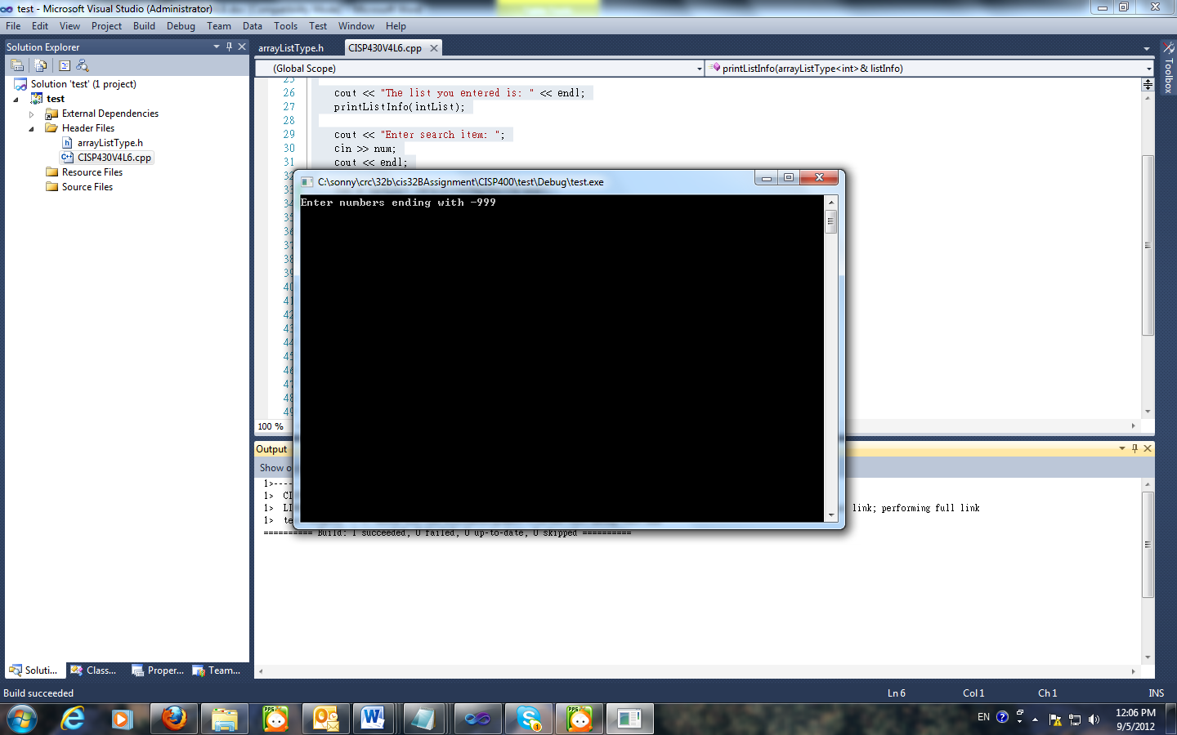
When the above screen showed, enter 60, 95, 32, 60, 1, 96, 37, 8, 25, 63, -33, 88, 33, 42, and -999. The screen on the right column displays. | 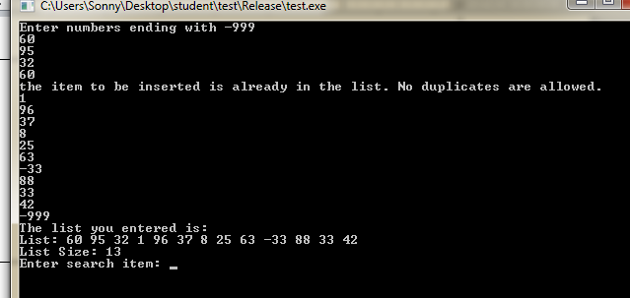
After the above screen enter 8 should get the right column screen. | 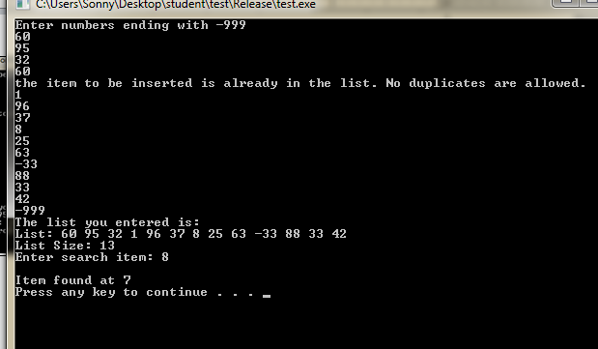
Instruction to this lab’s submittion file
Please follow the file name guide line at the assignment section of the class syllabus. This is a lab so replace the A(assignment) to L(Lab).
Please put only programming files(.h and .cpp) to the proper file named zip file and submit the zip file to the drop box of this lab.

