L9
This lab will enhance your knowledge on Graph and depth-first traversal.
Instruction
A programmer designed a depth-first traversal but he left before he had chance adding comments to the program. The main responsibility of you in this lab is understanding the program, implement assignment operator, destructor and copy constructor for linkedQueue class, and make comments on the program.
Other than this instruction there is another, CISP430V4L9.ZIP. It contains eight files, CISP430V4L9.exe, CISP430V4L9.txt, CISP430V4L9.cpp, graphType.h, linkedList.h, linkedQueue.h, queueADT.h, and unorderedLinkedList.h. The CISP430V4L9.exe file is an executable file, after you extract the file and CISP430V4L9.txt to a desktop you can double click the executable file to get to an expecting result of this program.
If we place CISP430V4L9.exe and CISP430V4L9.txt at the same location, we can double click the executable file to get to the next window result. | 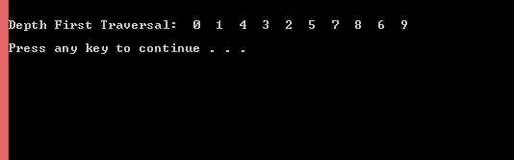
Instruction to this lab’s submittion file
Please follow the file name guide line at the assignment section of the class syllabus. This is a lab so replace the A(assignment) to L(Lab).
Please put only programming files(.hs and .cpp) to the proper file named zip file and submit the zip file to the drop box of this lab.

