A3.
In this assignment you will create, implement and test a sequence4.template file. The material from Ch1 ~ 6 of the textbook can help you tremendously. The chapter 6 of the text book is focus on Template class. You need to spend more time on understanding template prefix, template parameter, typename and etc. I call these (template prefix, template parameter, .etc.) are template stuff. Implementing the template class almost the same as implementing a regular class, but you need to add the template stuff in the file and save the file name with a template extension. If you feel confusion with the template stuff in a file you can implement the class as a regular class and add the template stuff at the end of implementation. You are welcome to use more advance skills than the techniques introduce in the textbook to do the assignment.
Following is an introduction to some files in this program.
- sequence4.h, the headers file for the new Sequence template class. You can start with the version and add your name and other documentation information at the top. Please pay attention to “#include "node2.h"” statement at the top of the file, it tells us that this class inherits from node2 class. So it is good idea to look into the note2 class. There is a “#include "sequence4.template"” statement at the end of the Sequence4.h file. This statement tells the compiler that we implement the sequence4 as a template class.
- sequence4.template is a file you need to implement. Notice that the name of this file ends in ".template" rather than ".cpp". This is to remind you that template implementation files are never compiled on their own. Section 6.2 gives us more detail on the conversion from a regular class to a template class.
- node2.h, a template version, is converted from node1.h, a class version. The file is provided. You can find it in CISP430A3. zip file. You can study the node1.h in chapter 5 to further understand the node class.
- node2.template, a template version, is converted from node1.cpp, a class version. The file is provided. You can find it in CISP430A3. zip file. You can study the node1.cpp in chapter 5 to further understand the node class and node template. This file will provide us a good example of a template file.
- sequence_test4.cpp is the same style interactive test program that you used with the earlier sequences. If you want to use it with the new sequence, then import it to your directory and open it with your editor.
- sequence_exam4.cpp is the same style non-interactive test program as you use in the previous assignment. You can add this file to a compiler to grade the sequence4.template.
- CISP430V4A3Exam.exe is an executable file which you can get to the result if you compile and run the node2.h, node2.template, sequence4.h, sequence4.template (proper implemented), sequence_exam4.cpp. When you click it you can see the following results.
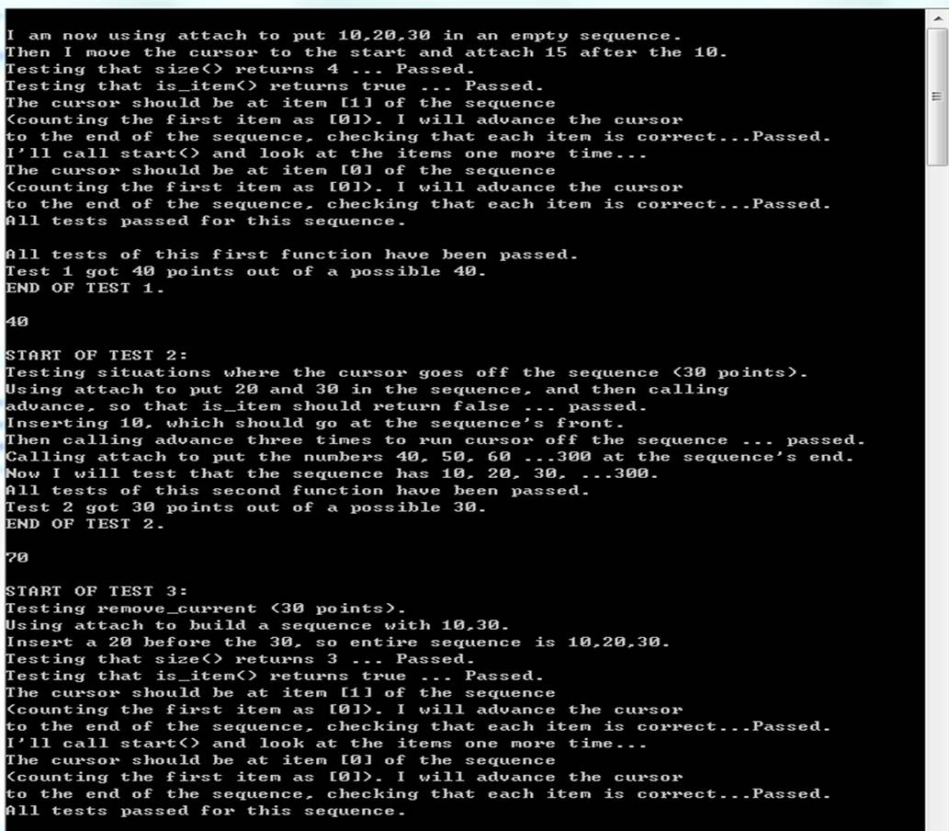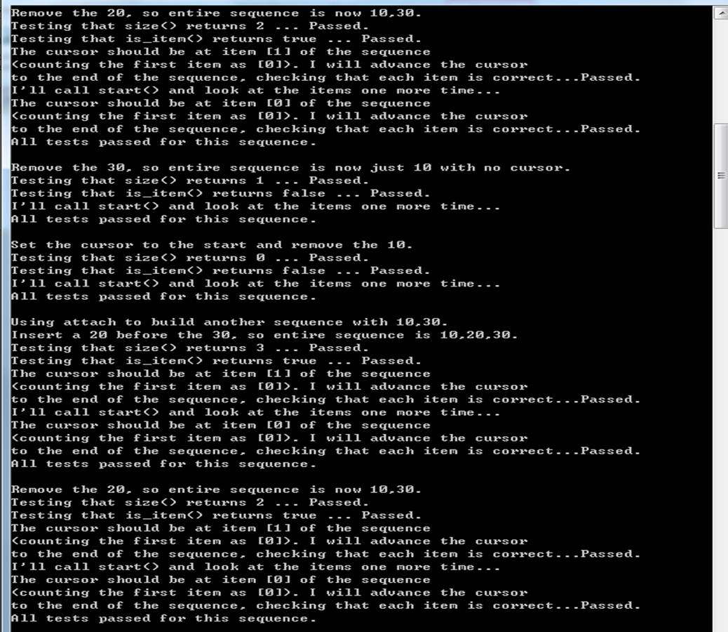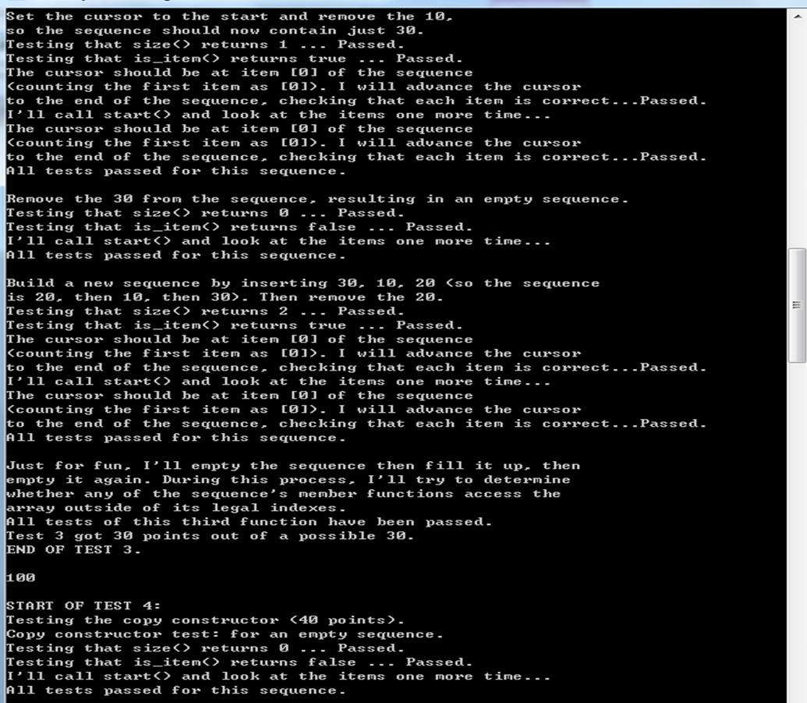
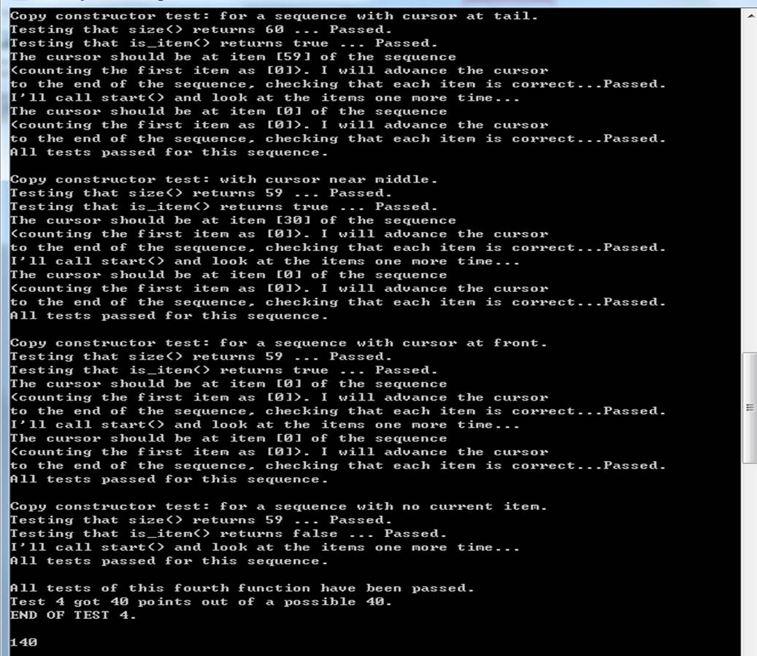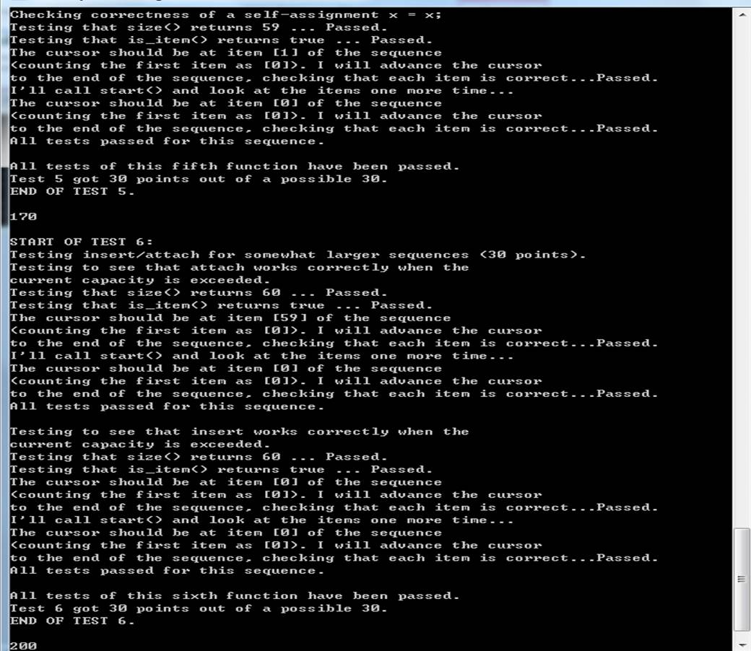
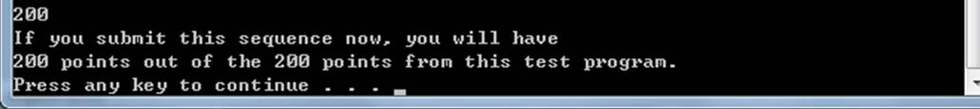

- CISP430V4A3Test.exe is an executable file which you can get to the interactive result if you compile and run the node2.h, node2.template, sequence4.h, sequence4.template (proper implemented), sequence_test4.cpp. When you click the CISP430V4A3Test.exe file and put in the proper information you should get to the following pictures.
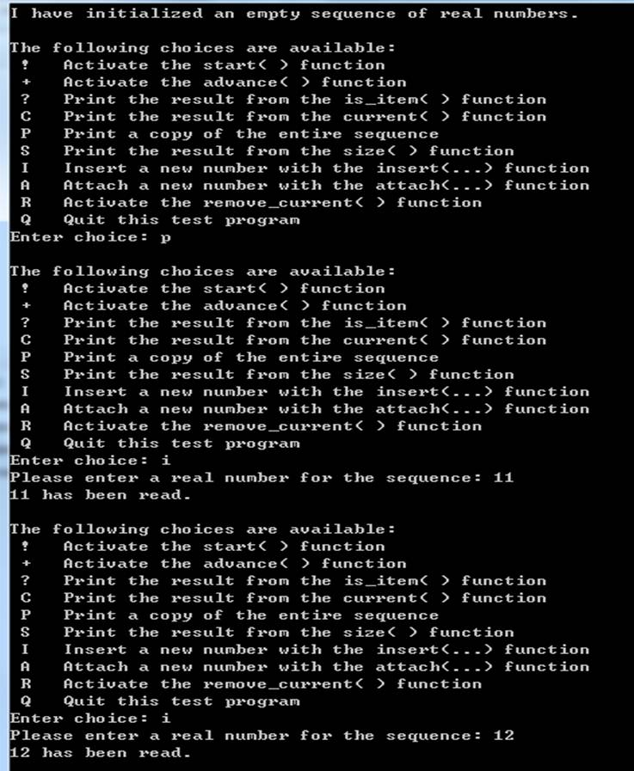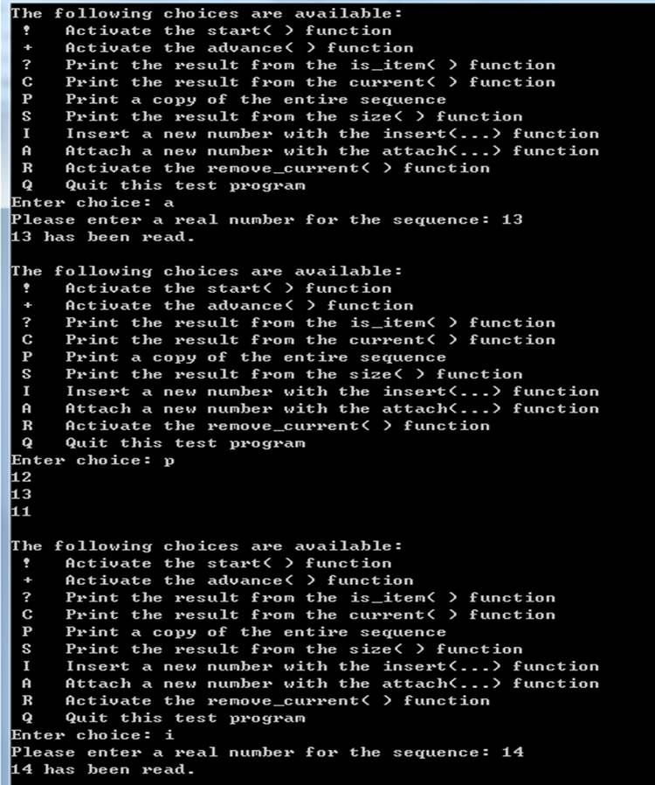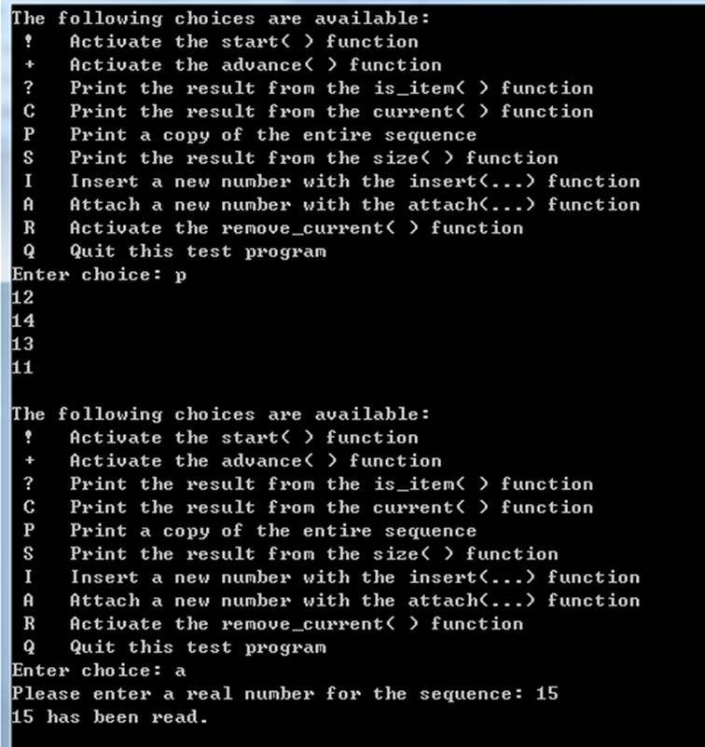
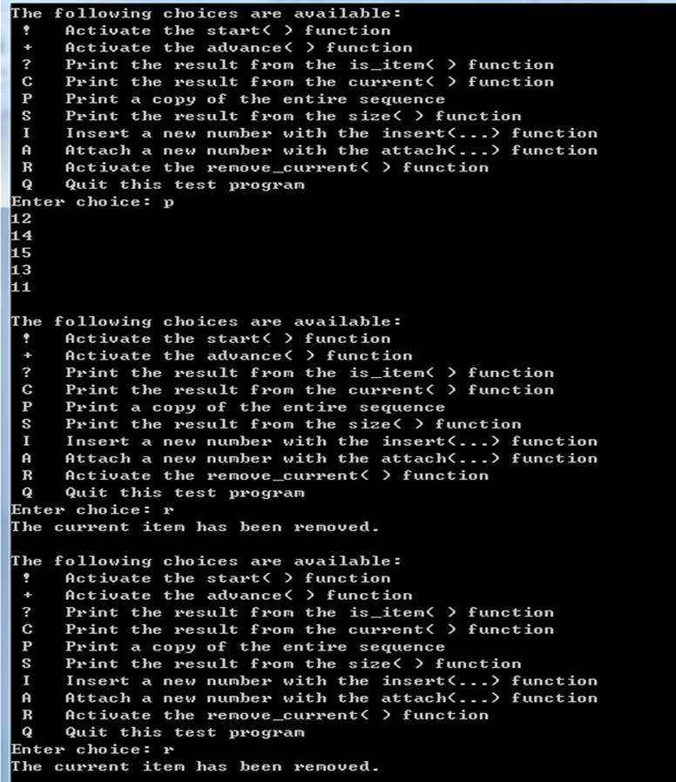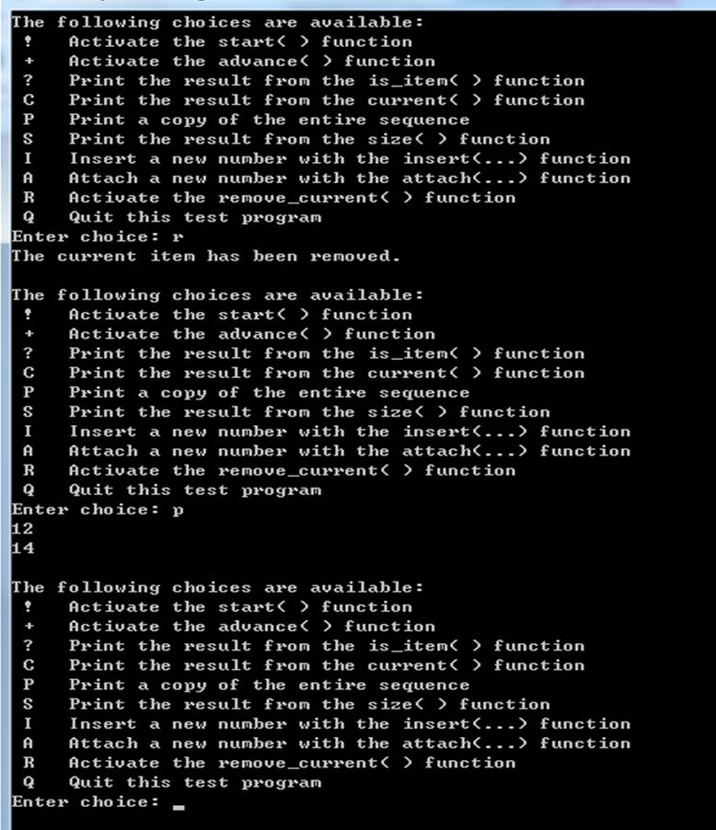

Please document the sequence4.h and sequence4.template files properly and zip them into a proper named zip file for the assignment (refer to the assignment section of the class syllabus) and submit it to the A3 folder of the Canvas Website.

Worth 200 points

