L8
This lab will enhance your knowledge on binary search trees, binary tree and template classes.
Instruction
Based on the definition of nodeCount function in binaryTree.h to create the function in binaryTree.h and create a program to test this function.
Other than this instruction there is another, CISP430V4L8.ZIP. It contains three files, CISP430V4L8.exe, binaryTree.h, and binarySearchTree.h. The CISP430V4L8.exe file is an executable file, after you extract the file to a desktop you can double click the file to get to an expecting result of this program.
binarySearchTree.h should have the codes in next column. | //Header File Binary Search Tree  #ifndef H_binarySearchTree  #define H_binarySearchTree  #include <iostream>  #include <cassert>  #include "binaryTree.h"  //*************************************************************  //  // This class specifies the basic operations to implement a  // binary search tree.  //*************************************************************  using namespace std;  template <class elemType>  class bSearchTreeType: public binaryTreeType<elemType>  {  public:  bool search(const elemType& searchItem) const;  //Function to determine if searchItem is in the binary  //search tree.  //Postcondition: Returns true if searchItem is found in the  // binary search tree; otherwise, returns false.  void insert(const elemType& insertItem);  //Function to insert insertItem in the binary search tree.  //Postcondition: If no node in the binary search tree has the  // same info as insertItem, a node with the info insertItem  // is created and inserted in the binary search tree.  void deleteNode(const elemType& deleteItem);  //Function to delete deleteItem from the binary search tree  //Postcondition: If a node with the same info as deleteItem  // is found, it is deleted from the binary search tree.  private:  void deleteFromTree(binaryTreeNode<elemType>* &p);  //Function to delete the node to which p points is deleted  //from the binary search tree.  //Postcondition: The node to which p points is deleted from  // the binary search tree.  };  template <class elemType>  bool bSearchTreeType<elemType>::  search(const elemType& searchItem) const  {  binaryTreeNode<elemType> *current;  bool found = false;  if (root == NULL)  cerr << "Cannot search the empty tree." << endl;  else  {  current = root;  while (current != NULL && !found)  {  if (current->info == searchItem)  found = true;  else if (current->info > searchItem)  current = current->llink;  else  current = current->rlink;  }//end while  }//end else  return found;  }//end search  template <class elemType>  void bSearchTreeType<elemType>::insert(const elemType& insertItem)  {  binaryTreeNode<elemType> *current; //pointer to traverse the tree  binaryTreeNode<elemType> *trailCurrent; //pointer behind current  binaryTreeNode<elemType> *newNode; //pointer to create the node  newNode = new binaryTreeNode<elemType>;  assert(newNode != NULL);  newNode->info = insertItem;  newNode->llink = NULL;  newNode->rlink = NULL;  if (root == NULL)  root = newNode;  else  {  current = root;  while (current != NULL)  {  trailCurrent = current;  if (current->info == insertItem)  {  cerr << "The insert item is already in the list-";  cerr << "duplicates are not allowed."  << insertItem << endl;  return;  }  else if (current->info > insertItem)  current = current->llink;  else  current = current->rlink;  }//end while  if (trailCurrent->info > insertItem)  trailCurrent->llink = newNode;  else  trailCurrent->rlink = newNode;  }  }//end insert  template <class elemType>  void bSearchTreeType<elemType>::deleteNode(const elemType& deleteItem)  {  binaryTreeNode<elemType> *current; //pointer to traverse the tree  binaryTreeNode<elemType> *trailCurrent; //pointer behind current  bool found = false;  if (root == NULL)  cout << "Cannot delete from the empty tree." << endl;  else  {  current = root;  trailCurrent = root;  while (current != NULL && !found)  {  if (current->info == deleteItem)  found = true;  else  {  trailCurrent = current;  if (current->info > deleteItem)  current = current->llink;  else  current = current->rlink;  }  }//end while  if (current == NULL)  cout << "The delete item is not in the tree." << endl;  else if (found)  {  if (current == root)  deleteFromTree(root);  else if (trailCurrent->info > deleteItem)  deleteFromTree(trailCurrent->llink);  else  deleteFromTree(trailCurrent->rlink);  }//end if  }  }//end deleteNode  template <class elemType>  void bSearchTreeType<elemType>::deleteFromTree  (binaryTreeNode<elemType>* &p)  {  binaryTreeNode<elemType> *current; //pointer to traverse the tree  binaryTreeNode<elemType> *trailCurrent; //pointer behind current  binaryTreeNode<elemType> *temp; //pointer to delete the node  if (p == NULL)  cerr << "Error: The node to be deleted is NULL." << endl;  else if(p->llink == NULL && p->rlink == NULL)  {  temp = p;  p = NULL;  delete temp;  }  else if(p->llink == NULL)  {  temp = p;  p = temp->rlink;  delete temp;  }  else if(p->rlink == NULL)  {  temp = p;  p = temp->llink;  delete temp;  }  else  {  current = p->llink;  trailCurrent = NULL;  while (current->rlink != NULL)  {  trailCurrent = current;  current = current->rlink;  }//end while  p->info = current->info;  if (trailCurrent == NULL) //current did not move;  //current == p->llink; adjust p  p->llink = current->llink;  else  trailCurrent->rlink = current->llink;  delete current;  }//end else  }//end deleteFromTree  #endif
The right column is codes for binaryTree.h. It has the declaration of the nodeCount and leavesCount functions. Please add the implementation for the nodeCount and leavesCount functions in here. | //Header File Binary Search Tree  #ifndef H_binaryTree  #define H_binaryTree  //*************************************************************  //  // class binaryTreeType  // This class specifies the basic operations to implement a  // binary tree.  //*************************************************************  #include <iostream>  using namespace std;  //Definition of the node  template <class elemType>  struct binaryTreeNode  {  elemType info;  binaryTreeNode<elemType> *llink;  binaryTreeNode<elemType> *rlink;  };  //Definition of the class  template <class elemType>  class binaryTreeType  {  public:  const binaryTreeType<elemType>& operator=  (const binaryTreeType<elemType>&);  //Overload the assignment operator.  bool isEmpty() const;  //Returns true if the binary tree is empty;  //otherwise, returns false.  void inorderTraversal() const;  //Function to do an inorder traversal of the binary tree.  void preorderTraversal() const;  //Function to do a preorder traversal of the binary tree.  void postorderTraversal() const;  //Function to do a postorder traversal of the binary tree.  int treeHeight() const;  //Returns the height of the binary tree.  int treeNodeCount() const;  //Returns the number of nodes in the binary tree.  int treeLeavesCount() const;  //Returns the number of leaves in the binary tree.  void destroyTree();  //Deallocates the memory space occupied by the binary tree.  //Postcondition: root = NULL;  binaryTreeType(const binaryTreeType<elemType>& otherTree);  //copy constructor  binaryTreeType();  //default constructor  ~binaryTreeType();  //destructor  protected:  binaryTreeNode<elemType> *root;  private:  void copyTree(binaryTreeNode<elemType>* &copiedTreeRoot,  binaryTreeNode<elemType>* otherTreeRoot);  //Makes a copy of the binary tree to which  //otherTreeRoot points. The pointer copiedTreeRoot  //points to the root of the copied binary tree.  void destroy(binaryTreeNode<elemType>* &p);  //Function to destroy the binary tree to which p points.  //Postcondition: p = NULL  void inorder(binaryTreeNode<elemType> *p) const;  //Function to do an inorder traversal of the binary  //tree to which p points.  void preorder(binaryTreeNode<elemType> *p) const;  //Function to do a preorder traversal of the binary  //tree to which p points.  void postorder(binaryTreeNode<elemType> *p) const;  //Function to do a postorder traversal of the binary  //tree to which p points.  int height(binaryTreeNode<elemType> *p) const;  //Function to return the height of the binary tree  //to which p points.  int max(int x, int y) const;  //Returns the larger of x and y.  int nodeCount(binaryTreeNode<elemType> *p) const;  //Function to return the number of nodes in the binary  //tree to which p points  int leavesCount(binaryTreeNode<elemType> *p) const;  //Function to return the number of leaves in the binary  //tree to which p points  };  //Definition of member functions  template <class elemType>  binaryTreeType<elemType>::binaryTreeType()  {  root = NULL;  }  template <class elemType>  bool binaryTreeType<elemType>::isEmpty() const  {  return (root == NULL);  }  template <class elemType>  void binaryTreeType<elemType>::inorderTraversal() const  {  inorder(root);  }  template <class elemType>  void binaryTreeType<elemType>::preorderTraversal() const  {  preorder(root);  }  template <class elemType>  void binaryTreeType<elemType>::postorderTraversal() const  {  postorder(root);  }  template <class elemType>  int binaryTreeType<elemType>::treeHeight() const  {  return height(root);  }  template <class elemType>  int binaryTreeType<elemType>::treeNodeCount() const  {  return nodeCount(root);  }  template <class elemType>  int binaryTreeType<elemType>::treeLeavesCount() const  {  return leavesCount(root);  }  template <class elemType>  void binaryTreeType<elemType>::copyTree  (binaryTreeNode<elemType>* &copiedTreeRoot,  binaryTreeNode<elemType>* otherTreeRoot)  {  if (otherTreeRoot == NULL)  copiedTreeRoot = NULL;  else  {  copiedTreeRoot = new binaryTreeNode<elemType>;  copiedTreeRoot->info = otherTreeRoot->info;  copyTree(copiedTreeRoot->llink, otherTreeRoot->llink);  copyTree(copiedTreeRoot->rlink, otherTreeRoot->rlink);  }  } //end copyTree  template <class elemType>  void binaryTreeType<elemType>::inorder(binaryTreeNode<elemType> *p) const  {  if (p != NULL)  {  inorder(p->llink);  cout << p->info << " ";  inorder(p->rlink);  }  }  template <class elemType>  void binaryTreeType<elemType>::preorder(binaryTreeNode<elemType> *p) const  {  if (p != NULL)  {  cout<<p->info<<" ";  preorder(p->llink);  preorder(p->rlink);  }  }  template <class elemType>  void binaryTreeType<elemType>::postorder(binaryTreeNode<elemType> *p) const  {  if (p != NULL)  {  postorder(p->llink);  postorder(p->rlink);  cout << p->info << " ";  }  }  //Overload the assignment operator  template <class elemType>  const binaryTreeType<elemType>& binaryTreeType<elemType>::  operator=(const binaryTreeType<elemType>& otherTree)  {  if (this != &otherTree) //avoid self-copy  {  if (root != NULL) //if the binary tree is not empty,  //destroy the binary tree  destroy(root);  if (otherTree.root == NULL) //otherTree is empty  root = NULL;  else  copyTree(root, otherTree.root);  }//end else  return *this;  }  template <class elemType>  void binaryTreeType<elemType>::destroy(binaryTreeNode<elemType>* &p)  {  if (p != NULL)  {  destroy(p->llink);  destroy(p->rlink);  delete p;  p = NULL;  }  }  template <class elemType>  void binaryTreeType<elemType>::destroyTree()  {  destroy(root);  }  //copy constructor  template <class elemType>  binaryTreeType<elemType>::binaryTreeType  (const binaryTreeType<elemType>& otherTree)  {  if (otherTree.root == NULL) //otherTree is empty  root = NULL;  else  copyTree(root, otherTree.root);  }  template <class elemType>  binaryTreeType<elemType>::~binaryTreeType()  {  destroy(root);  }  template <class elemType>  int binaryTreeType<elemType>::height(binaryTreeNode<elemType> *p) const  {  if (p == NULL)  return 0;  else  return 1 + max(height(p->llink), height(p->rlink));  }  template <class elemType>  int binaryTreeType<elemType>::max(int x, int y) const  {  if (x >= y)  return x;  else  return y;  }  template <class elemType>  int binaryTreeType<elemType>::leavesCount(binaryTreeNode<elemType> *p) const  {  cout << "Write the definition of the function leavesCount"  << endl;  return 0;  }  #endif
CISP430V4L8.cpp is the driver for this lab. In this program we need to
- Declare an integer bSearchTreeType object.
- Allow user to input numbers or -999 to end the inputting.
- The inputted numbers are stored in the bSearchTreeType object.
- Display the bSearchTreeType object’s nodes in inorder.
- Display the bSearchTreeType object’s nodes in preorder.
- Display the bSearchTreeType object’s nodes in postorder.
- Display the object’s height.
- Display the object’s number of nodes.
- Display the object’s number of leaves.

PS. You may need to make some adjustments in binarySearchTree.h to make it work.
After you finish all the requirements and put them ( CISP430V4L8.cpp, binaryTree.h, and binarySearchTree.h) into a project and should be able to run to a screen on the right. |  | 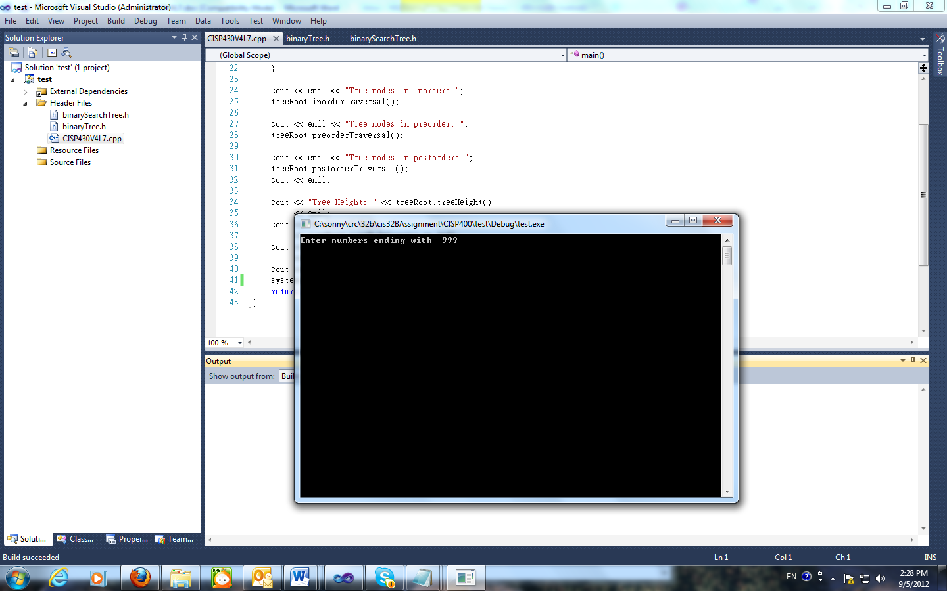
When the above screen showed, enter 68 43 10 56 77 82 61 82 33 56 72 66 99 88 12 6 7 21 -999. The screen on the right column displays. |  | 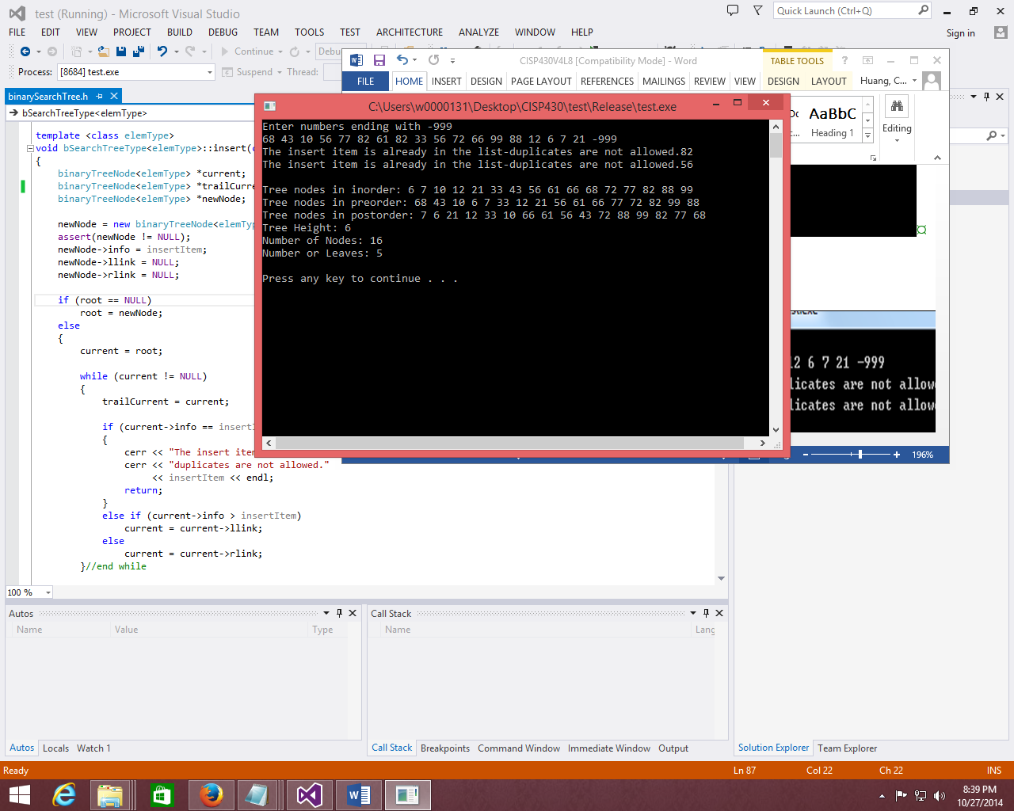
Instruction to this lab’s submittion file
Please follow the file name guide line at the assignment section of the class syllabus. This is a lab so replace the A(assignment) to L(Lab).
Please put only programming files(.hs and .cpp) to the proper file named zip file and submit the zip file to the drop box of this lab.

