WarlineCapture UI/UX Screen & Popup Implementation Spec
Version A visual mockups + Version B Codex/Unity Canvas reading guide
Synty Military low-poly art direction + Military Combat HUD style language
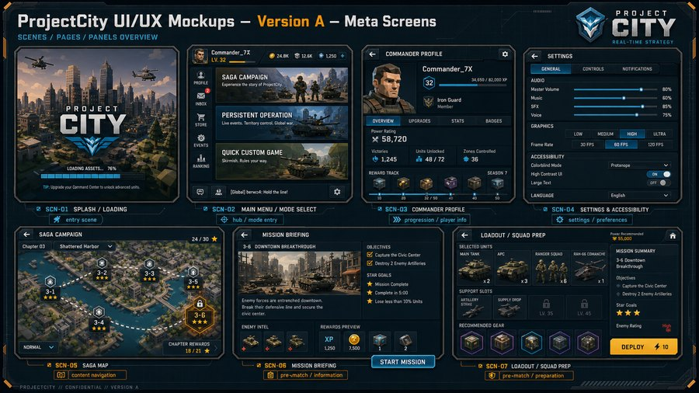  Meta Screens | 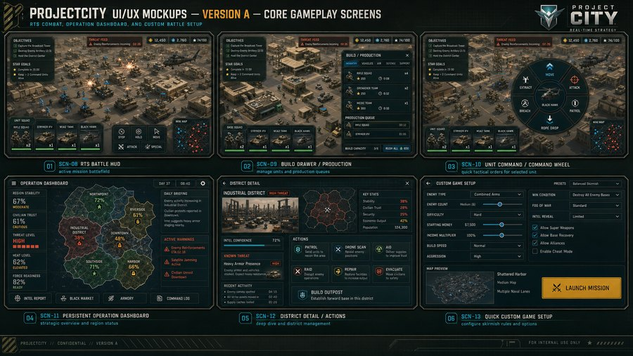  Core Gameplay | 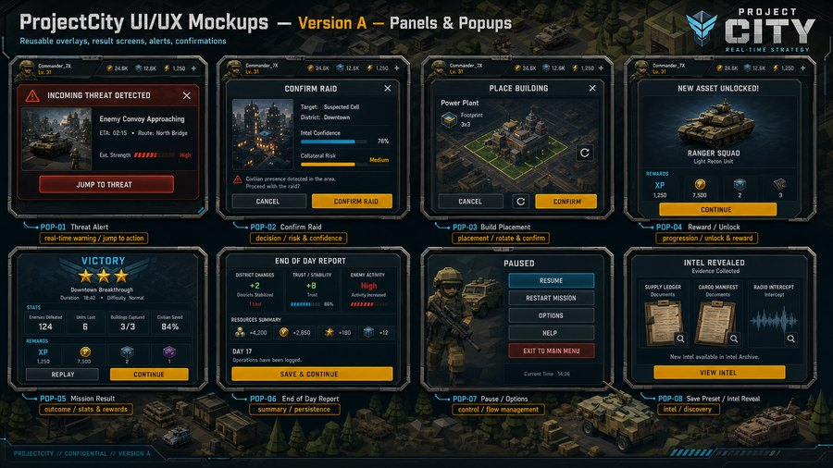  Panels & Popups
Purpose: This document explains every major scene, page, popup, and reusable panel shown in the mockup boards. Each entry pairs the visual reference with what the text, imagery, controls, and game-design meaning are, plus a Unity Canvas implementation contract for Codex.

How Codex should read this document
Rule | Implementation meaning
Visual style | Use the purchased Synty Military assets for low-poly soldiers, vehicles, buildings, and city/base props. Use the Military Combat HUD Synty Interface GUI package for frame, button, icon, tab, slider, and meter styling. The mockups are layout and behavior references, not final imported art.
Resolution | The boards are landscape 3840x2160 presentation references. In Unity, use Canvas Scaler = Scale With Screen Size, reference resolution 1920x1080 or 3840x2160 depending on project convention; keep safe-area padding for mobile devices.
Routing | All mode screens share one app shell: SafeAreaRoot > HeaderBar > ContentRoot > FooterBar > ModalOverlay > TooltipLayer. Tactical MatchScene has a persistent HUD plus overlay canvases for drawers, wheels, and modals.
Game design relationship | Saga screens implement the level-based map and star progression; Operation screens implement the multi-week city security campaign; Quick Custom setup implements replayable skirmishes and AI tuning.

Screen and Popup Index
ID | Name | Type | Shown / used in game
SCN-01 | Splash / Loading | Frontend | Shown immediately on app launch, during cold start, and when returning from a deep mode load that needs a...
SCN-02 | Main Menu / Mode Select | Frontend | Shown after Splash, after mission results, and whenever the player exits back to the hub.
SCN-03 | Commander Profile | Frontend | Shown from the Main Menu side navigation, after ranking/reward interactions, and from any screen that all...
SCN-04 | Settings & Accessibility | Frontend | Shown from Main Menu, Pause menu, and optionally from first-run onboarding.
SCN-05 | Saga Map | Frontend | Shown when the player enters Saga Campaign from the Main Menu.
SCN-06 | Mission Briefing | Frontend | Shown after selecting a Saga node, a generated operation mission, or a curated quick preset that needs pr...
SCN-07 | Loadout / Squad Prep | Frontend | Shown before launching a mission that allows player loadout choice.
SCN-08 | RTS Battle HUD | Gameplay / Operation / Quick | Shown during active tactical missions in Saga, Persistent Operation, and Quick Custom Game.
SCN-09 | Build Drawer / Production | Gameplay / Operation / Quick | Shown as an overlay/drawer during MatchScene when the player taps Build or a production facility.
SCN-10 | Unit Command / Command Wheel | Gameplay / Operation / Quick | Shown during MatchScene when the player long-presses or taps command mode for a selected squad, vehicle, ...
SCN-11 | Persistent Operation Dashboard | Gameplay / Operation / Quick | Shown when entering Persistent Operation and between tactical missions/days.
SCN-12 | District Detail / Actions | Gameplay / Operation / Quick | Shown after selecting a district from Persistent Operation Dashboard.
SCN-13 | Quick Custom Game Setup | Gameplay / Operation / Quick | Shown when selecting Quick Custom Game from Main Menu.
POP-01 | Threat Alert | Popup | Overlay during MatchScene and Persistent Operation Dashboard when a detected threat needs immediate playe...
POP-02 | Confirm Raid | Popup | Shown when the player chooses Raid from District Detail or a suspected target before enough intel is guar...
POP-03 | Build Placement | Popup | Shown after choosing a building from Build Drawer during tactical missions or outpost setup.
POP-04 | Reward / Unlock | Popup | Shown after mission completion, chapter reward claim, commander level-up, or unlock milestone.
POP-05 | Mission Result | Popup | Shown at the end of Saga missions, generated operation tactical missions, and Quick Custom Game matches.
POP-06 | End of Day Report | Popup | Shown in Persistent Operation when the player ends a day/session or after operation event resolution.
POP-07 | Pause / Options | Popup | Shown when the player pauses a tactical mission, operation dashboard, or custom setup where pause/options...
POP-08 | Intel Reveal | Popup | Shown in Persistent Operation or intel-focused missions when new evidence has been collected.
PREFAB-01 | Objective Tracker | Reusable Panel Prefab | Reusable in MatchScene HUD, Mission Briefing condensed previews, and tutorial overlays.
PREFAB-02 | Squad Tray | Reusable Panel Prefab | Reusable bottom HUD panel during tactical missions and loadout previews.
PREFAB-03 | Build Drawer | Reusable Panel Prefab | Reusable drawer for MatchScene production, base setup, and potentially outpost construction.

SCN-01 - Splash / Loading
Where shown: Shown immediately on app launch, during cold start, and when returning from a deep mode load that needs asynchronous asset preparation.
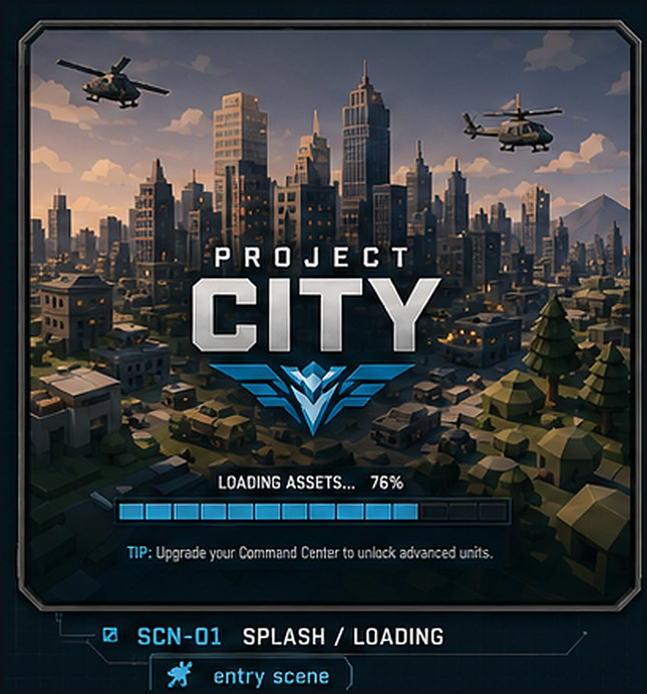  Image asset: SCN-01_splash_loading.png | Game design link: Supports the AAA polish target in GDD sections 3.3 and 11.4. It is the first player-facing proof that the game is a polished mobile RTS, and it hides mode/map loading before Main Menu.  Player/UX purpose: Set tone, communicate the brand, and give loading feedback without exposing technical loading noise.  Text labels and meaning  - PROJECT CITY logo and emblem: brand identity.  - LOADING ASSETS... 76%: async load progress.  - Tip line: teaches upgrades and command-center progression while the player waits.  Images/icons and meaning  - Low-poly city skyline, helicopters, and military base scenery: establishes Synty-style urban military setting.  - Dark beveled frame and cyan progress bar: matches Military Combat HUD UI kit direction.  Buttons and controls  - No player button by default. Optional Skip/Continue may appear only after minimum load time when the next scene is ready.  Unity/Codex implementation: Scene SplashScene. Canvas SplashCanvas. Root panels: SafeAreaRoot, LogoRoot, LoadingBar, StatusText, TipText. Bind LoadingBar.value to AsyncOperation.progress; randomize TipText from loading tips table.  Runtime data bindings  - Loading progress  - Localized loading tips  - Next route: MainMenuScene  Navigation / trigger: Auto-routes to SCN-02 Main Menu / Mode Select when all required assets are ready.

SCN-02 - Main Menu / Mode Select
Where shown: Shown after Splash, after mission results, and whenever the player exits back to the hub.
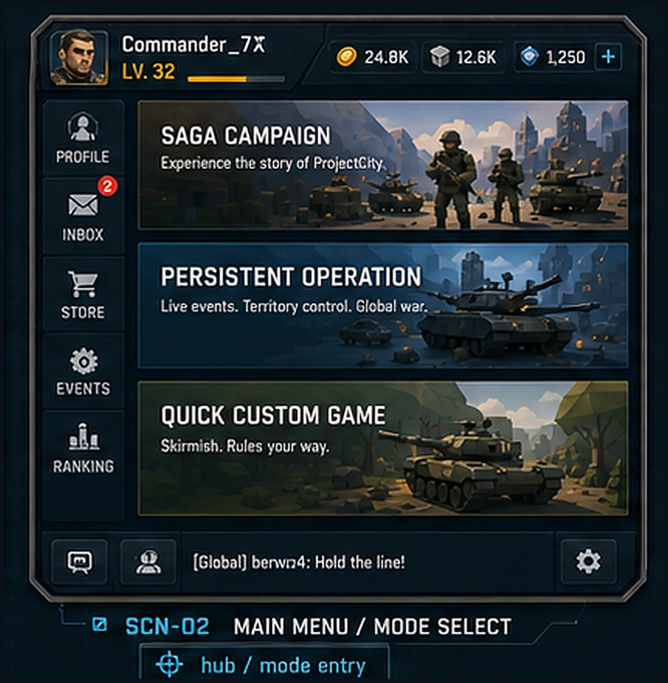  Image asset: SCN-02_main_menu_mode_select.png | Game design link: Directly implements the three-mode product structure from GDD sections 1, 7, 8, and 9: Saga Campaign, Persistent Operation, and Quick Custom Game.  Player/UX purpose: Let the player choose the game mode quickly while seeing account progression, resources, and secondary navigation.  Text labels and meaning  - Commander_7X, LV. 32: current player identity and progression.  - Resource counters 24.8K, 12.6K, 1,250: money/materials/premium or command currency placeholders.  - SAGA CAMPAIGN: story and level progression entry.  - PERSISTENT OPERATION: long saved operation mode entry.  - QUICK CUSTOM GAME: sandbox/skirmish entry.  - Global chat/status strip: social or system feed placeholder.  Images/icons and meaning  - Low-poly mode-card art: soldiers and armor for Saga, heavy vehicles for Persistent Operation, tank/terrain for Quick Custom.  - Commander avatar and left navigation icons: profile/store/events/ranking access.  Buttons and controls  - Mode cards are primary buttons.  - Profile, Inbox, Store, Events, Ranking are side-navigation buttons.  - Plus button beside resources opens currency/resource acquisition or details.  - Gear button opens Settings.  - Bottom icons open chat/social/commander shortcuts.  Unity/Codex implementation: Scene MainMenuScene. Canvas MainMenuCanvas. Panels: TopProfileBar, ModeCardList, LeftNav, BottomUtilityBar. Each mode card is a prefab using ModeCardView with title, subtitle, image, progress state, and OnClick route.  Runtime data bindings  - PlayerProfile  - ResourceWallet  - ModeUnlockState  - UnreadInboxCount  - LiveEventState  Navigation / trigger: Saga card -> SCN-05. Persistent Operation card -> SCN-11. Quick Custom Game card -> SCN-13. Profile icon -> SCN-03. Gear -> SCN-04.

SCN-03 - Commander Profile
Where shown: Shown from the Main Menu side navigation, after ranking/reward interactions, and from any screen that allows player-profile inspection.
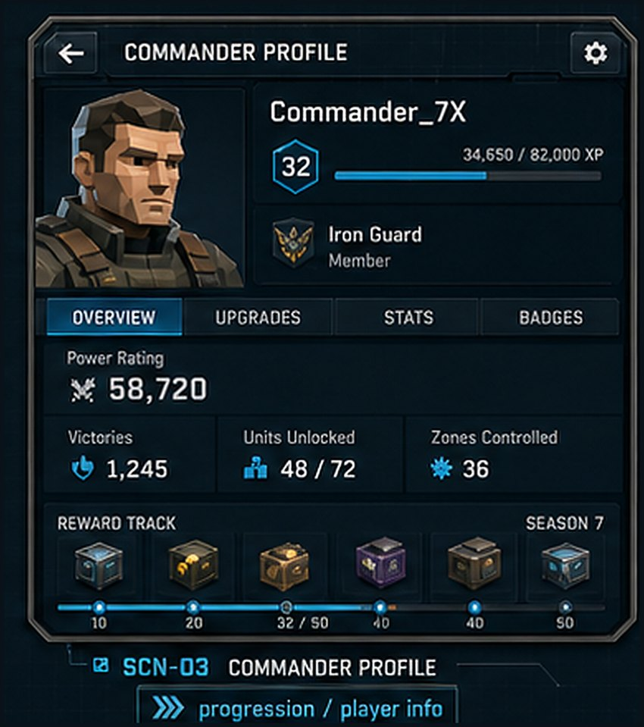  Image asset: SCN-03_commander_profile.png | Game design link: Implements GDD section 13 Player Progression and section 13.2 Upgrade Categories. It also supports long-term rewards across all three modes.  Player/UX purpose: Show player identity, XP, power rating, unit unlock progress, controlled zones, and seasonal reward track.  Text labels and meaning  - COMMANDER PROFILE: screen title.  - Commander_7X and level badge 32: account identity and current level.  - XP bar and numeric XP: progression to next level.  - Iron Guard / Member: alliance or squad affiliation placeholder.  - Power Rating 58,720: aggregate account strength.  - Victories, Units Unlocked, Zones Controlled: cross-mode summary stats.  - Reward Track / Season 7: seasonal or campaign reward progression.  Images/icons and meaning  - Low-poly commander portrait: player persona.  - Reward crates and badges: unlockable content or currencies.  - Shield/insignia icons: faction/alliance identity.  Buttons and controls  - Back arrow returns to previous screen.  - Gear opens profile settings or account options.  - Overview, Upgrades, Stats, Badges tabs switch content panels.  - Reward track nodes can open reward details.  Unity/Codex implementation: Scene ProfileScene. Canvas ProfileCanvas. Panels: HeaderBar, PortraitPanel, TabBar, StatsPanel, RewardTrackPanel. Use a TabController and reusable StatTile prefab.  Runtime data bindings  - PlayerProfile  - CommanderXP  - AccountStats  - UnitUnlockCollection  - RewardTrackProgress  Navigation / trigger: Back -> Main Menu or calling screen. Tabs stay within ProfileScene.

SCN-04 - Settings & Accessibility
Where shown: Shown from Main Menu, Pause menu, and optionally from first-run onboarding.
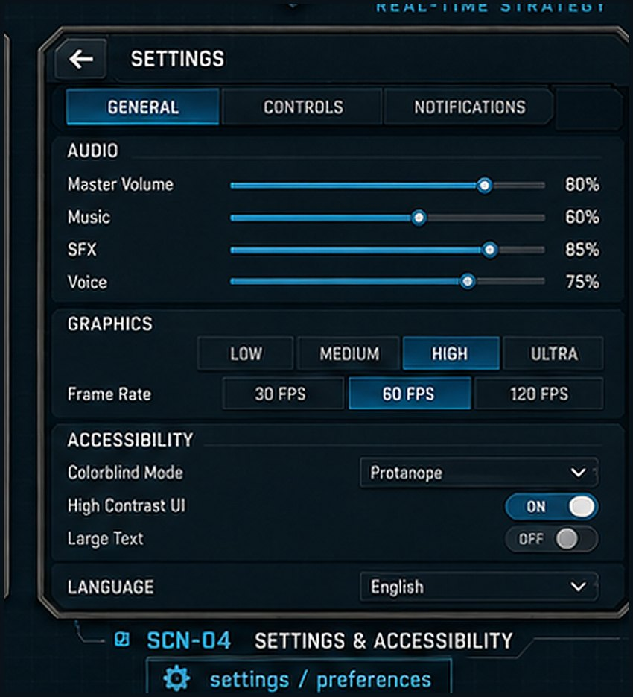  Image asset: SCN-04_settings_accessibility.png | Game design link: Supports GDD section 11.4 Accessibility and Readability, and the AAA mobile quality bar in section 3.3.  Player/UX purpose: Give players control over audio, graphics, controls, notifications, accessibility, and language.  Text labels and meaning  - SETTINGS: screen title.  - General, Controls, Notifications tabs: settings categories.  - Audio labels and percentages: volume controls.  - Graphics quality and frame rate labels: performance tuning.  - Colorblind Mode, High Contrast UI, Large Text: accessibility features.  - Language: localization entry.  Images/icons and meaning  - Sliders, toggle switches, segmented buttons, dropdowns: Synty HUD-style settings controls.  Buttons and controls  - Back arrow returns to previous screen.  - Tab buttons swap settings category.  - Quality and frame-rate segmented buttons choose discrete settings.  - Toggles switch accessibility options.  - Dropdowns choose colorblind mode or language.  Unity/Codex implementation: Scene SettingsScene or modal overlay. Canvas SettingsCanvas. Panels: HeaderBar, TabStrip, SettingsScrollView, FooterButtons. Persist values through SettingsService and PlayerPrefs/cloud settings.  Runtime data bindings  - AudioSettingsModel  - GraphicsSettingsModel  - AccessibilitySettingsModel  - LocalizationSettings  Navigation / trigger: Back -> calling screen. Settings can be opened from SCN-02 and POP-07.

SCN-05 - Saga Map
Where shown: Shown when the player enters Saga Campaign from the Main Menu.
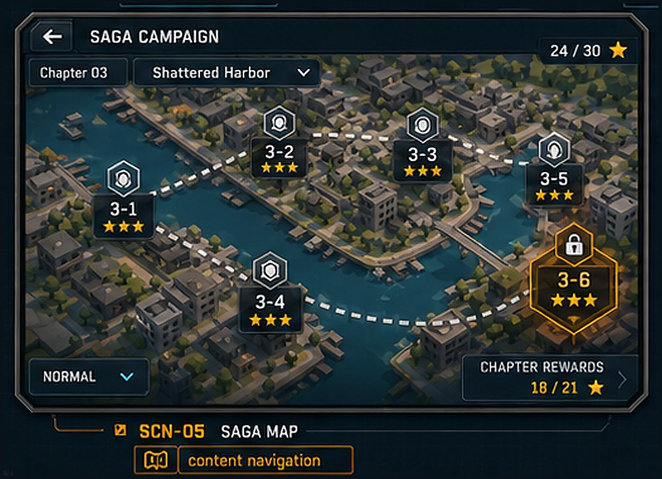  Image asset: SCN-05_saga_map.png | Game design link: Implements GDD section 7 Saga Campaign: curated level nodes, chapter unlocks, stars, and rewards.  Player/UX purpose: Let the player browse chapter nodes, see completion stars, select missions, and collect chapter rewards.  Text labels and meaning  - SAGA CAMPAIGN: mode title.  - Chapter 03 / Shattered Harbor: chapter selector.  - 24/30 stars: chapter completion progress.  - Node labels 3-1 through 3-6: individual mission nodes.  - NORMAL: difficulty selector.  - CHAPTER REWARDS 18/21: reward progress for chapter stars.  Images/icons and meaning  - Low-poly city/island map with waterways, bridges, and district blocks: saga path visualization.  - Node icons and dotted route: progression path.  - Gold highlighted node 3-6: currently selected or next playable mission.  Buttons and controls  - Back arrow returns to Main Menu.  - Chapter dropdown changes chapter.  - Mission nodes select MissionConfig.  - Difficulty dropdown changes mission difficulty if unlocked.  - Chapter Rewards opens reward detail panel.  Unity/Codex implementation: Scene SagaMapScene. Canvas SagaMapCanvas. Panels: HeaderBar, ChapterSelector, MapViewport, NodeInfoPanel, FooterBar. Use SagaMapController to populate node prefabs from MissionConfig list.  Runtime data bindings  - SagaProgress  - ChapterConfig  - MissionConfig  - StarProgress  - UnlockState  Navigation / trigger: Select playable node -> SCN-06 Mission Briefing. Back -> SCN-02.

SCN-06 - Mission Briefing
Where shown: Shown after selecting a Saga node, a generated operation mission, or a curated quick preset that needs preview information.
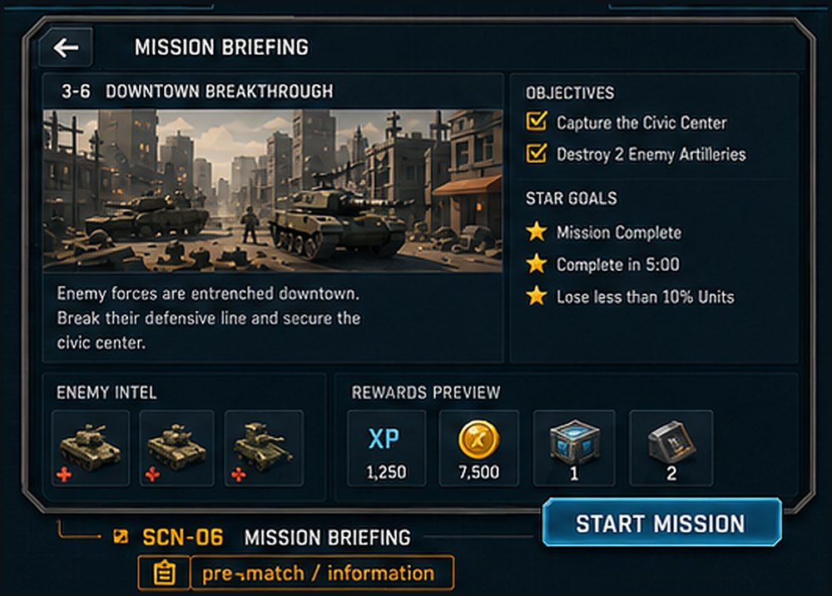  Image asset: SCN-06_mission_briefing.png | Game design link: Supports GDD sections 7.3, 7.5, and 10.2: MissionConfig, objectives, enemy intel, and rewards.  Player/UX purpose: Explain the mission before deployment: objective, threat, star goals, expected enemy, and reward preview.  Text labels and meaning  - MISSION BRIEFING and 3-6 DOWNTOWN BREAKTHROUGH: mission identity.  - Briefing paragraph: narrative and tactical context.  - OBJECTIVES: required win conditions.  - STAR GOALS: optional scoring goals.  - ENEMY INTEL: preview of expected unit families.  - REWARDS PREVIEW: XP, currency, crates/items.  Images/icons and meaning  - Low-poly mission key art: city street combat with armor.  - Enemy intel thumbnails: expected threats.  - Reward icons: tangible unlock/loot feedback.  Buttons and controls  - Back arrow returns to Saga Map or source screen.  - START MISSION proceeds to Loadout or directly to match depending on mode rules.  - Enemy/reward tiles can open details if desired.  Unity/Codex implementation: Scene MissionBriefingScene. Canvas BriefingCanvas. Panels: HeaderBar, MissionImagePanel, ObjectivePanel, IntelPanel, RewardPanel, PrimaryCTA. Populate from MissionConfig and RewardConfig.  Runtime data bindings  - MissionConfig  - ObjectiveConfig  - AIProfileConfig  - RewardConfig  - PlayerUnlockState  Navigation / trigger: Start Mission -> SCN-07 Loadout / Squad Prep. Back -> SCN-05 or calling operation/custom setup.

SCN-07 - Loadout / Squad Prep
Where shown: Shown before launching a mission that allows player loadout choice.
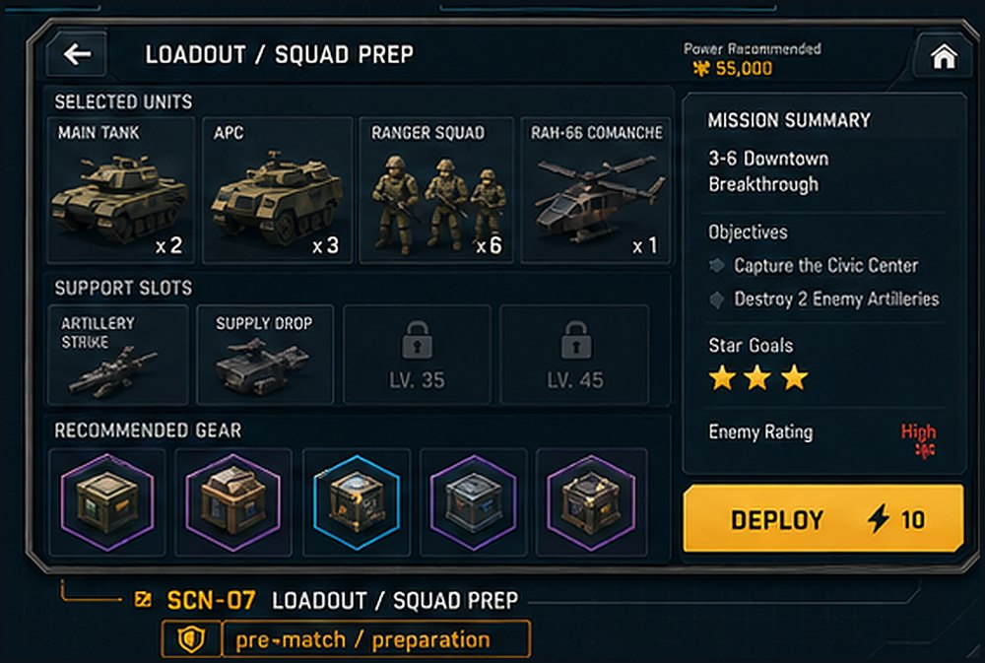  Image asset: SCN-07_loadout_squad_prep.png | Game design link: Supports GDD sections 7.7 rewards/unlocks, 11.1 mobile-first controls, and 13.2 upgrade categories.  Player/UX purpose: Let the player choose units, support abilities, and gear while checking mission power requirements and objectives.  Text labels and meaning  - LOADOUT / SQUAD PREP: screen title.  - Power Recommended 55,000: difficulty/power target.  - Selected Units: chosen squads/vehicles/aircraft and counts.  - Support Slots: tactical support abilities and locked slots.  - Recommended Gear: upgrade/boost item suggestions.  - Mission Summary: objectives, star goals, enemy rating.  - DEPLOY 10: launch button and energy/fuel cost.  Images/icons and meaning  - Low-poly tank, APC, infantry, helicopter cards.  - Crate/module gear icons with rarity-colored borders.  - Lock icons for slots gated by level.  Buttons and controls  - Back returns to briefing.  - Home returns to main hub after confirmation.  - Unit cards open roster selector.  - Support slot cards open support selector.  - Gear cards open equipment selector.  - Deploy launches MatchScene.  Unity/Codex implementation: Scene LoadoutScene. Canvas LoadoutCanvas. Panels: HeaderBar, UnitRosterGrid, SupportSlotsPanel, GearPanel, MissionSummaryPanel, DeployButton. Validate loadout against mission rules before enabling Deploy.  Runtime data bindings  - PlayerUnitRoster  - SelectedLoadout  - SupportAbilityInventory  - GearInventory  - MissionConfig  Navigation / trigger: Deploy -> MatchScene with GameModeConfig and loadout payload.

SCN-08 - RTS Battle HUD
Where shown: Shown during active tactical missions in Saga, Persistent Operation, and Quick Custom Game.
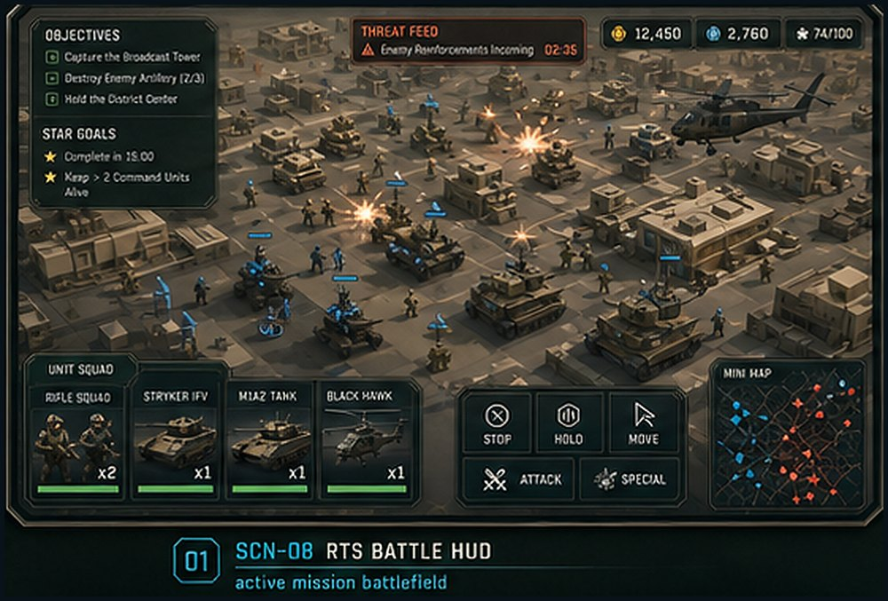  Image asset: SCN-08_rts_battle_hud.png | Game design link: Implements GDD sections 5.1 Match-Level Loop, 5.2 Combat Micro Loop, and 11.2 HUD Layout.  Player/UX purpose: Keep real-time battlefield information readable on mobile: objectives, threats, resources, squad cards, commands, and minimap.  Text labels and meaning  - OBJECTIVES: current required mission tasks.  - STAR GOALS: optional scoring conditions.  - THREAT FEED: current warning or timed event.  - Resource counters: money/materials/population or supply.  - Unit Squad: selected squads and health/status.  - Mini Map: tactical overview.  Images/icons and meaning  - Low-poly battlefield with friendly units, enemy units, explosions, helicopters, vehicles, and city/base structures.  - Unit cards and command buttons: player control surfaces.  Buttons and controls  - Squad cards select/focus squads.  - STOP, HOLD, MOVE, ATTACK, SPECIAL issue commands.  - Build button opens SCN-09 Build Drawer.  - Minimap can jump camera or expand.  Unity/Codex implementation: Scene MatchScene. Canvas MatchHUDCanvas. Panels: ObjectivePanel, ThreatFeedPanel, ResourceBar, SquadTray, CommandBar, MiniMapPanel, BuildToggle. Use anchors: objective top-left, resources top-right, squad tray bottom-left, commands bottom-center/right.  Runtime data bindings  - ObjectiveRuntimeState  - ThreatFeedState  - FactionResourceState  - SelectedUnitGroup  - MiniMapState  Navigation / trigger: Battle HUD remains active until win/loss -> POP-05, pause -> POP-07, build -> SCN-09 overlay.

SCN-09 - Build Drawer / Production
Where shown: Shown as an overlay/drawer during MatchScene when the player taps Build or a production facility.
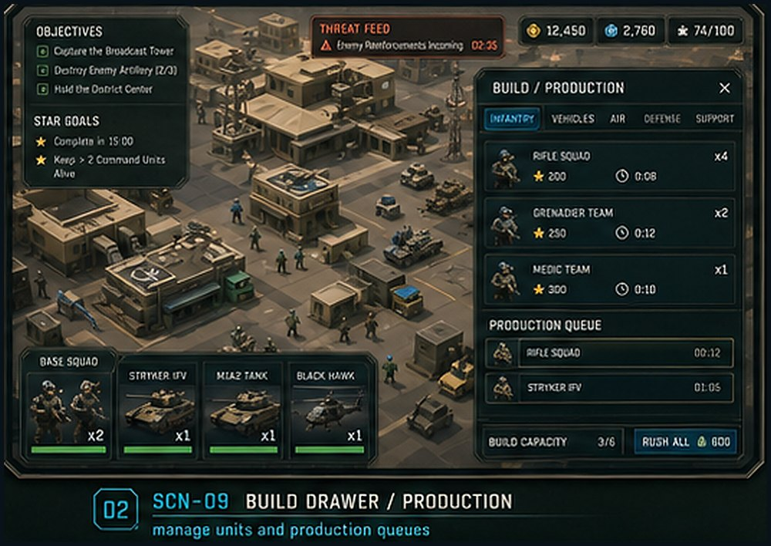  Image asset: SCN-09_build_drawer_production.png | Game design link: Uses existing base-building, production, and economy systems described in GDD section 2, plus mobile drawer guidance in section 11.1.  Player/UX purpose: Let the player build structures and queue units without leaving the battlefield.  Text labels and meaning  - BUILD / PRODUCTION: drawer title.  - Tabs: Infantry, Vehicles, Air, Defense, Support/Economy/Civilian depending on mission rules.  - Item names: Rifle Squad, Grenadier Team, Medic Team, or structures.  - Costs and timers: resource and production-time feedback.  - Production Queue: currently queued items and remaining time.  - Build Capacity: supply/population cap.  - Rush All: optional instant-complete action.  Images/icons and meaning  - Low-poly item thumbnails for units/buildings.  - Queue rows and tabs styled with Synty HUD panels.  Buttons and controls  - Category tabs filter build list.  - Build item rows create placement mode or queue production.  - Queue X cancels item.  - Rush All accelerates queued production if enabled.  - Close X hides drawer.  Unity/Codex implementation: Overlay in MatchScene. Canvas BuildDrawerCanvas or child of MatchHUDCanvas. Panels: CategoryTabs, BuildListScroll, ProductionQueuePanel, CapacityBar, RushButton. Use ScrollRect + object pooling for list items.  Runtime data bindings  - AllowedBuildCatalog  - FactionResources  - ProductionQueue  - BuildCapacity  - TechUnlockState  Navigation / trigger: Select structure -> POP-03 Build Placement. Select unit -> queue production. Close -> SCN-08 Battle HUD.

SCN-10 - Unit Command / Command Wheel
Where shown: Shown during MatchScene when the player long-presses or taps command mode for a selected squad, vehicle, or aircraft.
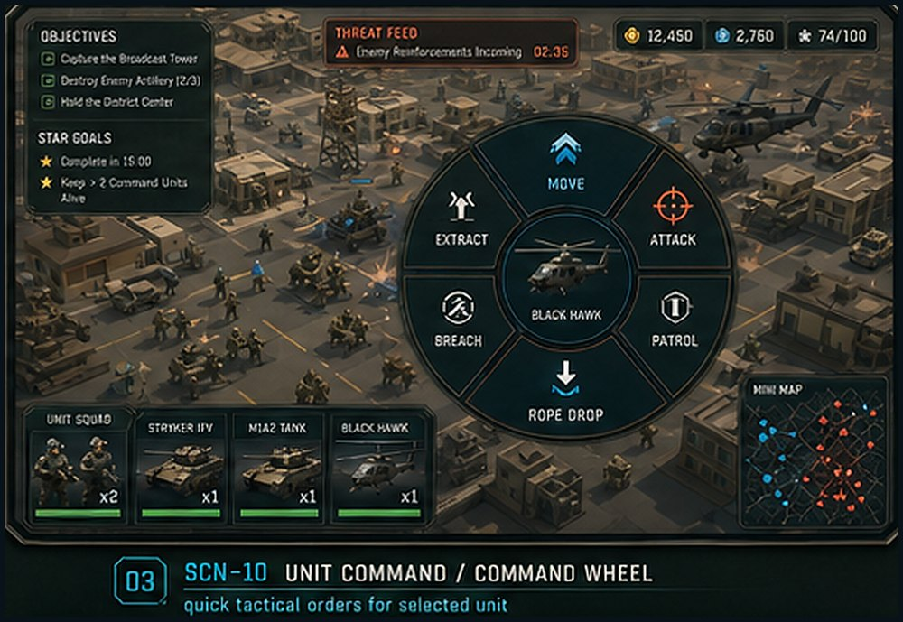  Image asset: SCN-10_unit_command_wheel.png | Game design link: Direct implementation of GDD section 11.3 Command Wheel and mobile-first RTS control philosophy.  Player/UX purpose: Expose fast contextual orders without requiring PC-style hotkeys.  Text labels and meaning  - Selected unit label such as BLACK HAWK or Ranger Squad.  - Radial commands: Move, Attack, Patrol, Breach, Extract, Rope Drop, Stop/Hold depending on unit type.  - Mini Map and squad cards remain visible for context.  Images/icons and meaning  - Large radial wheel over low-poly combat scene.  - Unit icon in wheel center clarifies command target.  Buttons and controls  - Wheel segments issue commands.  - Move/Attack require target selection after command tap.  - Rope Drop / Extract only enabled for transport aircraft or eligible units.  - Breach only enabled near gates/walls/compounds.  Unity/Codex implementation: Overlay in MatchScene. Canvas CommandWheelCanvas. Panels: SelectedEntityCard, RadialCommandRoot, CommandButtons, ContextInfo. Generate wheel segments from selected unit command capability list.  Runtime data bindings  - SelectedEntity  - CommandCapabilitySet  - ContextTarget  - UnitTransportState  - PathingState  Navigation / trigger: Command executes then overlay closes or remains pinned depending on control setting.

SCN-11 - Persistent Operation Dashboard
Where shown: Shown when entering Persistent Operation and between tactical missions/days.
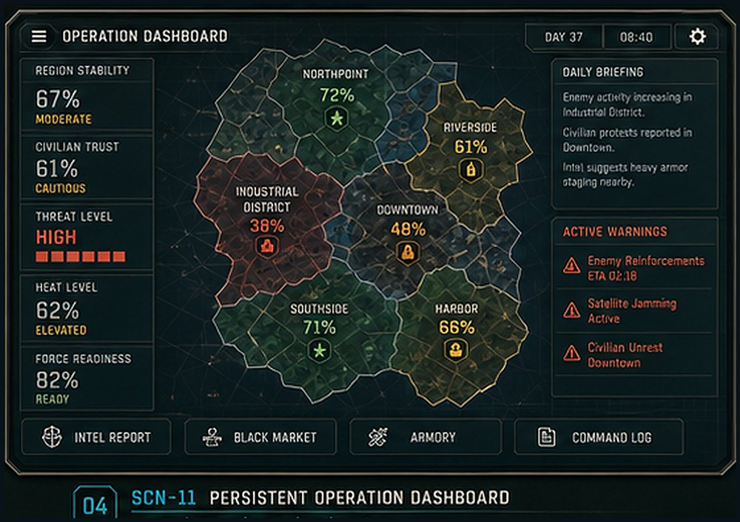  Image asset: SCN-11_operation_dashboard.png | Game design link: Implements GDD section 8 Persistent City Operation: district state, trust, stability, threat, heat, and day flow.  Player/UX purpose: Let the player manage a long saved city operation at the strategic layer.  Text labels and meaning  - OPERATION DASHBOARD: mode title.  - Region Stability, Civilian Trust, Threat Level, Heat Level, Force Readiness: core operation meters.  - District labels and percentages: per-district status.  - Daily Briefing: narrative/system summary for current day.  - Active Warnings: urgent threats that may launch tactical missions.  Images/icons and meaning  - District map with colored regions and status icons.  - Warning icons and low-poly tactical styling.  Buttons and controls  - Intel Report opens intel summary.  - Black Market opens supply/trade panel if enabled.  - Armory opens upgrades/loadouts.  - Command Log opens history.  - District regions open SCN-12 District Detail.  Unity/Codex implementation: Scene OperationDashboardScene. Canvas OperationDashboardCanvas. Panels: RegionMapViewport, MetricSidebar, DailyBriefingPanel, WarningList, BottomActionBar. Bind map regions to DistrictState objects.  Runtime data bindings  - OperationSaveState  - DistrictState[]  - OperationDay  - ActiveEventList  - PlayerReadiness  Navigation / trigger: Select district -> SCN-12. Start event mission -> SCN-06 or SCN-07 depending on mission setup. End day -> POP-06.

SCN-12 - District Detail / Actions
Where shown: Shown after selecting a district from Persistent Operation Dashboard.
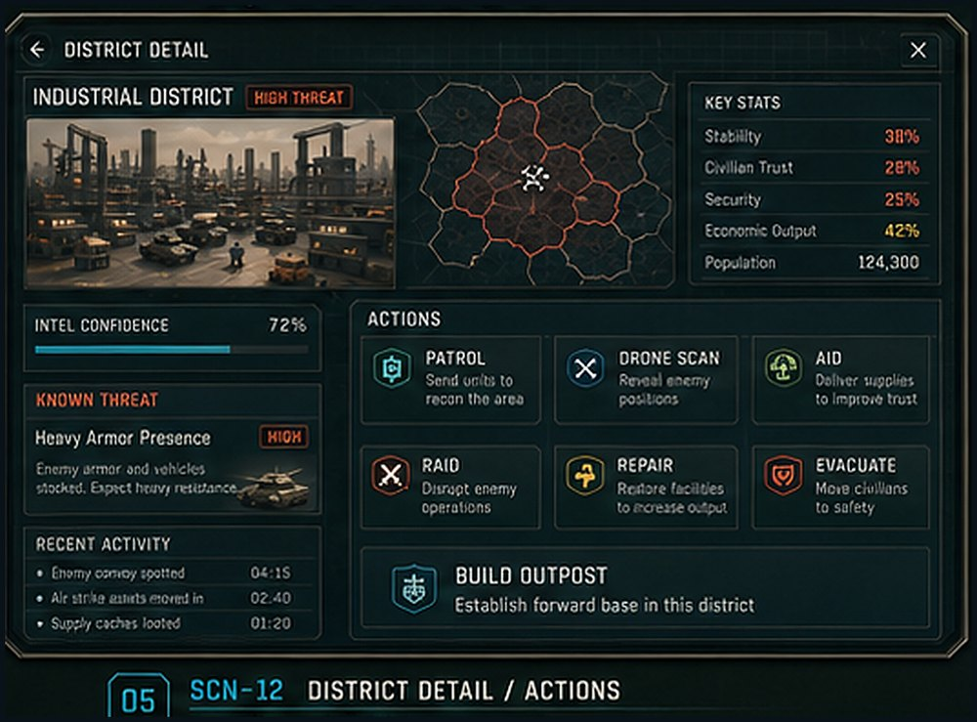  Image asset: SCN-12_district_detail_actions.png | Game design link: Supports GDD sections 8.5 District Model, 8.6 Hidden Cell Model, and 8.7 Player Actions.  Player/UX purpose: Let the player inspect a district, understand its risk, and choose strategic actions.  Text labels and meaning  - District title and High Threat tag: identity and alert level.  - Key Stats: stability, civilian trust, security, economic output, population.  - Intel Confidence: how reliable the current information is.  - Known Threat: current visible threat estimate.  - Recent Activity: last system events.  - Actions: Patrol, Drone Scan, Aid, Raid, Repair, Evacuate, Build Outpost.  Images/icons and meaning  - District key art and small map inset.  - Action icons: shield, drone, aid, raid, repair, evacuation, outpost.  Buttons and controls  - Patrol reduces local threat and may reveal clues.  - Drone Scan increases intel confidence.  - Aid raises trust/stability.  - Raid launches or generates tactical mission, often gated by confidence.  - Repair restores infrastructure.  - Evacuate starts civilian safety flow.  - Build Outpost creates forward base.  Unity/Codex implementation: Scene DistrictDetailScene or overlay. Canvas DistrictCanvas. Panels: HeaderBar, DistrictImagePanel, StatListPanel, IntelPanel, ActionGrid, RecentActivityPanel. Buttons dispatch OperationActionRequest.  Runtime data bindings  - DistrictState  - KnownThreatEstimate  - IntelConfidence  - AvailableDistrictActions  - RecentActivityLog  Navigation / trigger: Action may resolve instantly, open POP-02 Confirm Raid, open SCN-06 briefing, or update OperationSaveState.

SCN-13 - Quick Custom Game Setup
Where shown: Shown when selecting Quick Custom Game from Main Menu.
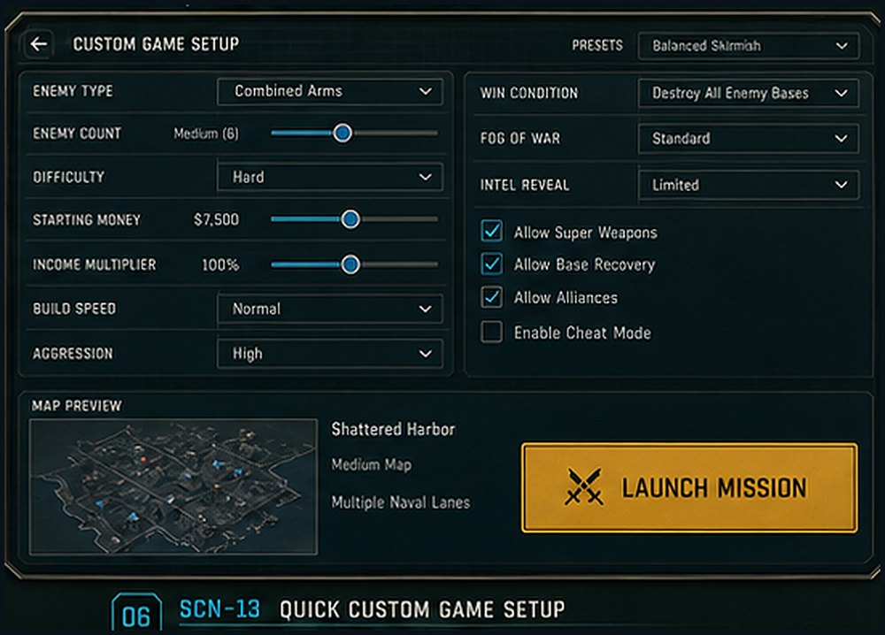  Image asset: SCN-13_quick_custom_game_setup.png | Game design link: Implements GDD section 9 Quick Custom Game and exposes existing AI tuning knobs as a player-facing setup screen.  Player/UX purpose: Let players create fast skirmishes against hidden-cell, military, defensive, air, swarm, or random AI profiles.  Text labels and meaning  - CUSTOM GAME SETUP: screen title.  - Enemy Type, Enemy Count, Difficulty: opponent configuration.  - Starting Money, Income Multiplier, Build Speed, Aggression: economy and pacing.  - Win Condition, Fog of War, Intel Reveal: match rules.  - Checkboxes for special rules: super weapons, base recovery, alliances, cheat/debug.  - Map Preview: selected map and size.  - Launch Mission: start button.  Images/icons and meaning  - Low-poly map preview and Synty-styled setup controls.  - Sliders, dropdowns, checkboxes, and orange CTA.  Buttons and controls  - Preset dropdown loads recommended configurations.  - Sliders adjust numeric values.  - Dropdowns choose modes/rules.  - Checkboxes toggle optional features.  - Launch Mission creates QuickGameConfig and starts MatchScene.  Unity/Codex implementation: Scene CustomGameScene. Canvas QuickGameCanvas. Panels: PresetDropdown, ConfigFormLeft, ConfigFormRight, MapPreviewPanel, LaunchButton. Validate config before launch.  Runtime data bindings  - QuickGameConfig  - AIProfileConfig[]  - MapDefinition  - WinConditionConfig  - PlayerDebugPermissions  Navigation / trigger: Launch Mission -> MatchScene. Back -> Main Menu.

POP-01 - Threat Alert
Where shown: Overlay during MatchScene and Persistent Operation Dashboard when a detected threat needs immediate player attention.
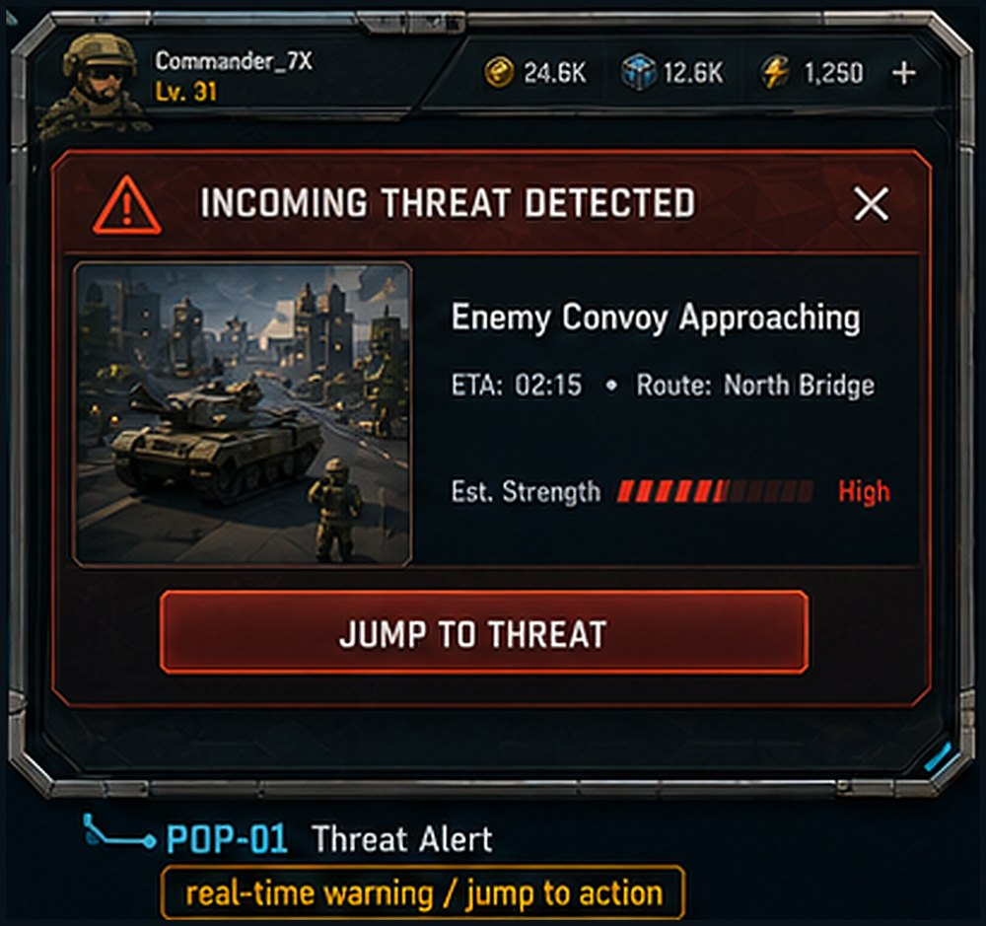  Image asset: POP-01_threat_alert.png | Game design link: Builds on existing radar/satellite warning systems in GDD section 2 and threat/intel loops in sections 5 and 8.  Player/UX purpose: Warn the player and provide a one-tap jump to the threat location.  Text labels and meaning  - INCOMING THREAT DETECTED: urgency header.  - Enemy Convoy Approaching: threat type.  - ETA 02:15 / Route: North Bridge: timing and route.  - Est. Strength High: risk level.  Images/icons and meaning  - Warning triangle icon, red panel styling, vehicle thumbnail.  - Dimmed tactical background behind modal.  Buttons and controls  - Jump to Threat focuses camera/map on threat and may close the popup.  - Close X dismisses but leaves warning in threat feed.  Unity/Codex implementation: Prefab ThreatAlertPopup. Root parts: Icon, TitleText, BodyText, ETA/Route row, StrengthMeter, CTAButton, CloseButton. Use ModalOverlay or non-blocking ToastOverlay depending severity.  Runtime data bindings  - ThreatEventId  - ThreatType  - ETA  - RouteName  - EstimatedStrength  - WorldPosition  Navigation / trigger: Triggered by ThreatFeedSystem, radar/satellite detection, AI attack director, or operation event tick.

POP-02 - Confirm Raid
Where shown: Shown when the player chooses Raid from District Detail or a suspected target before enough intel is guaranteed.
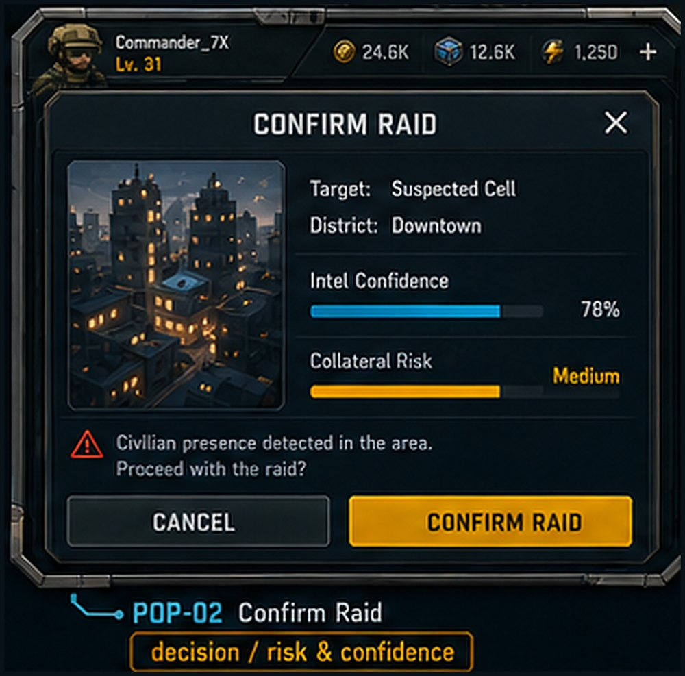  Image asset: POP-02_confirm_raid.png | Game design link: Implements the Intelligence Before Force design pillar and persistent mode hidden-cell model in GDD sections 4.3, 8.6, and 8.7.  Player/UX purpose: Force a deliberate decision when an action has confidence and collateral-risk consequences.  Text labels and meaning  - CONFIRM RAID: modal title.  - Target / District: suspected cell and location.  - Intel Confidence 78%: probability quality, not certainty.  - Collateral Risk Medium: civilian/infrastructure risk estimate.  - Civilian presence warning: ethical and gameplay consequence reminder.  Images/icons and meaning  - City/district thumbnail and red warning icon.  - Blue confidence bar and amber risk bar.  Buttons and controls  - Cancel returns to District Detail.  - Confirm Raid creates/loads a tactical mission or resolves an operation action if abstracted.  - Close X acts like Cancel.  Unity/Codex implementation: Prefab ConfirmRaidPopup. Root parts: Header, TargetInfo, DistrictThumbnail, IntelConfidenceBar, RiskMeter, WarningText, ButtonRow. Use CanvasGroup fade + scale animation.  Runtime data bindings  - DistrictId  - SuspectedCellId  - IntelConfidence  - CollateralRisk  - CivilianDensity  - RaidCost  Navigation / trigger: Confirm -> SCN-06/SCN-07/MatchScene or operation simulation result. Cancel -> SCN-12.

POP-03 - Build Placement
Where shown: Shown after choosing a building from Build Drawer during tactical missions or outpost setup.
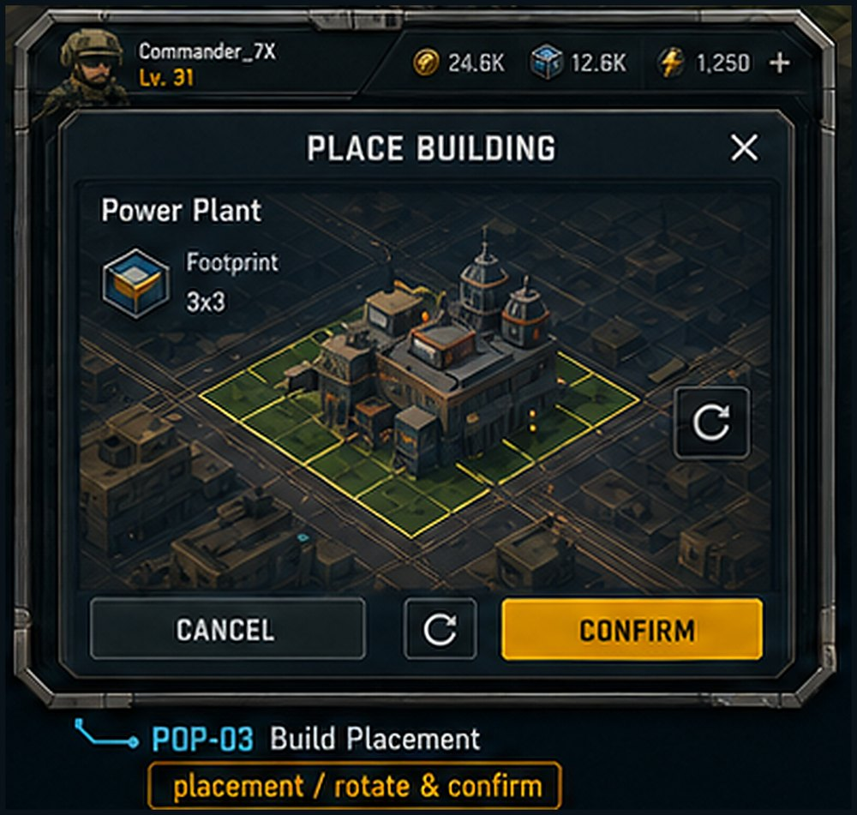  Image asset: POP-03_build_placement.png | Game design link: Uses the existing base-building and grid placement systems described in GDD section 2.  Player/UX purpose: Confirm building footprint, orientation, and placement validity before spending resources.  Text labels and meaning  - PLACE BUILDING: modal/drawer title.  - Power Plant: selected building name.  - Footprint 3x3: grid footprint size.  - Cancel / Confirm labels: placement decision.  Images/icons and meaning  - Low-poly building preview on green valid tiles.  - Placement grid, footprint outline, rotate icon.  Buttons and controls  - Rotate changes orientation.  - Confirm spends resources and places ghost/real building.  - Cancel exits placement mode and returns to build drawer.  Unity/Codex implementation: Prefab BuildPlacementPanel plus world-space ghost object. Root parts: PlacementPreview, RotateButton, ConfirmButton, CancelButton, CostRow, FootprintLabel. Confirm enabled only when BuildGridValidator is valid.  Runtime data bindings  - BuildingDefinition  - FootprintSize  - PlacementCell  - Rotation  - FactionResources  - BuildValidityReason  Navigation / trigger: Triggered from SCN-09. Confirm -> building construction. Cancel -> SCN-09/SCN-08.

POP-04 - Reward / Unlock
Where shown: Shown after mission completion, chapter reward claim, commander level-up, or unlock milestone.
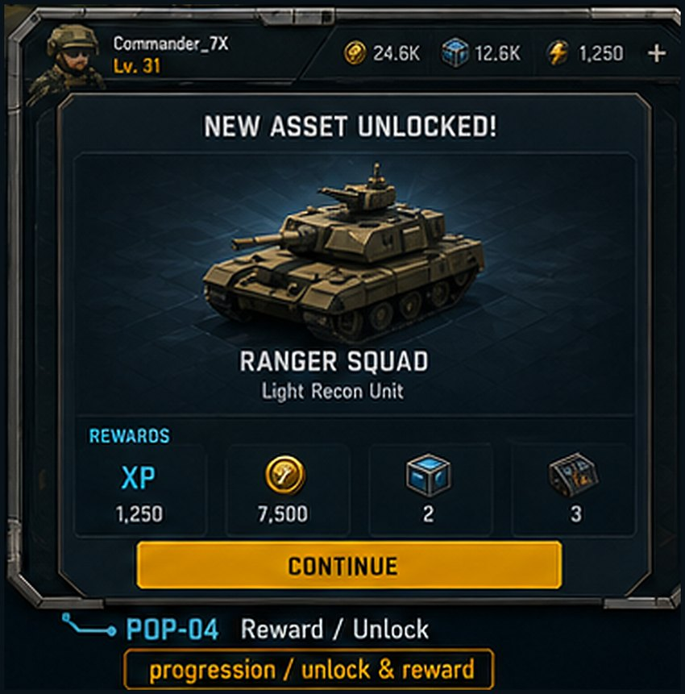  Image asset: POP-04_reward_unlock.png | Game design link: Supports GDD sections 7.7 Saga Rewards and 13 Progression and Meta Systems.  Player/UX purpose: Make new units, buildings, support abilities, or resources feel clear and rewarding.  Text labels and meaning  - NEW ASSET UNLOCKED: reward header.  - RANGER SQUAD / Light Recon Unit: unlock identity and role.  - Rewards row: XP, currency, crate/material counts.  - Continue: acknowledgement.  Images/icons and meaning  - Low-poly unlocked unit image on display pedestal.  - Reward icons: XP, coins, crates, parts.  Buttons and controls  - Continue closes popup and returns to result, map, or menu.  - Reward icons can open tooltips if desired.  Unity/Codex implementation: Prefab RewardUnlockPopup. Root parts: Header, UnlockImage, UnlockTitle, UnlockSubtitle, RewardIconGrid, ContinueButton. Use RewardPresentationData created by RewardSystem.  Runtime data bindings  - RewardConfig  - UnlockId  - RewardItems[]  - CommanderXPDelta  - CurrencyDelta  Navigation / trigger: Usually appears after POP-05 or SCN-05 chapter reward claim.

POP-05 - Mission Result
Where shown: Shown at the end of Saga missions, generated operation tactical missions, and Quick Custom Game matches.
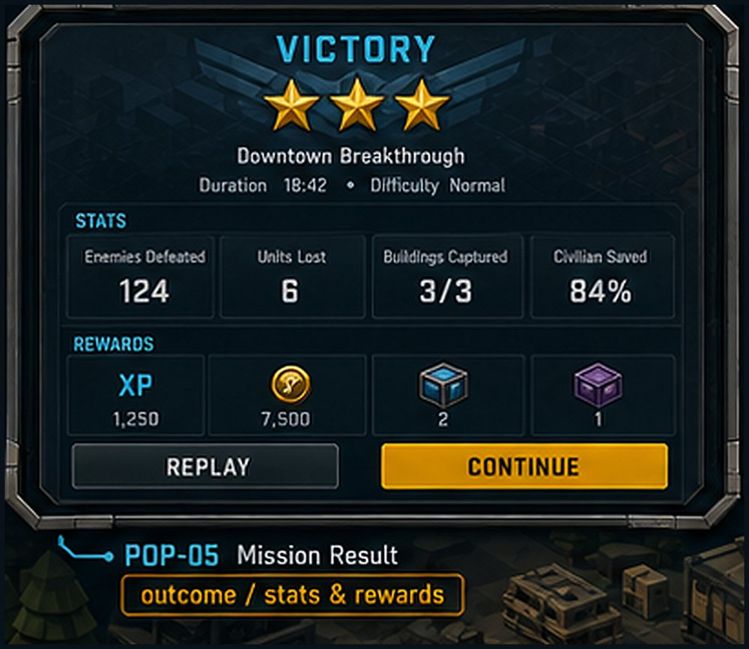  Image asset: POP-05_mission_result.png | Game design link: Implements GDD sections 7.6 Star Scoring, 7.7 Rewards, and 10.3 Objective Types.  Player/UX purpose: Summarize outcome, score, performance stats, stars, and rewards, then route the player forward.  Text labels and meaning  - VICTORY or Defeat: result state.  - Mission name and duration/difficulty: match metadata.  - Stats: enemies defeated, units lost, buildings captured, civilian saved.  - Rewards: XP, currency, crates, rare items.  - Replay / Continue: next action.  Images/icons and meaning  - Victory emblem and star row.  - Reward grid and stat tiles.  Buttons and controls  - Replay restarts the mission with same config.  - Continue applies rewards and routes to Saga Map, Operation Dashboard, or Main Menu.  - Defeat variant may show Retry instead of Continue emphasis.  Unity/Codex implementation: Prefab MissionResultPopup or scene ResultScene. Root parts: ResultHeader, StarRow, StatsGrid, RewardGrid, ActionButtons. ObjectiveSystem feeds MissionResultData.  Runtime data bindings  - MissionResultData  - ObjectiveCompletion  - StarResult[]  - CombatStats  - RewardGrantResult  Navigation / trigger: Win/Loss from MatchScene -> POP-05. Continue -> source mode screen. May chain to POP-04 unlock.

POP-06 - End of Day Report
Where shown: Shown in Persistent Operation when the player ends a day/session or after operation event resolution.
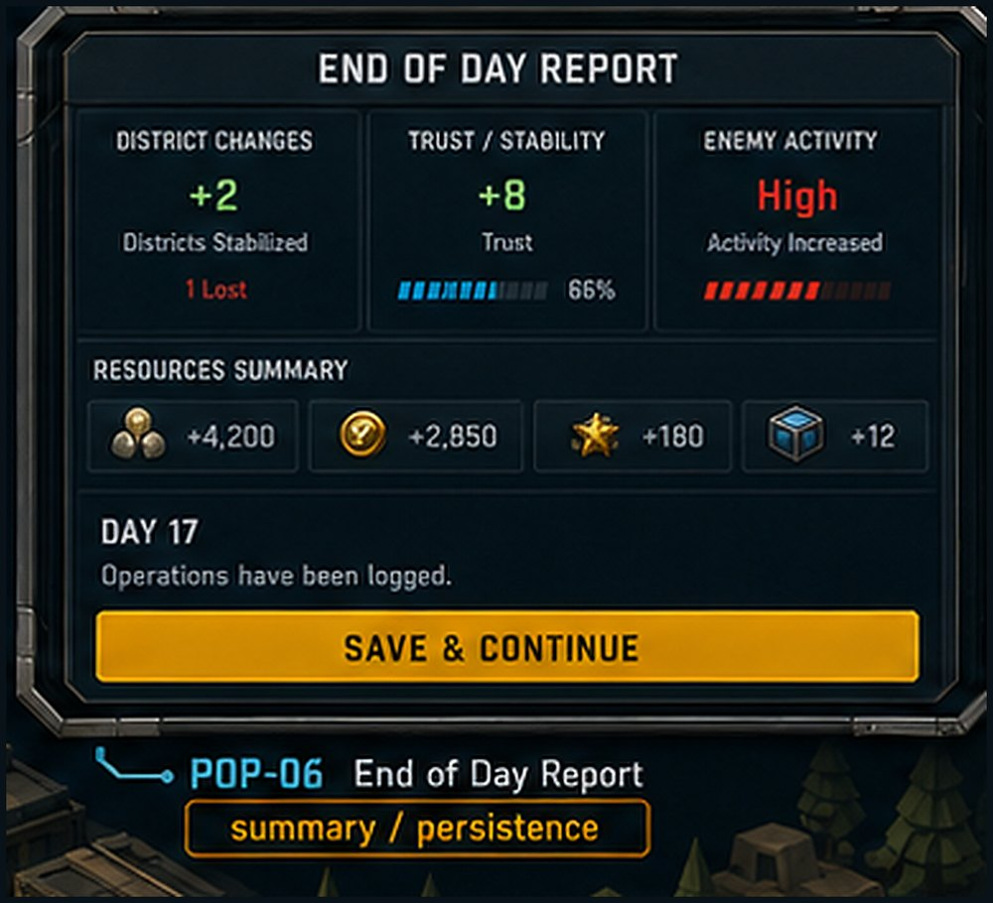  Image asset: POP-06_end_of_day_report.png | Game design link: Implements GDD section 8.9 Operation Day Flow and 8.11 Persistent Mode Meters.  Player/UX purpose: Explain how the city changed and confirm operation progress has been saved.  Text labels and meaning  - END OF DAY REPORT: summary title.  - District Changes +2: territory/stability change.  - Trust/Stability +8 and percentage bar: public/cooperation change.  - Enemy Activity High: threat trend.  - Resources Summary: money, supplies, intel, materials gained/lost.  - Day 17: operation timeline.  - Save & Continue: persistence action.  Images/icons and meaning  - Meter bars and resource icons in report layout.  - Amber CTA to reinforce save/continue.  Buttons and controls  - Save & Continue commits OperationSaveState and returns to dashboard or next day.  - Close may be disabled until save completes.  Unity/Codex implementation: Prefab EndOfDayReportPopup. Root parts: DeltaSummary, TrustStabilityPanel, EnemyActivityPanel, ResourceRow, SaveContinueButton. Save call should complete before routing.  Runtime data bindings  - OperationDaySummary  - DistrictDelta[]  - TrustDelta  - ThreatDelta  - ResourceDelta[]  - SaveStatus  Navigation / trigger: Triggered by Next Day or operation session close in SCN-11.

POP-07 - Pause / Options
Where shown: Shown when the player pauses a tactical mission, operation dashboard, or custom setup where pause/options are allowed.
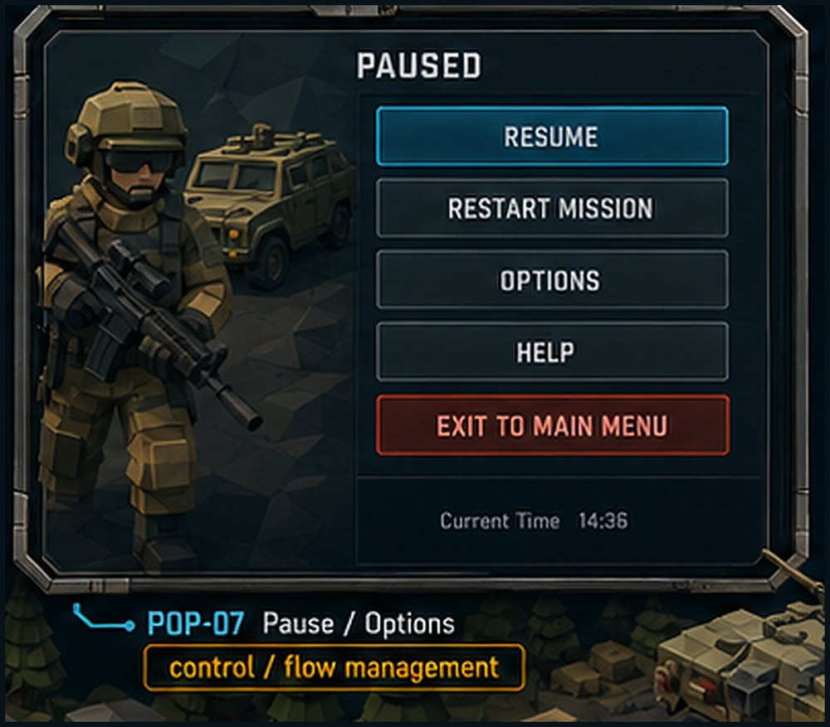  Image asset: POP-07_pause_options.png | Game design link: Supports GDD section 11 Mobile UX and Controls by giving player control over flow, settings, and exits.  Player/UX purpose: Provide safe pause-state navigation without accidental mission loss.  Text labels and meaning  - PAUSED: modal state.  - Resume, Restart Mission, Options, Help, Exit to Main Menu: available actions.  - Current Time: optional system/match time.  Images/icons and meaning  - Dimmed low-poly soldier/vehicle background to preserve game identity.  - Blue primary button and red destructive/exit button.  Buttons and controls  - Resume closes pause and resumes time.  - Restart Mission confirms then reloads current MissionConfig.  - Options opens SCN-04 or settings overlay.  - Help opens control/objective help.  - Exit to Main Menu requires confirmation if progress may be lost.  Unity/Codex implementation: Prefab PauseMenuPopup. Root parts: Header, ButtonStack, CurrentTimeText, BackgroundArt. PauseGameService controls Time.timeScale or ECS simulation pause.  Runtime data bindings  - CurrentSceneRoute  - CanRestart  - CanExitSafely  - MissionConfigId  - SaveStatus  Navigation / trigger: Opened from pause button/menu key. Options -> SCN-04 overlay. Exit -> SCN-02 after confirmation.

POP-08 - Intel Reveal
Where shown: Shown in Persistent Operation or intel-focused missions when new evidence has been collected.
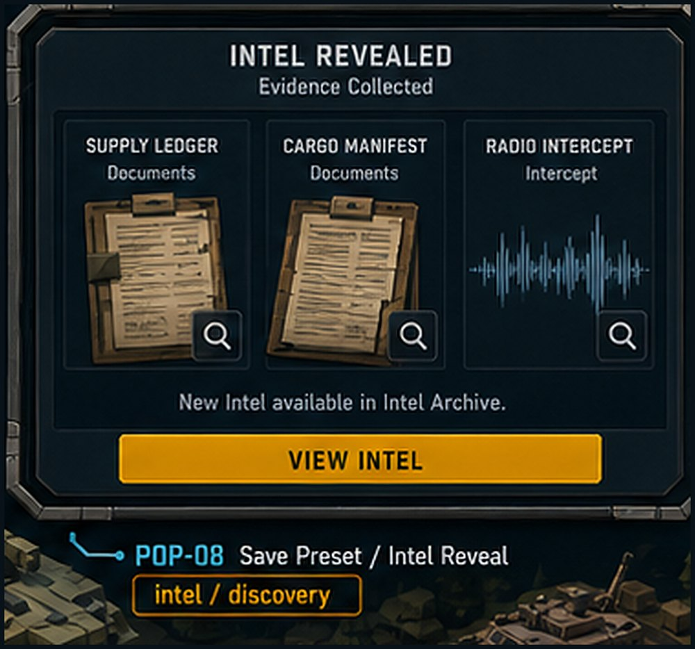  Image asset: POP-08_intel_reveal.png | Game design link: Supports GDD sections 4.3 Intelligence Before Force, 8.6 Hidden Cell Model, and 8.7 Player Actions.  Player/UX purpose: Reward scanning, patrols, raids, and captures with readable clues that increase intel confidence.  Text labels and meaning  - INTEL REVEALED: discovery header.  - Evidence Collected: category label.  - Supply Ledger, Cargo Manifest, Radio Intercept: evidence cards.  - New Intel available in Intel Archive: destination prompt.  - View Intel: action button.  Images/icons and meaning  - Document cards and audio waveform as fictional evidence.  - Magnifier icons for inspecting individual evidence.  Buttons and controls  - Evidence card magnifiers open detail view.  - View Intel opens intel dossier/archive.  - Close may return to district or mission result.  Unity/Codex implementation: Prefab IntelRevealPopup. Root parts: Header, EvidenceCards, CardInspectButtons, ViewIntelButton. Evidence cards should use non-real-world fictional content.  Runtime data bindings  - IntelEventId  - EvidenceItem[]  - DistrictId  - IntelConfidenceDelta  - ArchiveRoute  Navigation / trigger: Triggered by Drone Scan, Patrol, Raid success, CaptureIntel objective, or event reward.

Reusable Panel Prefabs for Codex
These are not separate full scenes. They are reusable Unity prefabs that should be instantiated inside the scene canvases above. They are included because they are the most important panels Codex must understand as prefabs, not one-off artwork.

PREFAB-01 - Objective Tracker
Where shown: Reusable in MatchScene HUD, Mission Briefing condensed previews, and tutorial overlays.
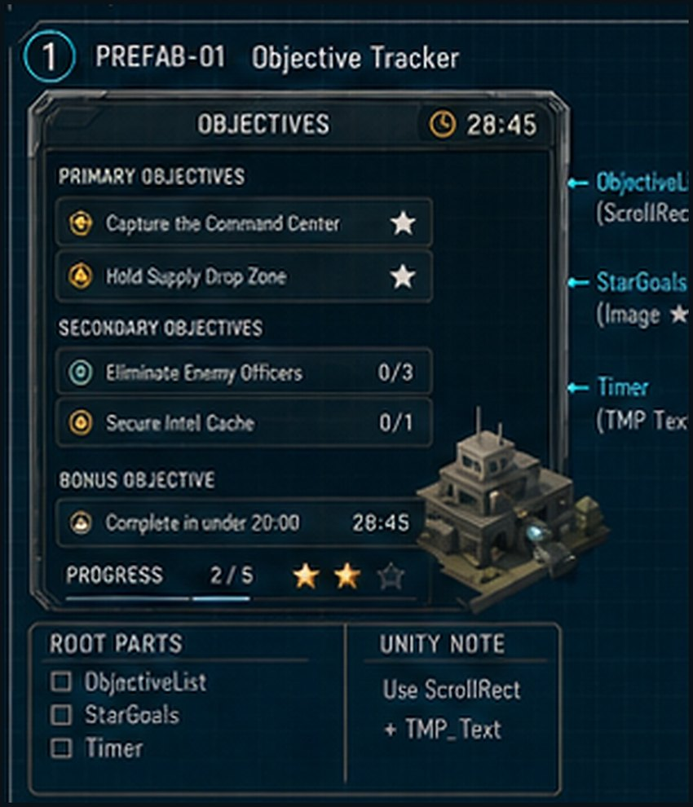  Image asset: PREFAB-01_objective_tracker.png | Game design link: Connected to Objective Manager, star scoring, and ObjectiveConfig types in GDD sections 7.6, 10.2, and 10.3.  Player/UX purpose: Show mandatory objectives, secondary objectives, bonus goals, timer, and progress without opening a full menu.  Text labels and meaning  - OBJECTIVES title; Primary/Secondary/Bonus categories; timer; progress count; star indicators.  Images/icons and meaning  - Small objective icons, star icons, progress bar, Synty-style dark module frame.  Buttons and controls  - Optional objective rows can focus camera or open objective detail; otherwise read-only.  Unity/Codex implementation: Prefab ObjectiveTrackerPanel. Root parts: ObjectiveList ScrollRect, StarGoals Image row, Timer TMP_Text. Use object pooling for objective rows.  Runtime data bindings  - ObjectiveRuntimeState[]  - StarGoalState[]  - MissionTimer  Navigation / trigger: Instantiated under MatchHUDCanvas/ObjectivePanel or BriefingCanvas/ObjectivePanel.

PREFAB-02 - Squad Tray
Where shown: Reusable bottom HUD panel during tactical missions and loadout previews.
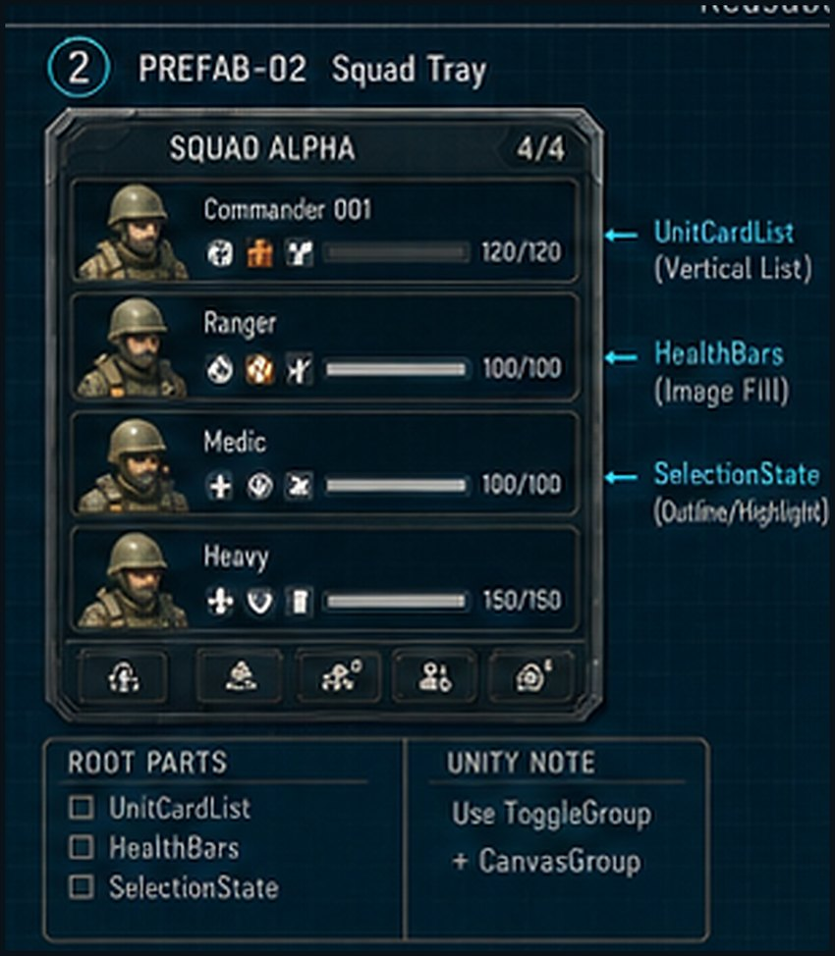  Image asset: PREFAB-02_squad_tray.png | Game design link: Connected to mobile-first unit selection and squad-based control in GDD sections 5.2 and 11.1.  Player/UX purpose: Let the player select and monitor squads quickly on a phone or tablet landscape layout.  Text labels and meaning  - Squad name, 4/4 count, unit names/classes, HP values, small status icons.  Images/icons and meaning  - Low-poly soldier portraits, health bars, selection outlines, ability/status icons.  Buttons and controls  - Unit card selects/focuses squad; card long-press can open details; bottom micro-buttons can filter/select all/assign group.  Unity/Codex implementation: Prefab SquadTrayPanel. Root parts: UnitCardList Vertical/Horizontal Layout, HealthBars Image Fill, SelectionState outline. Use ToggleGroup for selection state.  Runtime data bindings  - SelectedSquadSet  - UnitHealthState[]  - SquadStatusEffects  - TransportBoardingState  Navigation / trigger: Instantiated under MatchHUDCanvas/SquadTray and updated by SelectionSystem.

PREFAB-03 - Build Drawer
Where shown: Reusable drawer for MatchScene production, base setup, and potentially outpost construction.
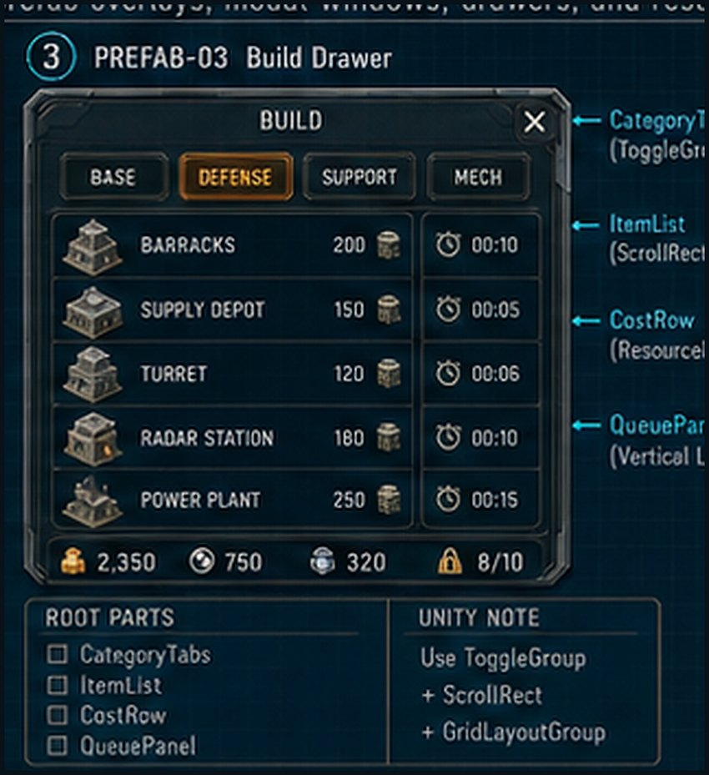  Image asset: PREFAB-03_build_drawer.png | Game design link: Connected to base building, production, economy, and mobile build drawer guidance in GDD sections 2 and 11.1.  Player/UX purpose: Show categorized build choices, cost rows, and queue status in a compact reusable drawer.  Text labels and meaning  - BUILD title; category tabs; item names and costs; queue rows; resource/capacity strip.  Images/icons and meaning  - Low-poly building icons, lock states, Synty-style frame and tab art.  Buttons and controls  - Tabs filter categories; item rows start build/queue; queue items can cancel; close X hides drawer.  Unity/Codex implementation: Prefab BuildDrawerPanel. Root parts: CategoryTabs ToggleGroup, ItemList ScrollRect/Grid, CostRow ResourceBar, QueuePanel Vertical List. Use GridLayoutGroup for item grid if enough space.  Runtime data bindings  - BuildCatalog  - AllowedCategories  - FactionResources  - ProductionQueue  - UnlockState  Navigation / trigger: Used by SCN-09 and any base/outpost construction flow.

Appendix A - Unity Canvas Naming Contract
Contract item | Codex implementation rule
Base shell hierarchy | CanvasRoot / SafeAreaRoot / HeaderBar / ContentRoot / FooterBar / ModalOverlay / TooltipLayer
Tactical HUD hierarchy | MatchHUDCanvas / TopHUD(ObjectivePanel, ThreatFeedPanel, ResourceBar) / BottomHUD(SquadTray, CommandBar, MiniMapPanel, BuildToggle) / ContextOverlay(CommandWheelCanvas) / ModalOverlay
Prefab naming | Use PascalCase prefab names: ModeCardView, StatTileView, UnitCardView, ObjectiveRowView, RewardItemView, ActionButtonView, PopupFrameView.
Model binding | Each screen should have a ViewModel or controller object. Do not hard-code mockup text into the prefab except for placeholder editor previews.
Localization | All player-facing text should use string keys. Keep mockup labels as English source values only.
Accessibility | Respect Large Text, High Contrast UI, and colorblind settings. Icons must remain distinguishable without color alone.
Modal behavior | Blocking popups use ModalOverlay with dark scrim. Non-blocking alerts use ToastOverlay/ThreatFeedPanel and should not pause simulation unless marked critical.

Appendix B - Full Board References
The following full-board references are included in the companion image package as 3840x2160 upscaled PNG files. Use the cropped images above for per-screen implementation and these boards for overall layout/style consistency.
  Version A - Meta Screens |   Version A - Core Gameplay |   Version A - Panels & Popups
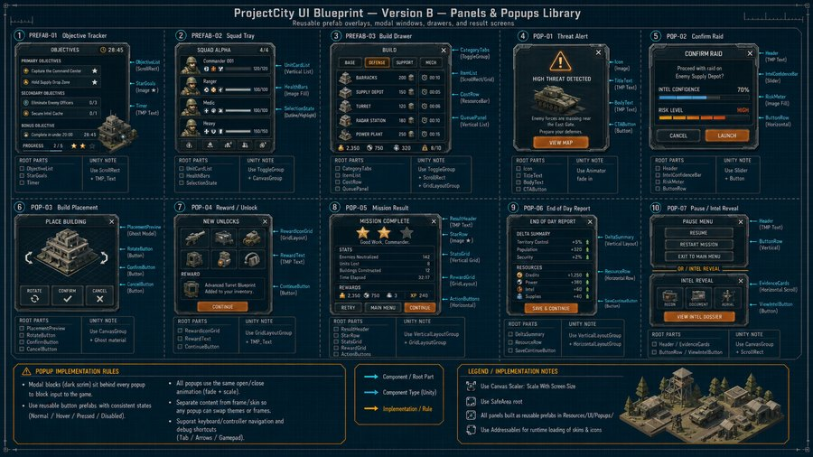
Version B - Popup Prefab Library

