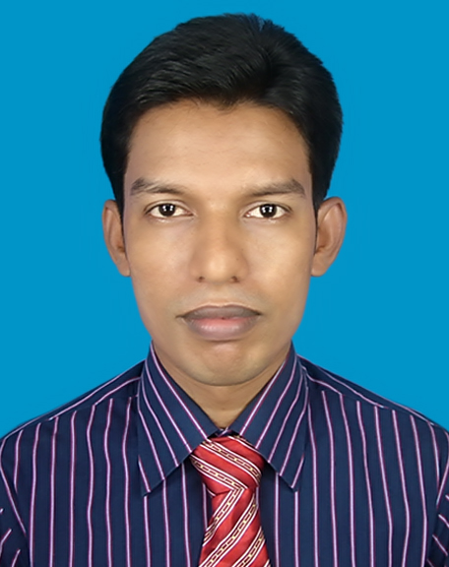
Resume Of
Md. Rakibul Islam
Road-19, House-29, (5th Floor) Mirpur-6 Dhaka-1216.
E-mail:View.rakib@gmail.com
Contact No: 01719365479

CAREER PLAN
Intend to work in a challenging and competitive environment, where strong sense of responsibility and commitment is required. I strongly believe my skills will equip me to work in any place, where dignity of work provides job satisfaction and place of work provides potential avenues to secure and executive position.
EXPERIENCE INFORMATION
Organization : Mars Software International LTD.
Designation : Web Developer
Duration : July 2014 to 2016 May
Front End : ASP.NET 2008, ASP.NET 2013
Database : SQL Server 2008, SQL Server 2012
Achievements :
- www.pn.edu.bd (ASP.Net 2008, SQL Server 2008)
- http://www.bota-bd.org (ASP.net 2013, SQL Server 2012)
- www.dohs.marssil.com (ASP.Net 2008, SQL Server 2008)
- www.samiyaenterprize.com (ASP.Net 2008, SQL Server 2008)
- http://pond.marssil.com (ASP.net 2013, SQL Server 2012)
- http://jghs.edu.bd (ASP.Net 2010, SQL Server 2008)
- http://prizebond.marssil.com (ASP.Net 2008, SQL Server 2008)
- http://dae.marssil.com/ (ASP.Net 2008, SQL Server 2008)
- http://digicricket.marssil.com/ (ASP.Net 2008, SQL Server 2008)
AREA OF EXPERTISE
area of expertise | description
Programming language | Java (J2EE), JSP.
Scripting language | HTML, JavaScript, XML.
Methodology | PPT, UML.
Style Sheet | CSS
Web Development Tools | Net Beans IDE 7.1/6.5, JCreator, Macromedia Dreamweaver, iSQL PLUS, DHTML.
Technologies & Framework | JSF, JSTL, J2EE/EJB, Servlet, Apache Tomcat Server, GlassFish, J2SE, Hibernate, POJO, GWT, JPA, Struts-2, Android.
RDBMS | Oracle10g (SQL), MySQL.
Operating System | Windows 98/2000/XP, Windows Vista, Windows 7.
Hardware & Networking | Basic Knowledge on Hardware, LAN, MAN, WAN.
Computer Application course | Microsoft Word , Microsoft Excel, Microsoft Access  Microsoft Power point, Internet Security, & Basic  Network Operating & Software Installation.

Professional Qualification

Degree | Diploma in Enterprise Systems Analysis & Design with J2EE
Authority | IDB-BISEW IT SCHOLARSHIP PROJECT
Institution | Daffodil Institute of IT
Duration | 940 Hours
Result | Pass
Course contents

Course contents | Object Oriented Systems Analysis & Design using UML
Course contents | Server-side Programming using Servlet & JSP
Course contents | Software Development using JAVA
Course contents | Object Oriented Programming using JAVA
Course contents | Database Development using Oracle10g
Course contents | Introduction to XML
Course contents | Web Publishing
Course contents | Computer Fundamentals
 | Oracle Certified Java Programming(OCJP) & Android

Scholarship
Recipient of IDB-BISEW (Islamic Development Bank-Bangladesh Islamic Solidarity Educational Wakf) IT Scholarship (Hi-end IT Professional Training with International Vendor Certification), IDB Bhaban (4th floor),E/8-A Rokeya Sharani Sher-e-Bangla Nagar, Dhaka-1207, Bangladesh.

Educational Qualification
M.Sc | Subject | Psychology | class
M.Sc | Duration | 1 Year | class
M.Sc | Session | 2008-2009 | Second
M.Sc | Year of Passing | 2012 | Second
M.Sc | University | National University of Bangladesh | Second
M.Sc | Institute | Rajshahi College, Rajshahi | Second

B.Sc (Hon’s) | Subject | Psychology | class
B.Sc (Hon’s) | Duration | 4 Year | class
B.Sc (Hon’s) | Session | 2004-2005 | Second
B.Sc (Hon’s) | Year of Passing | 2011 | Second
B.Sc (Hon’s) | University | National University of Bangladesh | Second
B.Sc (Hon’s) | Institute | Rajshahi College, Rajshahi | Second

H.s.c | Group | Science | CGPA
H.s.c | Board | Rajshahi | CGPA
H.s.c | Session | 2002-2003 | 3.70 (Out of 5)
H.s.c | Year of Passing | 2004 | 3.70 (Out of 5)
H.s.c | Institute | Kakanhat College, Rajshahi | 3.70 (Out of 5)

S.S.C | Group | Science | CGPA
S.S.C | Board | Rajshahi | CGPA
S.S.C | Session | 2000-2001 | 3.25 (Out of 5)
S.S.C | Year of Passing | 2002 | 3.25 (Out of 5)
S.S.C | Institute | Jhikrapara Adarsha High School, Rajshahi | 3.25 (Out of 5)

Proficiency
Language : English (Fluent in reading, writing and speaking)
Bengali (Mother Tongue).

Personal Information
Name : Md. Rakibul Islam
Father’s Name : Md. Naymul Islam
Mother’s Name : Most. Jarina Begum
Present Address : Road-19, House-29, (5th Floor) Mirpur-6 Pallabi Dhaka-1215
Permanent Address : Village: Jhikrapara, Post: Jhikrapara, Thana:
Godagari, Dist: Rajshahi
Date of Birth : 10 August , 1985
NID : 8113485683730
Email Address : view.rakib@gmail.com
Gender : Male
Marital Status : Unmarrid
Religion : Islam
Nationality : Bangladeshi
National id card no : 7113485683730

References
Md. Moshaidul Islam
Consultant
Show & Tell Consulting Ltd
House# 2/5 (3rd Floor), Road#5
Block-A Lalmatia Housing Estate
Dhaka-1207
PHN (Office): 9132568
Cell: +88017115071219
Email: moshaidul@showtellconsulting.com

Md. Nasimul Kader Sohel
Senior Faculty Member
Daffodil Institute of IT, Dhanmondi,Dhaka-1207.
Contact No :+8801712949753
Email : nasimulkader@yahoo.com
nasimulkader@diit.info

DECLARATION:
I certify that all of the above information is true and authentic to the best of my knowledge and belief.


Signature of Applicant

