Getting started
Before starting my personal portfolio, I had the chance to have a look at few other websites to get an idea of how I could design my own. I have used created my own portfolio from scratch regarding the theme and styling as I wanted it to be unique yet simple. The websites listed below are the examples I had a look at:
- https://joel.sh/
- http://www.leeannpica.com/
- http://godevfx.com/

Designs
Wireframes
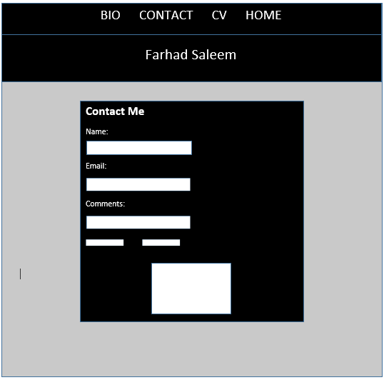
This wireframe is my contact page that includes a static contact form.

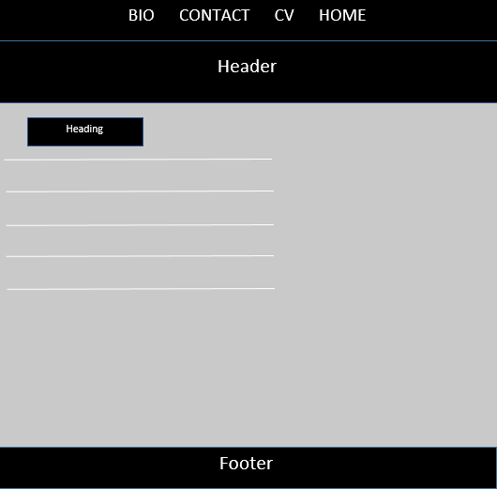
This is the wireframe for my bio page.

This wireframe is of my CV.
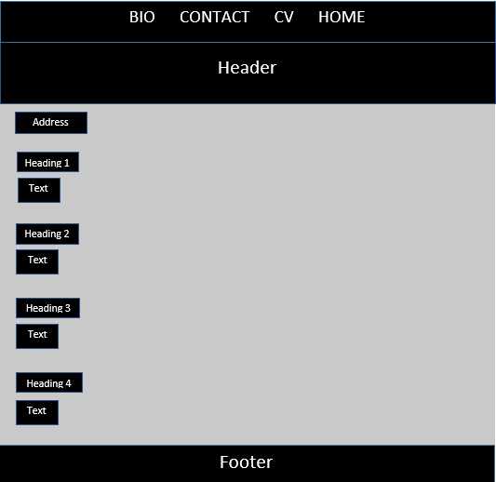

This is the wireframe for my homepage.
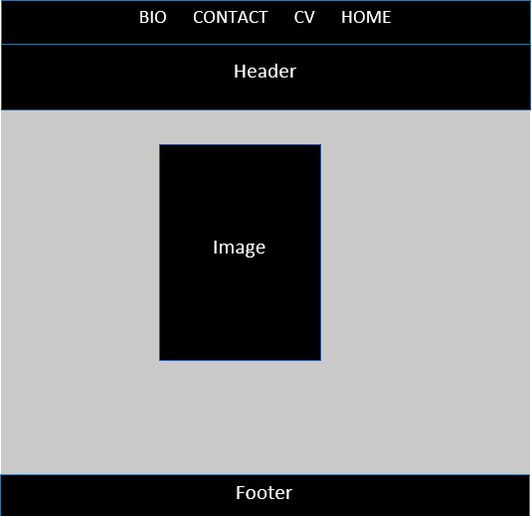

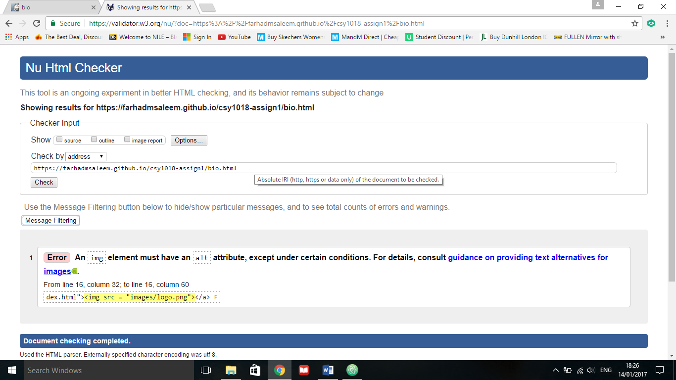
Errors/Validation

This is one of the error I received upon checking my html files for validation. The image code is not defined precisely therefore I will need to make changes to correct the error.

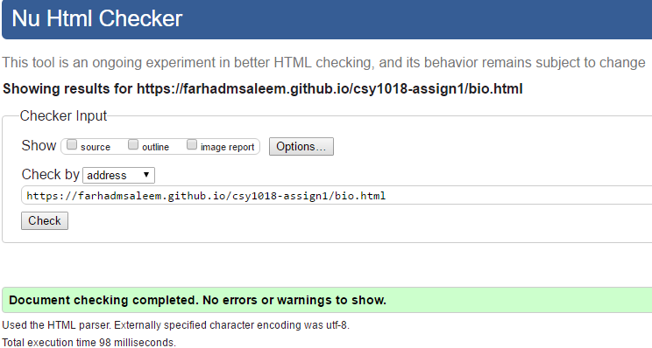

The error I had encountered in the previous step upon validation had now been corrected as you can see above.
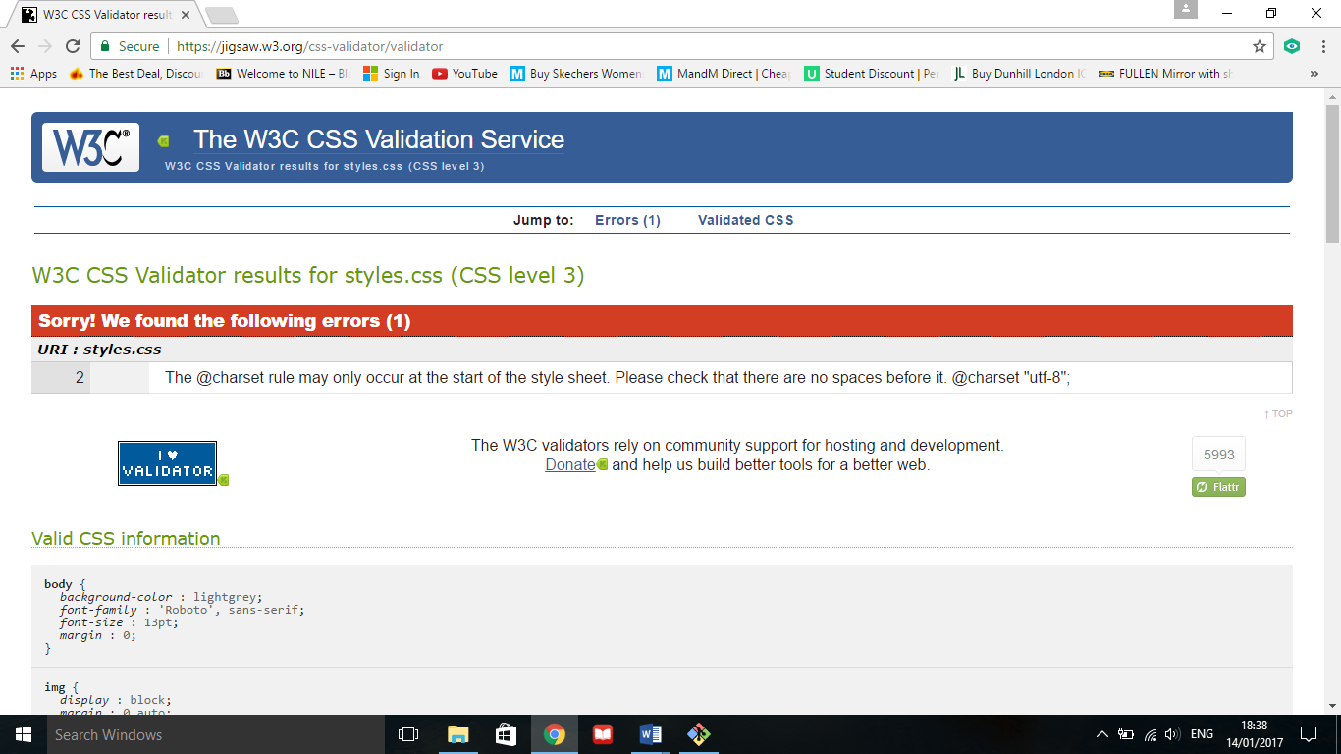

Upon checking my CSS style sheet for validation I received thee error listed above mentioning I have not positioned the code in the correct place.
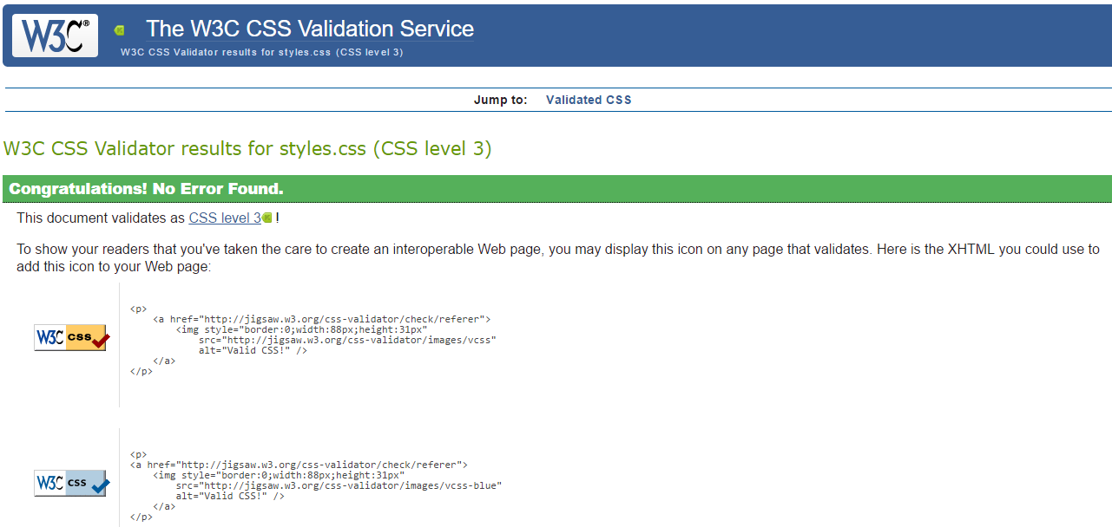

The stylesheet error has been rectified and no errors show.

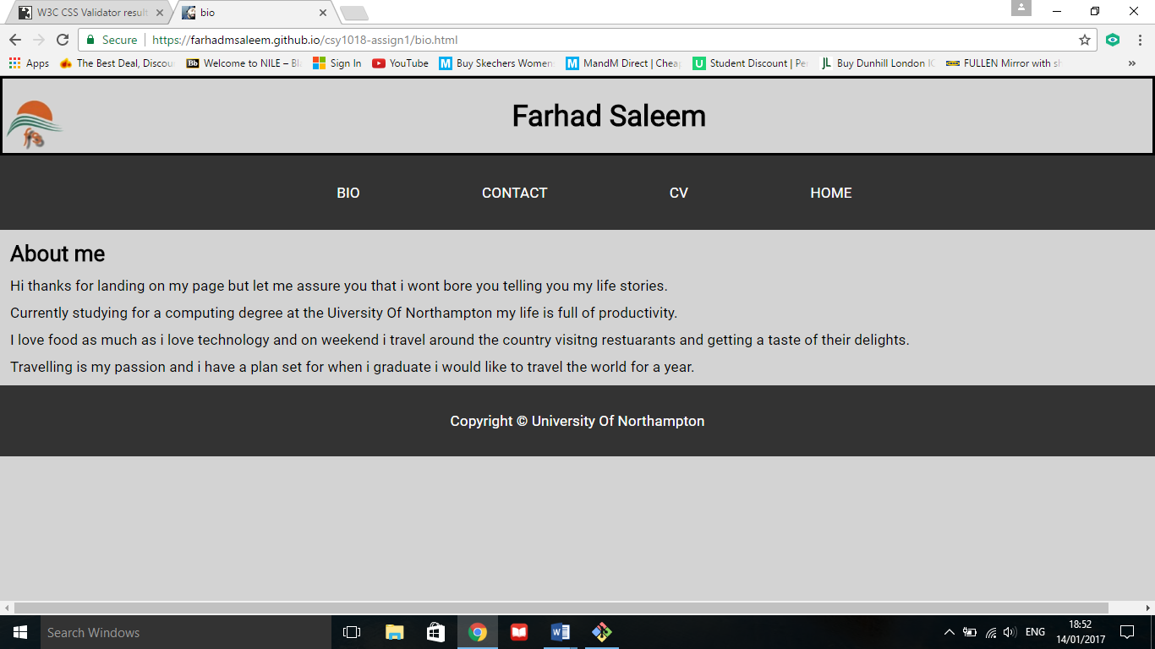
Final design
Here is my final design and Bio page as you can see it includes a the features required in the assignment brief; logo, header/footer, navigation bar and the text.

Conclusion
As you can see the design and the theme has been consistent through the entire portfolio. The navigation is visible throughout all pages to ease accessibility so users do not have problems going back to a page. On my first wireframe of the contact page I had not included a footer which was a downfall as that was a requirement of the assignment brief so therefore I had constructed in a footer on all pages.
I have listed the errors I had received upon CSS and HTML validation therefore I had to tweak the code and make changes to eliminate the errors. Also you can see in my wireframes I had included a logo/icon which was a disadvantage because it was a requirement from the assignment brief. But in my final design I had manages to put a functional logo that directs a user to the homepage when clicked.
Overall the design has been created from scratch and has been kept simple but effective.
I have spent roughly around 40 hours on my assignment.

