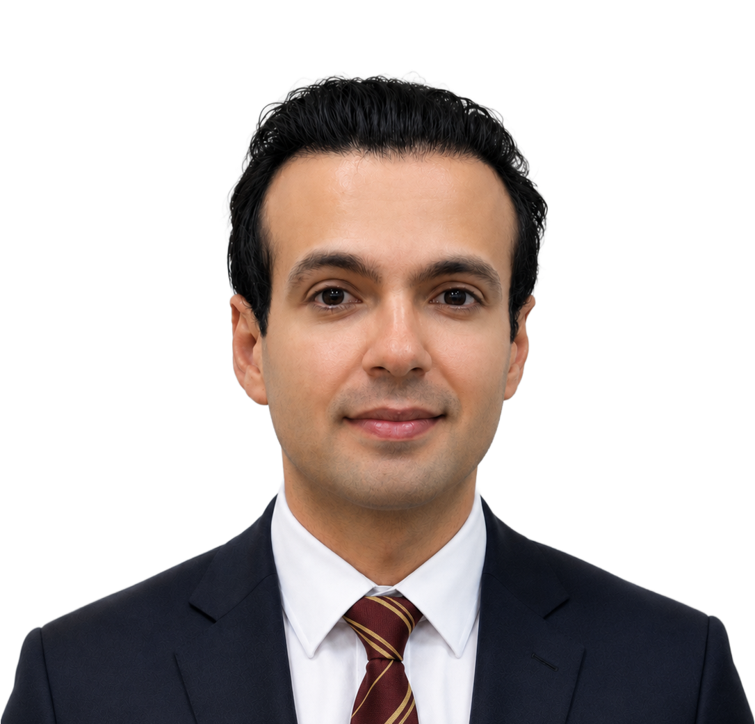 | Farhad Shadmand  AI Researcher and Developer  +351 912 292 634  farhadsh1992@gmail.com  www.farhadshad.com  linkedin.com/in/farhadsh1992  github.com/farhadsh1992  orcid.org/0000-0003-4399-4845  ResearchGate

ABOUT
I am a researcher and developer with hands-on experience building deep learning models based on diffusion models, GANs, and VLM-based systems on multi-GPU platforms (CUDA). My work has led to multiple publications, including CVPR, WACV, and IEEE Access. I bring strong skills in PyTorch, computer vision, model optimization, and AI agents.
EXPERIENCE
Post-doctoral Researcher — VisTeam, Institute of Systems and Robotics – Coimbra (ISR) 2026 – Present
Coimbra, Portugal
- Research on generative video models, including video watermarking and diffusion-based generation (Stable Diffusion).
- Stack: PyTorch, Hugging Face, Accelerate, Slurm, OpenCV, Weights & Biases (wandb).
Research Intern — Adobe Aug 2025 – Dec 2025
Paris, France
- Developed robust watermarking models using geometric symmetry-aware convolutional networks combined with a VLM-based generative noise-simulation pipeline to accurately replicate print-and-scan degradation effects.
- This approach significantly enhanced watermark resilience against real-world distortions introduced during printing, scanning, and image recapture.
- Stack: Deep Learning, AWS, PyTorch Lightning, data distribution.
Manager: Dr. Shruti Agarwal (shragarw@adobe.com)
Researcher — VisTeam, Institute of Systems and Robotics – Coimbra (ISR) Sep 2019 – Jul 2025
Coimbra, Portugal
- Developed deep learning models for steganography, watermarking, object detection, face detection, and face verification.
- Contributed to the projects VISUAL-ID, TruIM, and FACING, resulting in multiple publications and practical solutions for identity-document security.
- Stack: deep learning libraries, computer vision libraries (OpenCV, dlib, Pillow), C++, Django, FastAPI.
Researcher — Instituto Universitário de Lisboa (ISCTE) 2018 – 2019
Lisbon, Portugal
- In 2018, I moved to Lisbon and began my research at Instituto Universitário de Lisboa (ISCTE) and the Faculty of Sciences of the University of Lisbon (FCUL), under the supervision of Prof. José Carlos Dias.
- Applied machine learning, deep learning, and natural language processing (NLP) techniques to analyze financial markets, processing data from online news websites, Twitter, and stock market platforms to develop predictive models for financial trends.
- Stack: NLP libraries, Python, MATLAB, Requests, BeautifulSoup, REST API.
SKILLS
Programming Languages: Python, C++, Java (Basic), HTML, CSS
AI/ML: PyTorch, TensorFlow, ONNX, PyTorch Lightning, Hugging Face, DeepSpeed, Scikit-learn, OpenVINO, XGBoost, LightGBM, CatBoost, torchdata, Accelerate, Keras, JAX, FLAX, Optax, Core ML
NLP: spaCy, NLTK, AllenNLP, Transformers, Tokenizers, Optimum-Intel, Optimum-Neuron, Optimum-Habana, Optimum-ONNX, OpenAI SDK
AI Agents: LangChain, LangSmith, LangGraph, LangFlow, RAG, Gradio
Systems: Multi-GPU, CUDA, SLURM, Docker, Kubernetes (K8s), OpenHPC
CI/CD: Jenkins, GitHub Actions, GitLab CI
Computer Vision: OpenCV, dlib, Pillow
Data: SQL, MySQL, Spark, pandas, ChromaDB
LANGUAGES
Persian (Native), English (Fluent), Portuguese (Beginner)
EDUCATION
PhD in Electrical Engineering and Intelligent Systems 2021 – 2026
University of Coimbra — Coimbra, Portugal
My PhD focused on developing printable steganography and watermarking models for identity-document security, combining encoder–decoder architectures, geometric-symmetric convolutions, and advanced noise-simulation pipelines. I designed and optimized several deep-learning frameworks for reliable message embedding under real print-and-capture distortions. The work resulted in multiple publications, including IEEE Access, CVPR, and WACV.
Supervisors: Prof. Nuno Gonçalves (nunogon@deec.uc.pt) and Prof. Luiz Schirmer (Luiz.schirmer@ufsm.br)
M.Sc. in Complex Systems, Physics 2015 – 2017
Isfahan University of Technology — Isfahan, Iran
I specialize in predicting and modeling stock market behavior, utilizing advanced data analysis and machine learning techniques to forecast trends and inform investment strategies.
Supervisor: Prof. Farhad Shahbazi (shahbazi@iut.ac.ir)
Bachelor's in Physics 2011 – 2015
Isfahan University of Technology — Isfahan, Iran
Among the top 10% of graduates.
PATENTS
Encoding, Decoding and Integrity Validation Systems for a Security Document with a Steganography-Encoded Image Granted Oct. 2025
Inventors: Nuno Gonçalves and Farhad Shadmand · Applicants: Imprensa Nacional Casa da Moeda and University of Coimbra
Encoding, decoding and integrity validation systems for a security document with a steganography-encoded image and methods, computer programs and associated computer-readable data carrier.
PT117136A (Portugal) · EP4064095A1 (European Patent Office)
PUBLICATIONS
StampOne: Addressing Frequency Balance in Printer-proof Steganography
CVPR (2024)
CodeFace: A Deep Learning Printer-Proof Steganography for Face Portraits
IEEE Access 9 (2021)
StylePuncher: Encoding a Hidden QR Code into Images
ICPRAM (2025)
DocSafe: Towards Practical Print-Proof Image Steganography via Frequency Decomposition and Covariance Alignment
IEEE Access (2026.3680290), 2026
RiemStega: Covariance-based loss for print-proof transmission of data in images
WACV (2025)
Young Labeled Faces in the Wild (YLFW): A Dataset for Children Faces Recognition
IEEE 18th International Conference on Automatic Face and Gesture Recognition (FG) (2024)
MorDeephy: Face Morphing Detection via Fused Classification
12th International Conference on Pattern Recognition Application and Methods (2022)
Towards Facial Biometrics for ID Document Validation in Mobile Devices
Applied Sciences 11.13 (2021)

