# **The Hall of Fame & Shame**

### **The Review:**

The assignment for the hall of fame & shame is to study of security or privacy of the usability of the user interface.

### **The interface of Login or Sign in:**

For the interface of the Bank Login or Sign in have the following below:

* User Name or Email or Login ID is required
* Password also required
* Remember checkbox for use in future
* Forgot Your Password Link if the password is not correct
  + Figure 1
  + Figure 2

Figure: 1

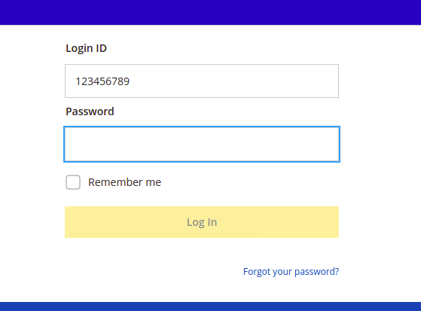

Figure: 2

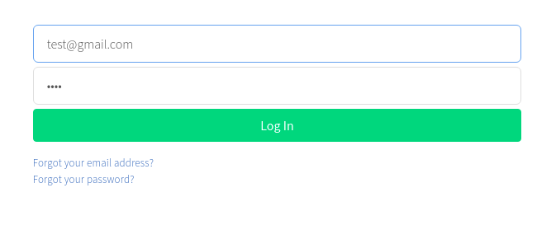

### **General Steps for Login Process:**

For the login or sign-in process User Name or User ID or Login ID or Email is required for confirmation identity with Password essential for taking access to the account. Without the accurate ID & Password, no one can able to authenticate an account. In the case of a wrong ID or Password can get a new password through the Forgot your password or Forgot your email link.

1. Open your Bank Website through your favorite web browser
2. Give your Login ID or User Name
3. Type your Password as same as you gave when you create an account
4. If your User Name or Login ID with Password is verified only then you are able to access your account

### **The interface of Sign up or Register:**

The interface of the Bank Sign up or Registration form required some of the essential data following below:

* First Name, Last Name
* Email
* Account Number
* Account Type
* Social Security Number
* Date of Birth
* Create Log in ID
  + Figure 3
  + Figure 4
  + Figure 5

Figure - 3

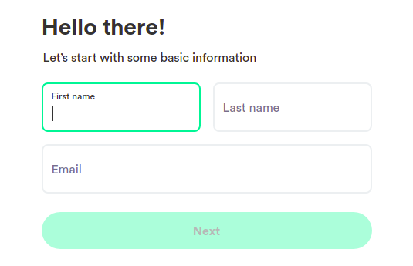

Figure - 4

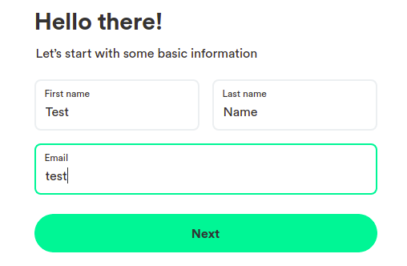

Figure - 5

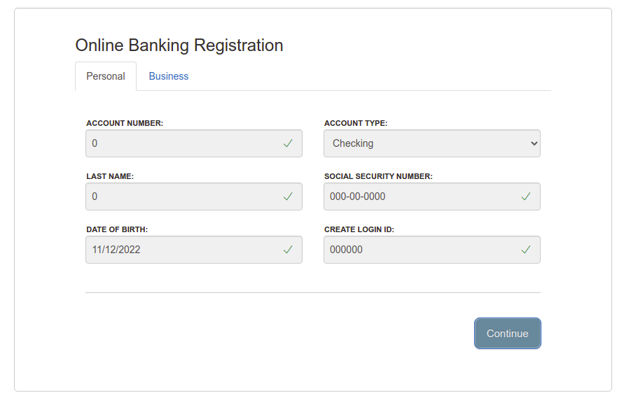

### **General Steps for Registration Process:**

For the Registration or Sign up process, some essential data are required for confirmation of future identity with the Bank as First Name, Last Name, Email, Account Number, Account Type,

Social Security Number, Date of Birth, Create login ID.

### **Summary**

Pros:

* The usability for the “Login” or “Sign in” is good as Learnability, Efficiency, Memorability.
* In the case of forgot email or password, have the link where can solve the issues and thus Errors & Satisfaction usability well.

Cons:

* When giving the wrong user name and password, the Login button should be inactive but it is activated which is not the best security usability.
* For a strong security password, it should be a two-factor acuthentication.
* In the registration form, the password field has some information visible so that the user can create an account with a strong password.
* If anyone sets the wrong email like test@test.com it should show that it is the wrong email same as another field.