FSDO003ONL011

Farhan Eka Fajri

Employee Swagger

API : Get

URL = https://localhost:44342/api/Employee

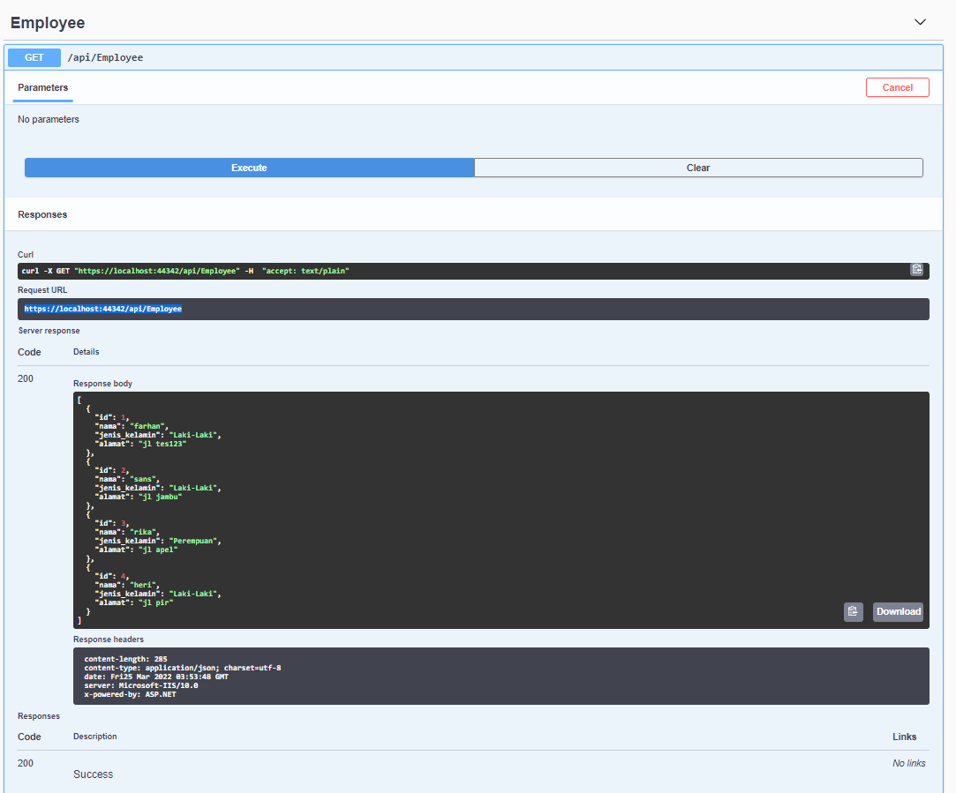

Employee Where Swagger

API : Get  
URL : <https://localhost:44342/api/Employee/1>

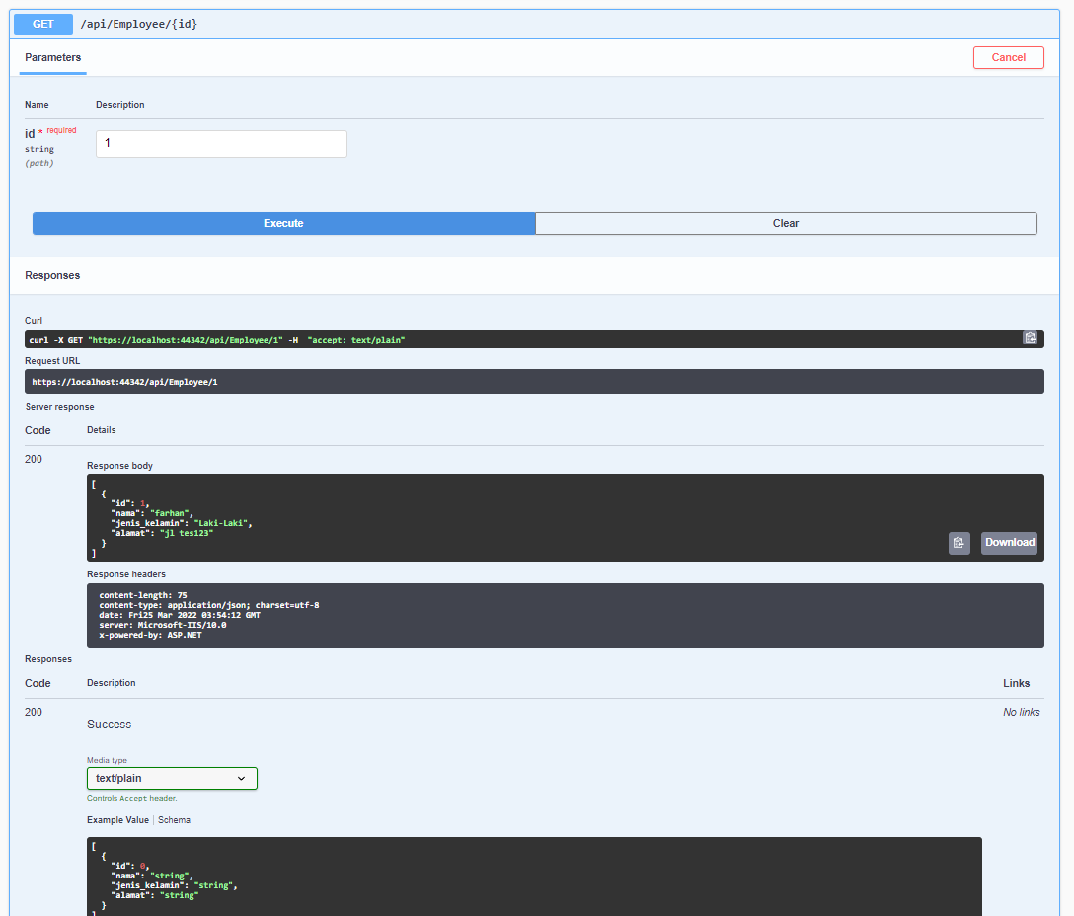

Weather Swagger

API : Get  
URL : <https://localhost:44342/WeatherForecast>

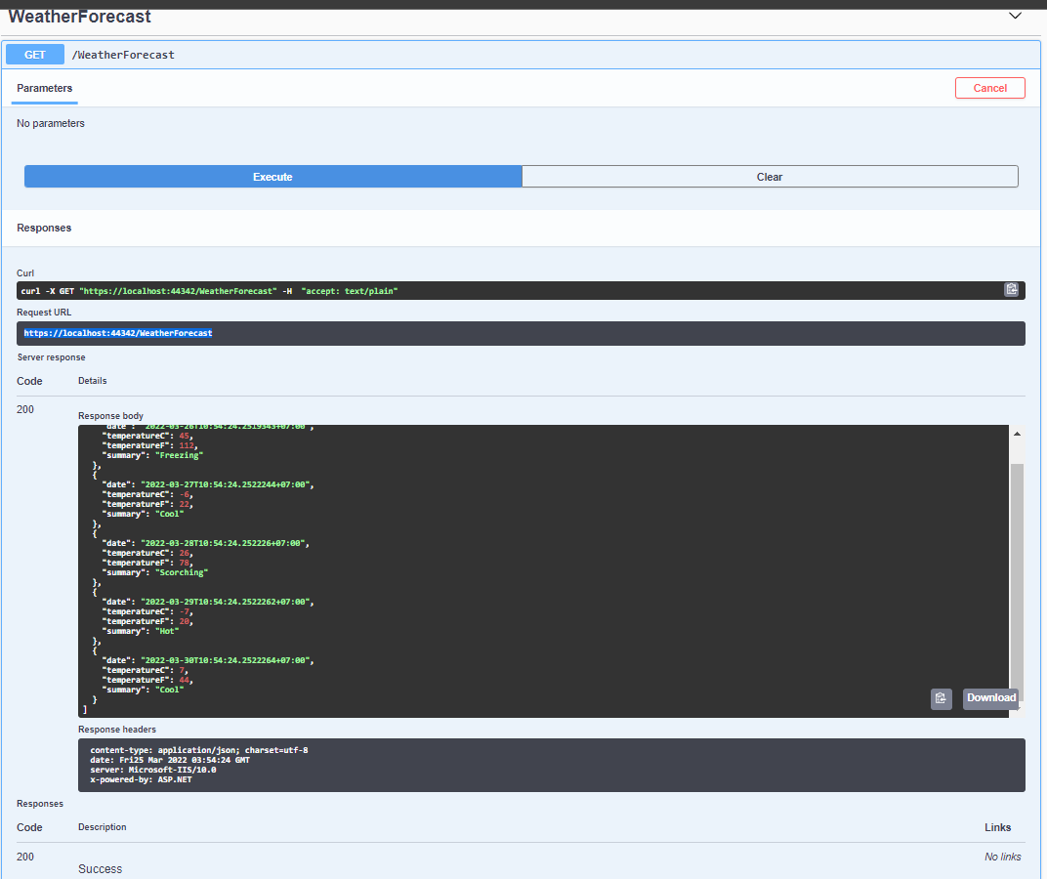

Skema DB :

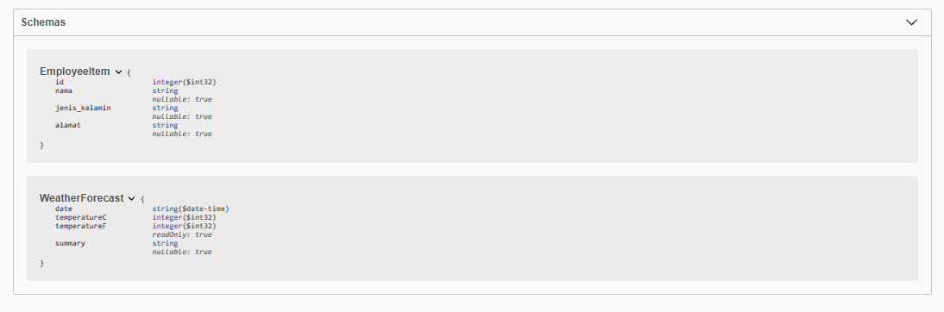

Employee Postman

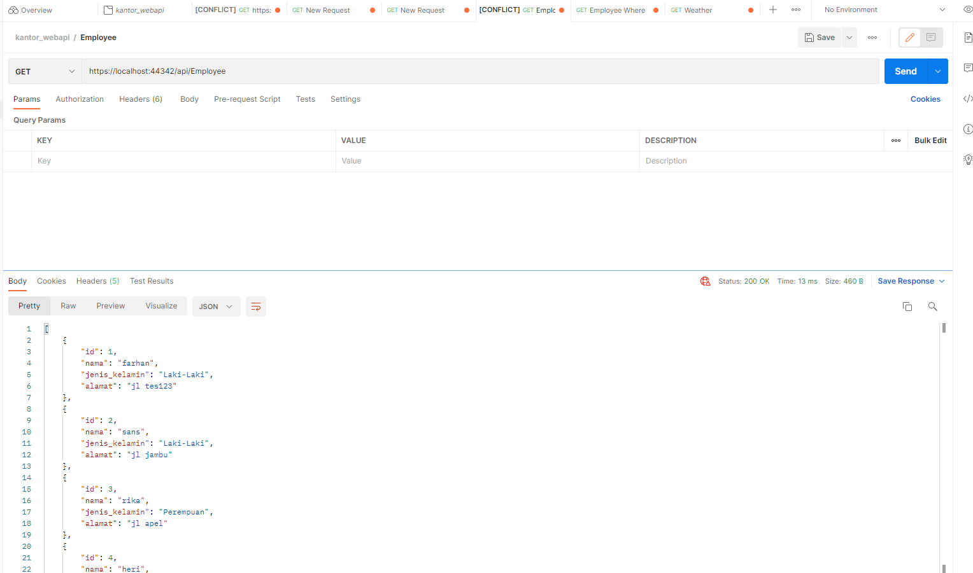

Employee Where Postman

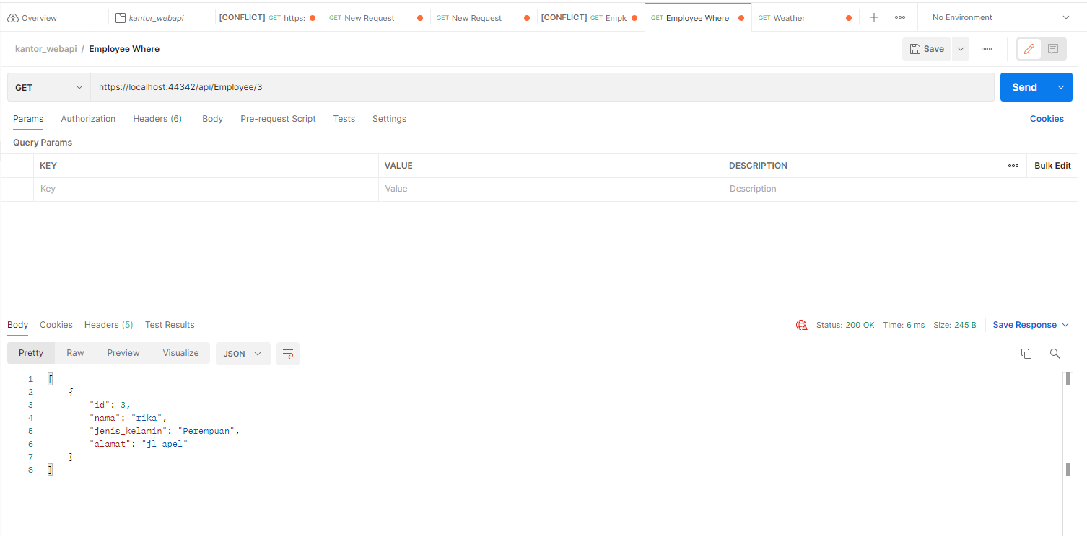

Weather Postman

