Cisco Packet Tracer Network Design Project

Student Information
Name: Farhan Rahman Farabi
University: Romanian-American University
Course: Computer Networks and Internet

1. Project Overview
This project implements a complete network infrastructure for a company with two buildings, each containing three departments. The buildings are connected to an ISP router using serial point‑to‑point links. Each building has its own LAN, running DHCP for automatic host addressing. RIP v2 dynamic routing is used to enable communication between all subnets. Spanning Tree Protocol (STP) is validated on both switches to ensure loop‑free operation. The project includes configuration of routers, switches, PCs, DHCP pools, routing protocols, and verification using pings and routing tables.
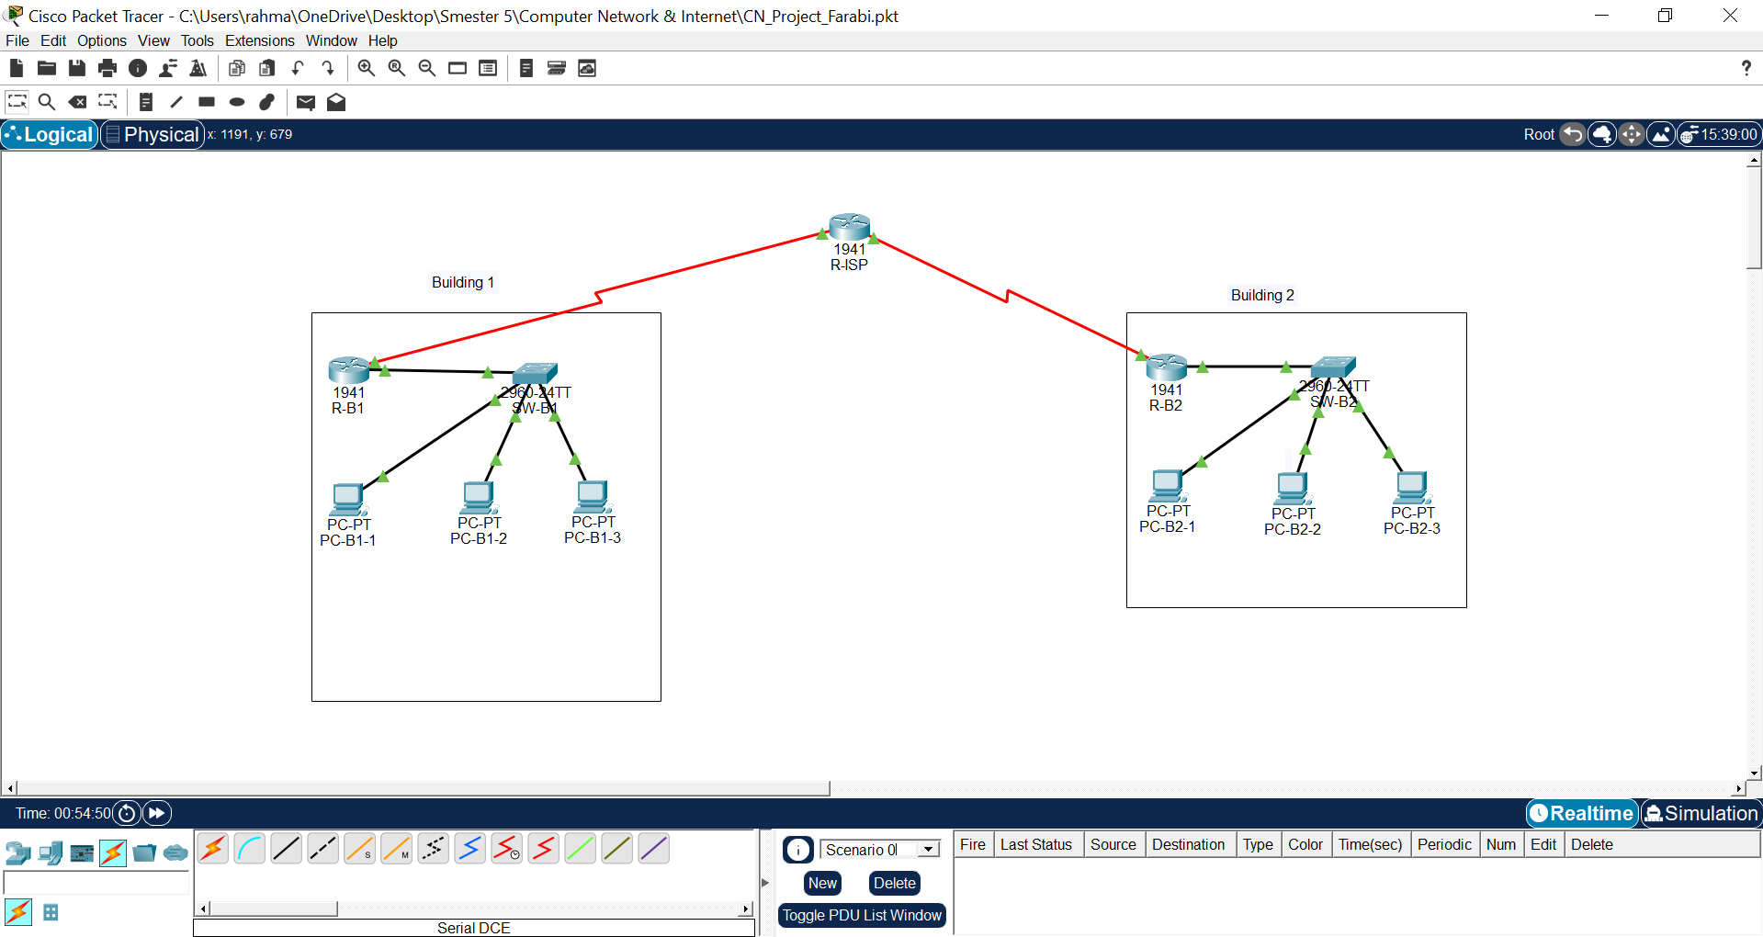

2. Network Topology Description
The network consists of:
• One ISP router (R‑ISP)
• Two building routers (R‑B1 and R‑B2)
• Two switches (SW‑B1 and SW‑B2)
• Six PCs distributed across two buildings
• Serial WAN connections between buildings and the ISP
• Ethernet LAN connections inside each building
3. Network Addressing Documentation
WAN Subnet #1 – ISP ↔ Building 1
Network ID: 93.1.2.0
1st Host (R‑ISP): 93.1.2.1
2nd Host (R‑B1): 93.1.2.2
Broadcast Address: 93.1.2.3
WAN Subnet #2 – ISP ↔ Building 2
Network ID: 93.1.2.4
1st Host (R‑ISP): 93.1.2.5
2nd Host (R‑B2): 93.1.2.6
Broadcast Address: 93.1.2.7
Building 1 LAN – 10.0.1.0/24
Network ID: 10.0.1.0
Gateway: 10.0.1.1
Host Range: 10.0.1.2 – 10.0.1.254
Broadcast: 10.0.1.255
Building 2 LAN – 10.0.2.0/24
Network ID: 10.0.2.0
Gateway: 10.0.2.1
Host Range: 10.0.2.2 – 10.0.2.254
Broadcast: 10.0.2.255
4. DHCP Configuration
R‑B1 DHCP Configuration:
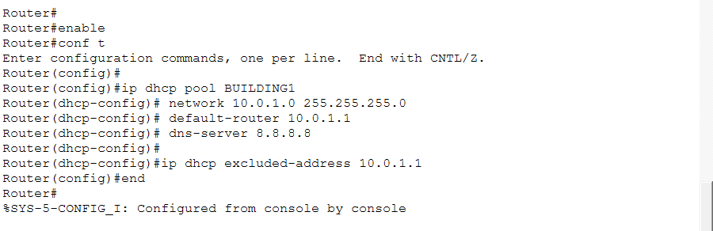
R‑B2 DHCP Configuration:
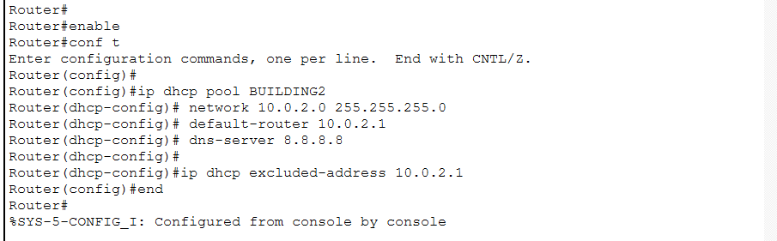
5. RIP v2 Routing Configuration
Router-ISP
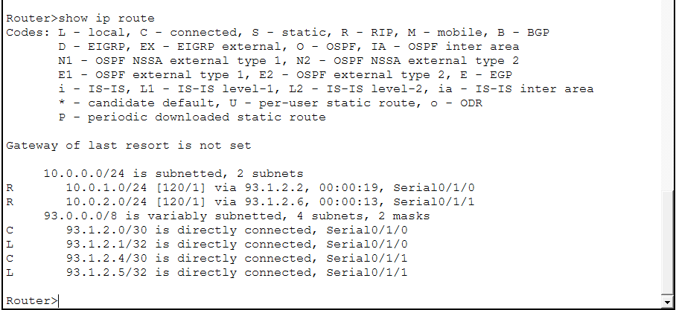
Router-Building1
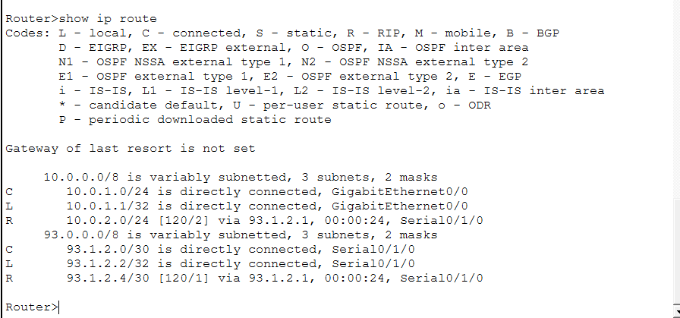

Router-Building2
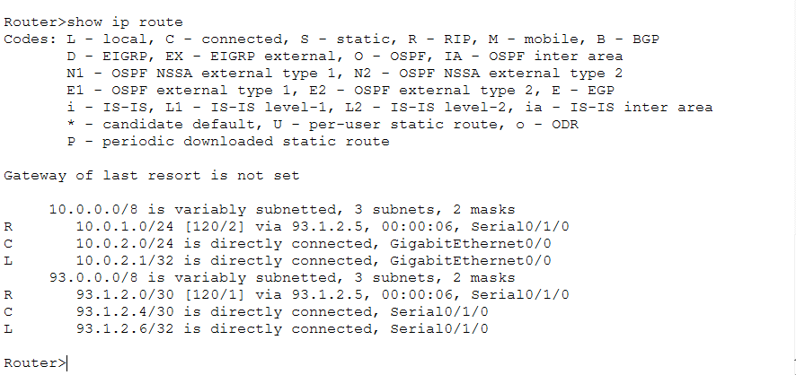
Verifying
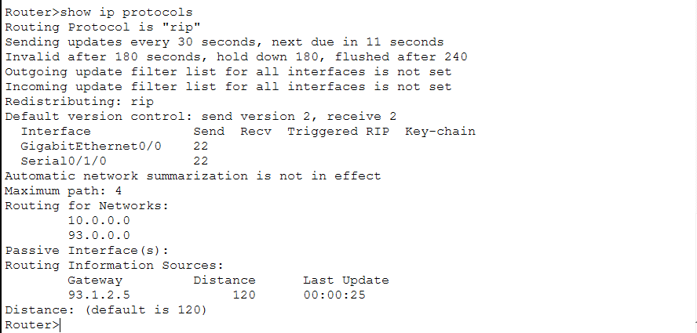

6. Spanning Tree Verification
Switch-Building 1
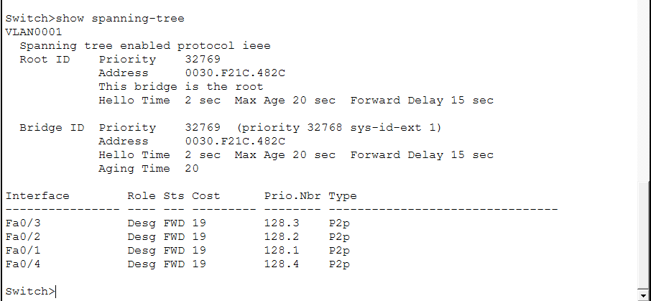

Switch – Building2
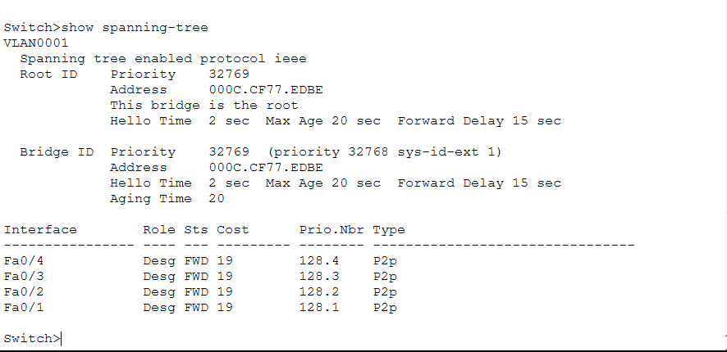
7. Connectivity Testing

Buildin1-Pc1
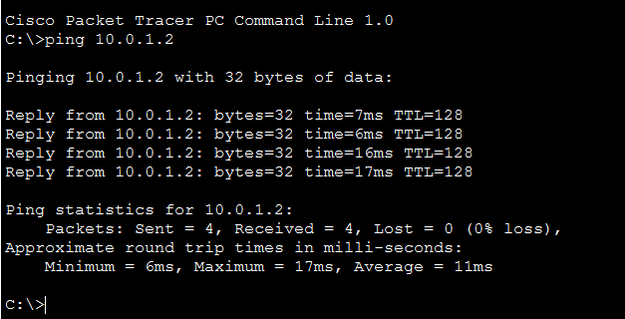
Building2-Pc2
