
American International University-Bangladesh (AIUB)
Department of Computer Science
Faculty of Science &Technology (FST)
Fall2019-2020
CSC 2210 Object Oriented Analysis and Design (OOAD)
Section: L
Group No: 01
SMART HOME SYSTEM
An Object-Oriented Analysis and Design (OOAD) project submitted
By
Kowshik Chakraborty (18-36200-1)
Hasan, Morad (17-35566-3)
Abu, Shaker (18-36230-1)
Jabil, Farhan, Hassan (18-36216-1)

The project will be evaluated for the following Course Outcomes

CO3:Formulate a baseline document to perform feasibility study of a proposed project idea | Total Marks
Project Background Analysis[5Marks]
Project Content Knowledge[5Marks]
Project Feasibility Study [5Marks]
CO4:Design a Complex engineering problem using UML Tools and explain the system using a project report and presentation | Total Marks
Diagram Standard [5Marks]
Report Organization [5Marks]
Presentation Delivery [5Marks]

- PROBLEM DOMAIN
  - Project Background Analysis
Since the dawn of history mankind has been trying to achieve comfort combined with simplicity, as the goal is so bright it still stumbles with lots of obstacles. A home is the place where people usually relax, spend quality time with their families and sometimes even work on their jobs. Building a home went through many phases, at the stone age it was just a cave but now at the 21st century a home might be just a small place or a huge apartment in a skyscraper that would cost millions. The idea of building a smart home is considered a luxury for now but actually in few decades most of the houses will probably be a smart home in a way or another depending on its complexity, efficiency, and cost.

As people lived in their homes a lot of problems popped up which needs to be resolved. Some of the problems that people face in ordinary homes are the waste of energy and other resources, security, and time saving. The smart home solves these problems in a very effective way as for the security smart homes are supplied with surveillance cameras that monitor the whole place form inside and outside. These cameras are connected to the display screens in the house, warning alerts are used and they send out messages to the owner whenever a door or a window is unlocked in an appropriate way or in case the owner is not at the house. Efficiency in the smart house is covered by easy control over all devices available in the home. The control of these devices is done by a special application called voice recognition.

1.2 Project Solution and Feasibility Analysis

In the world of smart houses different levels and technologies are used, as mentioned before there are different stages of complexity that can be used in designing a smart home, those different levels certainly come with different prices which will change the economical point of view of the customer, as he will decide their choice upon the allowed, needed, and the affordability of their home. As we all know the performance varies with the kind of level and complexity so the very famous and well known saying is applied “the more you pay, the more you get”. The difference in the price could be due to different reasons, for example the quality of components used which will differ in the lifetime of system and its reliability. The price would also differ due to the different options available in the smart home. The design is chosen to be simple but effective, full of features but not expensive, the reason for this choice is to provide a good smart home with a low price. Although it’s clear that our design if full of components but actually it is not highly priced, the economical view is taken in consideration to help in finding the most flexible and efficient home. A lot of smart homes are more complex than this design but we choose the most important and needed issues to solve. From the view of maintainability, our design is very easy to be maintained, there is no need to bring an expert each time a problem is found, any issue can be fixed in an easy and fast way, in other words people living in this smart home can fix any bug by themselves with no need to professional persons.

2. UML DIAGRAM
2.1 Use Case Diagram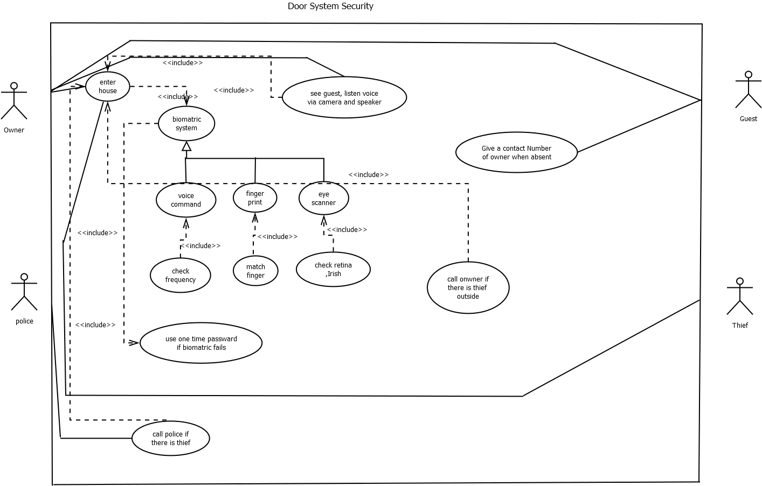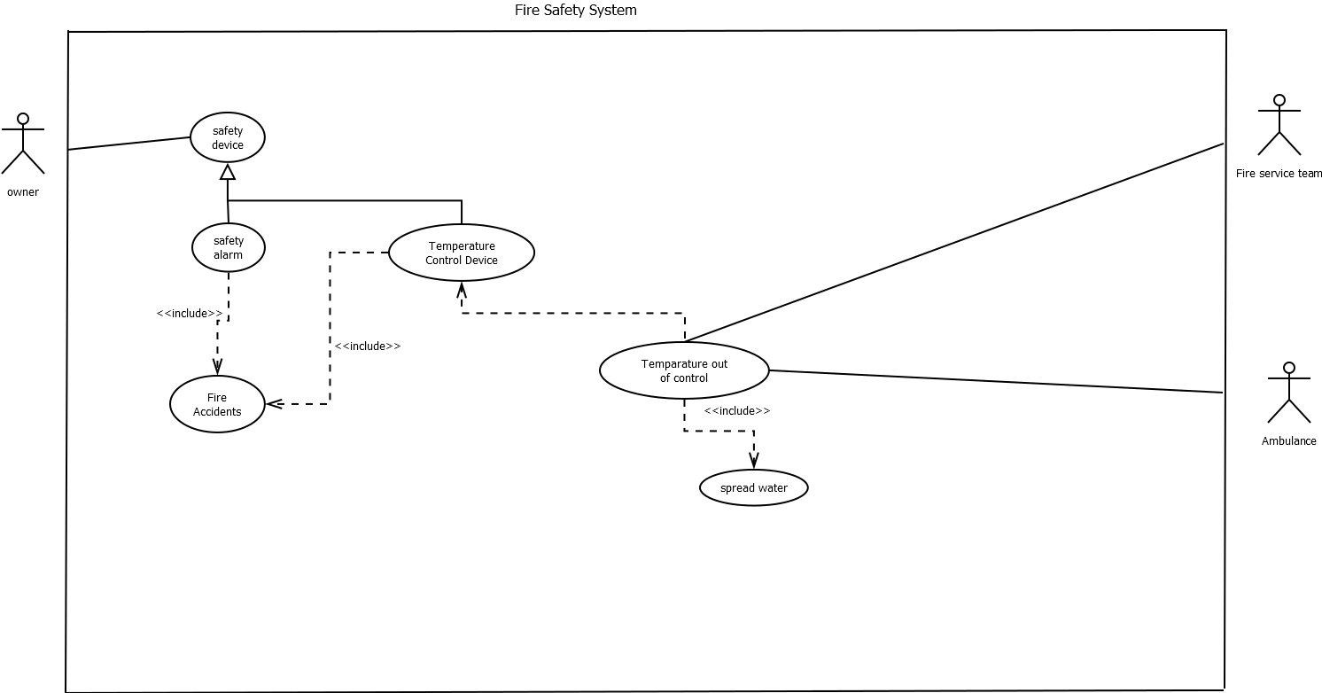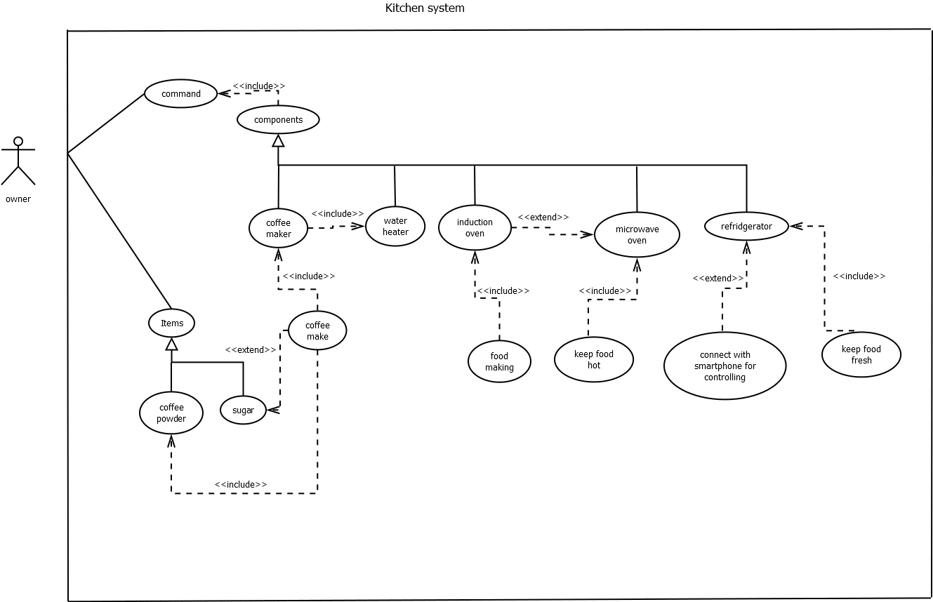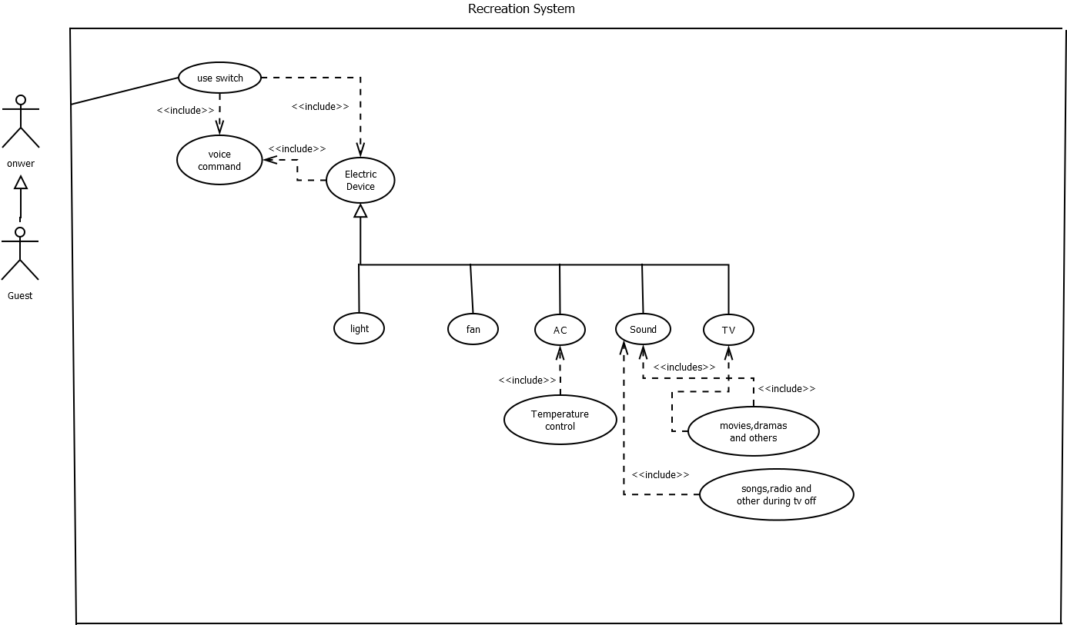

  - Class Diagram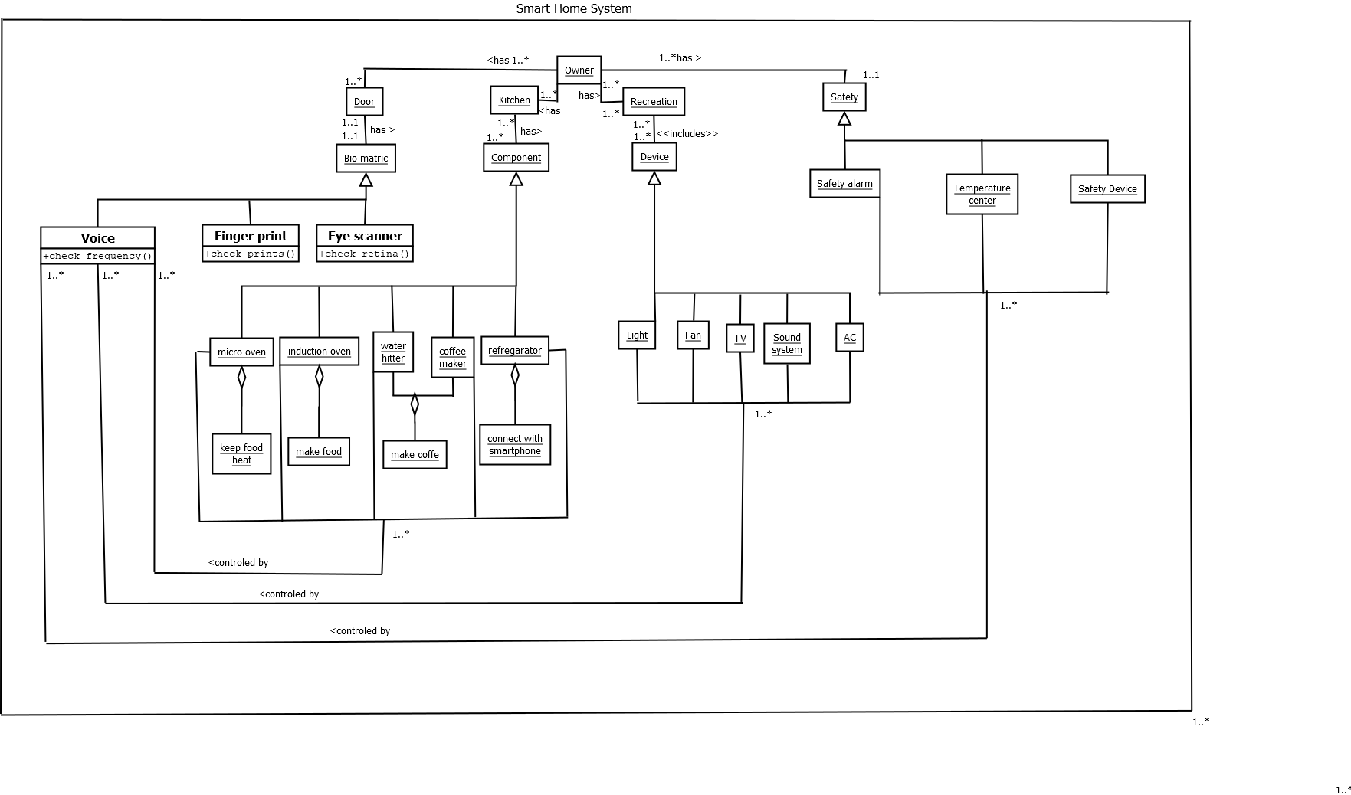

2.3 Activity Diagram 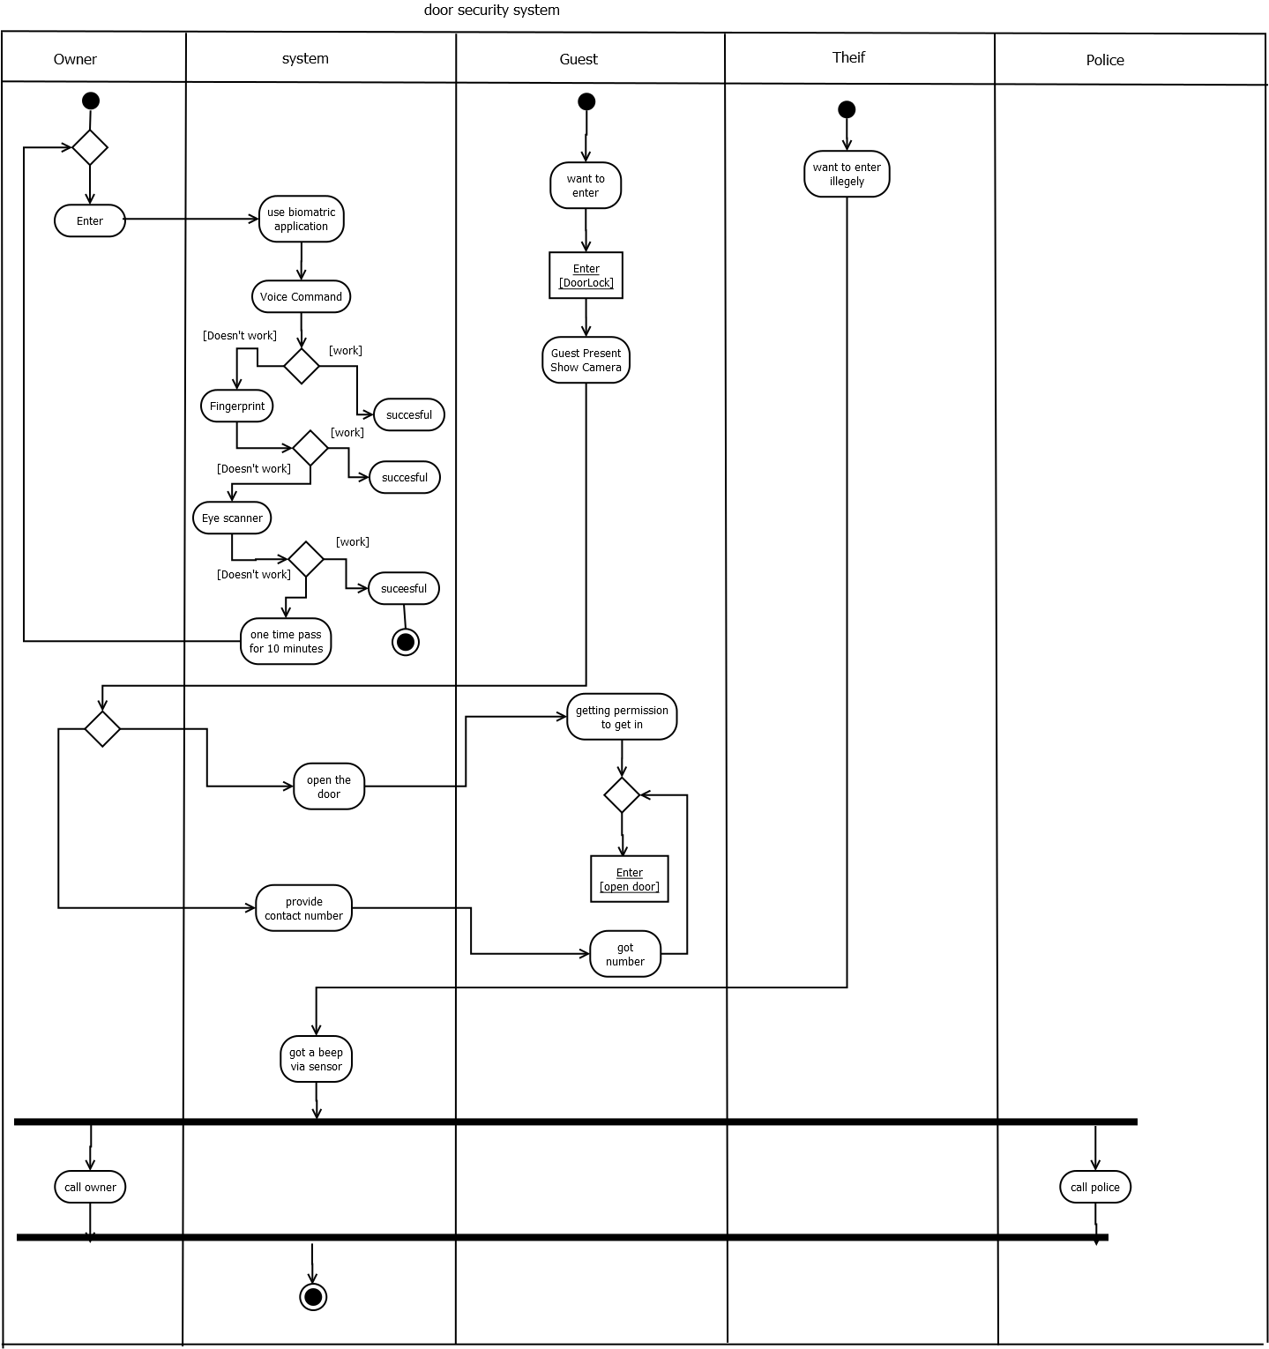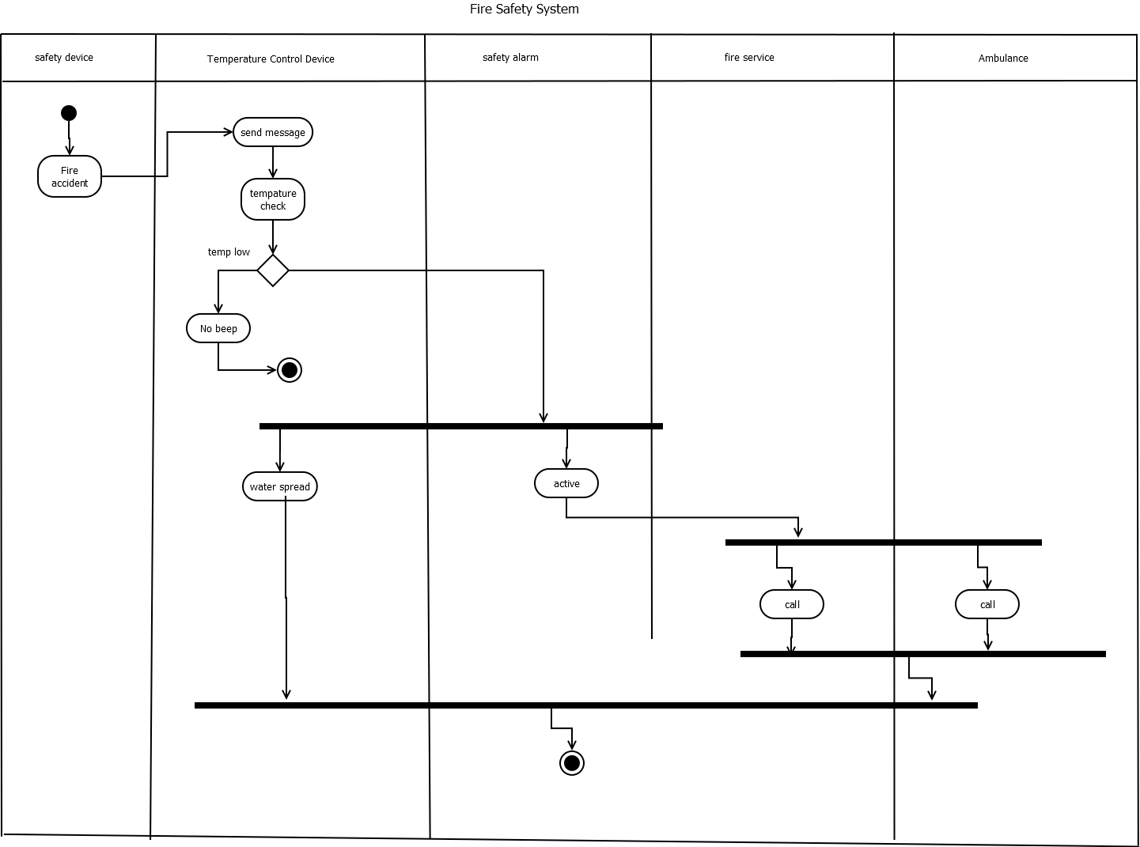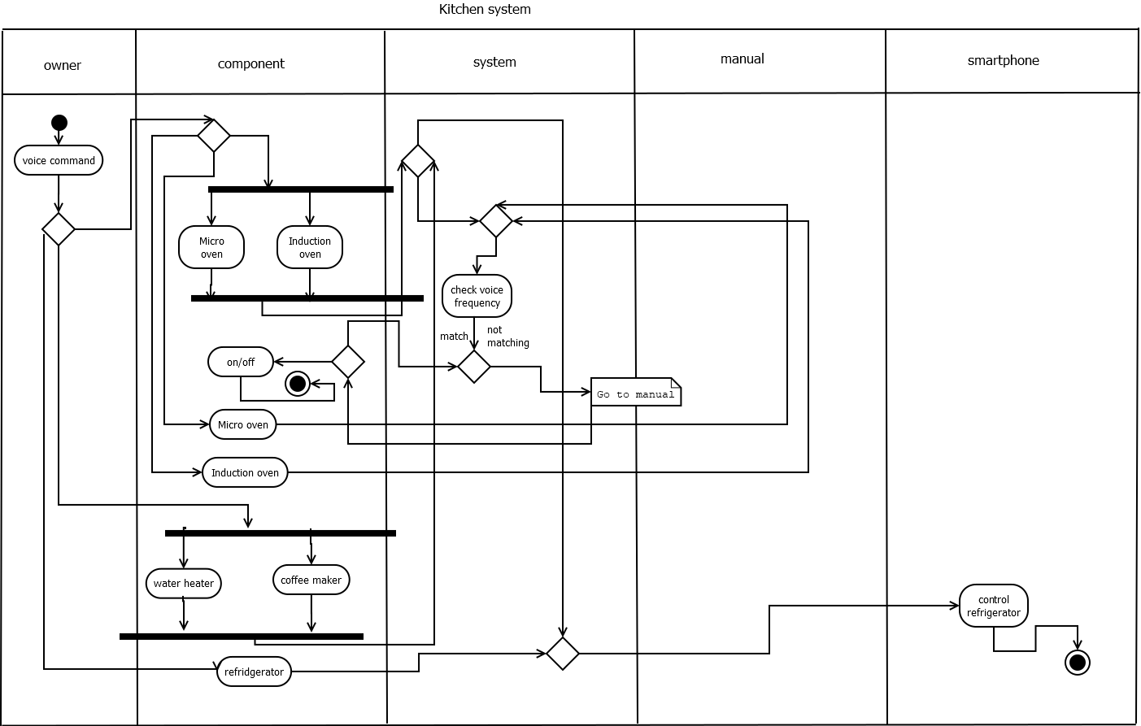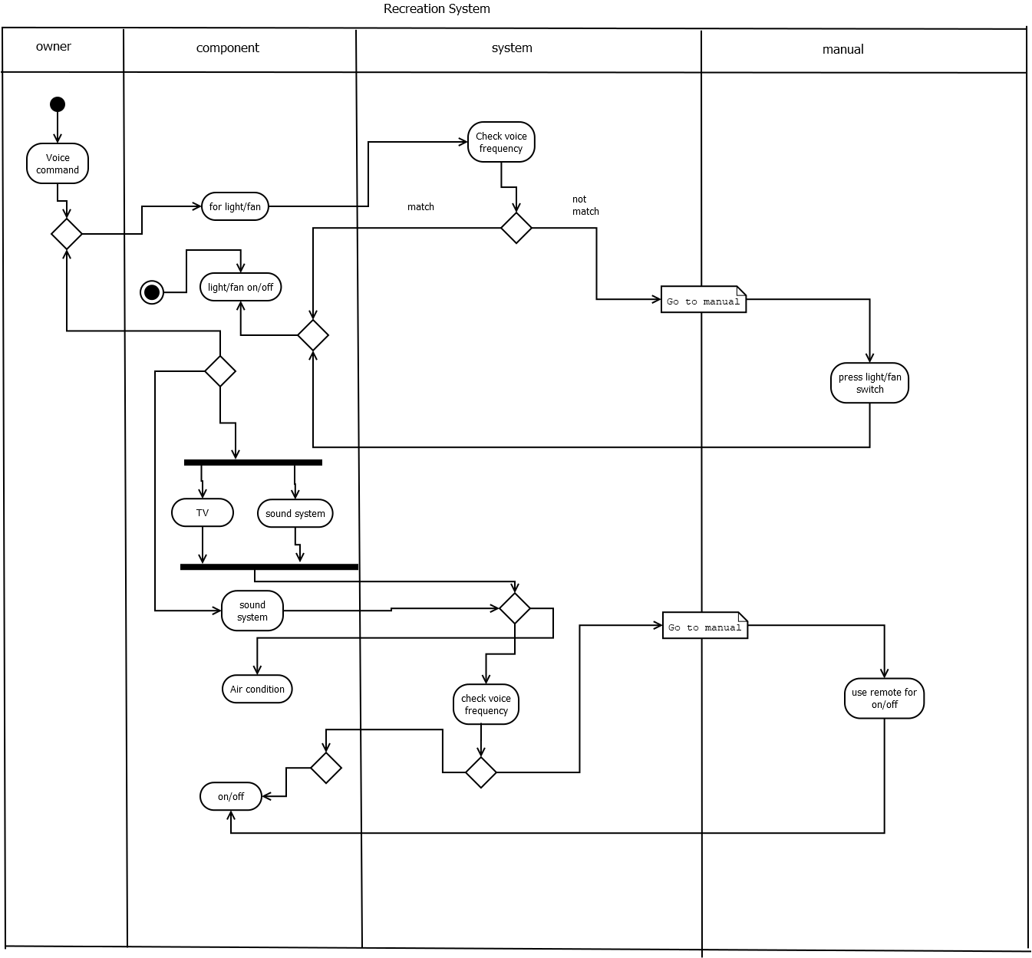
  - Sequence Diagram
