

| **Name:** | **Roll no:** |
| --- | --- |
| **Class: BECO** | **Semester: 8** |

**Experiment No: 1**

**Aim:** Study various social media platforms and their analytics tools.

**Theory:**

1. **Google analytics**

Google Analytics is a Tracking Platform that monitors and records what people do on a website or a social network. Google Analytics stores the activities of web and app users, and it reports these activities comprehensively in an organized form to help businesses make smarter decisions. By extension, this service gives business owners the tools they need to get their business results with their Marketing Strategies – all in one place!

### **Key Features of Google Analytics**

* Google Analytics tracks Website Traffic, its sources, frequency, and pages visited.
* It measures user behavior through their activities like keywords and preferences.
* It helps you monitor your Marketing Performance.
* It gives web customizable metrics and audience data.
* It enables the user to visualize web and app data.
* It provides data-powered insights into the effectiveness of your marketing strategies.

**Some Analytics that can be performed are shown below**

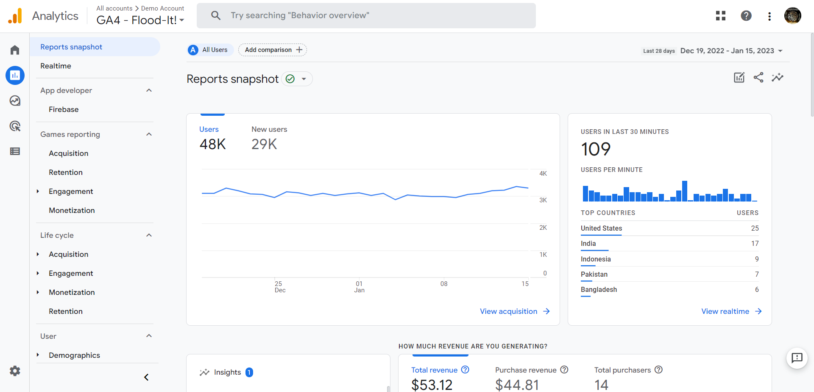

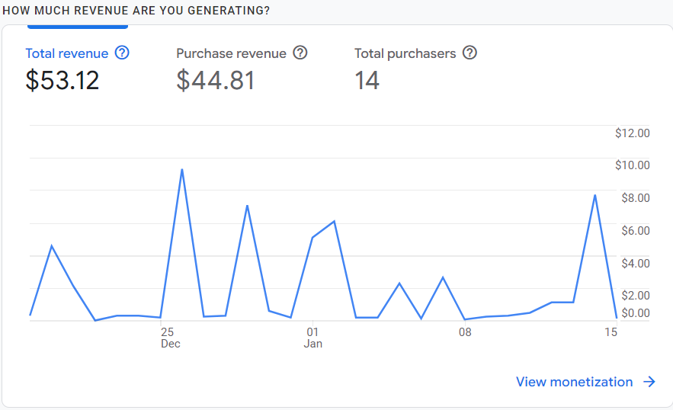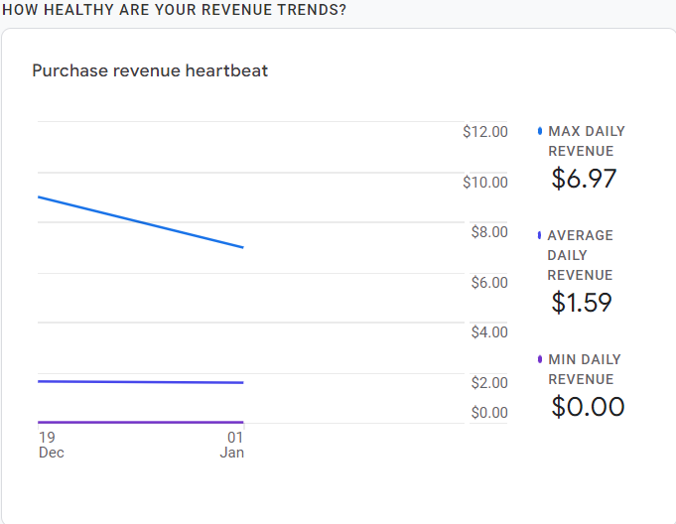

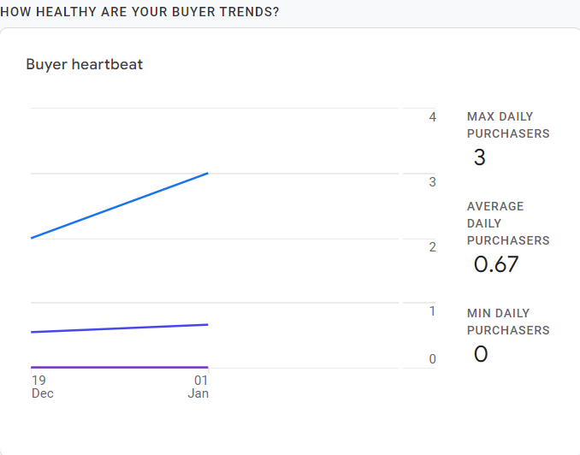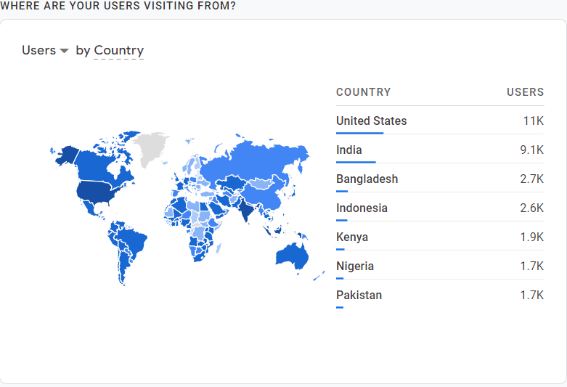

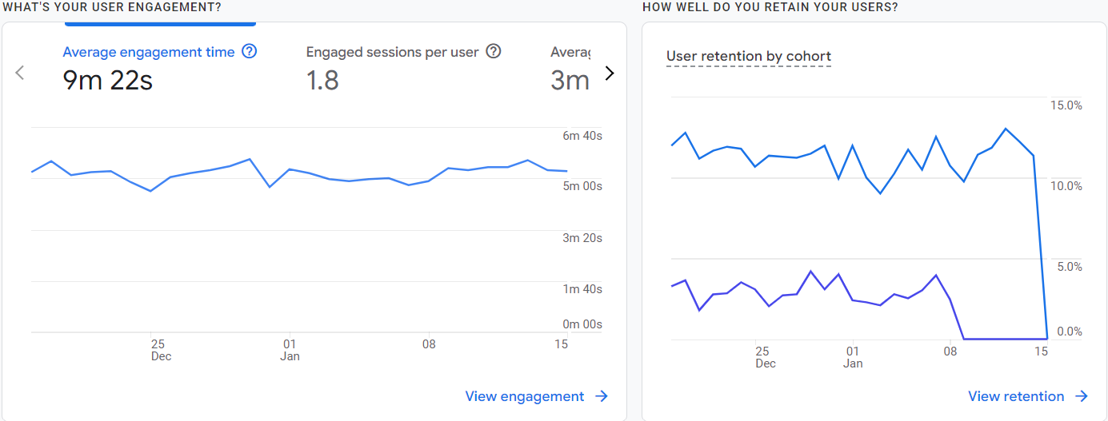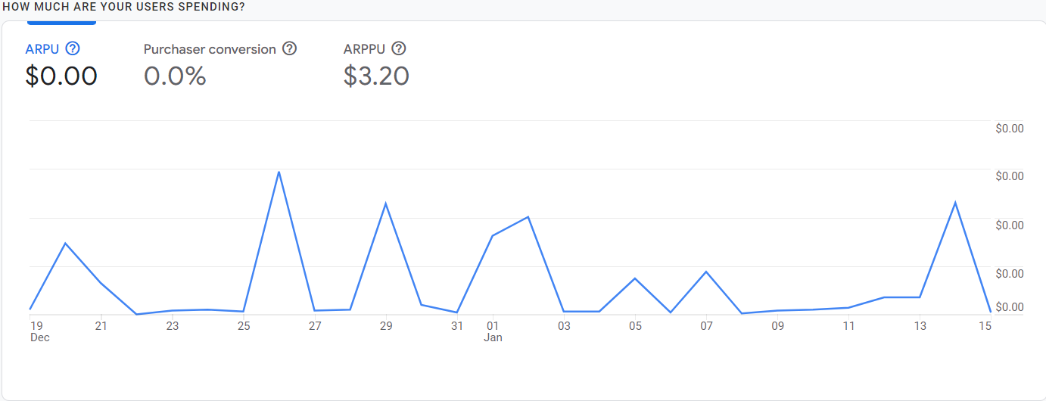

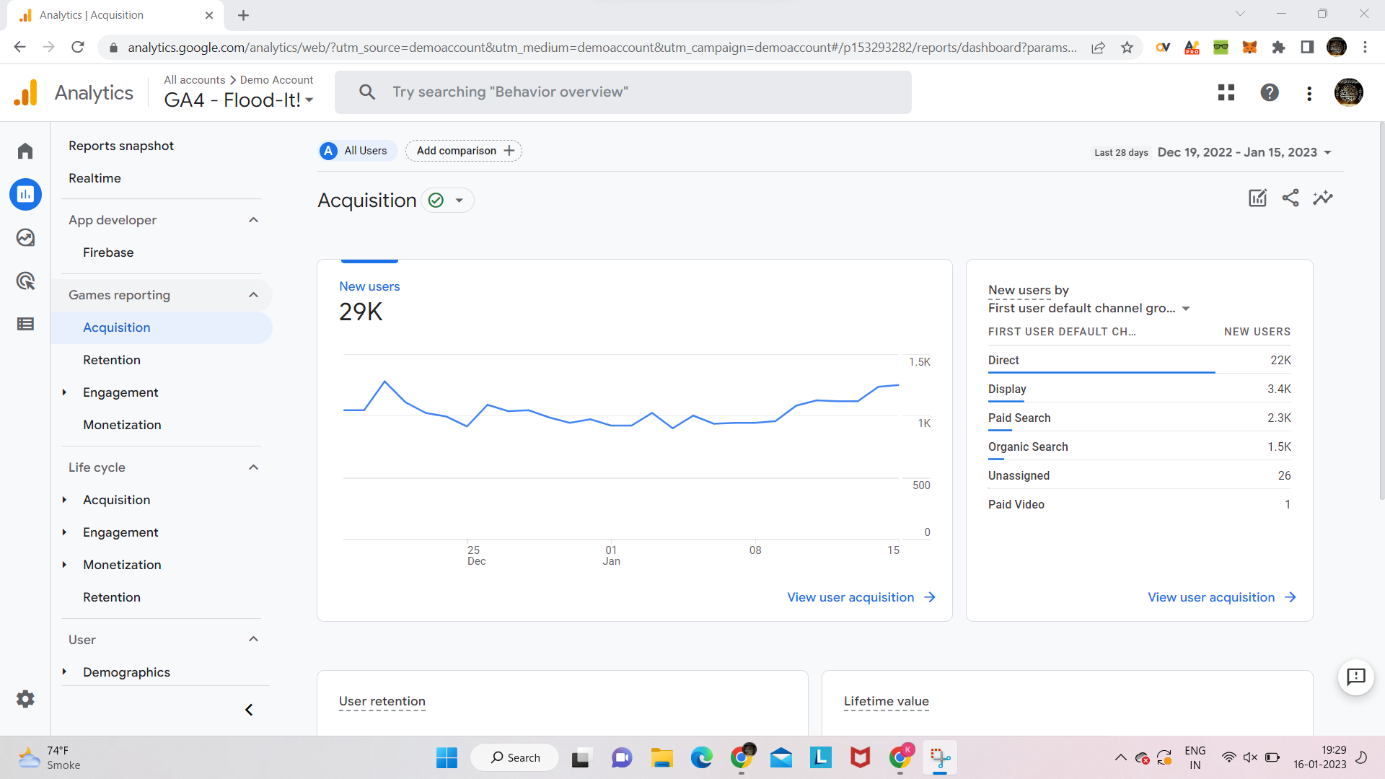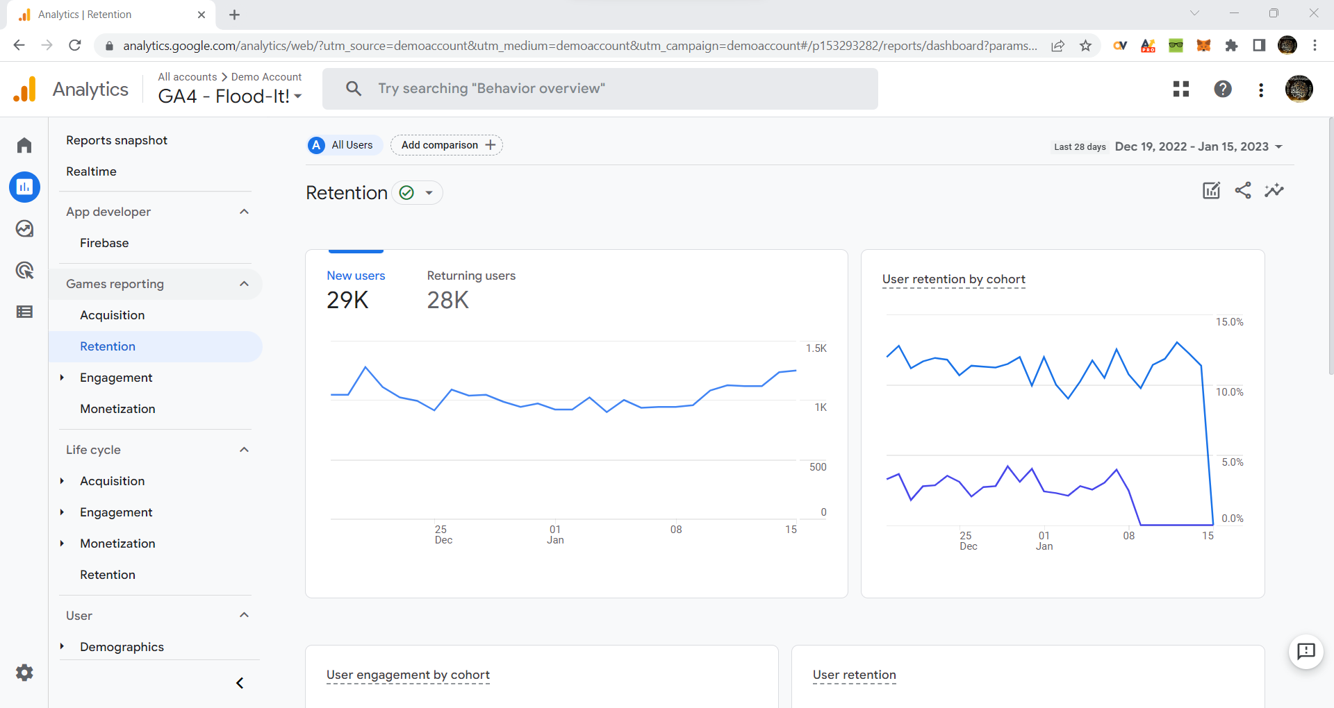

1. **Facebook Pixel**

Facebook Pixel is an Analytics Tool that collects information about actions taken on a website by users. When used without ads, Facebook Pixel helps build a list of prospects who you can target in your advertisements. With Facebook Ads, however, this service measures conversions from Facebook and Instagram Advertisements so businesses can determine the effectiveness of their sales strategies. Generally, Facebook Pixel is a tool that enhances optimization in that it helps businesses build the right audience, and it provides insights for businesses to tailor their services and products to the needs of the audience.

### **Key Features of Facebook Pixel**

* Facebook Pixel helps your business build a custom audience list without any hassle.
* It tracks the success of your Facebook and Instagram Ad campaigns.
* It allows you to monitor Lead Conversions.
* It guides your company’s formulation and implementation of advertisement strategies.
* It presents the data in a user-friendly format.

**Some Analytics that can be performed are shown below**

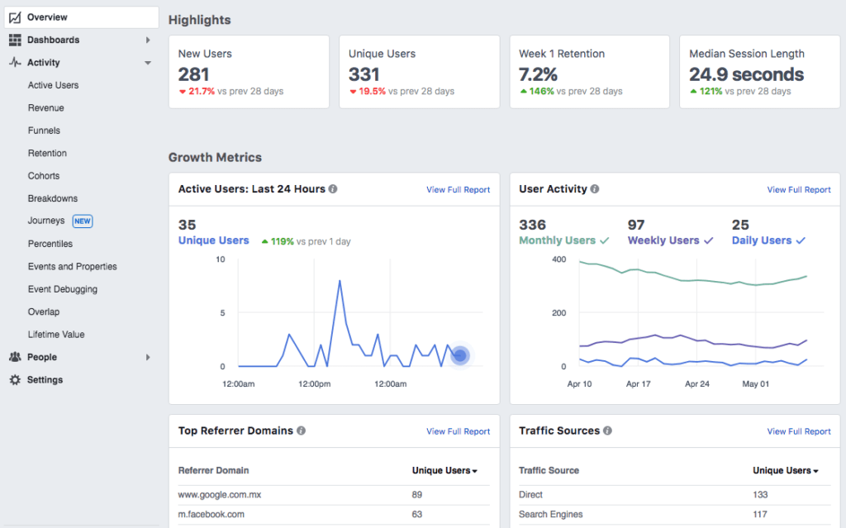

1. **Netlytic**

Netlytic is a community-supported text and social networks analyzer that can automatically summarize and visualize public online conversations on social media sites. It is made for researchers by researchers, no programming/API skills required.

**Key Features of Netlytic**

* Capture publicly available posts from social media sites or other sources (Twitter, YouTube, RSS Feed, or text/csv file)
* Discover popular topics
* Find and explore emerging themes of discussions
* Build, visualize and analyze online communication networks using social network analysis
* Map geo-coded social media data

**Step 1: Go to netlytic.org**

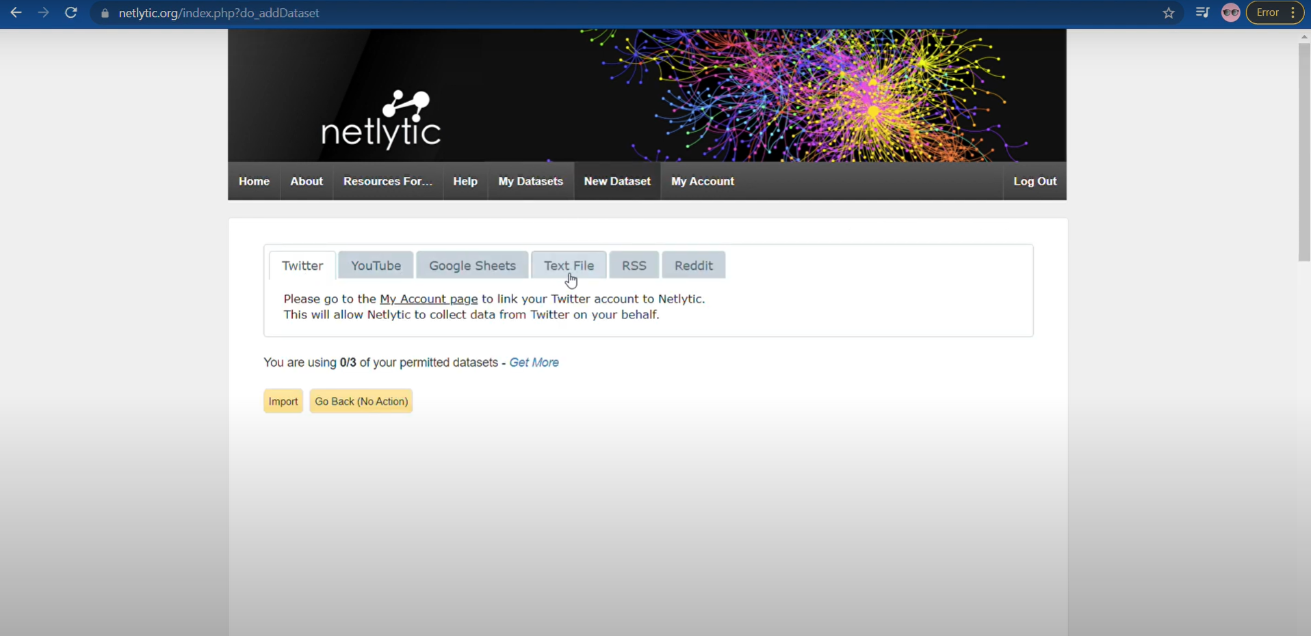



**Step 2: Enter dataset name and youtube link as mentioned below.**

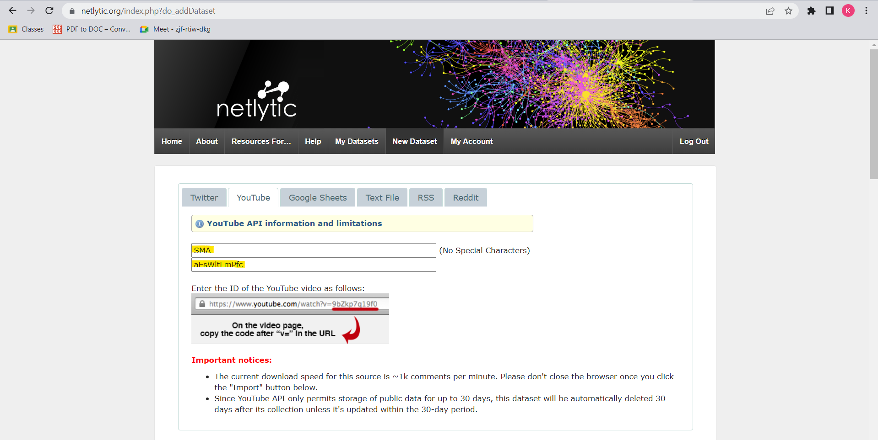

**Step 3: Click on import**

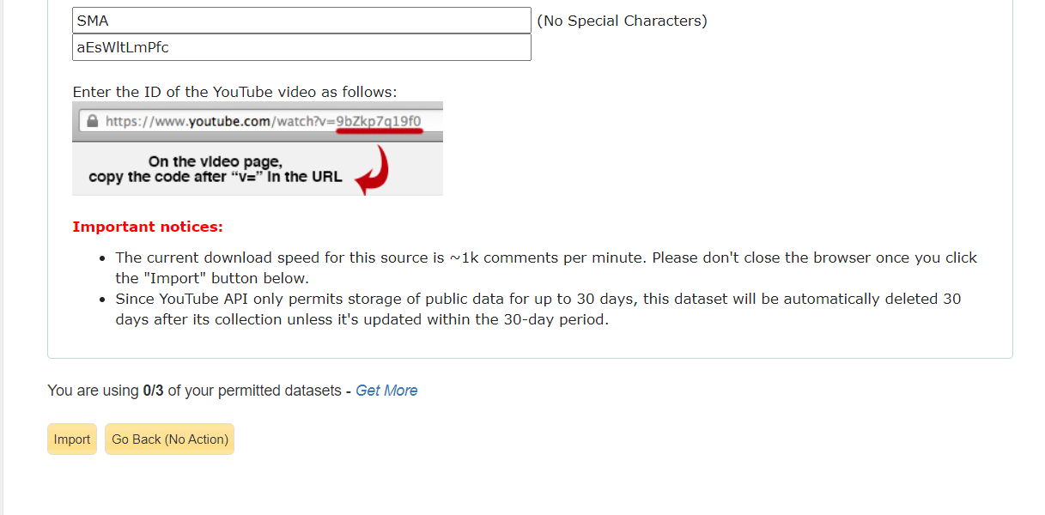

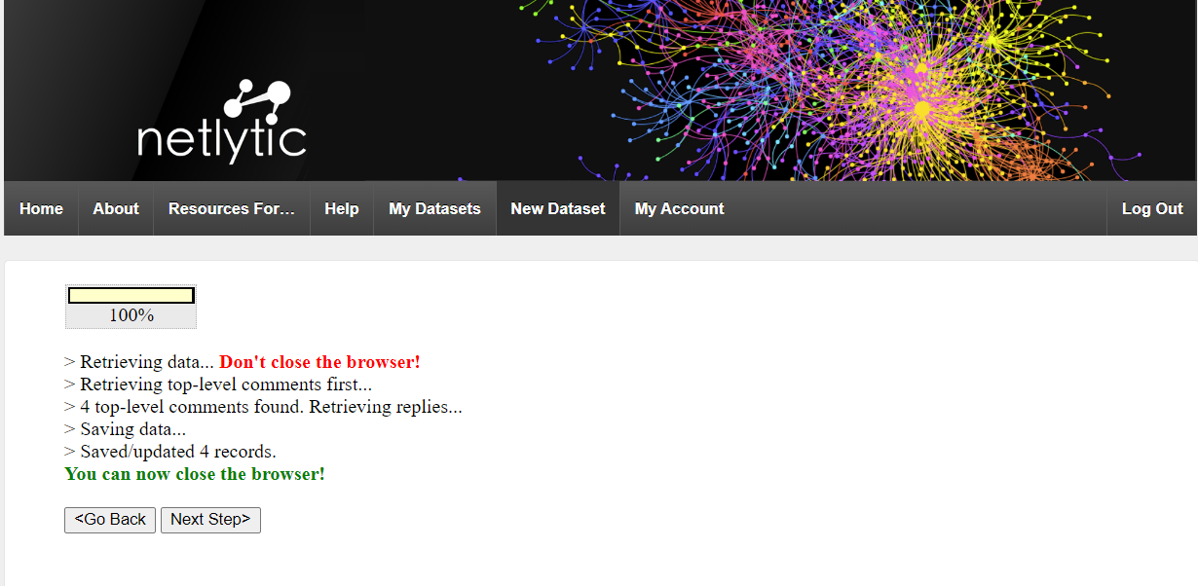

**Step 4: Preview**

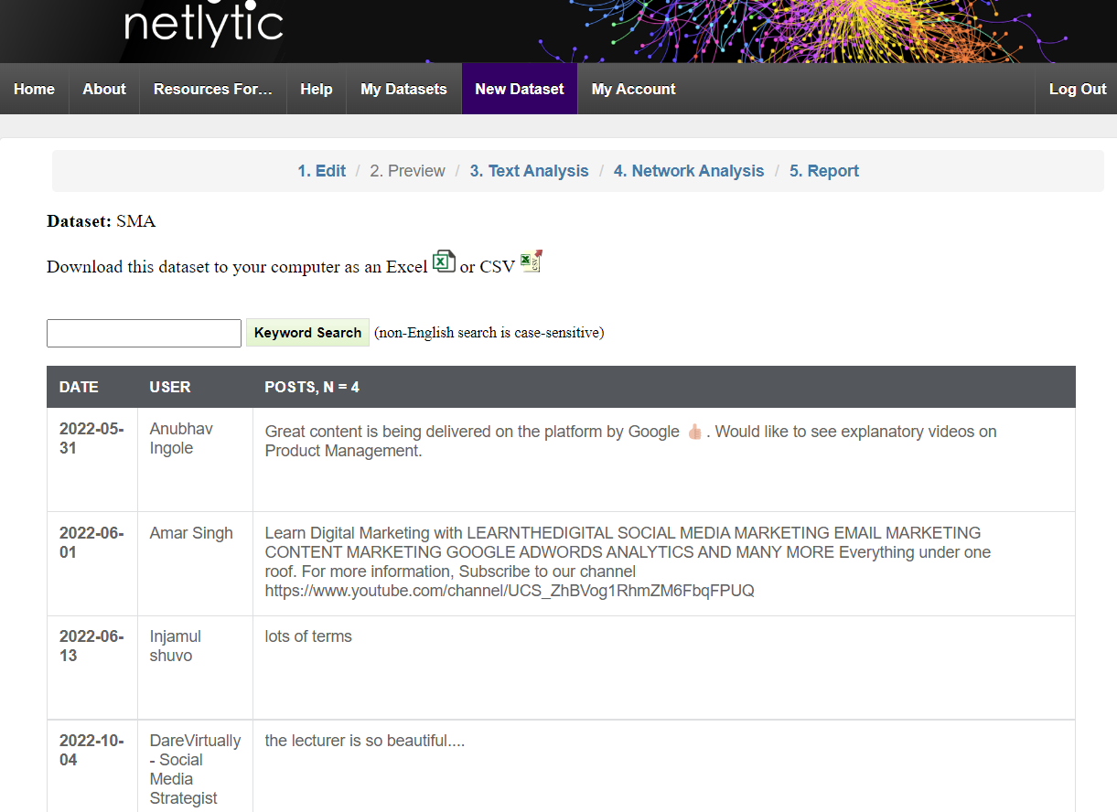

**Step 5: Text Analysis**

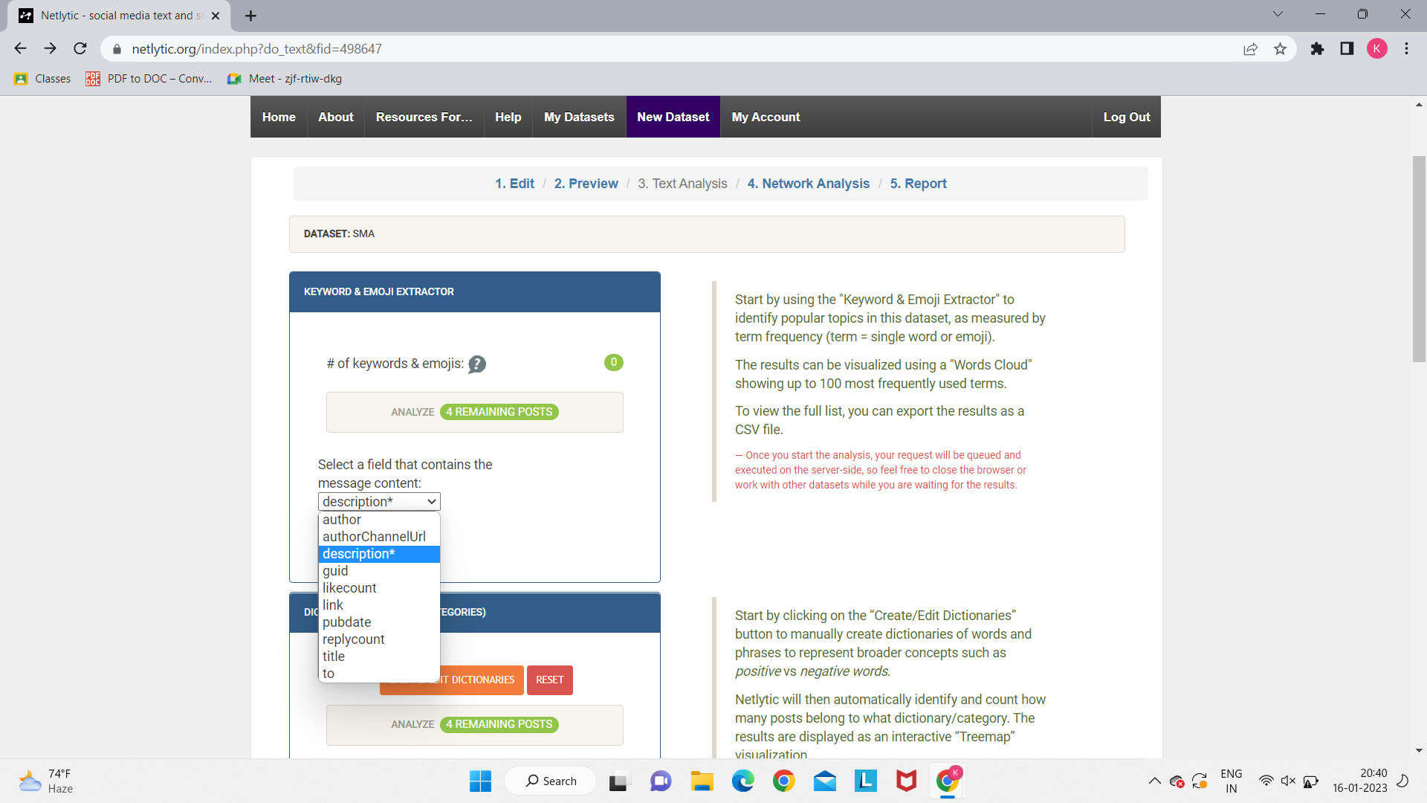

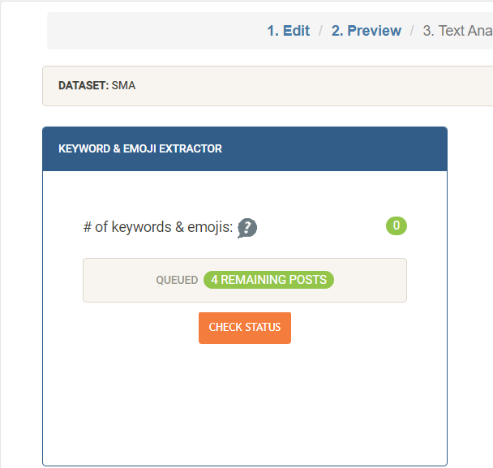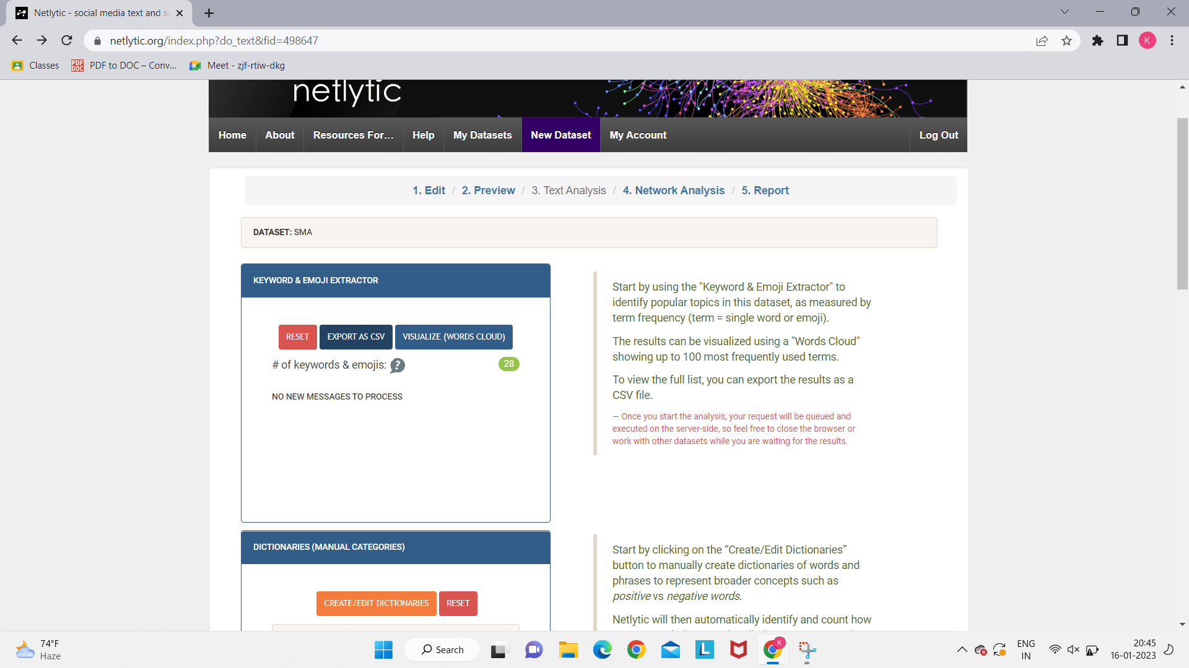

**We can export data to csv.**

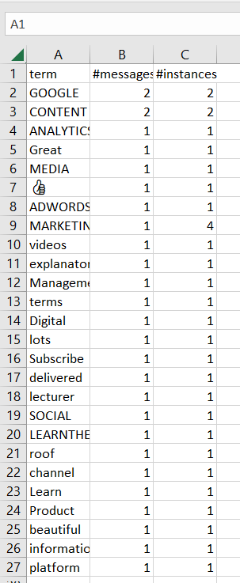

**Step 6: Network Analysis**

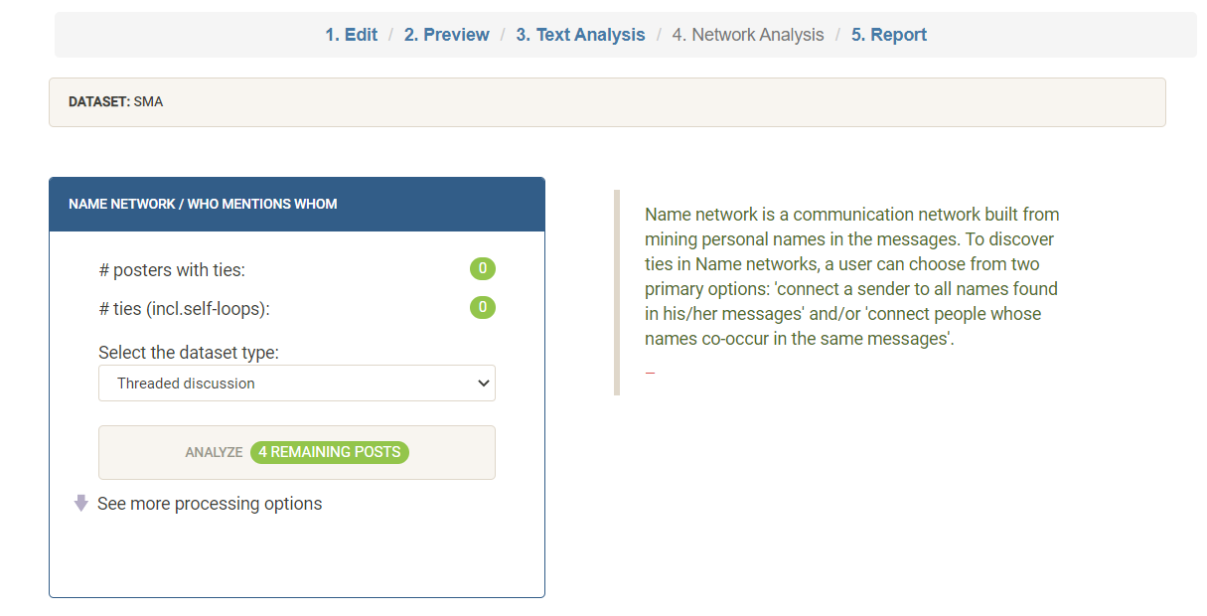

**Step 7: Report**

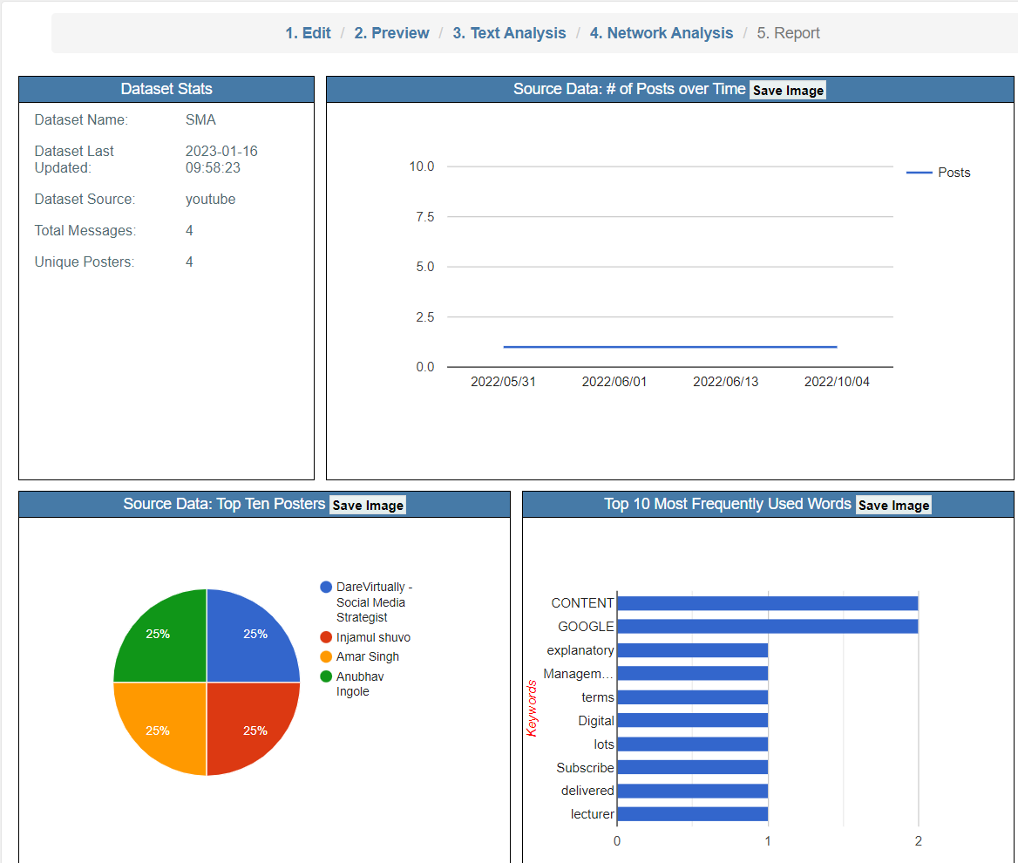

**Conclusion:**

Thus we explored **Google Analytics**, **Facebook Pixel** and **Netlytics**. These tools help us to perform Social Media Analytics which help us to build a sustainable business.