Part 2) Xv6
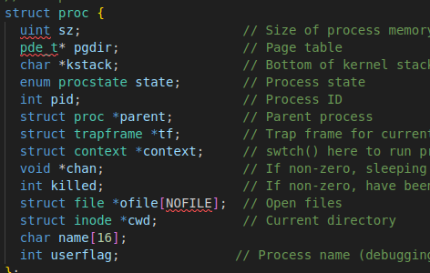
Step 1) Declared an integer named userflag in proc.h to preprocess integer variable via system call
Step2)Set syscall no.22 and 23 for setflag and get flag in syscall.h
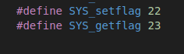
Step3)Declared kernel handler function for setflag and getflag using extern in syscall.c.
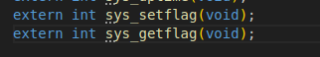
Step4)Declared handler function for sys_setflag and sys_getflag in sysproc.c
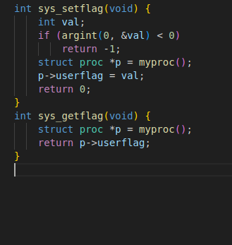
Step 5)set prototypes for both sys call so user program can call them in user.h
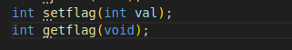
Step6)Adding syscall macro for setflag and getflag in usys.S
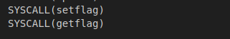
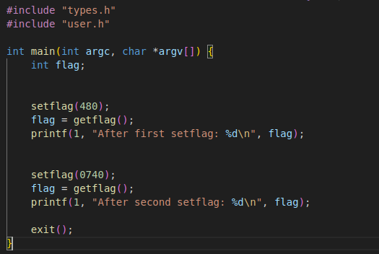
Step7) Implementing testflags.c to test the functions
Step 8) Adding to Uprogs
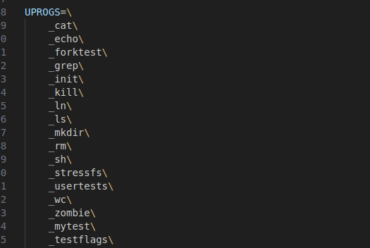
Final output:
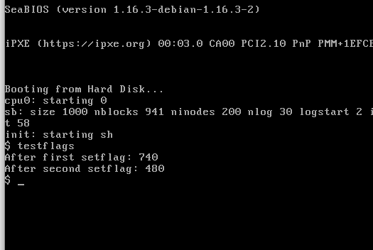
Note: was having error when entering a no. which started with 0 and was getting 480 instead for those no.

