CLASS ASSIGNMENT 11
12340740

Q1)
Added two ints in proc.h
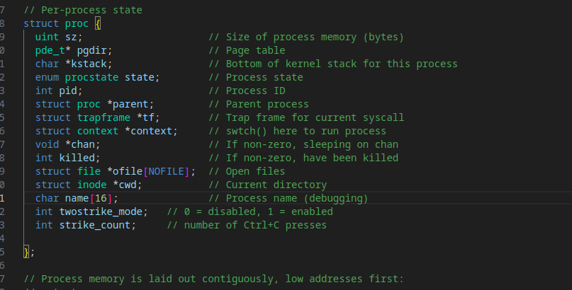
initialized both to 0 in proc.c
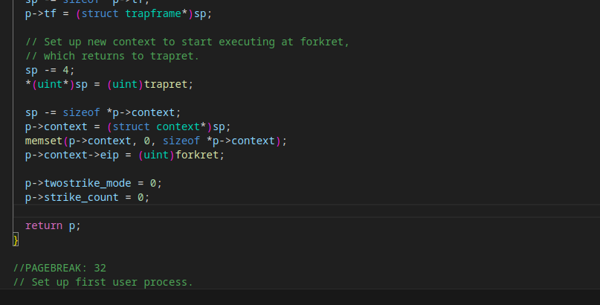
Syscall setup in syspro.c
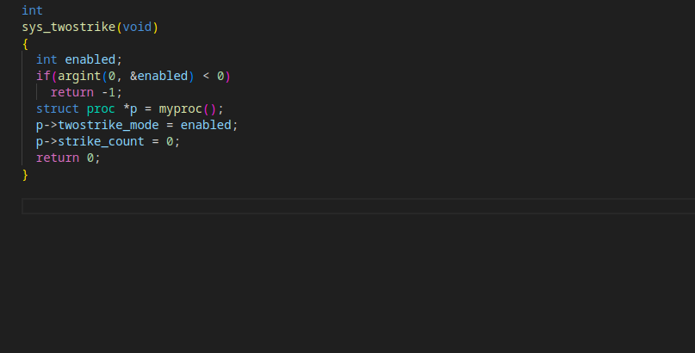
existing consoleintr function in kernel console.c replaced
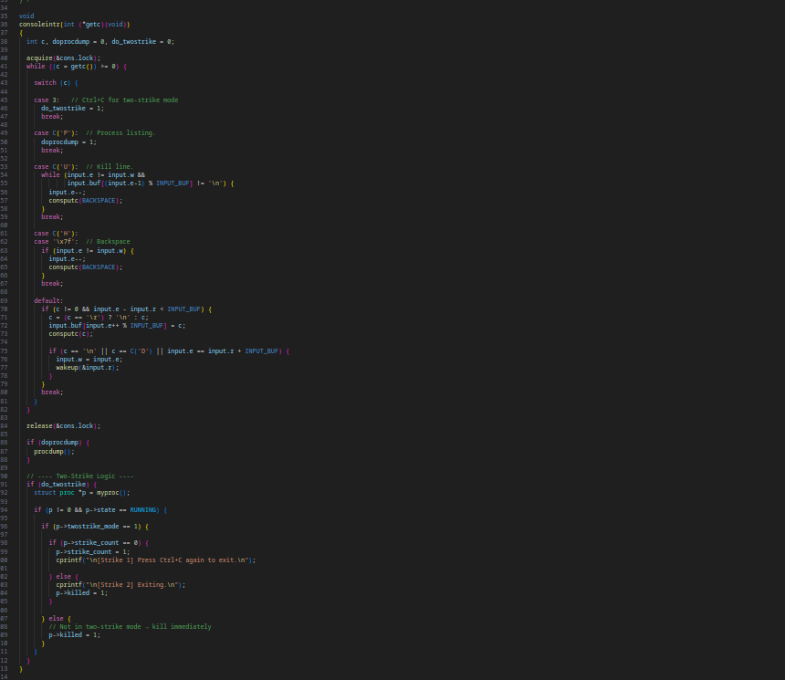
Created twostrikes.c
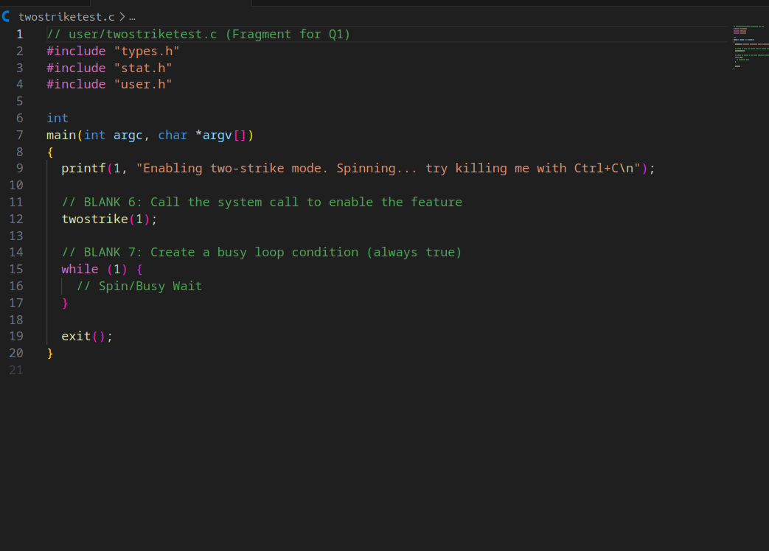
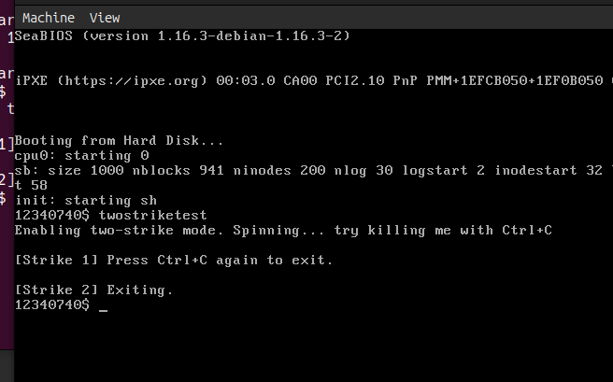
Output on xv6
Q2)
The code is as follows:-
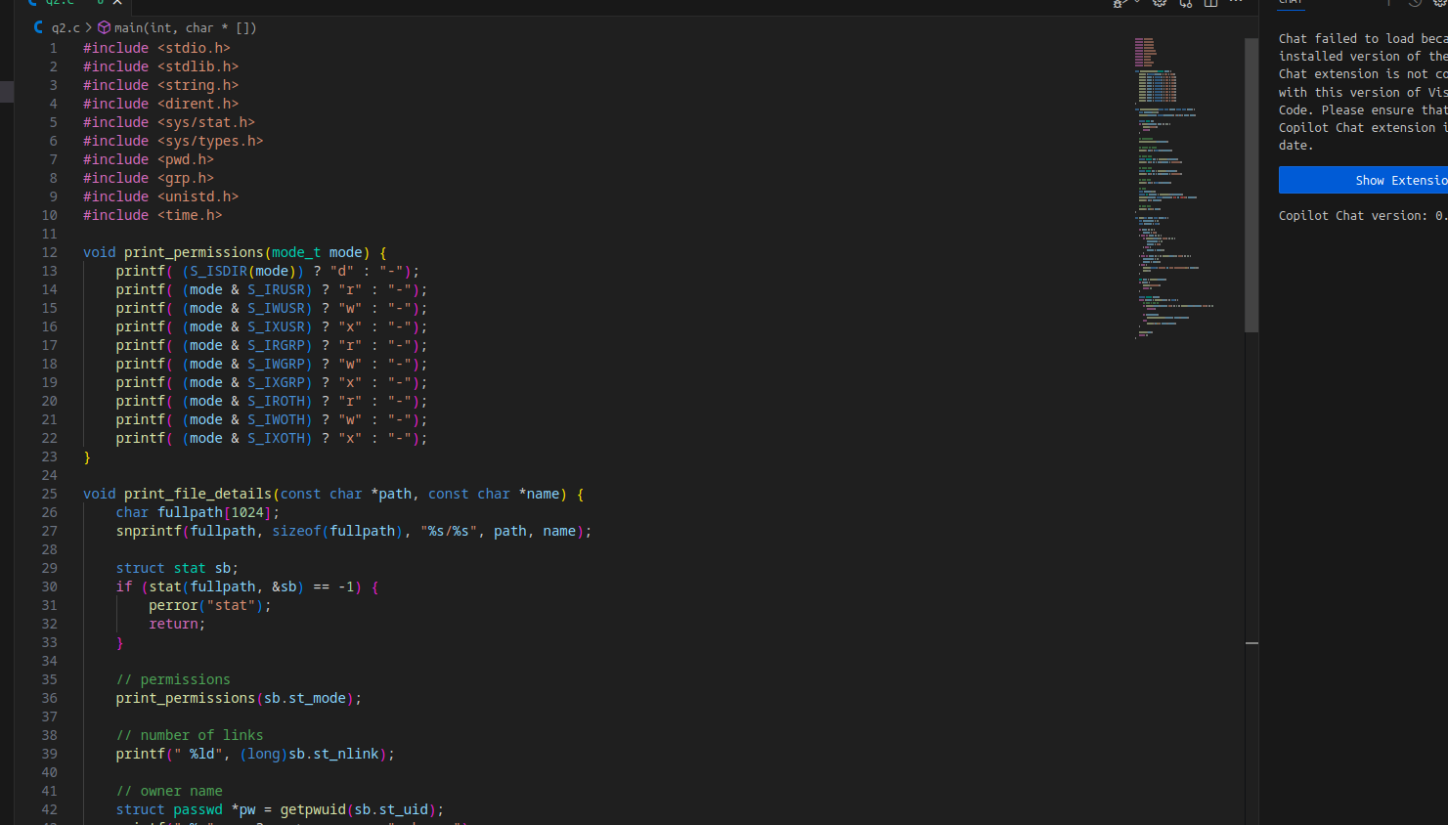
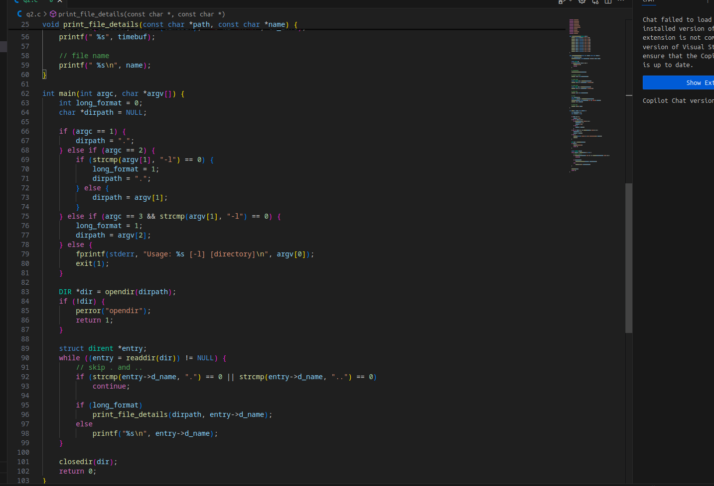
The output is as follows:-
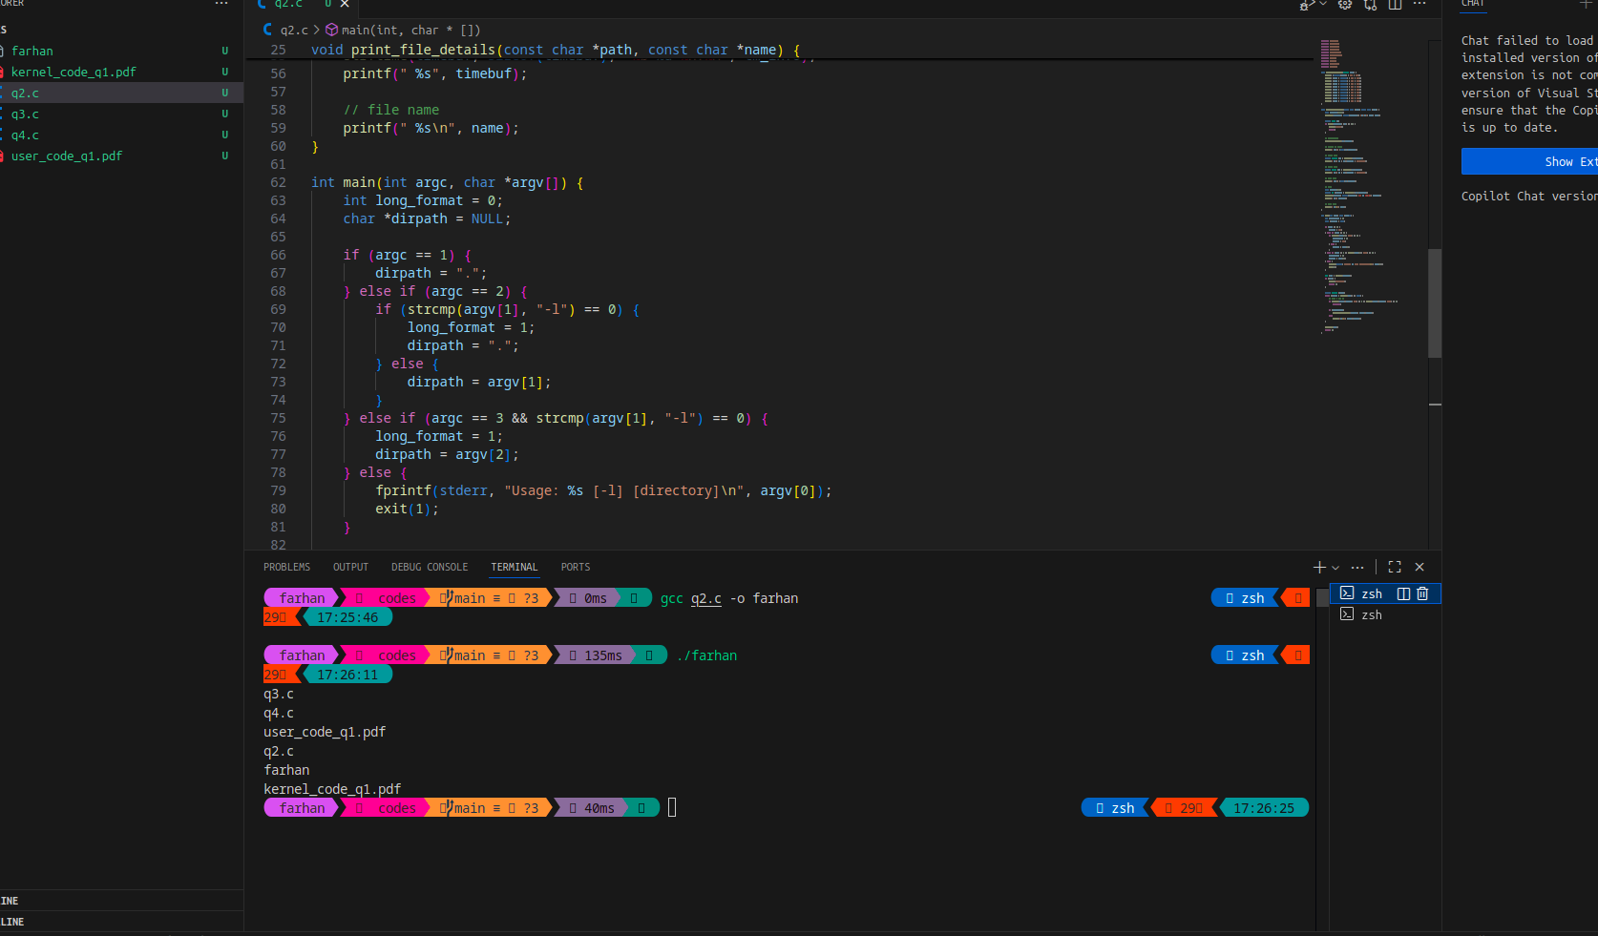
Q3)
Code is as follows:-
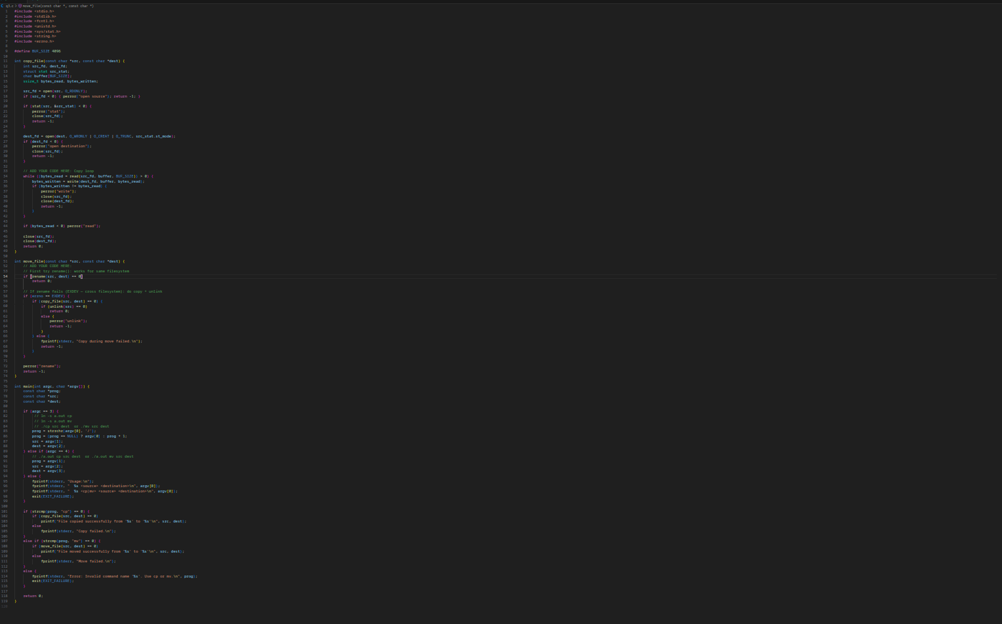
Output is as followss:-
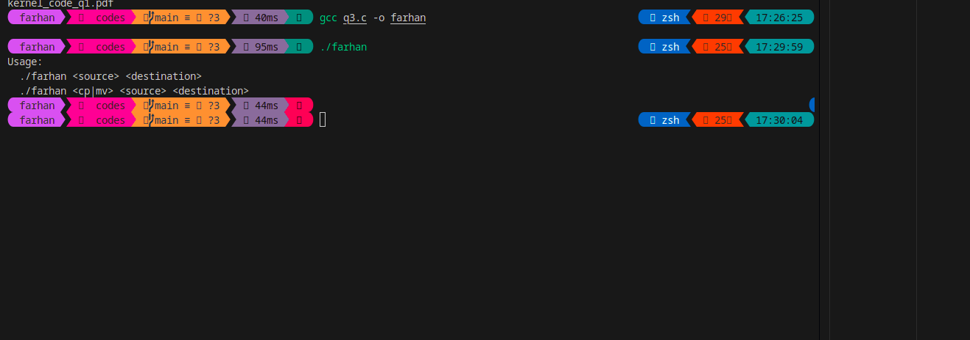
Q4)
The code is as follows:-
#include <stdio.h>
#include <stdlib.h>
#include <string.h>
#include <time.h>

#define MAX_INODES 8
#define MAX_BLOCKS 64
#define MAX_FILENAME 32
#define MAX_DESC 64
#define DIRECT_PTRS 4
#define MAX_DIR_ENTRIES 16

struct inode {
int used; // 0 = free, 1 = allocated
int size; // file size in bytes
int type; // 0 = file, 1 = directory
int creator_id; // user ID who created file
time_t created_at; // creation timestamp
char description[MAX_DESC]; // short file description
int direct[DIRECT_PTRS]; // direct data block pointers
};

struct dir_entry {
char name[MAX_FILENAME];
int inum;
};

struct inode inode_table[MAX_INODES];
int data_block_bitmap[MAX_BLOCKS];
struct dir_entry directory[MAX_DIR_ENTRIES];
int dir_count = 0;

int alloc_inode() {
for (int i = 0; i < MAX_INODES; i++) {
if (!inode_table[i].used) {
inode_table[i].used = 1;
inode_table[i].size = 0;
inode_table[i].type = 0;
inode_table[i].creator_id = 0;
inode_table[i].created_at = time(NULL);
strcpy(inode_table[i].description, "No description");
for (int j = 0; j < DIRECT_PTRS; j++)
inode_table[i].direct[j] = -1;
return i;
}
}
return -1;
}

void free_inode(int inum) {
inode_table[inum].used = 0;
inode_table[inum].size = 0;
inode_table[inum].creator_id = 0;
inode_table[inum].created_at = 0;
strcpy(inode_table[inum].description, "");
for (int j = 0; j < DIRECT_PTRS; j++)
inode_table[inum].direct[j] = -1;
}

int alloc_block() {
for (int i = 0; i < MAX_BLOCKS; i++) {
if (data_block_bitmap[i] == 0) {
data_block_bitmap[i] = 1;
return i;
}
}
return -1;
}

void free_block(int blocknum) {
if (blocknum >= 0 && blocknum < MAX_BLOCKS)
data_block_bitmap[blocknum] = 0;
}

int fs_create(const char *name, int creator_id, const char *desc) {

// check if already exists
for (int i = 0; i < dir_count; i++) {
if (strcmp(directory[i].name, name) == 0) {
printf("Error: File '%s' already exists\n", name);
return -1;
}
}

int inum = alloc_inode();
if (inum < 0) {
printf("Error: No free inode available\n");
return -1;
}

// ----------- ADD YOUR CODE (Metadata setup) ----------
inode_table[inum].creator_id = creator_id;
inode_table[inum].type = 0; // file
strncpy(inode_table[inum].description, desc, MAX_DESC - 1);
inode_table[inum].description[MAX_DESC - 1] = '\0';
// -------------------------------------------------------

int block = alloc_block();
if (block < 0) {
printf("Error: No free data block available\n");
free_inode(inum);
return -1;
}

inode_table[inum].direct[0] = block;
inode_table[inum].size = 0;

strcpy(directory[dir_count].name, name);
directory[dir_count].inum = inum;
dir_count++;

printf("File '%s' created (inode %d, block %d)\n", name, inum, block);
return inum;
}

int fs_delete(const char *name) {
int found = -1;
for (int i = 0; i < dir_count; i++) {
if (strcmp(directory[i].name, name) == 0) {
found = i;
break;
}
}

if (found < 0) {
printf("Error: File '%s' not found\n", name);
return -1;
}

int inum = directory[found].inum;

// ------------ ADD YOUR CODE: free all blocks ----------
for (int j = 0; j < DIRECT_PTRS; j++) {
int blk = inode_table[inum].direct[j];
if (blk != -1)
free_block(blk);
}
// -------------------------------------------------------

free_inode(inum);

// compact directory
for (int i = found; i < dir_count - 1; i++)
directory[i] = directory[i + 1];
dir_count--;

printf("File '%s' deleted (inode %d freed)\n", name, inum);
return 0;
}

void fs_show_state() {
printf("\n--- File System State ---\n");
printf("Directory entries (%d):\n", dir_count);
for (int i = 0; i < dir_count; i++)
printf(" %s → inode %d\n", directory[i].name, directory[i].inum);

printf("\nInode table:\n");
for (int i = 0; i < MAX_INODES; i++) {
if (inode_table[i].used) {
printf(" inode %d: creator=%d, size=%d, desc='%s'\n",
i, inode_table[i].creator_id, inode_table[i].size, inode_table[i].description);
printf(" created: %s", ctime(&inode_table[i].created_at));
printf(" blocks: ");
for (int j = 0; j < DIRECT_PTRS; j++)
if (inode_table[i].direct[j] != -1)
printf("%d ", inode_table[i].direct[j]);
printf("\n");
}
}
printf("--------------------------\n\n");
}

int main() {
printf("File Creation and Deletion with Metadata Simulation\n");

fs_create("file1.txt", 101, "User text document");
fs_create("report.pdf", 102, "PDF project report");
fs_create("data.bin", 103, "Binary data log");
fs_show_state();

fs_delete("report.pdf");
fs_show_state();

fs_create("notes.txt", 104, "Important notes");
fs_show_state();

return 0;
}
The output is as follows:-
File Creation and Deletion with Metadata Simulation
File 'file1.txt' created (inode 0, block 0)
File 'report.pdf' created (inode 1, block 1)
File 'data.bin' created (inode 2, block 2)

--- File System State ---
Directory entries (3):
file1.txt → inode 0
report.pdf → inode 1
data.bin → inode 2

Inode table:
inode 0: creator=101, size=0, desc='User text document'
created: Wed Nov 19 17:32:18 2025
blocks: 0
inode 1: creator=102, size=0, desc='PDF project report'
created: Wed Nov 19 17:32:18 2025
blocks: 1
inode 2: creator=103, size=0, desc='Binary data log'
created: Wed Nov 19 17:32:18 2025
blocks: 2
--------------------------

File 'report.pdf' deleted (inode 1 freed)

--- File System State ---
Directory entries (2):
file1.txt → inode 0
data.bin → inode 2

Inode table:
inode 0: creator=101, size=0, desc='User text document'
created: Wed Nov 19 17:32:18 2025
blocks: 0
inode 2: creator=103, size=0, desc='Binary data log'
created: Wed Nov 19 17:32:18 2025
blocks: 2
--------------------------

File 'notes.txt' created (inode 1, block 1)

--- File System State ---
Directory entries (3):
file1.txt → inode 0
data.bin → inode 2
notes.txt → inode 1

Inode table:
inode 0: creator=101, size=0, desc='User text document'
created: Wed Nov 19 17:32:18 2025
blocks: 0
inode 1: creator=104, size=0, desc='Important notes'
created: Wed Nov 19 17:32:18 2025
blocks: 1
inode 2: creator=103, size=0, desc='Binary data log'
created: Wed Nov 19 17:32:18 2025
blocks: 2
--------------------------

