LAB 8
Question1:
For the first task we declare a global variable and a local variable into the main function. The thread function myfunc prints the address of the global vairable and the pointer passed to it we make two threads for the task 1 and we print the address of local and global variable in the main function also. The code is as follows:
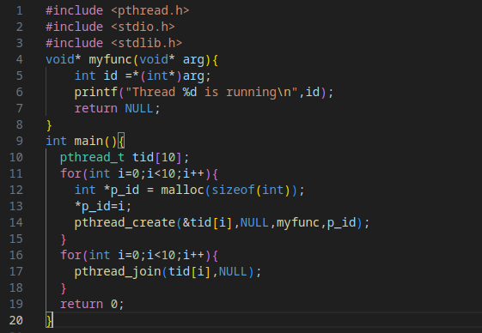
The output is as follows:-
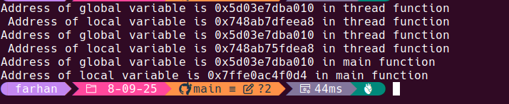
Here we can see that the local variable address is different for thread1,thread2 and the main function but the global vairable remains same.Thus we can say that the heap remains same for thread as well as the main program because global variables are stored on heap where as each of them has a different stack as the stack stores local vairables thus resulting in different local variable addresses.
Question2
For the second task we need to create ten threads and then see which one runs at what time and then check is there any given sequence for that or is the process random the code for it is as follows:
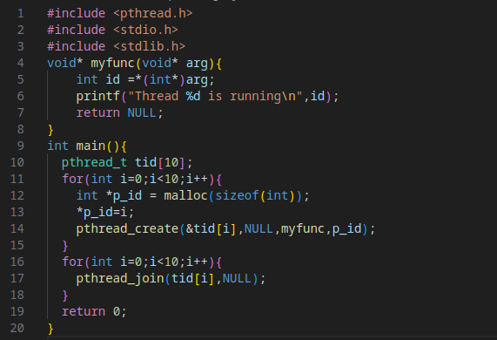
The output after running several times is as follows:
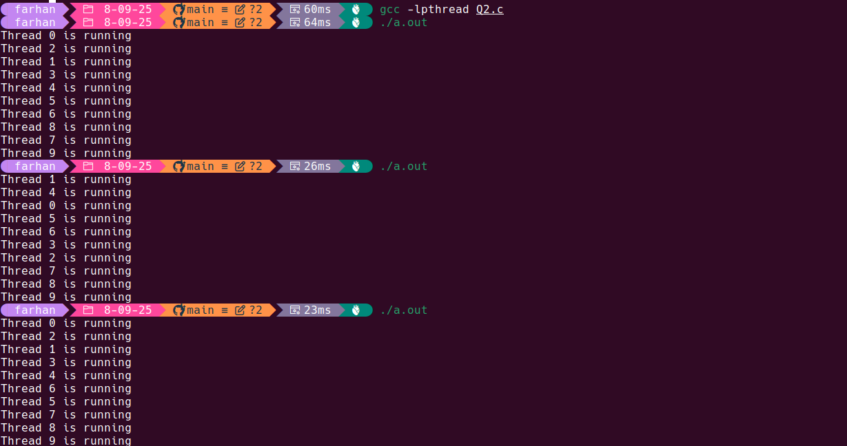
From this we can conclude that the sequence in which the threads run is not a fixed thereby changes every time we run the program.
Question3
In the third question we declare a global variable x and then we have a function myfunc which increments x 10^6 times .and at the end of the program we print the final value of x . We create 10 threads with same function.We need to check whether the final values is if we execute the programs multiple time or does it differ.The code is as follows:
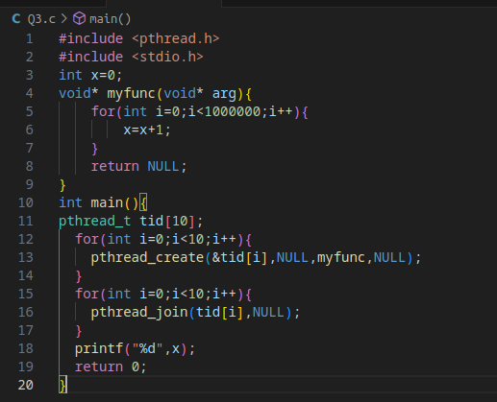
The output after runnning several times is as follows:

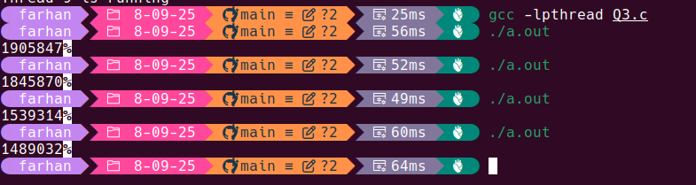
We can see that each time we get a different value of x which is due to the function not being atomic as well as due to the scheduling fo the threads.

Question4
The code is as follows:
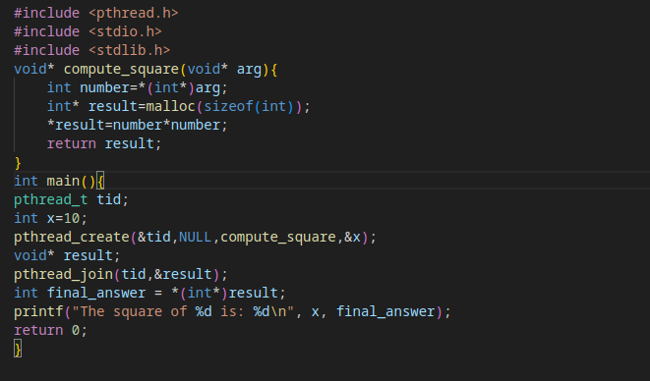
The output is as follows:
Question 5
The code is as follows:
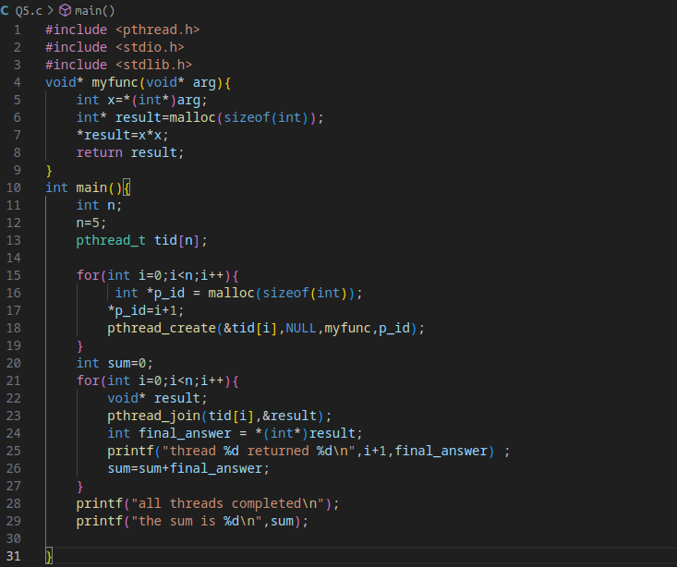
The output is as follows:
