CLASS ASSIGNMENT 8
Date-15-10-25
Roll no-12340740
Question 1)
1)The output is as follows :-
2)After removing the semaphoric logic and executing the code multiple time output is as follows:-
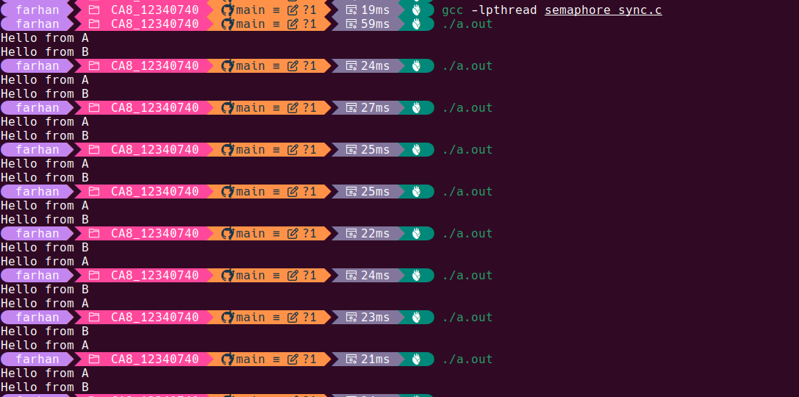
We can see that the output does not remain same each time we run the reason being now the scheduling process does not have any constraint which was before created due to the semaphore thus the execution becomes random.
4) For the 4th part code used is as follows:-
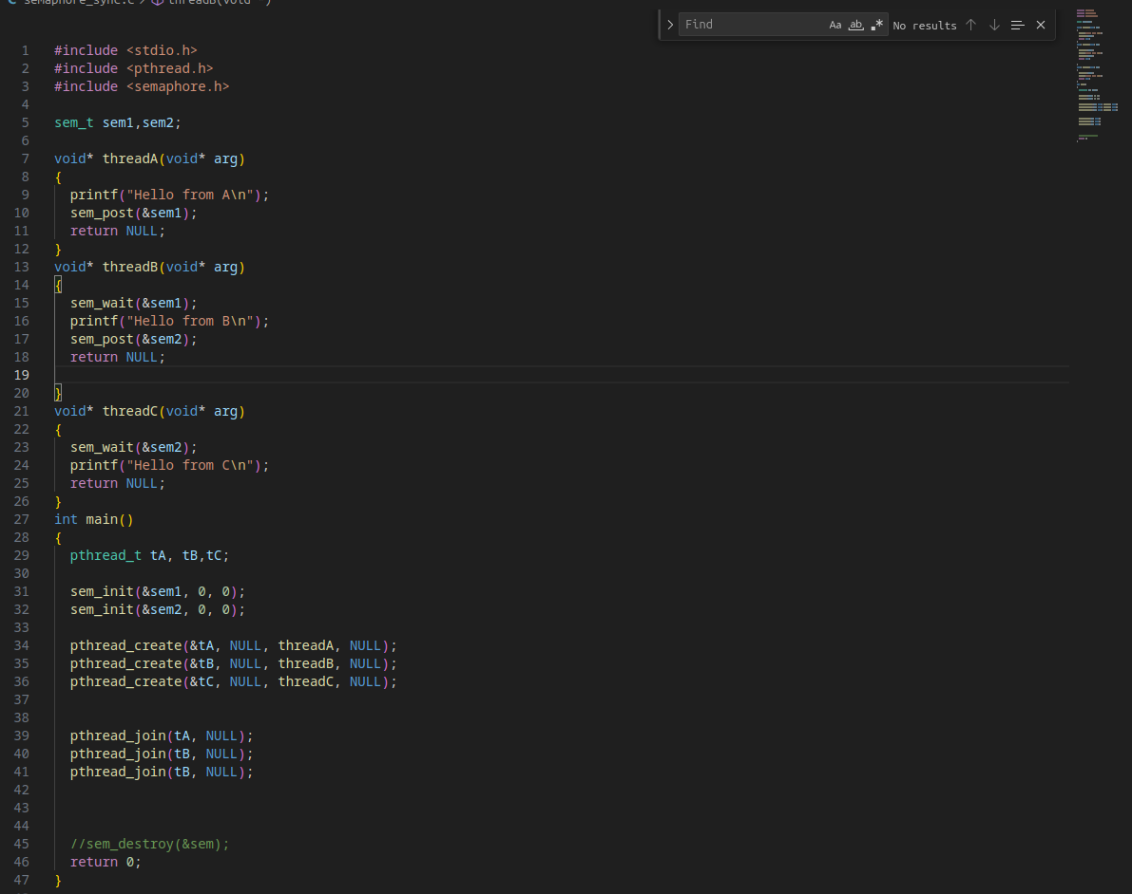
we introduce one more semaphore and then decrement it only in thread c and increment only in thread b thus order between them I. a>b>c. Even the output signifies it:-
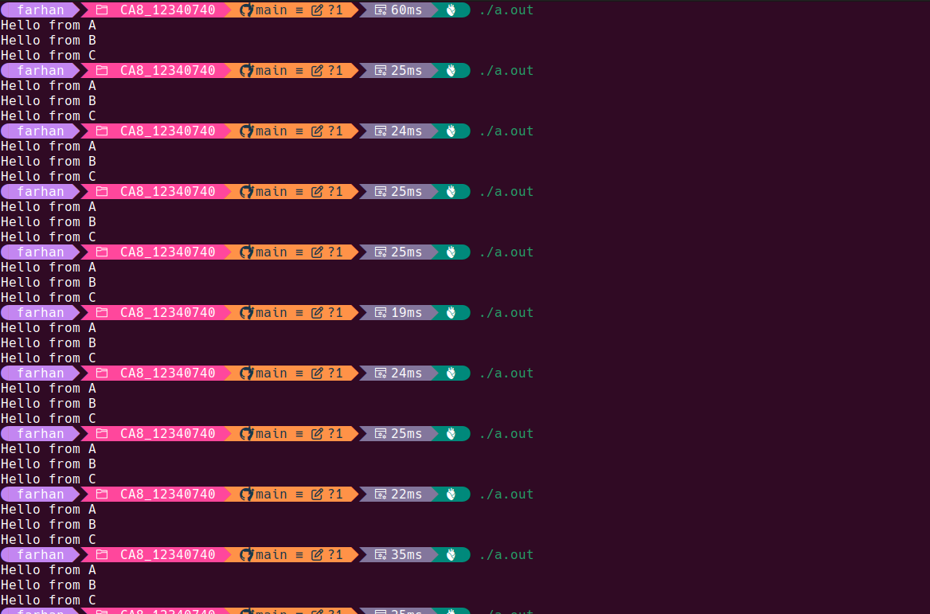
Question 2)
The code used is as follows :-

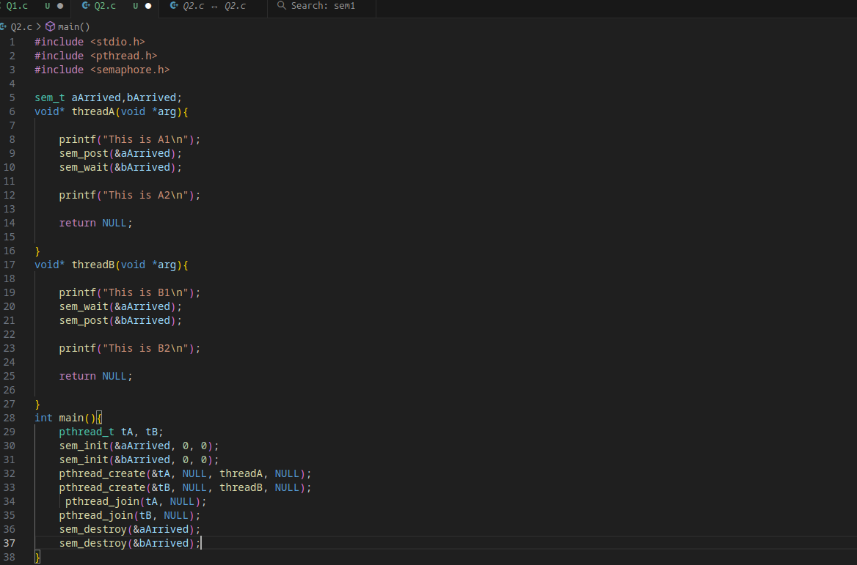
the ouptut obtained is as follows:-

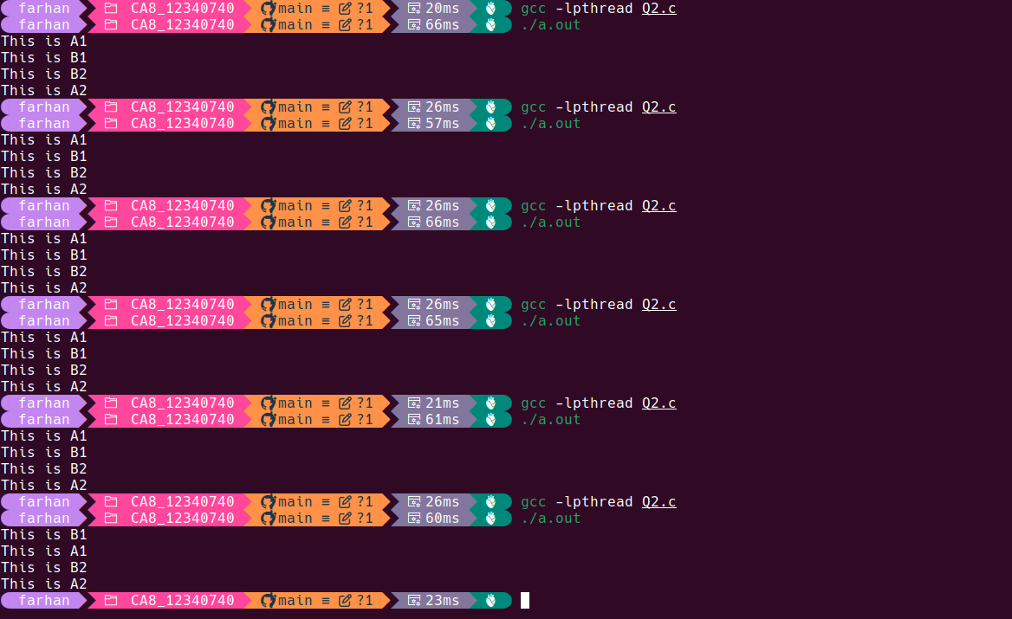
Question 3)
The code (without mutex ) used is as follows:-
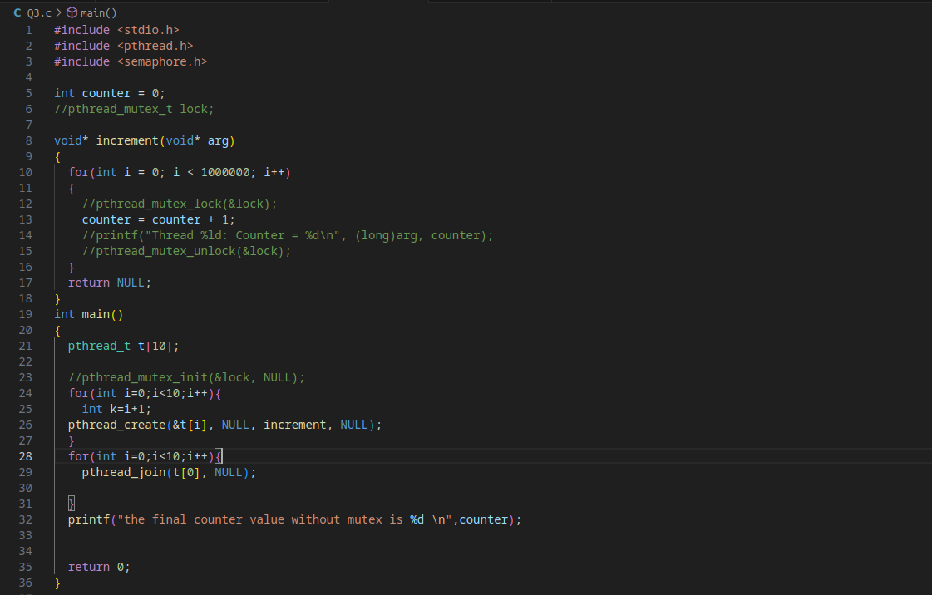
The output for code is as follows:-
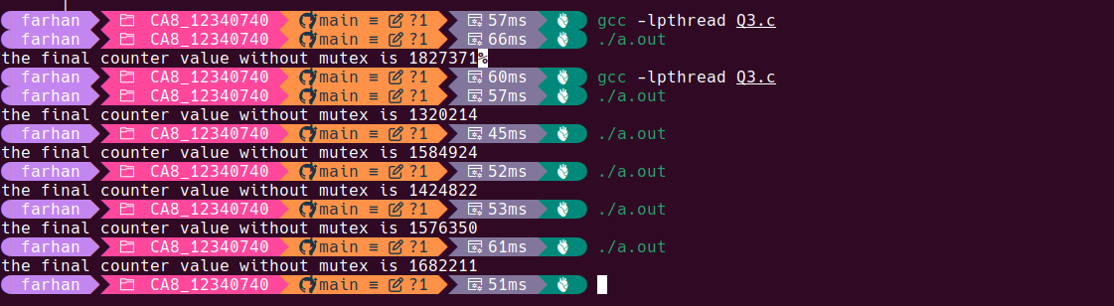
We can observe that each time we have a different value now this problem occurs due to simultaneous access of the variable by multiple processes at the same time thus having inconsistency in the final value of the variable.

The code for with mutex is as follows:-
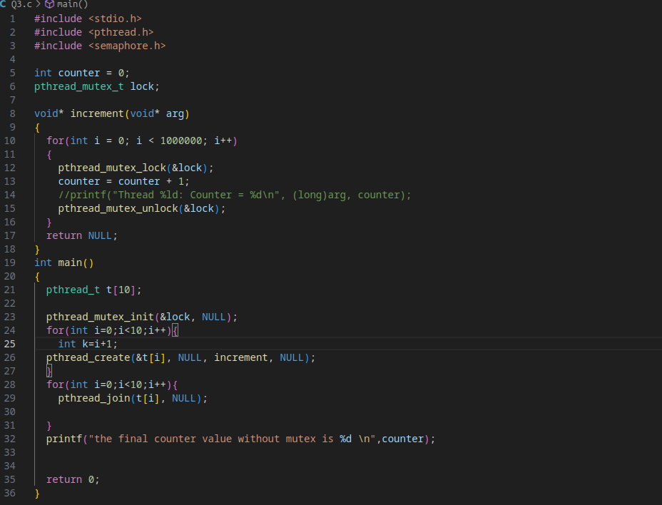
The output is as follows:-

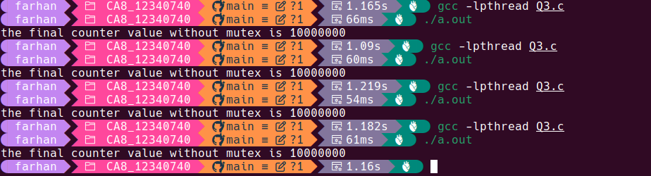
IN with mutex code we can see that same final value is printed no matter how many time we run the code this is because of the locking mechanism provided by the mutex thus only thread is able to access the value of counter and hence the final value is consistent among numerous executions.

Question 4)
The code used is as follows:-
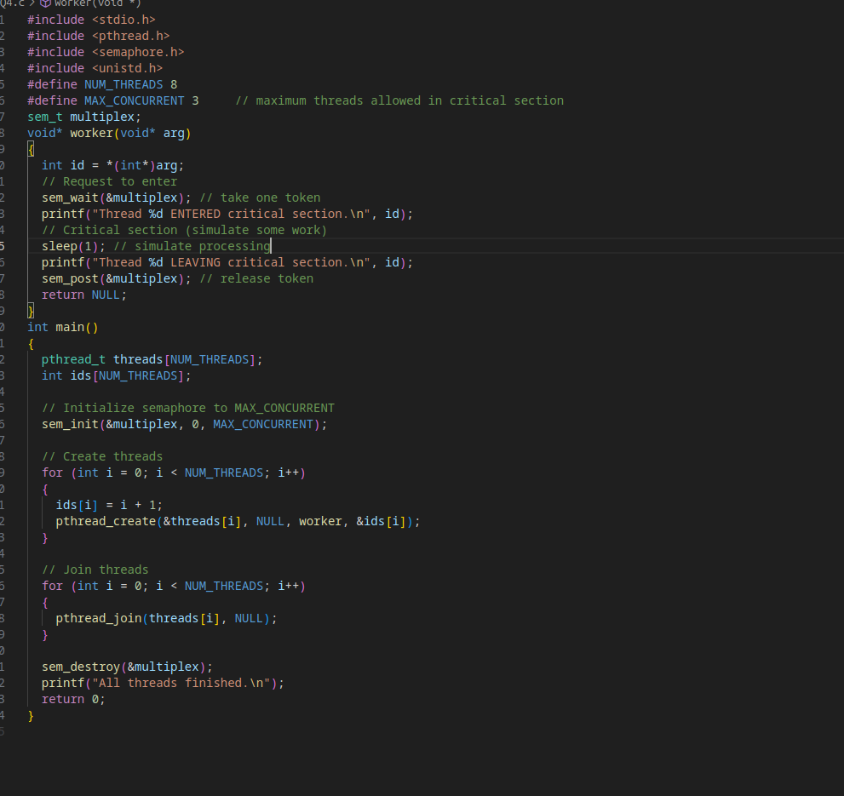
The output obtained is as follows:-

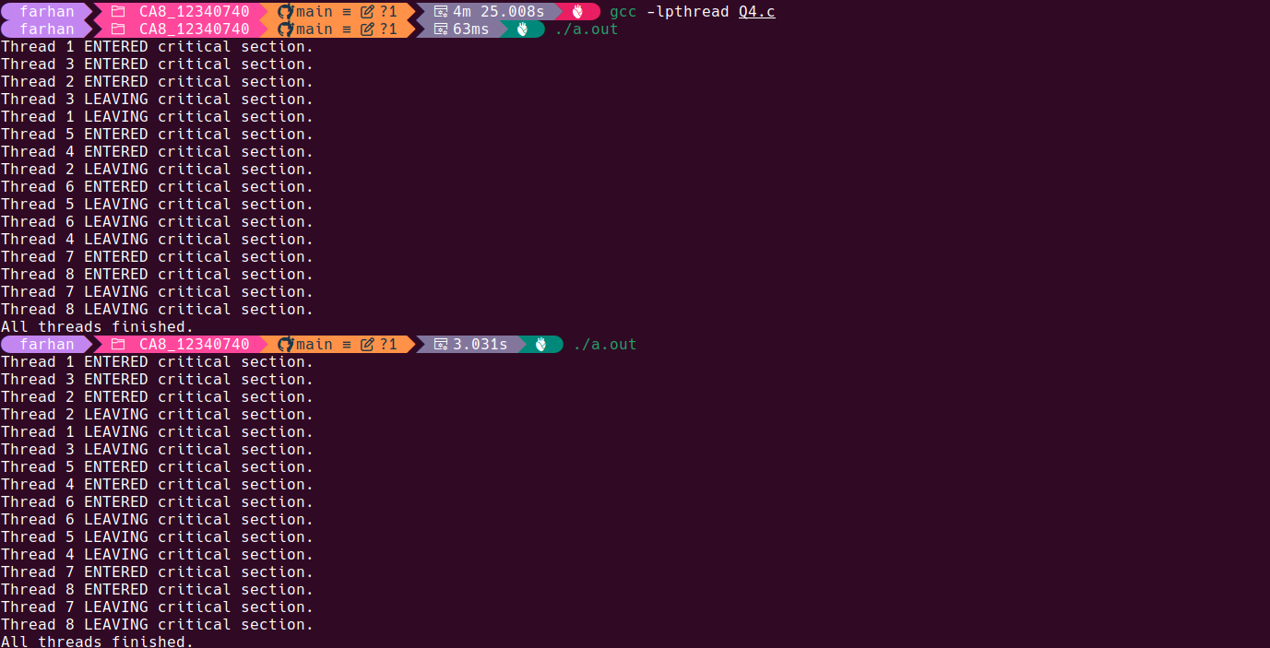
The semaphore controls concurrent access by acting as a gatekeeper with a limited number of tokens.
- Tokens: The semaphore is initialized with a count of 3 (MAX_CONCURRENT). This represents the maximum number of threads allowed in the critical section.
- Entry (sem_wait): When a thread wants to enter, it calls sem_wait, attempting to claim one token (decrement the count).
  - The first three threads successfully claim tokens, and the semaphore count drops to zero.
- Blocking: Any thread that tries to enter when the count is zero is immediately blocked and placed in a waiting queue. This prevents more than three threads from entering.
- Exit (sem_post): When a thread leaves, it calls sem_post, which releases one token (increments the count). This action also unblocks one waiting thread, allowing it to enter the section and re-claim the token.
This ensures the number of threads inside the critical section never exceeds 3.
Question 5)
This is the part a code:-

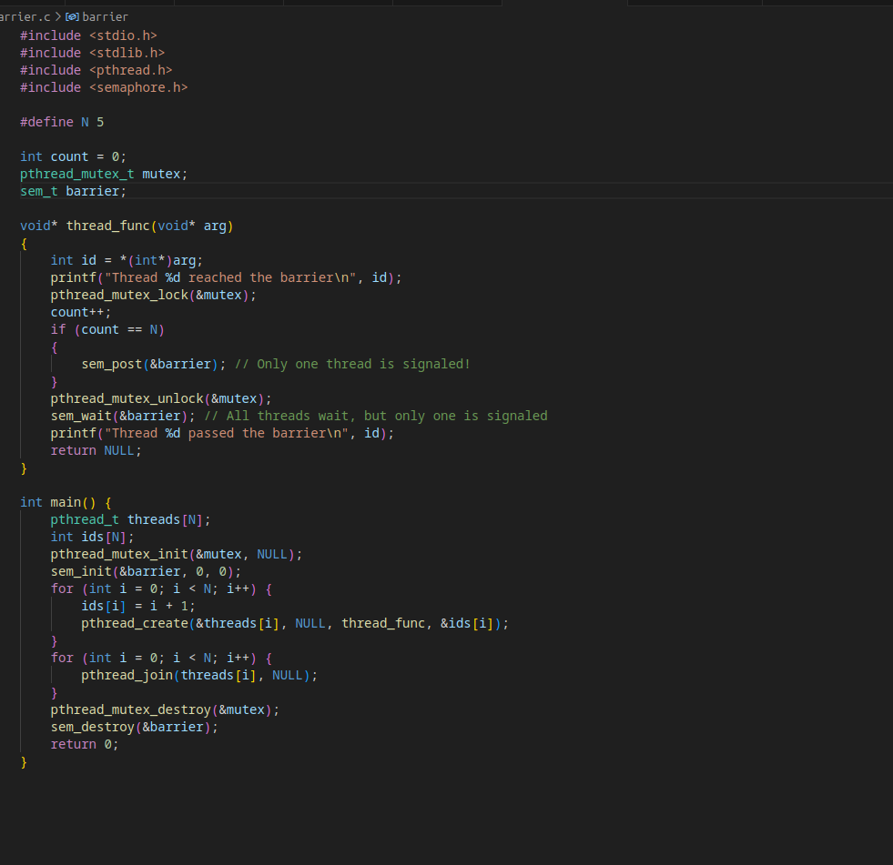
The output obtained is as follows:-
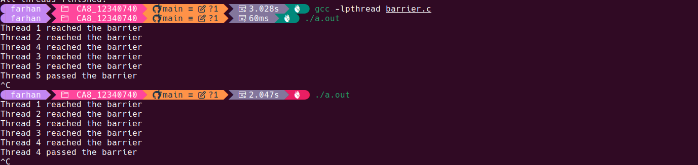

This program fails because the semaphore is initialized to zero, and the thread that detects count==N only signals the semaphore once (sem_post(&barrier)).
- Waiting: All N threads reach the barrier and call sem_wait(&barrier). Since the semaphore's initial count is 0, all threads immediately block and wait for a signal.
- Single Signal: When the N-th thread arrives, it increments the count to N and calls sem_post(&barrier). This increases the semaphore's count to 1.
- The Flaw: This single signal only allows one of the N blocked threads to wake up. This thread immediately passes the barrier by consuming the single token (decrementing the count back to 0).
- Deadlock/Stall: The remaining N−1 threads are still blocked, waiting on a semaphore with a count of 0. Since no other code will ever signal the semaphore again, these threads remain permanently blocked, causing the program to stall or deadlock.
A proper barrier implementation would require the final thread to signal the semaphore N (or N−1) times to release all waiting threads.
The code for part b is as follows:-

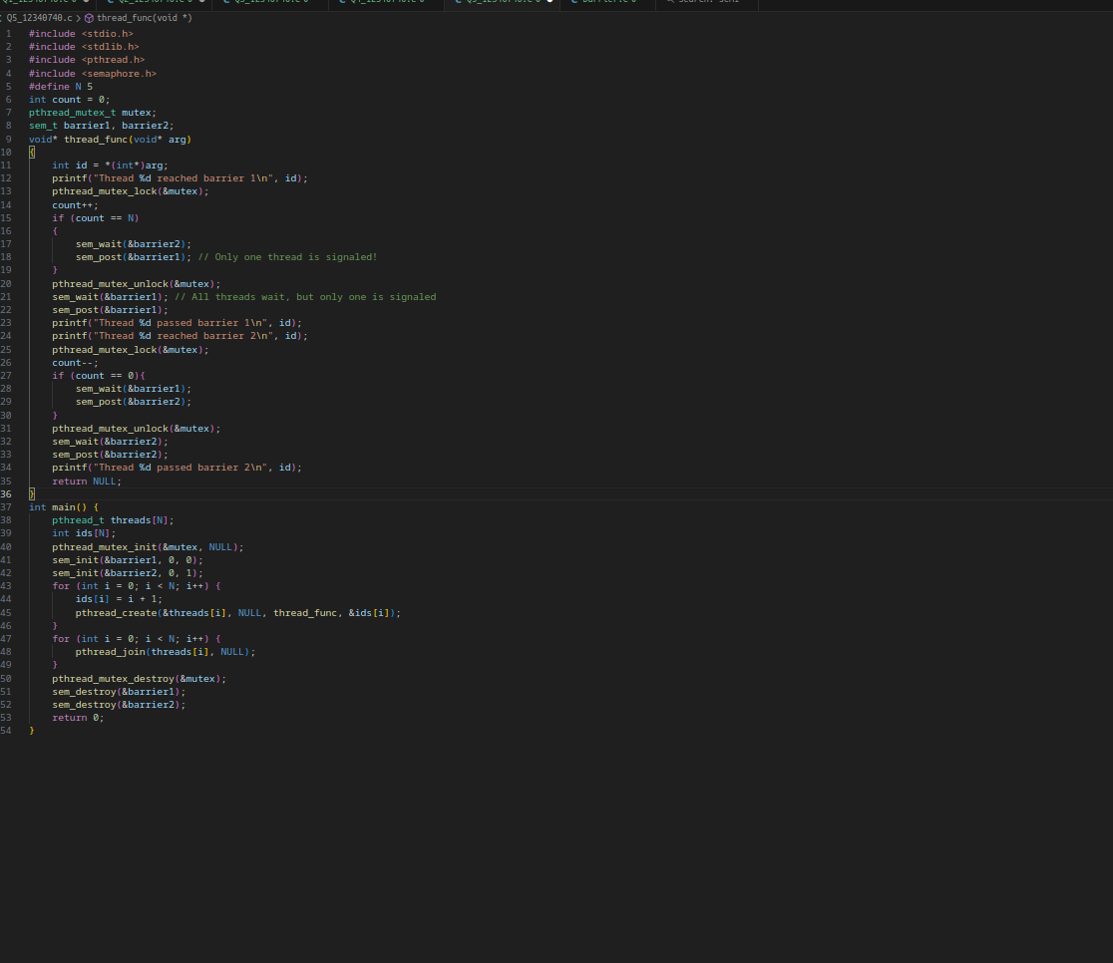
The output is as follows:-
