TAKE HOME ASSIGNMENT 3
12340740
1)proc.h(in struct proc)
2)proc.c
allocproc()-
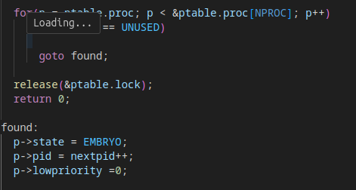
scheduler()-
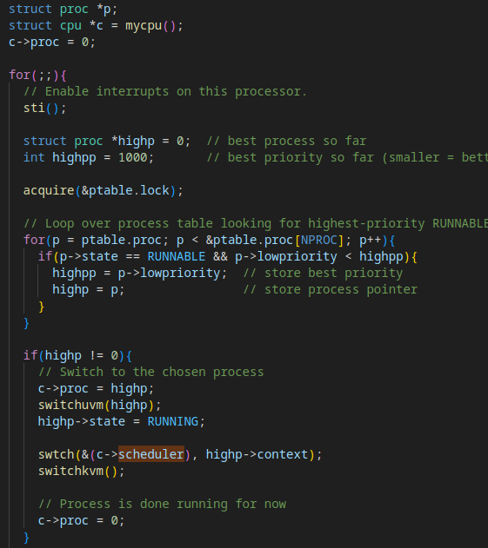
3)sysproc.c
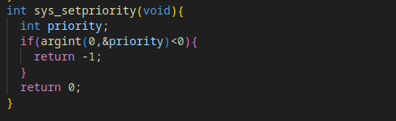
4)syscall.h
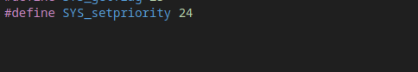
5)syscall.c
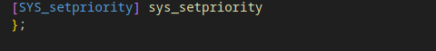
6)user.h
7)usys.S

8)prioritytest.c
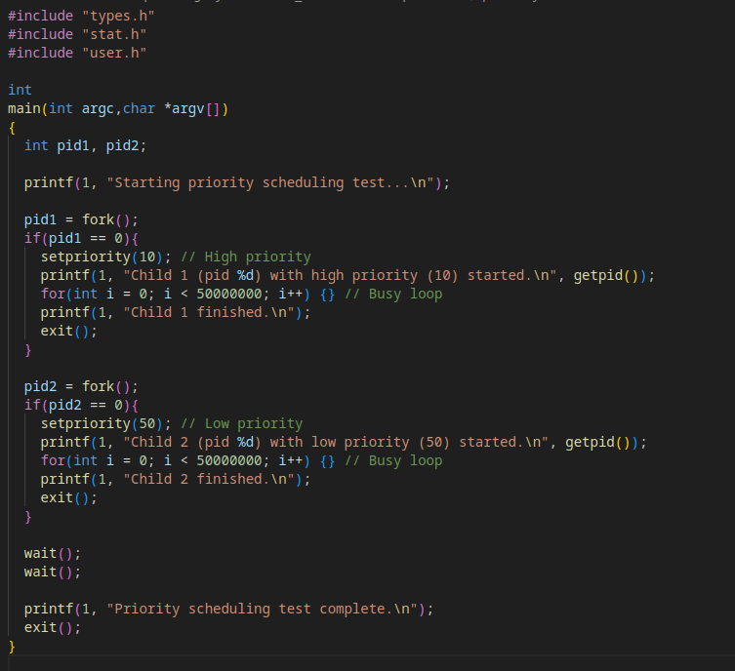
Final Output-
