CLASS ASSIGNMENT 6
12340740

LRU

1.proc.h

declaring frameinfo
struct frameinfo {
uint va ; // Virtual address of page
pte_t * pte ; // Page table entry
int ref ; // Reference ( optional for CLOCK )
uint last_used ; // Time of last access ( for LRU )
};
adding fields in struct proc
struct frameinfo frames [16]; // Track resident pages ( up to 16)
int framecount ;

2.vm.c
extern uint ticks ;
void upd ate_l ru_acc ess ( struct proc *p , uint va ) {
for ( int i = 0; i < p - > framecount ; i ++) {
if (p - > frames [ i ]. va == va ) {
p - > frames [ i ]. last_used = ticks ; // update on access
break ;
}
}
}

int
allocuvm(pde_t *pgdir, uint oldsz, uint newsz)
{
char *mem;
uint a;

if (newsz >= KERNBASE)
return 0;
if (newsz < oldsz)
return oldsz;

a = PGROUNDUP(oldsz);
for (; a < newsz; a += PGSIZE) {
mem = kalloc();
if (mem == 0) {
cprintf("allocuvm out of memory\n");
deallocuvm(pgdir, newsz, oldsz);
return 0;
}
memset(mem, 0, PGSIZE);
if (mappages(pgdir, (char*)a, PGSIZE, V2P(mem), PTE_W | PTE_U) < 0) {
cprintf("allocuvm out of memory (2)\n");
deallocuvm(pgdir, newsz, oldsz);
kfree(mem);
return 0;
}

// ---------------- LRU Update ----------------
struct proc *curproc = myproc();
if (curproc) {
if (curproc->framecount < 16) {
// Still space left, add frame info
curproc->frames[curproc->framecount].va = a;
curproc->frames[curproc->framecount].pte =
walkpgdir(pgdir, (void*)a, 0);
curproc->frames[curproc->framecount].last_used = ticks;
curproc->framecount++;
} else {
// Perform LRU replacement
int victim_index = 0;
for (int i = 1; i < curproc->framecount; i++) {
if (curproc->frames[i].last_used <
curproc->frames[victim_index].last_used) {
victim_index = i;
}
}

// Free victim’s physical memory
pte_t *vpte = curproc->frames[victim_index].pte;
uint vpa = PTE_ADDR(*vpte);
kfree(P2V(vpa));
*vpte = 0; // Invalidate victim PTE

// Replace victim entry with new frame
curproc->frames[victim_index].va = a;
curproc->frames[victim_index].pte =
walkpgdir(pgdir, (void*)a, 0);
curproc->frames[victim_index].last_used = ticks;
}
}
}
return newsz;
}
3.mystest.c

#include "types.h"
#include "user.h"

#define MAX_PAGES 5
#define TOTAL_ACCESSES 15

int
main(int argc, char *argv[])
{
int lru[MAX_PAGES];
int last_used[MAX_PAGES];
int i, j, page, hit = 0, miss = 0, time = 0;

// Initialize
for (i = 0; i < MAX_PAGES; i++) {
lru[i] = -1;
last_used[i] = -1;
}

printf(1, "Starting LRU page replacement simulation...\n");

int accesses[TOTAL_ACCESSES] = {0, 1, 2, 3, 4, 1, 5, 0, 6, 1, 2, 7, 3, 8, 4};

for (i = 0; i < TOTAL_ACCESSES; i++) {
page = accesses[i];
time++;

int found = 0;
for (j = 0; j < MAX_PAGES; j++) {
if (lru[j] == page) {
found = 1;
last_used[j] = time;
break;
}
}

if (found) {
hit++;
printf(1, "Access page %d : HIT\n", page);
} else {
miss++;
int replaced = -1;

// Check for free frame
for (j = 0; j < MAX_PAGES; j++) {
if (lru[j] == -1) {
lru[j] = page;
last_used[j] = time;
replaced = j;
break;
}
}

if (replaced == -1) {
// Need to replace victim using LRU
int lru_index = 0;
int min_time = last_used[0];
for (j = 1; j < MAX_PAGES; j++) {
if (last_used[j] < min_time) {
min_time = last_used[j];
lru_index = j;
}
}
printf(1, "Access page %d : MISS, replacing page %d\n", page, lru[lru_index]);
lru[lru_index] = page;
last_used[lru_index] = time;
} else {
printf(1, "Access page %d : MISS, placed in free frame\n", page);
}
}
}

printf(1, "LRU simulation completed.\n");
printf(1, "Total hits : %d\n", hit);
printf(1, "Total misses : %d\n", miss);

exit();
}

OUTPUT

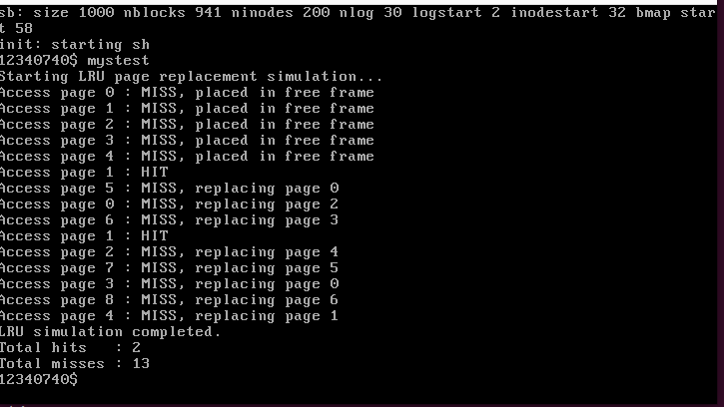
FIFO
1.in proc.h
#define MAX_PAGES 20
struct proc {
// existing members ...
int pages[MAX_PAGES]; // FIFO pages
int page_count;
};
2. vm.c
#include "types.h"
#include "defs.h"
#include "param.h"
#include "memlayout.h"
#include "mmu.h"
#include "proc.h"
#include "x86.h"
#include "elf.h"
extern char data[];
pde_t *kpgdir;
void seginit(void) {
struct cpu *c = &cpus[cpuid()];
c->gdt[SEG_KCODE] = SEG(STA_X|STA_R, 0, 0xffffffff, 0);
c->gdt[SEG_KDATA] = SEG(STA_W, 0, 0xffffffff, 0);
c->gdt[SEG_UCODE] = SEG(STA_X|STA_R, 0, 0xffffffff, DPL_USER);c->gdt[SEG_UDATA] = SEG(STA_W, 0, 0xffffffff, DPL_USER);
lgdt(c->gdt, sizeof(c->gdt));
}
static pte_t* walkpgdir(pde_t *pgdir, const void *va, int alloc);
static int mappages(pde_t *pgdir, void *va, uint size, uint pa, int perm);
// Implement allocuvm with FIFO tracking
int allocuvm(pde_t *pgdir, uint oldsz, uint newsz) {
char *mem;
uint a;
if(newsz >= KERNBASE) return 0;
if(newsz < oldsz) return oldsz;
a = PGROUNDUP(oldsz);
for(; a < newsz; a += PGSIZE) {
mem = kalloc();
if(mem == 0) {
cprintf("allocuvm out of memory\n");
deallocuvm(pgdir, newsz, oldsz);
return 0;
}
memset(mem, 0, PGSIZE);
if(mappages(pgdir, (char*)a, PGSIZE, V2P(mem), PTE_W|PTE_U) < 0) {
kfree(mem);
deallocuvm(pgdir, newsz, oldsz);
return 0;
}
struct proc *cur = myproc();
if(cur->page_count < MAX_PAGES) {
cur->pages[cur->page_count++] = (int)a;
cprintf("Allocated page %d at virtual address 0x%x\n", cur->page_count-
1, a);
} else {
int evict = cur->pages[0];
mem = (char*)P2V(PTE_ADDR(*walkpgdir(pgdir, (void*)evict, 0)));
kfree(mem);
for(int i = 1; i < MAX_PAGES; i++) cur->pages[i-1] = cur->pages[i];
cur->pages[MAX_PAGES-1] = (int)a;
cprintf("Evicted page at 0x%x, allocated new page at 0x%x\n", evict,
a);
}
}
return newsz;
}
// Other vm.c functions (deallocuvm, freevm, copyuvm, etc.) remain same with
correct declarations.
3.mytest.c
#include "types.h"
#include "user.h"
#define MAX_PAGES 5
// Number of physical pages available
#define TOTAL_ACCESSES 15 // Total virtual pages to access
int main(int argc, char *argv[])
{
int fifo[MAX_PAGES];
// Stores allocated virtual pages
int next_to_replace = 0; // FIFO pointer
int i, j;
int page;
int hit, miss;
// Initialize page table
for(i = 0; i < MAX_PAGES; i++)
fifo[i] = -1;
hit = 0;
miss = 0;
printf(1, "Starting FIFO page replacement simulation...\n");
// Simulated accesses
int accesses[TOTAL_ACCESSES] = {0,1,2,3,4,1,5,0,6,1,2,7,3,8,4};for(i = 0; i < TOTAL_ACCESSES; i++) {
page = accesses[i];
int found = 0;
// Check if page is already in memory (hit)
for(j = 0; j < MAX_PAGES; j++) {
if(fifo[j] == page) {
found = 1;
break;
}
}
if(found) {
hit++;
printf(1, "Access page %d: HIT\n", page);
} else {
miss++;
printf(1, "Access page %d: MISS, replacing page %d\n", page,
fifo[next_to_replace]);
fifo[next_to_replace] = page;
next_to_replace = (next_to_replace + 1) % MAX_PAGES;
}
}
printf(1, "FIFO simulation completed.\n");
printf(1, "Total hits: %d\n", hit);
printf(1, "Total misses: %d\n", miss);
OUTPUT
with 3 cache size
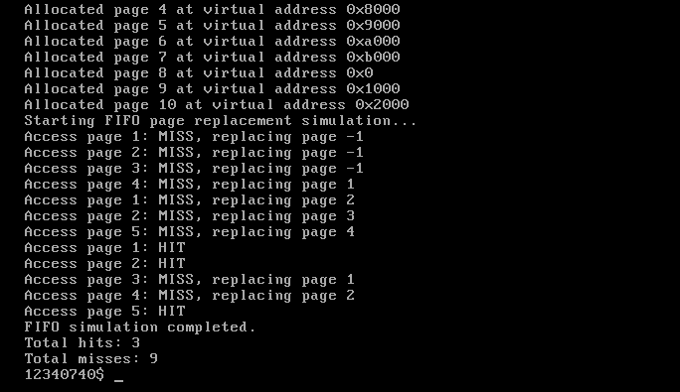
with 4 cache size
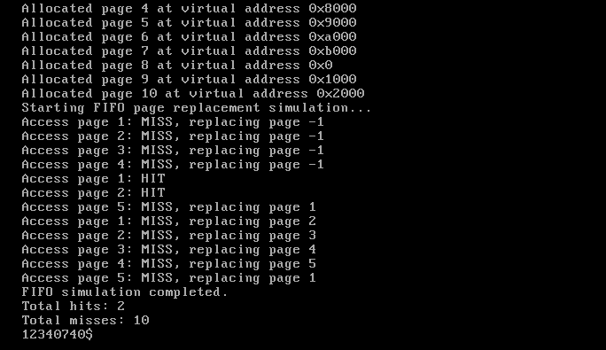
with 5 cache size
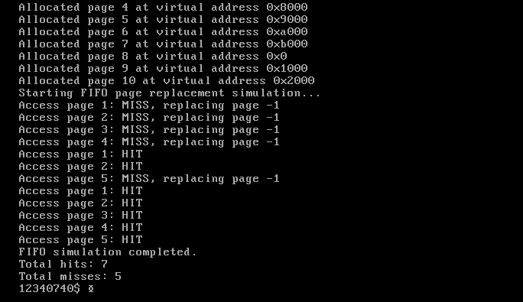
Observation :
We can see that the hit rate decreases from page size 3 to 4 thus proving bellady’s anomaly.

