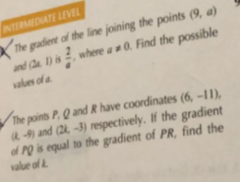Q1: both Questions



Q2:

Q3:

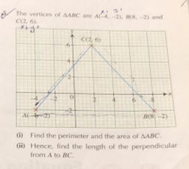

Q4:

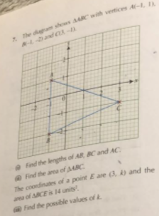

Q5:

1. The point (-3,3)lies on the line y= 4x + k, find the value of K
2. 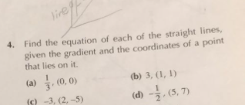

Q6:

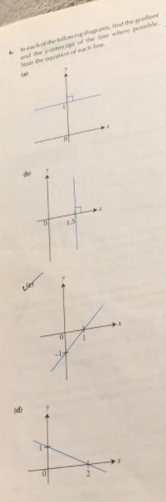

Q7:

Q8:

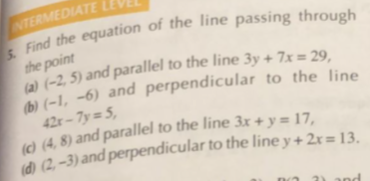

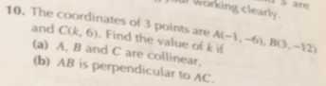Q9: