
Project Report
Only for Course Teacher
 |  | Needs Improvement | Developing | Sufficient | Above Average | Total Marks
Allocate Marks & Percentage |  | 25% | 50% | 75% | 100% | 40
Problem understanding & Analysis | 14
Implementation | 16
Report Writing | 10
Total obtained marks
Comments

Semester: Fall 2024
Students Name: Md.Rousin , Farhan Alom, Ahmed Sayed Khan ,Md Mehrab Hossain
Student ID: 172-35-2127, 0242220005341122, 0242220005341016, 222-35-1128
Batch: 39th Section: C1
Course Code: SE231 Course Name: Software Analysis and Design Project

Course Teacher Name: Khalid Bin Md. Badruzzaman Biplob
Designation: Lecturer
Department of Software Engineering (SWE)
Faculty of Science and Information technology (FSIT)
Daffodil International University

Submission Date: 2, December, 2024
Table of Contents

Introduction 4
Objective 4
Key Features 4
Scenario Writing 4
Scenario-1: Profile Creation 5
Scenario-2: Submit Complain 5
Scenario-3: Assig collector 5
Scenario-4: Task Report 5
Scenario-5: Resident Bill Payment 5
Stakeholder 6
User Profile 6
User Profile-01: Resident 6
User Profile-02: Garbage Collector 7
User Profile-03: Admin 7
Scope 8
1. System Development: 8
2. Data Management: 8
3. Service Implemention: 8
4. 4. West Utilization: 8
Feasibility Study 9
1. Technical Feasibility: 9
2. Operational Feasibility: 9
3. Economic Feasibility: 9
4. Scheduling Feasibility: 9
5. Security and Privacy Considerations: 9
Project Block Diagram 10
Block Diagram-1: Resident 10
Block Diagram-2: Garbage Collector 11
Block Diagram-3: Admin 12
Software Requirement Specification 13
SRS 13
User Case Diagram 15
User Case Description 16
Case Description-01: Registration 16
Case Description-02: Login 17
Case Description-03: Add Profile 18
Case Description-04: Complain 19
Case Description-05: Assign Collector 20
Case Description-06: Collection Status 21
Case Description-07:Bill payment 22
Case Description-08: Reports 23
Case Description-09: Notification 24
Case Description-10: Logout 25
System Design 26
Activity Diagram 28
Activity Diagram-1: Registration 28
Activity Diagram-2: Login 29
Activity Diagram-3: Add Profile 30
Activity Diagram-4: Complain 31
Activity Diagram-5: Assign Collector 32
Activity Diagram-6: Update Collection Status 32
Activity Diagram-7: Bill Payment 32
Activity Diagram-8: Reports 32
Activity Diagram-9: Logout 32

Sequence Diagram 38
Sequence Diagram-1: Registration 38
Sequence diagram-2: Login 39
Sequence diagram-3: Add Profile 40
Sequence diagram-4: Complain 41
Sequence diagram-5: Assign Collector 42
Sequence diagram-6: Update Collection Status 42
Sequence diagram-7: Bill Payment 42
Sequence diagram-8: Reports 42
Sequence diagram-9: Logout 42
Class Diagram 43
Er Diagram 44

Introduction
Bangladesh, with its large population, faces significant challenges in waste management. Rapid urbanization has led to increased garbage production, particularly in densely populated colonies where a large number of householder, contribute to daily waste accumulation. The existing waste collection services are inadequate and inefficient, leading to environmental degradation and health hazards. To address this issue, we propose a "SMART WASTE MANAGEMENT SYSTEM", which aims to revolutionize waste handling by introducing a streamlined, technology-driven solution that not only simplifies waste collection but also ensures proper utilization of garbage.

Objective
The “SMART WASTE MANAGEMENT SYSTEM” is to develop an integrated platform that facilitates efficient waste collection, management, and utilization. The system will:
- Enhance the efficiency of waste collection services.
- Provide a database-driven approach to track and manage waste production.
- Promote proper utilization and recycling of waste materials.
- Improve the overall cleanliness and health standards of the community.

Key Features
- User Registration and Login: The system facilitates a straightforward registration process for users, ensuring secure access through robust authentication mechanisms. Password recovery options further enhance user convenience.
- Database Collection: Each users will be registered in a database, tracking waste generation patterns .
- Profile Management: Allows all stakeholders—residents, garbage collectors, and admins—to manage and update their profiles with relevant personal and professional details.
- Complaint Handling System: Residents can file complaints regarding missed collections or service issues. Complaints are automatically assigned to relevant garbage collectors, who can update the status, with admins overseeing the resolution process.
- Garbage Collector Assignment: Admins can assign or reassign garbage collectors to specific areas or tasks based on demand and complaint volume.
- Reporting: Garbage collectors log daily activities, including areas covered, waste collected, and issues encountered, generating reports for admin review.
- Billing and Payment System: Users can view their billing history, and make secure payments online.

Scenario Writing
Scenario writing involves describing specific situations or use cases that illustrate how a system or software application will be used by its users. These scenarios help to better understand the system's functionalities, interactions, and outcomes. In the context of the Smart West Management System, let's write some scenarios to depict typical user interactions:

Scenario-1: Profile Creation
- Users requests to create a profile.
- Users fills in name, address, and contact info.
- Submits the form.
- System confirms profile is created.
Scenario-2: Submit Complaint
- Users reports missed garbage collection.
- Submits the complaint.
- System confirms complaint submission with a tracking number.
Scenario-3: Assign Garbage Collector
- Admin reviews complaints and assigns a garbage collector to the area.
- Admin specifies the area for the collector.
- Submits the assignment.
- System confirms the collector is assigned.
Scenario-4: Task Reporting by Garbage Collector
- Garbage collector logs into the system at day’s end.
- Collector enters areas covered, waste collected, and issues.
- Collector submits the report.
- System confirms report submission.
Scenario-5: Resident Bill Payment
- Users logs in to pay their bill.
- Selects the pending bill.
- Chooses payment type.
- Submit completes payment.
- System confirms payment was successful.

These scenarios provide practical examples of how different users interact with the Smart West Management System and how the system responds to their actions. Scenarios like these help stakeholders understand the system's behavior and can be used for testing, validation, and refining the software to meet user needs effectively.

Stakeholder

- Residents: Users of the system who generate waste and require efficient collection services.
- Waste Collectors: Workers responsible for collecting waste in assigned areas and addressing complaints related to waste collection services.
- Admins: System administrators responsible for overseeing the entire waste management operation, ensuring that services run smoothly and efficiently.

User Profile

User Profile-01: Residents
User Class | Notes on Characteristic | Requirement Implied
Type of User | Residents | Verification
Age Range | 18-65 | Verification
Frequency of Use | Weekly or bi-weekly | Performance, Operation
Mandatory | Yes | --
Computer Experience | No need | --
Education |  | --
Goals | Efficient waste disposal | --
Language Skills | Bangla, English | --
Number of Users | -- | --
Training | -- | --
Other System Used | No | --
Ways of Working | Garbage collection | --

User Profile-02: Garbage collector
User Class | Notes on Characteristic | Requirement Implied
Type of User | Waste Collectors | Verification
Age Range | 18-55 | Verification
Frequency of Use | When it need | Performance, Operation, Acceptance
Mandatory | yes
Computer Experience | use of mobile devices for tracking and notifications
Goals | Take a good service
Language Skills | Bangla, English
Number of Users | -- | --
Training | Yes
Other System Used | No
Ways of Working | Sometime

User Profile-03: Admins
User Class | Notes on Characteristic | Requirement Implied
Type of User | Admins | Verification
Age Range | 29-45 | Verification
Frequency of Use | Most of the time per day | Performance, Operation, Acceptance
Mandatory | Yes
Computer Experience | Experienced | Documentation
Education | BSC
Goals | Make the system easy and user-friendly | Resource, Performance, Security, Acceptance, Operation
Language Skills | Bangla, English, and Computer Language
Number of Users | 15-20 | Performance, Operation, Acceptance, Portability
Training | May accept some training, but be unwilling to repeat it | Documentation
Other System Used | No

Scope
- System Development:
  - Mobile application for residents.
  - Web dashboard for authorities.
- Data Management:
  - Secure databases for user information and waste tracking.
  - Analytics for waste production patterns.
- Service Implementation:
  - Scheduling and routing algorithms for waste collection.
  - Customer support and feedback mechanisms.
- Waste Utilization:
  - Partnerships with recycling centers.
  - Programs for converting waste to energy or compost.

Feasibility Study
The Smart West Management System (SWMS) proposes a comprehensive solution to address the challenges and demands of the industry. This feasibility study aims to assess the viability of implementing the SWMS by analyzing its technical, operational, economic, and scheduling aspects.

Technical Feasibility
- Requirements: The system needs a simple web platform for residents, garbage collectors, and admins, plus a central database.
- Scalability: It can be expanded in the future with additional features, like IoT integration, if needed.
- Development Timeline: Estimated to be completed in 4-6 months.
- Conclusion: Technically feasible with straightforward requirements and scalability.
Operational Feasibility
- User Adoption: Clear interfaces will make it easy for users to learn and use.
- Implementation: The system can be introduced in phases to minimize disruption.
- Maintenance: Managed by a small IT team for updates and support.
- Conclusion: Operationally feasible, with likely user adoption and minimal disruption.

Economic Feasibility
- Costs: Initial development, training, and maintenance are affordable and can be covered by grants or municipal funding.
- Savings: The system reduces costs by optimizing waste collection routes and lowering complaint management expenses.
- Conclusion: Economically feasible with potential cost savings and funding options.

Legal Feasibility

- Data Privacy: Ensures user data is protected and follows local privacy laws.
- Compliance: Meets local waste management standards and regulations.
- Risk Management: Has plans in place to handle data and system issues.
Environmental and Social Feasibility
- Environmental Impact: Positive effects through reduced pollution and promotion of recycling.
- Community Acceptance: Likely to be well-received due to improvements in living conditions and health.

The feasibility study concludes that the Smart West Management System is technically, operationally, economically, and schedulable viable. The benefits of enhanced operational efficiency, improved user satisfaction, and potential revenue growth outweigh the costs associated with development and implementation. Recommendations for mitigating risks and maximizing benefits will be incorporated into the project plan to ensure successful SWMS deployment.

Project Block Diagram

Block Diagram-1: Resident

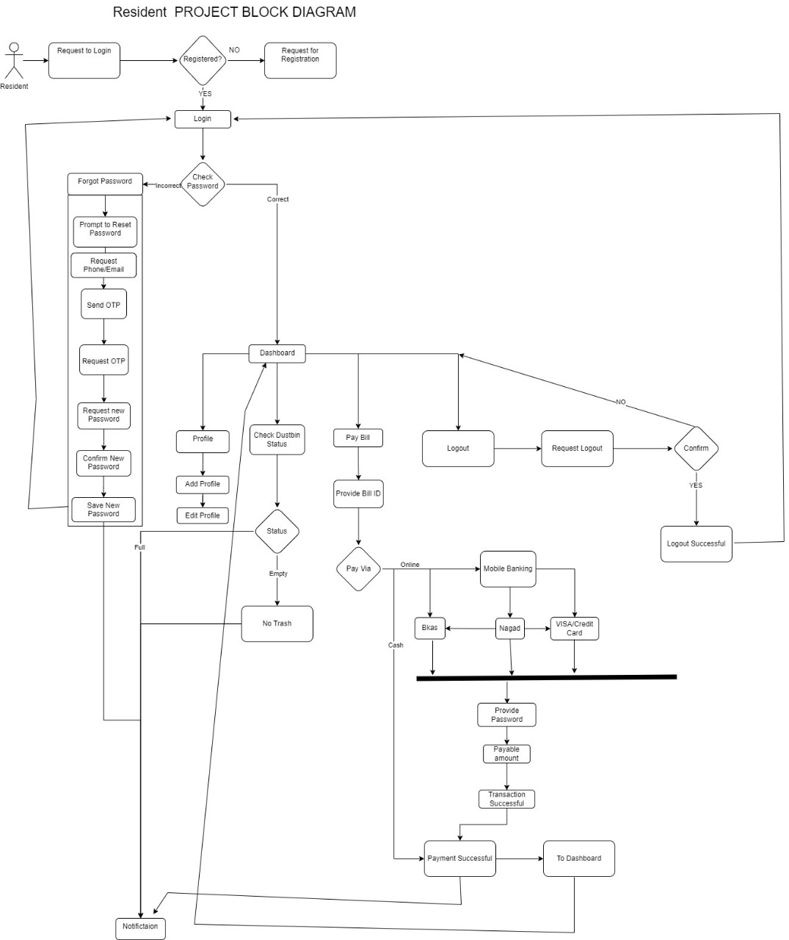

Figure-1: Block Diagram for Resident

Block Diagram-2: Garbage Collector

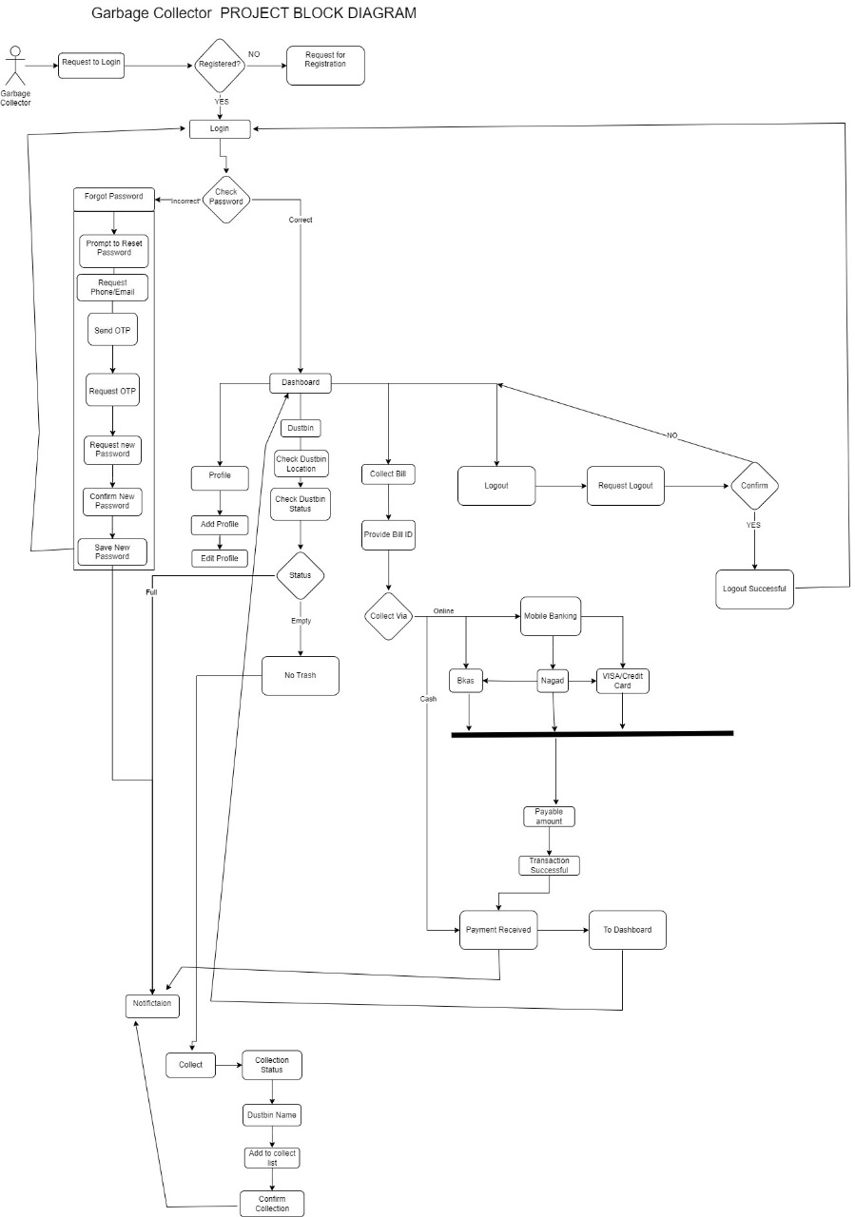
Figure-2: Block Diagram for Garbage Collector

Block Diagram-3: Admin
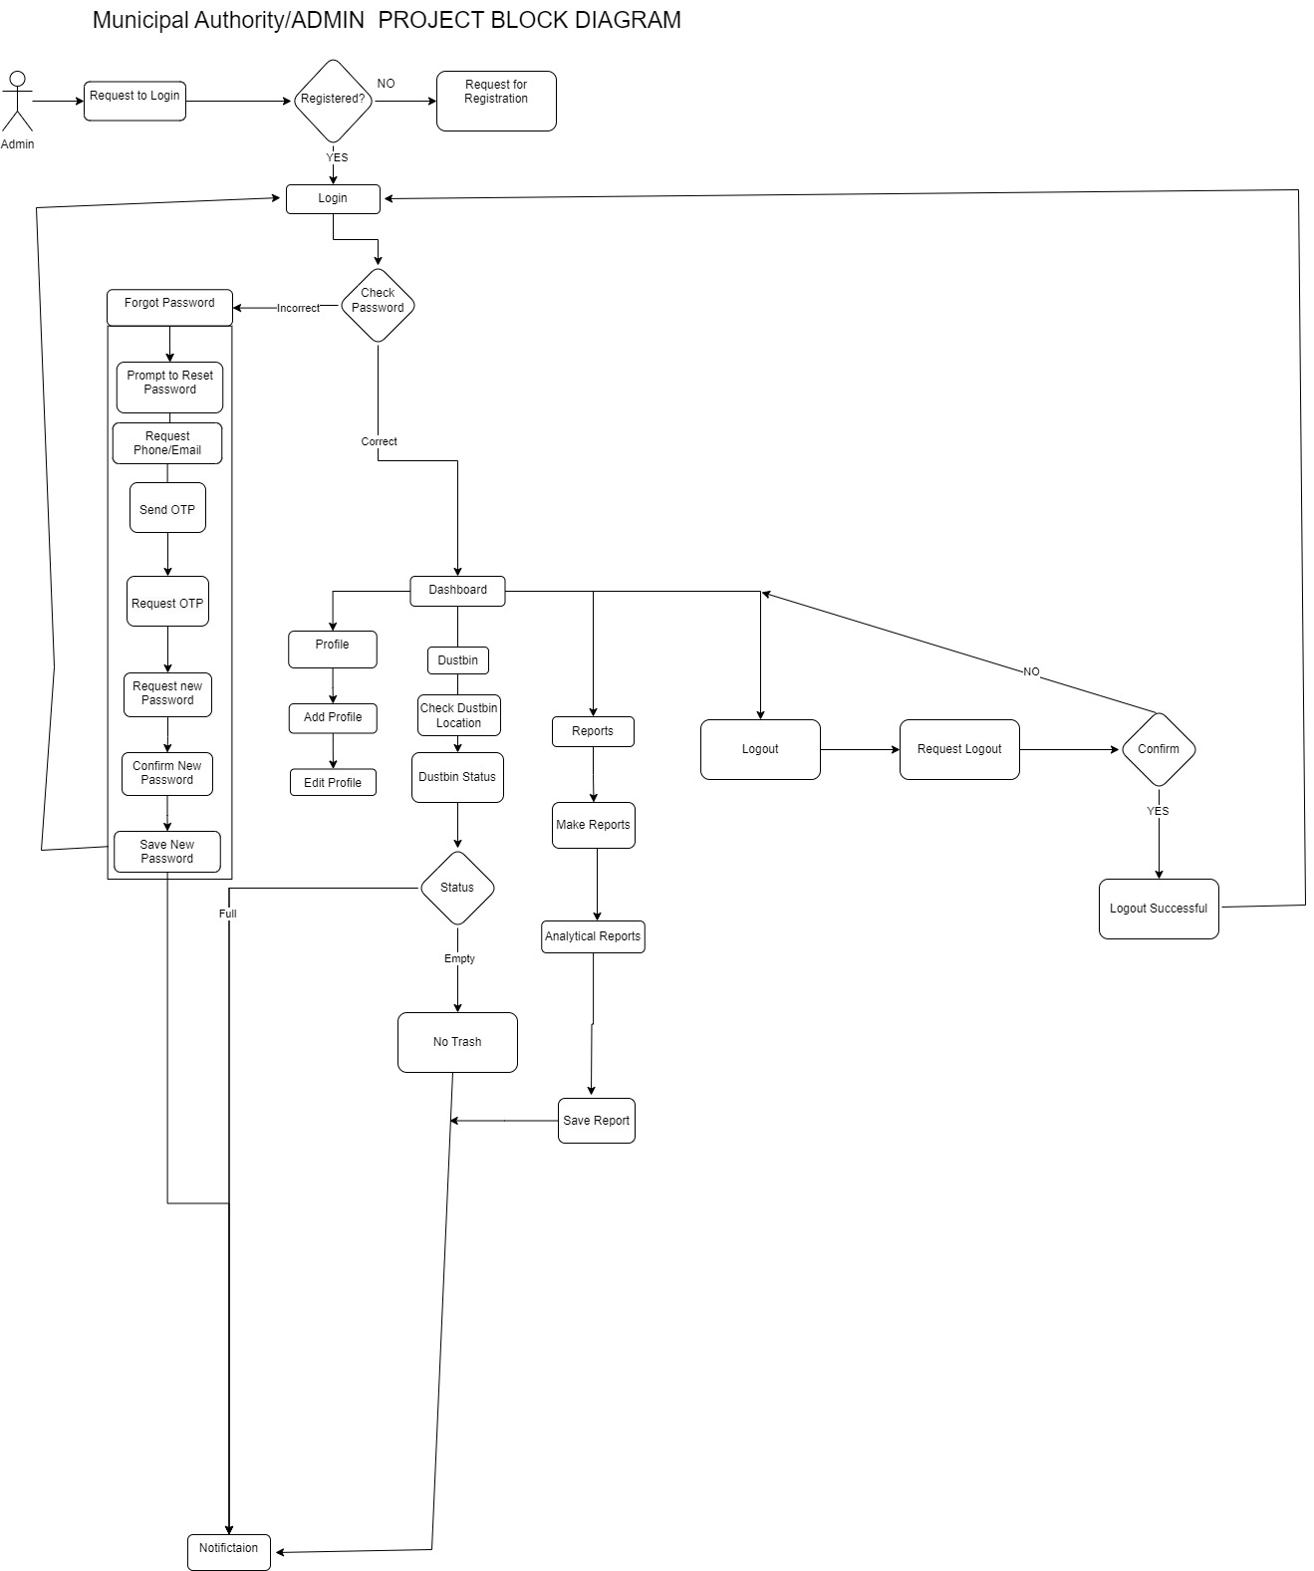

Figure-3: Block Diagram for Admin

Software Requirement Specification

FR01: Registration
Attribute | Details
Description | Users (Residents, Garbage Collectors, and Admins) must be able to register and create an account in the system.
Stakeholder | Residents, Garbage Collectors

FR02: Login
Attribute | Details
Description | Registered users must be able to log in using secure credentials to access their respective dashboards.
Stakeholder | Residents, Garbage Collectors, Admin

FR03: Profile Management
Attribute | Details
Description | Users can add or edit their profile information.
Stakeholder | Residents, Garbage Collectors, Admin

FR04: Complain
Attribute | Details
Description | Residents can submit complaints if garbage collection services are not performed as scheduled. Garbage Collectors can view complaints submitted by residents, take necessary actions, and mark them as resolved.
Stakeholder | Residents, Garbage Collectors, Admin

FR05: Assign Garbage Collectors
Attribute | Details
Description | Admins can assign and reassign garbage collectors to specific areas or tasks based on complaint volume and demand.
Stakeholder | Admins

FR06: Collection Status
Attribute | Details
Description | Garbage collectors can update the status of garbage collection in real time.
Stakeholder | Garbage Collectors, Admin

FR07: Bill Payment
Attribute | Details
Description | Residents can view and pay bills for waste collection services,
Stakeholder | Residents, Admin

FR08: Reports
Attribute | Details
Description | Admin generates and views reports on waste collection efficiency, task completion, complaint resolution, and usage trends to monitor and optimize operations.
Stakeholder | Admin

FR09: Notification
Attribute | Details
Description | Users receive notifications for new task assignments, complaint updates, and payment reminders.
Stakeholder | Residents, Garbage Collectors, Admin

FR10: Logout
Attribute | Details
Description | Users must be able to logout from the system
Stakeholder | Residents, Garbage Collectors, Admin

User Case Diagram
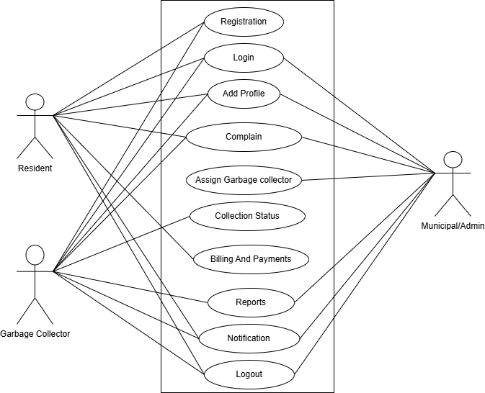
Figure-4: User Case Diagram for Smart West Management System

User Case Description

Case Description-01: Registration
Use Case | Registration
Goal | Residents and garbage collectors must be registered before using the Smart Waste Management System.
Precondition | None
Success End Condition | Notification “Registration Successful.”
Failed End Condition | Notification “Registration Failed.”
Primary Actors | Residents, Garbage Collectors
Secondary Actors | None
Trigger | Users request to register by providing necessary details.
Description / Main Success Scenario | 1. Visit Registration Page.  2. Provide necessary details (name, address, etc.).  3. Submit registration form.  4. Registration Successful.
Alternative Flows | 2.1. Server Down.  2.1.a. Try again later.  3.1. System doesn’t respond.  3.1.a. Try again later.
Quality Requirements | Users will get 30 mins to complete registration.

Case Description-02: Login
Use Case | Login
Goal | Registered users must log in using secure credentials to access the system.
Precondition | Must be registered in the system.
Success End Condition | Notification “Login Successful.”
Failed End Condition | Notification “Login Failed.”
Primary Actors | Residents, Garbage Collectors, Admin
Secondary Actors | None
Trigger | Users request to log in by providing credentials.
Description / Main Success Scenario | 1. Visit Login Page.  2. Enter credentials (username and password).  3. Submit login form.  4. Login Successful.
Alternative Flows | 2.1. Server Down.  2.1.a. Try again later.  3.1. System doesn’t respond.  3.1.a. Try again later.
Quality Requirements | Users will get 5 mins to log in.

Case Description-03: Add Profile
Use Case | Add Profile
Goal | Users can create, update, or delete their profiles, including personal details and service preferences.
Precondition | Must be logged in the system.
Success End Condition | Notification “Profile Updated Successfully.”
Failed End Condition | Notification “Profile Update Failed.”
Primary Actors | Residents, Garbage Collectors, Admin
Secondary Actors | None
Trigger | Users request to manage their profiles.
Description / Main Success Scenario | 1. Visit Profile Page.  2. Update personal details and preferences.  3. Submit changes.  4. Profile Updated Successfully.
Alternative Flows | 2.1. Server Down.  2.1.a. Try again later.  3.1. System doesn’t respond.  3.1.a. Try again later.
Quality Requirements | Users will get 15 mins to update profiles.

Case Description-04: Complain
Use Case | Complain
Goal | Residents can submit complaints if garbage collection services are not performed as scheduled. Garbage Collectors can view complaints submitted by residents, take necessary actions, and mark them as resolved.
Precondition | Must be logged in the system.
Success End Condition | Complaint submitted successfully with a confirmation message.
Failed End Condition | Complaint submission failed. Error message displayed.
Primary Actors | Residents , Garbage collector (view complaints)
Secondary Actors | Admin (review complaints)
Trigger | Residents identify missed or unsatisfactory garbage collection and request to file a complaint.
Description / Main Success Scenario | 1. Navigate to Complaint Submission Page.  2. Select the relevant issue and enter details.  3. Submit complaint.  4. System displays “Complaint Submitted Successfully.”
Alternative Flows | 2.1. Required fields missing.  2.1.a. Prompt user to complete required fields.  3.1. Server down.  3.1.a. Try again later.
Quality Requirements | System response time should be less than 3 seconds for complaint submission confirmation.

Case Description-05: Assign Collector
Use Case | Assign Garbage Collector
Goal | Admin assigns or reassigns garbage collectors to specific areas or tasks.
Precondition | Must be logged in the system.
Success End Condition | Garbage collector assigned successfully with confirmation.
Failed End Condition | Assignment fails, displaying an error message.
Primary Actors | Admin
Secondary Actors | Non
Trigger | Admin requests to assign or reassign a garbage collector to a location or task.
Description / Main Success Scenario | 1. Navigate to Assignment Page.  2. Select area and garbage collector.  3. Confirm assignment.  4. System confirms assignment with “Assignment Successful.”
Alternative Flows | 2.1. No garbage collectors available.  2.1.a. Prompt admin to try again later or check other collectors.  3.1. Server down.  3.1.a. Try again later.
Quality Requirements | Assignment confirmation must appear within 2 seconds.

Case Description-06: Update Collection Status
Use Case | Update collection Status
Goal | Garbage collectors can update the status of garbage collection tasks.
Precondition | Must be logged in the System
Success End Condition | Collection status updated successfully with confirmation.
Failed End Condition | Error displayed if update fails.
Primary Actors | Garbage Collector
Secondary Actors | Admin (monitor status)
Trigger | Garbage collector completes a collection task and requests to update the status.
Description / Main Success Scenario | 1. Navigate to Collection Status Page.  2. Select task to update.  3. Mark as “Collected.”  4. System displays “Status Updated Successfully.”
Alternative Flows | 2.1. Task not found.  2.1.a. Display error and prompt user to check task ID.  3.1. System doesn’t respond.  3.1.a. Try again later.
Quality Requirements | System should confirm status update within 2 seconds.

Case Description-07: Bill Payment
Use Case | Bill Payment
Goal | Residents can view and pay their bills for garbage collection services.
Precondition | Must be logged in the System
Success End Condition | Payment successful with confirmation and updated bill status.
Failed End Condition | Payment fails, displaying an error message.
Primary Actors | Resident
Secondary Actors | Admin (view billing data), Payment Gateway
Trigger | Resident requests to pay their garbage collection bill.
Description / Main Success Scenario | 1. Navigate to Billing Page.  2. Select bill to pay.  3. Choose payment method.  4. Confirm payment.  5. System displays “Payment Successful” and updates bill status.
Alternative Flows | 2.1. No outstanding bill.  2.1.a. Display message “No outstanding bill.”  3.1. Payment gateway fails.  3.1.a. Prompt to try again or use another payment method.
Quality Requirements | Payment processing should be completed within 5 seconds if successful.

Case Description-08: Reports
Use Case | Repots
Goal | Admin generates and views reports on waste collection efficiency, task completion, complaint resolution, and usage trends to monitor and optimize operations.
Precondition | Must be logged in the System
Success End Condition | Reports generated and displayed successfully with relevant data.
Failed End Condition | Report generation fails, and an error message is displayed.
Primary Actors | Admin
Secondary Actors | No
Trigger | Admin requests to generate or view a specific report.
Description / Main Success Scenario | 1. Navigate to Reports Page  2. Select Report Type  3. Enter Report Parameters  4. Generate Report  5. Display Report
Alternative Flows | 2.1 No data available for selected parameters.  2.1.a Display message "No data available for the selected criteria."  3.1 Invalid parameters entered.  3.1.a Prompt admin to enter valid parameters.  4.1 Server error or system doesn’t respond.  4.1.a Prompt to try again later or contact technical support.
Quality Requirements | Reports should be generated and displayed within 5 seconds of the request.

Case Description-09: Notification
Use Case | Notification
Goal | Users receive notifications for new task assignments, complaint updates, and payment reminders.
Precondition | Must be logged in the system.
Success End Condition | Notification is sent successfully, and the user receives it on their dashboard.
Failed End Condition | Notification fails to send, and the user does not receive the update.
Primary Actors | Residents, Garbage Collectors, Admin
Secondary Actors | Non
Trigger | A specific event (e.g., collection status update, bill generation, complaint response) triggers the system to send a notification.
Description / Main Success Scenario | 1. Event Occurs.  2. Generate Notification.  3. Receive Notification.  4. View Notification (Optional)
Alternative Flows | 2.1 Notification fails to send due to server error  2.1.a. System retries sending the notification. 3.1. Server down.  3.1.a. Try again later.
Quality Requirements | Notifications should be sent within 1 second of the triggering event.

Case Description-10: Logout
Use Case | Logout
Goal | Registered users must log out using secure credentials to exit the system.
Precondition | Must be logged in the system.
Success End Condition | Notification “Logout Successful.”
Failed End Condition | Notification “Logout Failed.”
Primary Actors | Residents, Garbage Collectors, Admin
Secondary Actors | None
Trigger | Users request to log out.
Description / Main Success Scenario | 1. Click on Logout button.2. Confirm logout.3. Logout Successful.
Alternative Flows | 2.1. Server Down.  2.1.a. Try again later.  3.1. System doesn’t respond.  3.1.a. Try again later.
Quality Requirements | Users will get 1 min to log out.

System Design

Activity Diagram

Activity Diagram-1: Registration
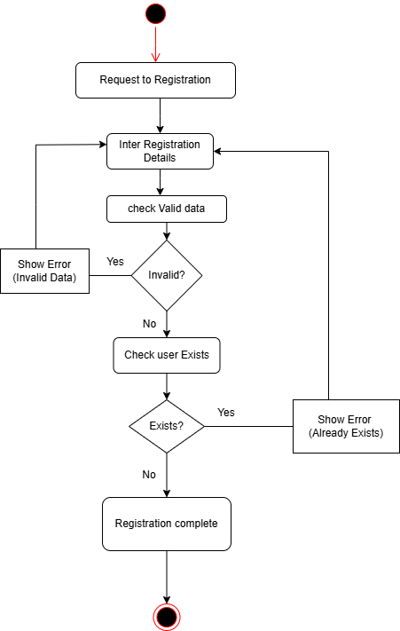

Activity Diagram-2: Login
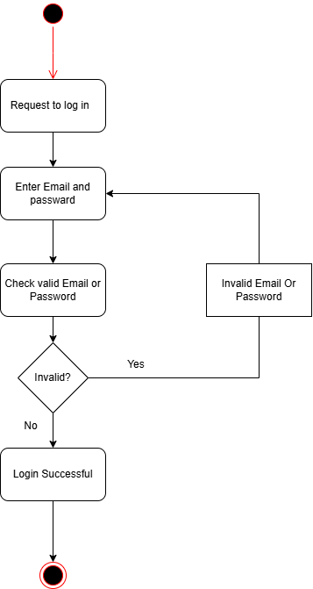

Activity Diagram-3: Add Profile
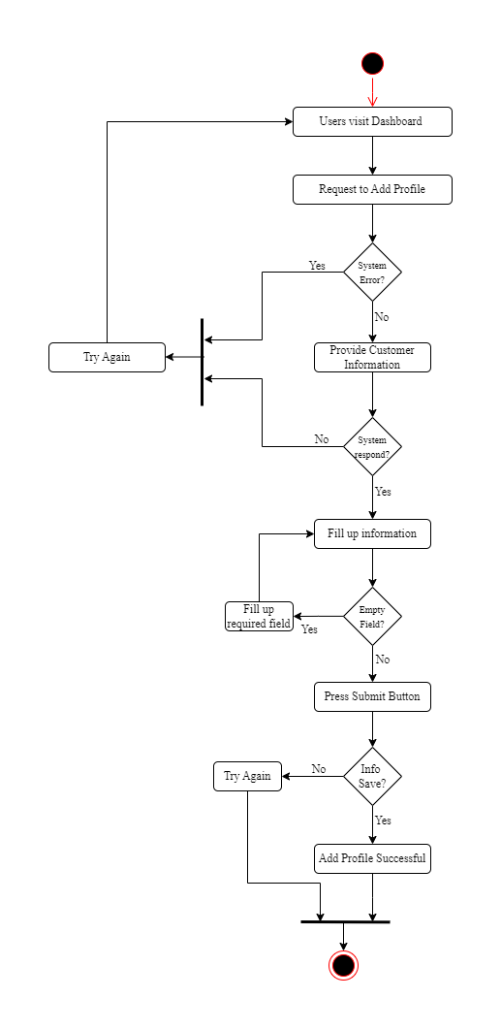

Activity Diagram-4: Complain
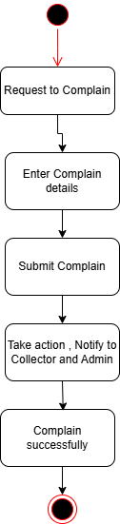

Activity Diagram-5: Assign Garbage Collector
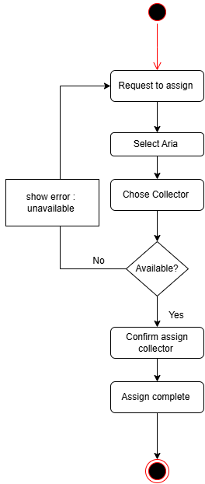

Activity Diagram-6: Update collection Status
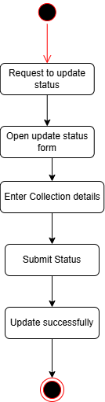

Activity Diagram-7: Bill Payment
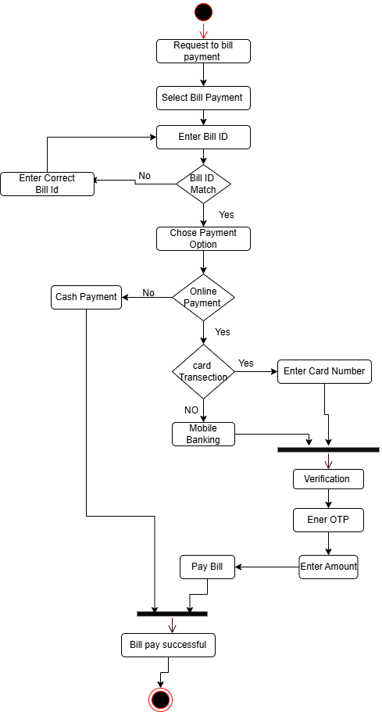

Activity Diagram-8: Reports
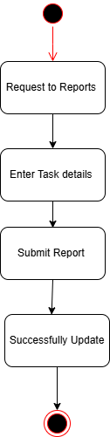

Activity Diagram-9: Logout


Sequence Diagram

Sequence Diagram-1: Registration

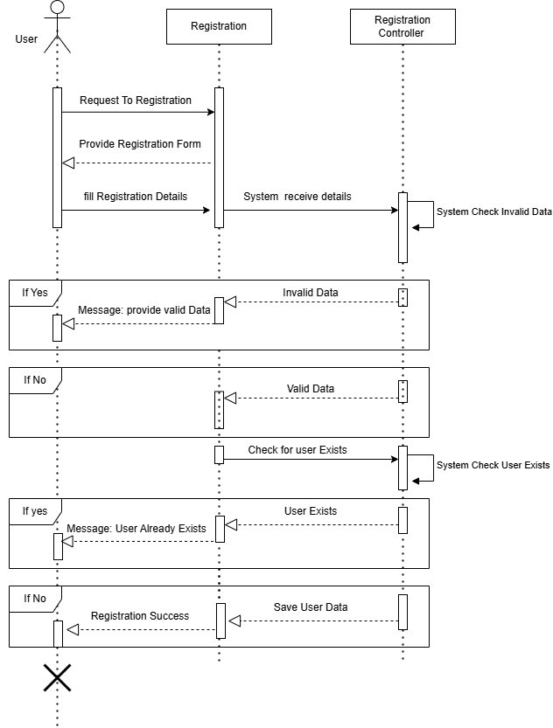

Sequence diagram-2: Login
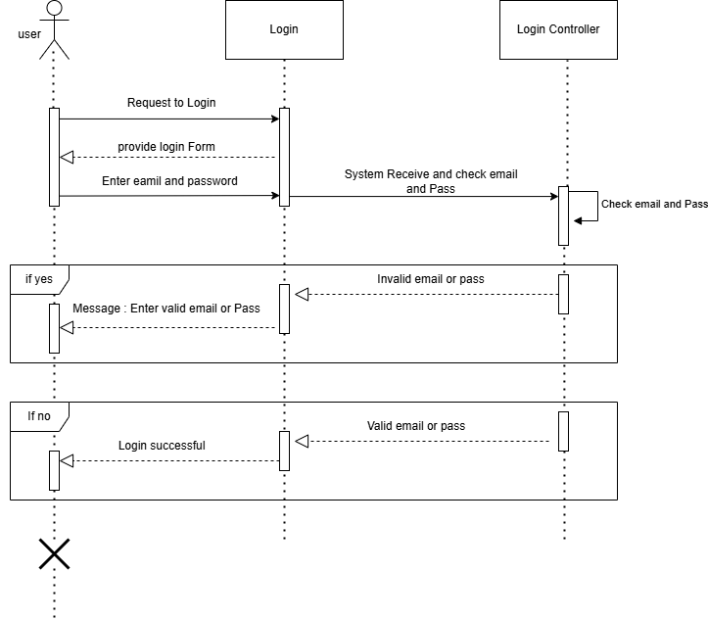

Sequence diagram-3: Add Profile

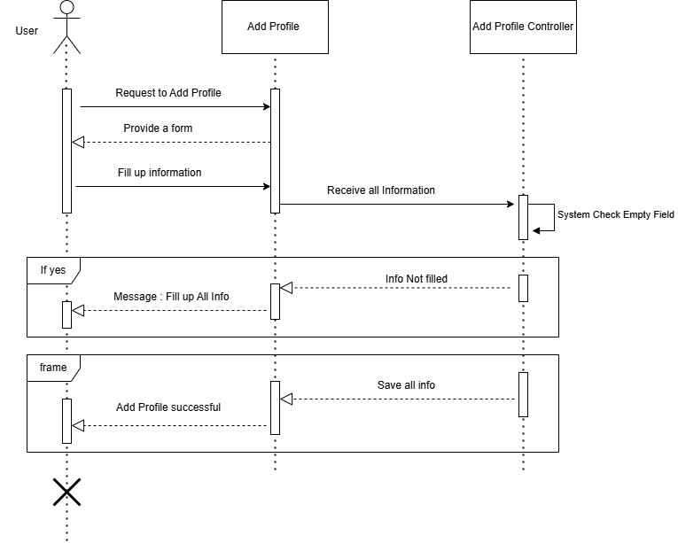

Sequence diagram-4: Complain
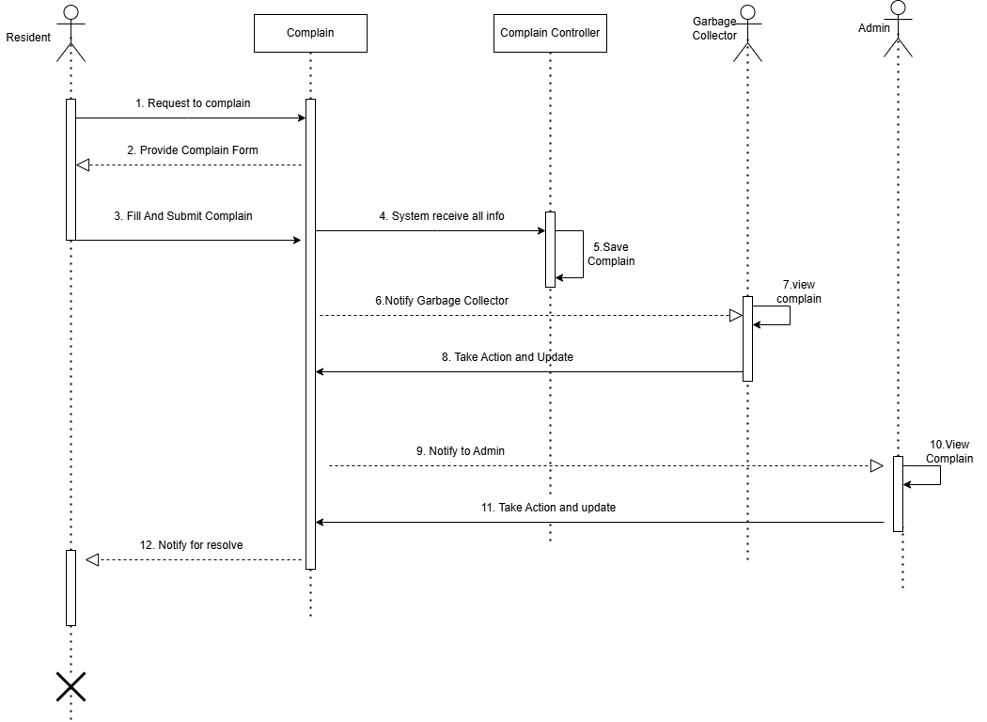

Sequence diagram-5: Assign Collector

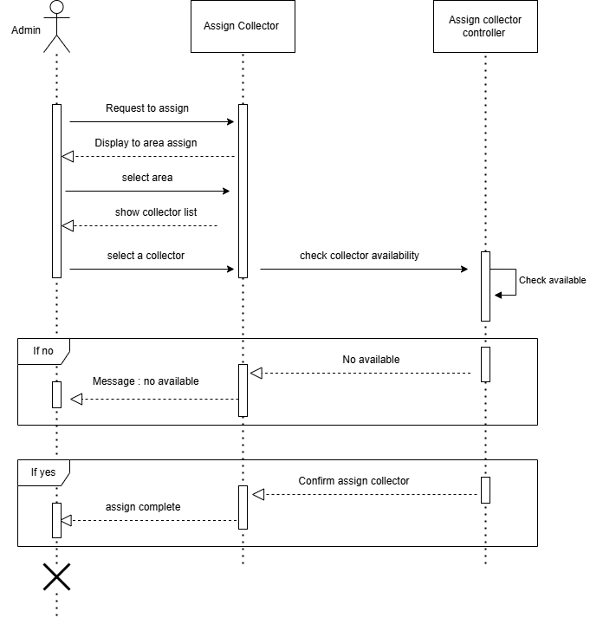

Sequence diagram-6: Update Collection Status
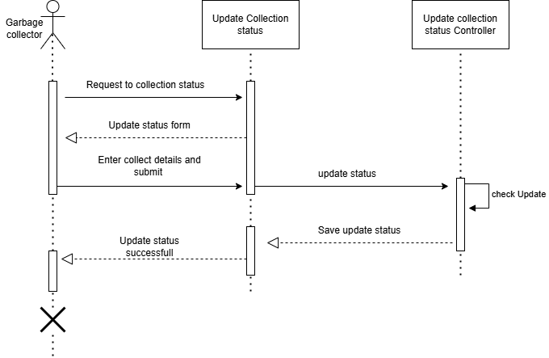

Sequence diagram-7: Bill Payment
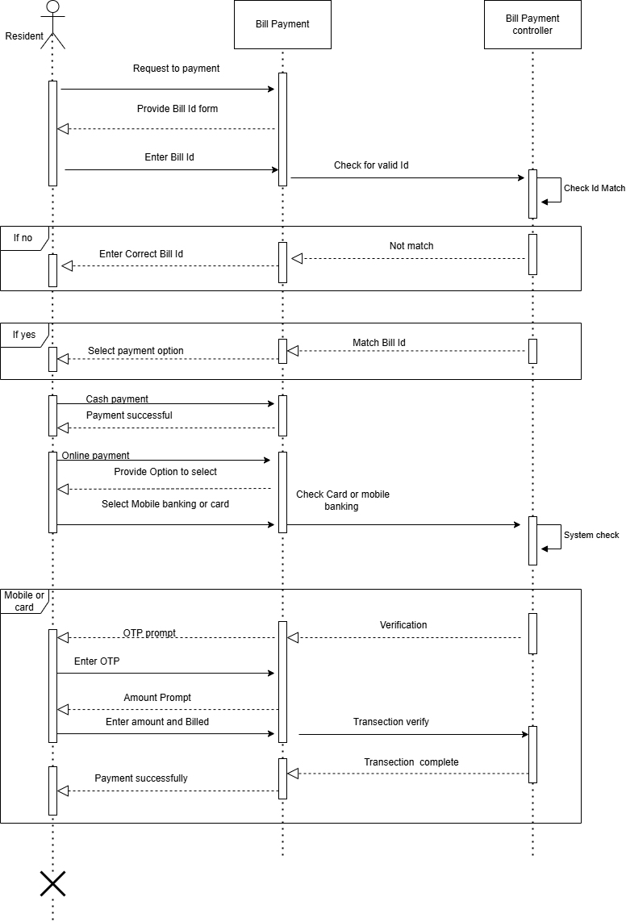

Sequence diagram-8: Reports
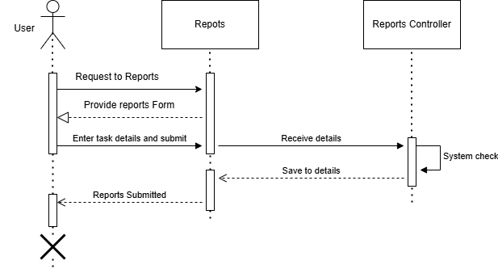

Sequence diagram-9: Logout
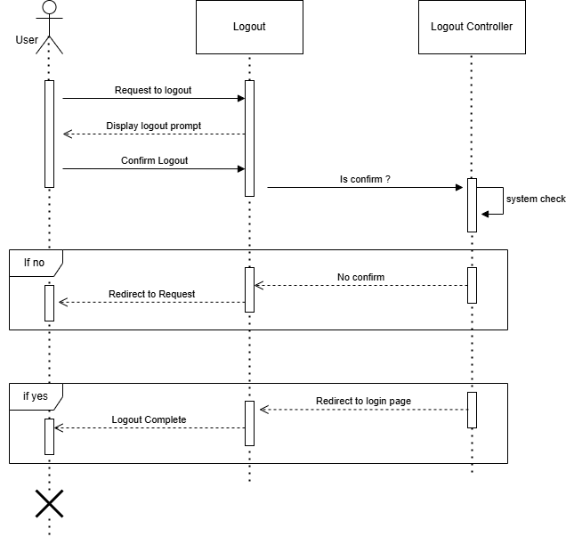

Class Diagram

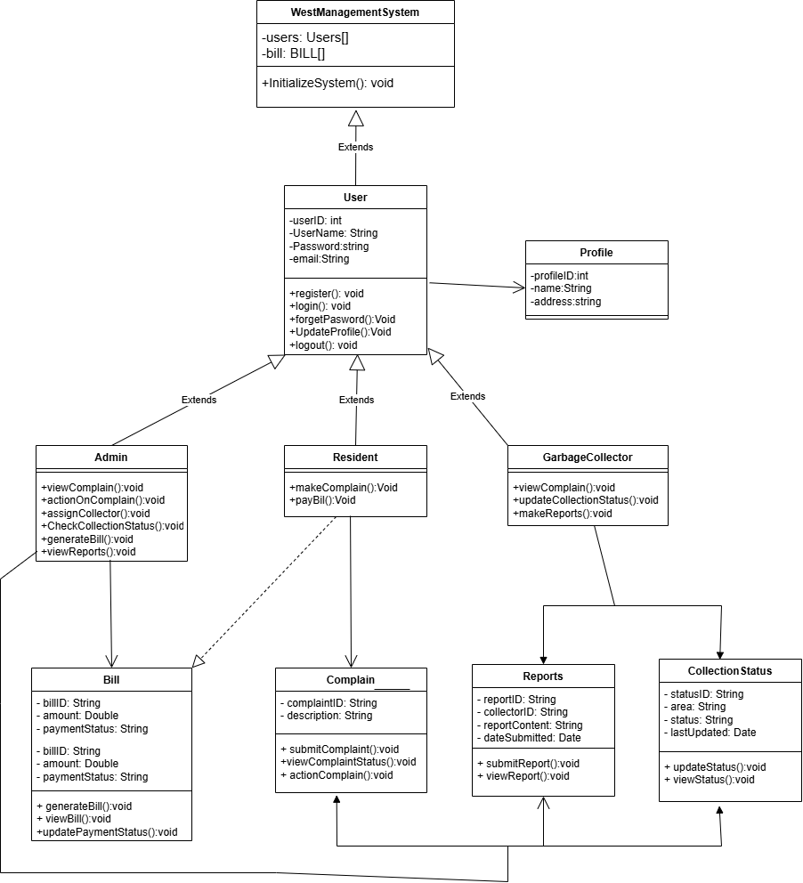

Er Diagram

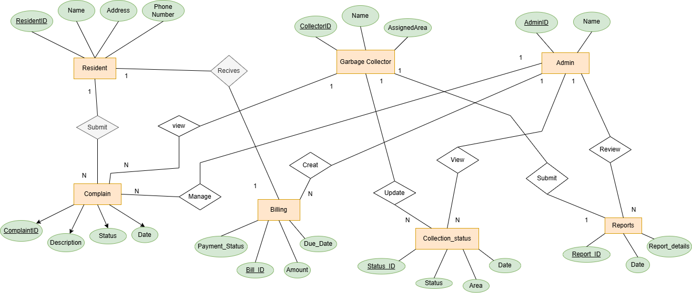

Figure-23: ER Diagram for Smart West Management System

