**Ex No: 8 Database Connectivity**

**Date: 26/03/2024**

**Aim:**

To work on the given question and get the output using Java Database Connectivity.

**1.Assume you have a database schema that contains a table called "movies" with the following columns:  
 • movie_id (int, primary key)  
 • title (varchar)  
 • director (varchar)  
 • rating (varchar)  
 • price (double)  
Write a JSP program that connects to the database using JDBC and retrieves the following information:  
 1. The total number of movies in the database.  
 2. The average price of all movies.  
 3. The director with the highest-rated movies (based on the average rating of their  
 movies).  
Once you have retrieved this information, create a JSP page that displays this information in a table format.**

**Algorithm:**

Step 1: Start

Step 2: Initialize variables including `number_Of_Movies`, `total_Amount`, `average_Price_Of_Movies`, `highest_Rating_Of_Movies`, `con`, `st`, and `rs` for database operations.

Step 3: Attempt database connection and query execution: Use Class.forName() to load MySQL JDBC driver, establish connection using DriverManager.getConnection(), print "Connection established successfully", create statement object st, formulate SQL query to select all movies, print "Executing query: SELECT * FROM Movies", execute query using st.executeQuery().

Step 4: Process the query result: Iterate through result set rs, inside loop increment number_Of_Movies, add price of current movie to total_Amount, retrieve rating of current movie, update highest_Rating_Of_Movies if rating is higher.

Step 5: Calculate average price: If number_Of_Movies is greater than 0, calculate average_Price_Of_Movies as total_Amount / number_Of_Movies.

Step 6: Output results in HTML table: Create HTML table with headers "Number_Of_Movies", "Average_Price_Of_Movies", "Highest_Rating_Of_Movies", populate table rows with respective values of variables using scriptlet expressions.

Step 7: Close database resources in finally block: Close result set rs, statement st, and connection con.

Step 8: End.

**Source Code:**

index.jsp

<%@page contentType="text/html;charset=UTF-8" language="java" %>

<%@page import="java.sql.Connection" %>

<%@page import="java.sql.Statement" %>

<%@page import="java.sql.ResultSet" %>

<%@page import="java.sql.DriverManager" %>

<%@page import="java.util.*" %>

<html>

<head>

<title>JDBC Program</title>

</head>

<body>

<%

int number_Of_Movies = 0;

double total_Amount = 0.0;

double average_Price_Of_Movies = 0.0;

String highest_Rating_Of_Movies = "";

Connection con = null;

Statement st = null;

ResultSet rs = null;

try {

Class.forName("com.mysql.cj.jdbc.Driver");

con = DriverManager.getConnection("jdbc:mysql://localhost:3306/internetprogramming", "root", "Vishwa@2024");

out.println("Connection established successfully."); // Debug output

st = con.createStatement();

String query = "SELECT * FROM Movies";

out.println("Executing query: " + query); // Debug output

rs = st.executeQuery(query);

while (rs.next()) {

out.println("Inside while loop."); // Debug output

number_Of_Movies++;

total_Amount += rs.getDouble("price");

String s = rs.getString("rating");

if (highest_Rating_Of_Movies.isEmpty() || s.compareTo(highest_Rating_Of_Movies) > 0)

highest_Rating_Of_Movies = s;

}

if (number_Of_Movies > 0) {

average_Price_Of_Movies = total_Amount / number_Of_Movies;

}

} catch (Exception e) {

out.println(e.getMessage());

} finally {

try {

if (rs != null) {

rs.close();

}

if (st != null) {

st.close();

}

if (con != null) {

con.close();

}

} catch (Exception e) {

out.println(e.getMessage());

}

}

%>

<table border="1">

<thead>

<th style="font-size: 30px">Number_Of_Movies</th>

<th style="font-size: 30px">Average_Price_Of_Movies</th>

<th style="font-size: 30px">Highest_Rating_Of_Movies</th>

</thead>

<tbody>

<tr>

<td style="font-size: 25px"><%= number_Of_Movies %></td>

<td style="font-size: 25px"><%= average_Price_Of_Movies %></td>

<td style="font-size: 25px"><%= highest_Rating_Of_Movies %></td>

</tr>

</tbody>

</table>

</body>

</html>

**Output:**

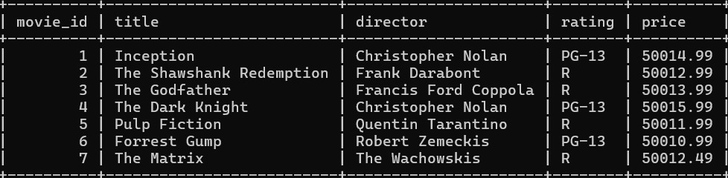

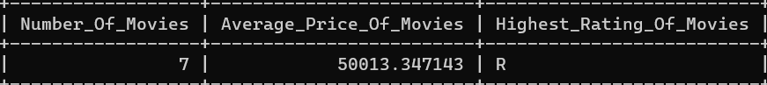

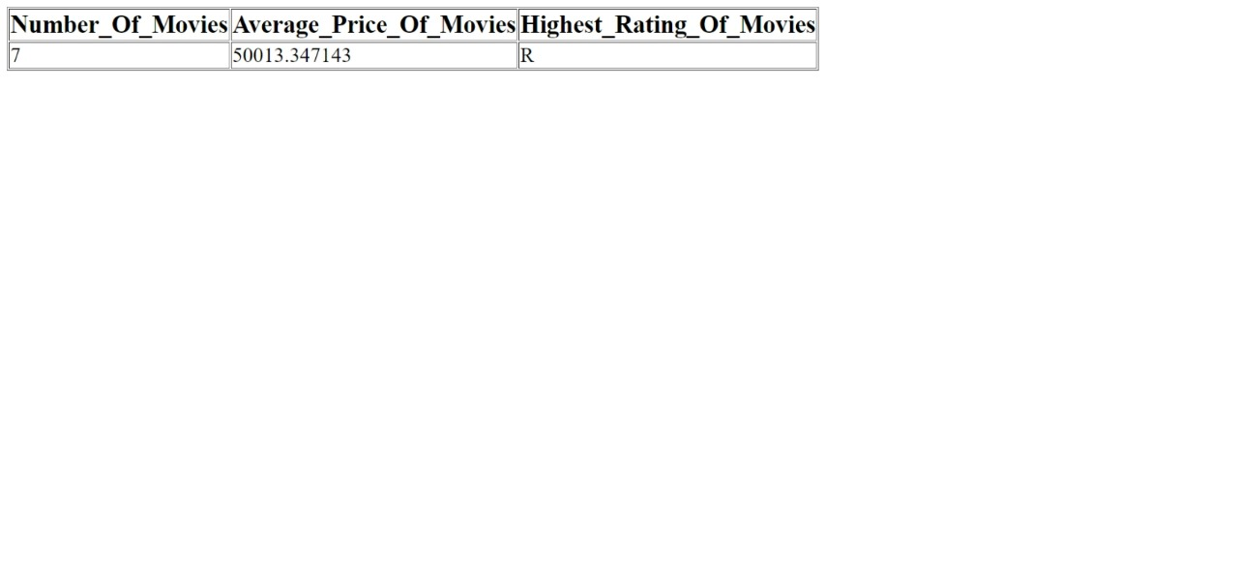

|  |  |
| --- | --- |
| **Code & Output (20)** |  |
| **Quiz (5)** |  |
| **Timely Submission (5)** |  |
| **Total (30)** |  |
| **Initial** |  |

**Result:**

Thus, the Java Database Connectivity Programming question is executed and the output is verified successfully.