AI SEO Tool
User guide
Elite plan
Elite · ₹1,599/mo
Document generated: 2026-03-27. Regenerate with: npm run docs:user-guides-docx
Audience: Business clients using the platform.

At a glance
Elite includes everything in Growth, plus paid-social depth and the highest client limits.
Topic | Elite limit / note
Tracked keywords | 100 maximum
Competitor URLs | 5
Ad creative angles in Site audit | Yes — Meta + Google RSA-style blocks
Social ads page | Yes — Meta credentials JSON + draft gallery
Campaign idea → Create draft | Yes — writes today’s Social ad draft via second Gemini pass
Monthly email | HTML + optional PDF attachment when configured

Elite-only features

Ad creative angles (inside Site audit)
• Extra section with headline and body variants for Meta and Google RSA-style ads.
• How: Run a new site audit; scroll to Ad creative angles; copy into Ads Manager.
• Benefit: Organic fixes and paid creative stay aligned.

Social ads
• Paste Meta credentials JSON (Page token, Instagram Business Account ID — see in-app tooltip).
• Review AI drafts: caption pack plus image (stock fallback or Imagen when server allows).
• Benefit: One hub for creative before publishing.

Campaign ideas → Create draft in Social ads
• On Campaign ideas, Elite sees a button to generate full Meta copy from a chosen idea.
• Saves as today’s Social ad row (same daily slot as admin-generated drafts; running again replaces that day’s draft).

Growth vs Elite (summary)
Area | Growth | Elite
Keywords | 50 | 100
Competitors | 3 | 5
Ad angles in audit | No | Yes
Social ads page | No | Yes
Draft from campaign idea | No | Yes
Monthly email PDF | No (HTML) | Yes when configured

Journey diagram — Elite
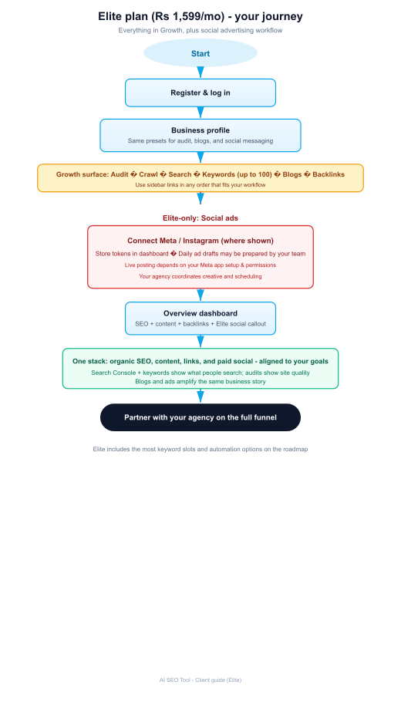
All Growth workflows (blogs, GA4, campaign ideas, backlinks, etc.) work the same as in the Growth user guide.
AI SEO Tool — end of document

