AI SEO Tool
User guide
Growth plan
Growth · ₹899/mo
Document generated: 2026-03-27. Regenerate with: npm run docs:user-guides-docx
Audience: Business clients using the platform.

At a glance
Growth includes everything in the Starter guide, plus the capabilities below. This document focuses on what is added or different.
Topic | Growth limit / note
Tracked keywords | 50 maximum
Content calendar items | 500 maximum
Competitor URLs | 3
Social captions | LinkedIn + Instagram + Facebook on audits and blogs
AI blogs | Yes — weekly limits per subscription
Backlinks checklist | Yes
Web analytics (GA4) | Yes — OAuth + Property ID
Campaign ideas | Yes — ideas only (no in-app Social draft)
Monthly email | HTML opt-in when Resend configured

Growth-only features

Blogs
• AI-generated drafts aligned to your business profile presets.
• How: Open Blogs from the sidebar; open or generate posts per your workflow.
• Benefit: Faster first drafts for your CMS or site.

Backlinks
• Structured checklist of directories and submission-style tasks.
• Benefit: Off-page work stays organized.

Web analytics (GA4)
• Read-only Google connection; enter numeric GA4 Property ID, then Sync.
• Benefit: Sessions and top pages next to Search Console queries.
• Note: Same Google OAuth app as Search Console; GA4 callback URI must be enabled in Cloud Console.

Campaign ideas
• Optional free-text direction (up to 2,000 characters) + Get today’s campaign ideas.
• Returns four hooks with format, rationale, hashtags. AI does not browse live news — verify dates before ad spend.
• Growth does not show Create draft in Social ads (Elite only).

Monthly executive email
• Opt in under Business profile when your operator enabled email delivery (Resend + cron).

Higher limits and three-platform social packs
• Use Social post pack on blog posts and on audits for Instagram and Facebook as well as LinkedIn.

Starter vs Growth (summary)
Area | Starter | Growth
Keywords | 10 | 50
Calendar | 2 items | 500 items
Competitors | 1 | 3
Blogs | — | Yes
Backlinks | — | Yes
GA4 | — | Yes
Campaign ideas | — | Yes (ideas only)
Audit social pack | LinkedIn only | 3 platforms

Journey diagram — Growth
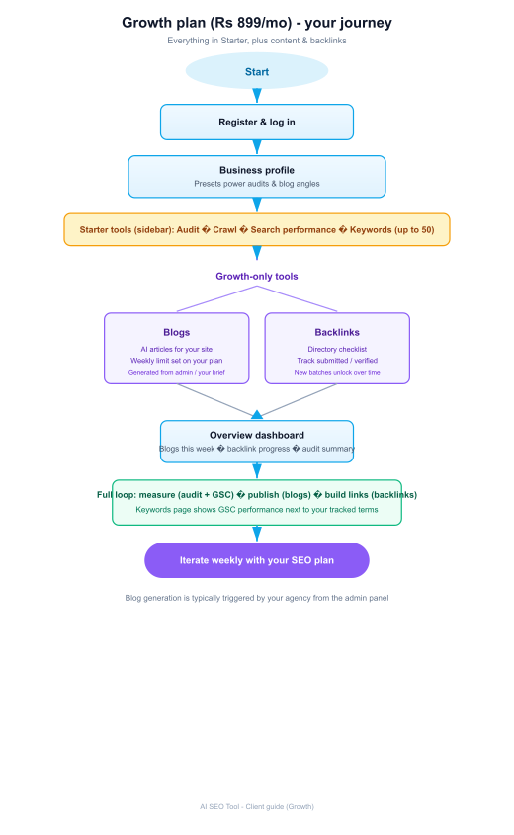
For every Starter feature (audit, crawl, GSC, checklist, share report, etc.), follow the same steps as in the Starter user guide.
AI SEO Tool — end of document

