AI SEO Tool
User guide
Starter plan
Starter · ₹499/mo
Document generated: 2026-03-27. Regenerate with: npm run docs:user-guides-docx
Audience: Business clients using the platform.

At a glance
Topic | Your limit / note
Tracked keywords | 10 maximum
Content calendar items | 2 maximum
Competitor URLs | 1
Social captions from audit | LinkedIn only
AI blogs | Not included — upgrade to Growth
GA4 / Campaign ideas | Not included — upgrade to Growth
Social ads / ad angles in audit | Not included — upgrade to Elite

What makes Starter valuable
• Lowest tier with full SEO core: AI site audit, site crawl, Search Console, keyword tracking, calendar, on-page checklist, competitor watch, shareable report.
• Business profile presets (industry vertical + marketing goal) tune every AI output to your model.
• Strict caps encourage focus before you scale content volume on Growth.

Before you start
• Complete Business profile: business name, website URL, description, industry vertical, marketing goal, target keywords.
• Optional: Gemini and PageSpeed API keys on the same page (use ? tooltips). Otherwise the server keys apply when configured.
• Optional: turn on Local SEO pack for Google Business Profile–style audit drafts when your profile is local.

Features — how to use and benefits

Overview
Shows unified growth score when you have audit data, and audit progress comparing early vs latest runs when you have two or more audits.
• Benefit: One place to see momentum without building spreadsheets.

Business profile
Central place for brand facts, presets, optional API keys, and local SEO toggle.
• Benefit: Audits, captions, and suggestions stay specific to you, not generic.

Site audit
Technical review plus AI blocks: keywords, meta, CTAs, FAQs, lead capture, LinkedIn-only social pack, Lighthouse when PageSpeed is available.
• How: Confirm website in profile → run audit → copy blocks into your CMS.
• Benefit: Actionable, brand-aware output in one session.

Site crawl
Crawls linked pages from your start URL (within app limits).
• Benefit: Broader health view than a single URL audit.

Search performance
Connect Google Search Console with OAuth; sync recent queries.
• Benefit: Write and optimize for real queries.
• Requires: Operator-configured Google OAuth on the server.

Keywords
Track up to 10 phrases; match to GSC when connected.
• Benefit: One prioritized list tied to performance data.

Content calendar
Plan topics and dates; Starter allows 2 items total.
• Benefit: Lightweight planning. Upgrade to Growth for large calendars.

On-page checklist
Per-URL checklist with saved checkboxes.
• Benefit: Repeatable QA so pages do not regress.

Competitors
One competitor homepage; refresh to see title/meta/H1 diffs.
• Benefit: Quick competitive intelligence. You cannot add your own domain.

Share report
Create a time-limited public link (no login) for stakeholders; revoke when done.
• Benefit: Professional sharing without sharing passwords.

Not included on Starter
Capability | Available on
AI blogs | Growth
Backlinks checklist | Growth
Web analytics (GA4) | Growth
Campaign ideas | Growth
Campaign idea → Social draft in app | Elite
Social ads page | Elite
Ad creative angles in audit | Elite
Monthly executive email opt-in | Growth / Elite

Journey diagram — Starter
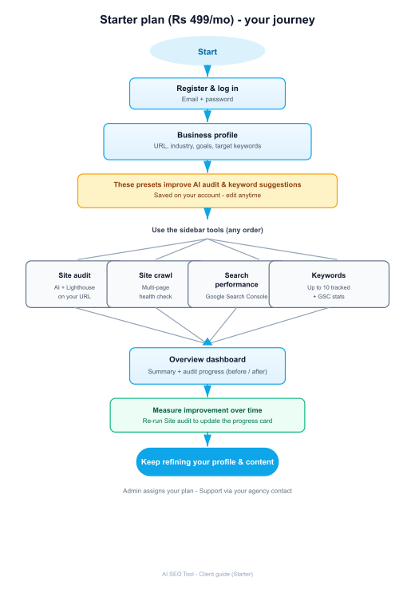

Troubleshooting
Issue | What to check
Audit AI errors | GEMINI_API_KEY on server or your Gemini key in profile
Missing Lighthouse scores | PageSpeed API key (server or BYOK)
GSC will not connect | OAuth client + redirect URI in Google Cloud
Cannot add 3rd calendar item | Starter cap is 2 — delete an item or upgrade
AI SEO Tool — end of document

