How to Explain the Stratus QA Tool — A Pitch Script
A simple, jargon-free script you can use to explain the testing tool to anyone — a manager, a new hire, a client, or your mom. No coding terms. Just plain English.

1. The 30-second pitch (memorize this)
Use this whenever someone says "so what does your tool do?"
"Stratus has hundreds of screens. Right now, every time the developers change something, someone from QA has to manually click through every screen to make sure nothing broke. That takes weeks. I built a tool that does the clicking automatically. We trained it once — using AI as the trainer — and now it knows every kind of screen in Stratus and what tests to run on each one. The tool runs on a regular computer. No cloud. No subscription. No monthly bill. Anyone on the team can run it. You paste the website address, paste the password, click one button. A few hours later you get a report: here are the bugs, here are the screenshots, here's where to find them."
That's the whole thing. One paragraph. 30 seconds.

2. The "trained employee" analogy (when they want to understand HOW)
This is the analogy that lands. Use it when someone asks "but how does the tool know what to test?"
"Think of it like hiring a brilliant employee and training them for three months. After that, they know your business inside and out. They go to work every day, they don't ask questions, they just do the job — for years. That's our tool. We spent the training period — the build phase — using AI as the teacher. The AI looked at Stratus, studied every kind of screen, wrote down all the rules: 'a list screen has these patterns, a form has these patterns, a price field should be tested with negative numbers, an SKU field should be tested for duplicates.' Once that training was written down, the AI's job was done. We saved all those rules in a file. Now the tool reads those rules and tests Stratus on its own — no cloud connection, no AI bill, no subscription. It's like the difference between paying a consultant by the hour forever, versus paying once for the consultant's playbook."

3. The picture for a whiteboard
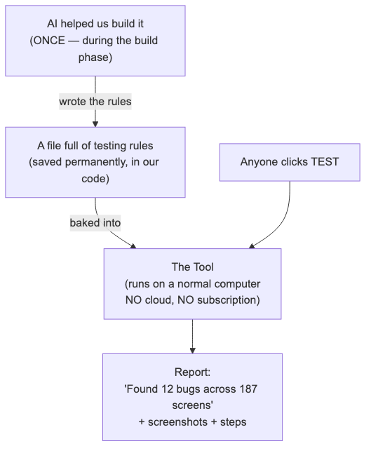
Diagram 1
The key sentence to say while pointing at the diagram:
"The AI is on the LEFT side — used once, finished. Once we built the rule book, the AI is no longer needed. The tool on the RIGHT side runs forever, on a normal computer, with no ongoing cost."

4. The 3-step "how do I actually use it" pitch
When someone says "OK, so how would I use this?" — give them exactly 3 steps.
"Step 1. Open the tool. You see one screen with two text boxes. *Step 2. Paste the website address (like 'dev-stratus.company.com') and your QA username and password. Step 3. Click TEST. Walk away. Come back in a few hours or come in the next morning. The tool reads its built-in rule book, walks through every screen in Stratus, tries different kinds of input — like a real tester would — takes screenshots, checks the database, and writes you a report. That's the whole job. No coding. No setup. No cloud."*

5. Common questions and how to answer them

If they ask… | You say…
"Can't we just hire more manual testers?" | "Sure, but every release we'd have to test all 200 screens again. The tool does that overnight, automatically, for free. People sleep, the tool doesn't."
"What about that AI testing thing — Mabl or testRigor?" | "Those tools cost $30,000 to $100,000 every year, forever. Our tool costs us once to build, then $0 every year after. Same idea, way better economics."
"What if our app changes a lot?" | "When a new screen appears, the tool figures it out on its own — that's what the built-in rules are for. When a brand-new type of screen ships (rare — happens once a year), we add one rule to the rule book. Five minutes."
"Why is there no monthly cost?" | "Because we use AI once — during the build — to write down all the rules the tool needs. After that, the tool just reads the rules. It doesn't call the cloud. No API fees."
"What if the AI we used goes out of business?" | "Doesn't matter. The rules they helped us write live in our code. The tool doesn't talk to any AI service to run."
"What about screens with money — payments, receipts?" | "Those get special treatment. A senior QA writes the exact test for each money flow, and engineering reviews it. The auto-tool is not allowed to touch them. Money flows demand certainty, not best-guess."
"What if a screen is really unusual?" | "Then we write that one screen by hand — plain Python — the old way. About 5% of screens end up here. The rest are auto-tested."
"How long to build for the whole project?" | "About fourteen weeks with two engineers. After that, we spend nothing. The tool just runs."
"What happens when a test fails?" | "Three things: a screenshot of the screen at the moment of failure, a short video of the whole test, and the exact error. You can tell in 60 seconds whether it's a real bug or a flaky test."
"Does it know our business rules?" | "Yes — there's a file we update as a team. Things like 'consignor must be 18+', 'negative prices should be rejected'. It's a few lines of plain text. Anyone can add to it."
"Who maintains the tool itself?" | "An automation engineer, part-time. The bulk of the rules don't change — Stratus' patterns are stable. Maintenance is occasional, not constant."

6. The hallway one-liner
For when someone walks by and asks "hey what are you working on?" — you have 10 seconds.
"A tool that auto-tests every screen in Stratus from a single button click. Built once with AI. Runs forever with no subscription."
18 words. The whole thing.

7. The progression — pick the right version for the moment

You have… | Use the…
10 seconds | One-liner (§6)
30 seconds | The pitch (§1)
2 minutes | Pitch + trained-employee analogy (§1 + §2)
5 minutes | Pitch + analogy + whiteboard diagram + 3 steps (§1 + §2 + §3 + §4)
15 minutes | All of the above + walk through one real Q&A from §5
30 minutes | Open the Quickstart guide and add a real screen together

8. What NOT to say
Avoid these — they make people's eyes glaze over and they don't help your case:
- ❌ "YAML"
- ❌ "Heuristics"
- ❌ "Pattern engine"
- ❌ "Pytest"
- ❌ "Playwright"
- ❌ "Page Object Model"
- ❌ "CI/CD pipeline"
- ❌ "Hibernate"
- ❌ "Schema-driven"
- ❌ "LLM"
- ❌ "Computer-use agent"
Use these instead:
- ✅ "Rule book"
- ✅ "The tool"
- ✅ "Trained once"
- ✅ "Runs on a normal computer"
- ✅ "No subscription"
- ✅ "No cloud connection"
- ✅ "Screen-by-screen testing"
- ✅ "Nightly check"
- ✅ "The database"
The technical words only help when you're talking to engineers. For everyone else, the simple words land.

9. The "money sentence" — how it beats commercial tools
When you're pitching to a manager or owner, the strongest single sentence in the entire pitch is this:
"A commercial AI testing tool costs thirty to a hundred thousand dollars every year. Ours cost once to build, then zero. After year one we're already saving money. After year five we've saved over a hundred thousand."
Say it slowly. Watch their face. That sentence wins meetings.

10. The closing line (use this to end a pitch)
"It turns testing from something only one or two people can do — slowly, by hand — into something the whole team can run on demand, that costs us nothing to keep using, on every screen, forever."
That's the win. Say it slowly. Let it sit.

11. Quick reference card — print and keep on your desk
WHAT IT IS: A tool that automatically tests every screen in Stratus.
WHO USES IT: Anyone on the team. No coding.
HOW THEY USE IT:
- Paste website address.
- Paste credentials.
- Click TEST.
WHAT IT CHECKS:
- The screen (clicks, fills, submits)
- The network (the right call was made)
- The database (the data was really saved)
WHAT MAKES IT DIFFERENT:
- Built once — AI helped during the build phase, then it's done
- Runs on a normal computer — no cloud, no subscription
- Zero ongoing cost — no API fees, no monthly bill, ever
- Anyone can use it — no coding required
HOW LONG IT TAKES:
- Building the whole tool: 14 weeks (one time)
- Adding one new screen: 0 minutes (the tool figures it out)
- A nightly test run: 30-60 minutes — unattended
WHY IT'S BETTER:
- vs hand-coding: 200 fewer broken files
- vs hiring more testers: never sleeps, never gets bored
- vs commercial AI tools: saves $90-180k over 5 years
- vs LLM-at-runtime tools: no per-test API bills

*Want to see what the tool actually looks like when it runs, or how a real test run produces its report? Open the Quickstart for QA (see quickstart-for-qa.docx). Want the architecture details? Open the Architecture guide (see architecture.docx).*

