Stratus QA Automation Platform — Architecture & Design
Audience: leads, automation engineers, and anyone evaluating the approach. Manual QA team — you don't need to read this; jump to the Quickstart for QA (see quickstart-for-qa.docx). Come back here when you're curious why the tool works the way it does.
Design principle: Built once. Runs forever. No subscriptions, no API bills, no per-test costs. AI is used once during the build phase to generate the rules and heuristics. After that, the tool runs purely on deterministic local code. Nothing calls the cloud at runtime.

Table of contents
- The problem at real scale
- The big idea — Build Once, Run Forever
- The economic constraint that shaped this design
- The three tiers — Money / Auto-discovered / Manual
- The setup phase — used once, then never again
- How the tool works at runtime (zero API calls)
- The Knowledge Base — what gets committed to git
- How a user actually uses it
- Layered architecture
- Tier 0 — money-flow specs (required)
- Tier 1 — auto-discovered (the default)
- Tier 2 — manual YAML overrides (when auto is wrong)
- Tier 3 — hand-coded escape hatch
- Folder structure
- Personas
- Honest tradeoffs — build-once vs LLM-at-runtime
- Cost model — zero ongoing
- Rollout plan
- Documentation strategy
- Why this approach vs alternatives
- Risks and mitigations
- Glossary pointer
- Appendix A — Mapping to Stratus' real architecture
- Appendix B — One-page exec summary

1. The problem at real scale
Stratus BackOffice has hundreds of screens. Every release, someone has to verify none of them broke. The traditional answers all fail at this scale:

Approach | Why it fails
Manual regression by QA team | Takes weeks per release. People miss things. Doesn't scale.
One hand-coded automated test per screen | 200+ Python files; each breaks differently when JSP changes.
Generic record/playback (Selenium IDE) | No version control, no parameterization, dies in 6 months.
Commercial AI testing tool | $30-100k per year forever. Vendor lock-in. Still needs setup.
LLM-driven testing at runtime | Per-night API bill grows with screen count. If you can afford the LLM, you could just pay a QA salary instead.
Build-once, deterministic tool (this design) | One-time build cost, then zero ongoing cost. Decades of value from a single investment.

2. The big idea
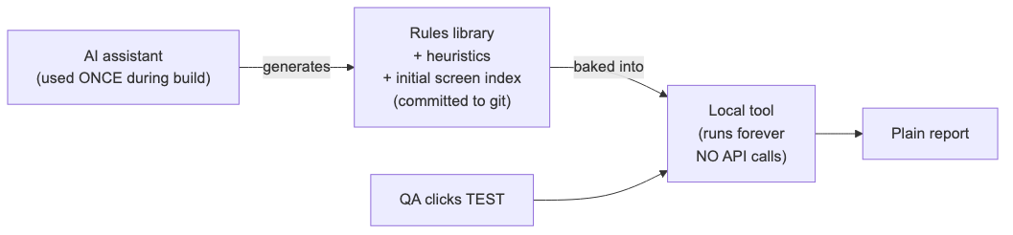
Diagram 1
The AI is a consultant we hire once, not an employee on the payroll forever. It produces a rules library, that library gets committed to git, and from that day forward the tool runs purely on local deterministic code. Nothing dials out. No tokens. No bills.
This matches the SQL agent pattern: AI helped build it, then it runs locally on its own.

3. The economic constraint
A test automation tool is only valuable if it eliminates ongoing cost, not just shifts it from people to APIs. Two failure modes to avoid:

Trap | Why it's a trap
"Just use the LLM at runtime" | $50-100 per nightly run = $20-36k/year. At that price you could just hire another QA. The tool replaced a recurring cost with another recurring cost.
"Buy a commercial AI testing tool" | $30-100k/year. Vendor lock-in. Same problem, more expensive.

The math we want:

 | One-time | Annual ongoing
Build the tool | ~14 weeks × 2 engineers | $0
Maintain the tool | — | Code changes only when Stratus changes
Run nightly regression | — | $0
Add a brand-new screen | — | 0 minutes (auto-discovered)

That's the bar. Anything else is just renting intelligence by the hour.

4. The three tiers
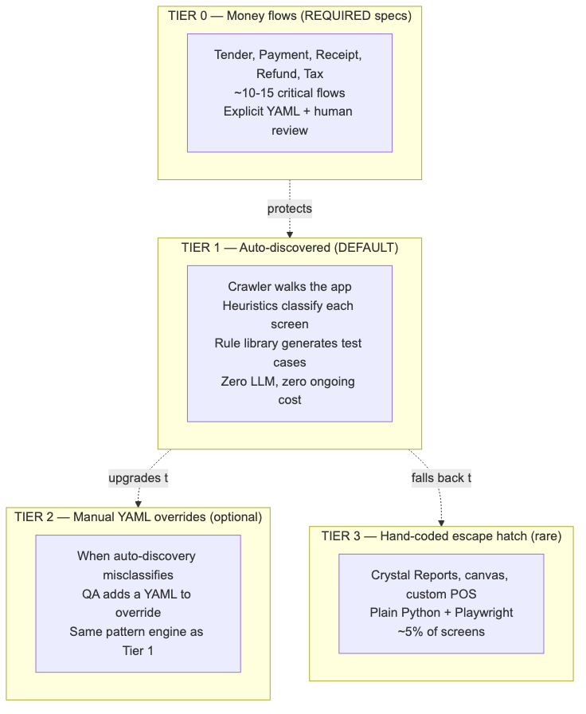
Diagram 2

Tier | What | Who maintains | Coverage | Runtime cost
0 — Money flows | Explicit specs for ~10-15 critical financial flows | Senior QA + Eng | ~5% of screens, 80% of business risk | $0
1 — Auto-discovered (default) | Deterministic crawler + heuristic classifier + rule-based test generator | Nobody — runs itself | ~80% of screens | $0
2 — Manual YAML overrides | QA adds a YAML when auto-discovery gets a screen wrong | Manual QA when needed | ~10% of screens | $0
3 — Hand-coded | Python tests for genuinely weird screens | Automation engineer | ~5% of screens | $0

Every tier runs locally. Every tier costs $0 per night. The only ongoing cost is electricity.

5. The setup phase
This is the one-time AI-assisted build. Happens once during Phase 1. After this, AI is not in the loop anymore.
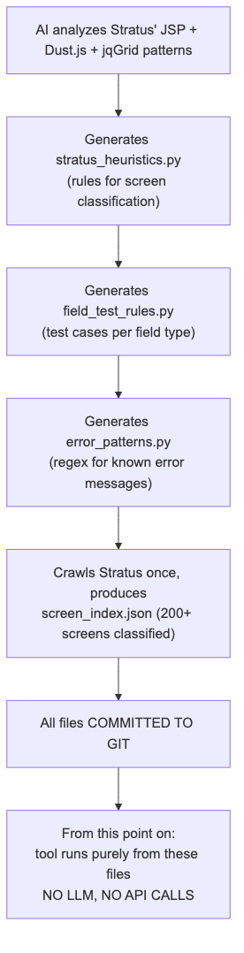
Diagram 3

What gets generated, once

File | What it contains | Lines (est.)
stratus_heuristics.py | Python rules: "if DOM contains <table class="jqgrid"> → list screen. If it has <div class="wizard-step"> → wizard…" | ~300
field_test_rules.py | "For type=number, min=0 → test 0, -1, 0.01, 999999999, empty, 'abc'. For type=text, maxlength=50 → test 0, 1, 50, 51, 100, unicode, SQL injection patterns…" | ~400
error_patterns.py | Regex library: known Stratus error message patterns and how to recognize them | ~150
screen_index.json | Static index of every screen the crawler found, with its classification | ~200 entries
business_rules.py | Stratus-specific rules ("consignor must be 18+", "negative prices rejected") | ~100

Total: ~1,200 lines of code, written once, used forever.
After this is done, anyone on the team can git pull and have a working testing tool. No API keys. No cloud setup. No subscriptions.

6. How the tool works at runtime
The same six-step pipeline as a smart AI agent — but every step is deterministic local code.
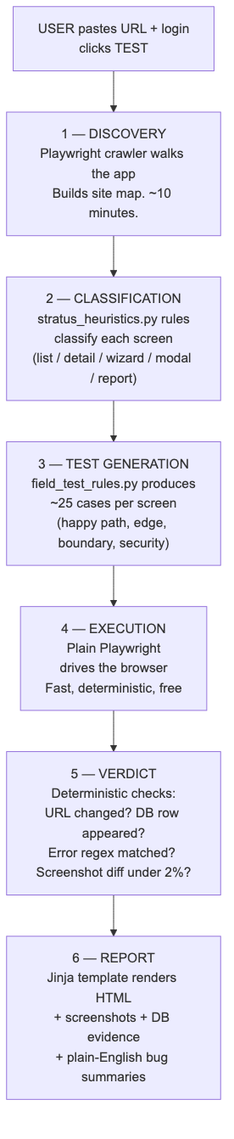
Diagram 4

What each step uses (and does NOT use)

Step | Uses | Does NOT use
1. Discovery | Playwright + Python | LLM, vision API
2. Classification | DOM inspection rules in Python | LLM, vision API
3. Test generation | Static rule library | LLM, reasoning API
4. Execution | Playwright | Computer-use agent, LLM
5. Verdict | URL diff, DB query, regex match, screenshot pixel-diff | LLM judge
6. Report | Jinja2 templates + pre-written bug-description templates | LLM writer

Total external API calls per run: 0.

7. The Knowledge Base
The Knowledge Base is the set of files generated during setup and committed to git. It is the durable, valuable artifact of the project.
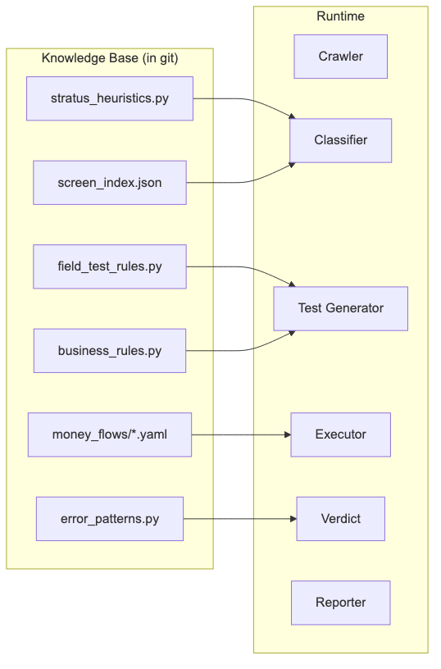
Diagram 5
The Knowledge Base lives forever. When Stratus adds a new screen type, you update one rule in stratus_heuristics.py (a 5-minute change) and commit. The tool now handles that new screen type forever, at no runtime cost.
This is the difference between owning intelligence and renting it.

8. How a user actually uses it
Diagram 6
Workflow: paste, click, wait, read. Same as before. The user experience does not change. What changed is what's inside the box.
For the remaining 20%:
- New money flow → senior QA writes a Tier 0 YAML
- Auto-discovery misclassifies a screen → QA writes a Tier 2 YAML
- Genuinely weird screen → automation engineer writes Tier 3 Python
These are escalations, not the default.

9. Layered architecture
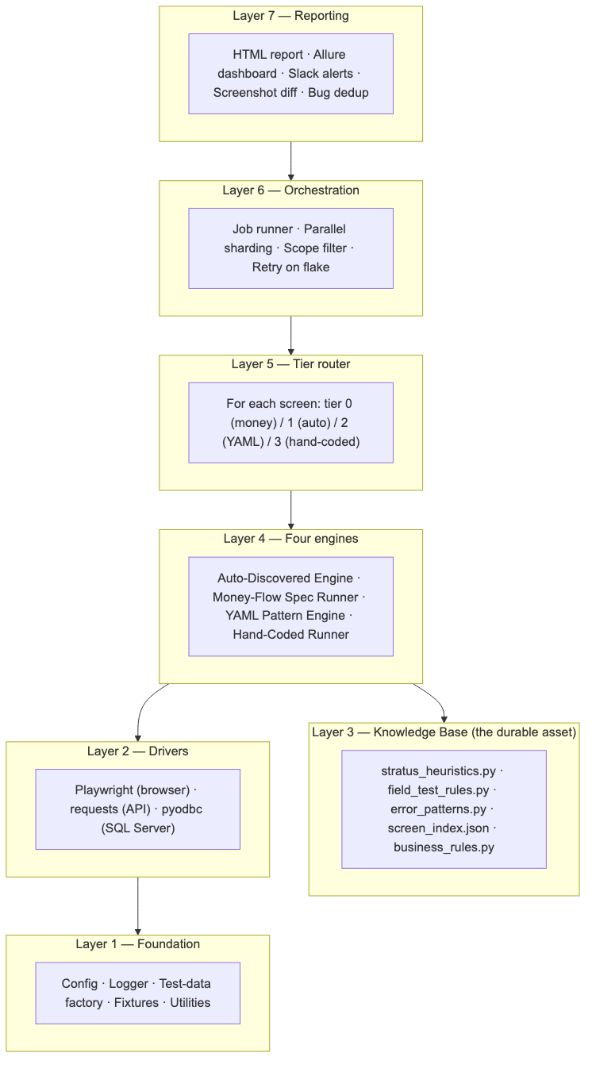
Diagram 7
Note: Layer 3 (Knowledge Base) is now the durable centerpiece. It replaces what was previously an LLM client.

10. Tier 0 — money-flow specs
The protected layer. Required, not optional.
These flows touch money or compliance — tender, payment, receipt, refund, tax calculation, frequent-buyer credit, trade credit. Bugs here are reputational and legal incidents, not just inconveniences.
For each Tier 0 flow:
- A senior QA writes an explicit YAML spec (specific amounts,
specific expected DB rows, specific receipt outputs)
- Engineering reviews it
- Auto-discovery is not allowed to mutate the spec
- Test runs are deterministic and reproducible
- A failure pages someone immediately

Example: money_flows/credit_card_tender.yaml
YAML
flow:
id: credit_card_tender
tier: 0
owners: [senior_qa@example.com, eng_lead@example.com]
pages_on_failure: true

scenarios:
- id: TC-CC-01
name: "Authorize and capture $42.13 on a Visa"
steps:
- login: { user: pos_user, store: "001" }
- open: { screen: pos_main }
- add_item: { sku: "TEST-SKU-42", qty: 1 }
- tender: { type: visa, amount: 42.13, last4: "4242" }
- confirm
expect:
ui:
- { selector: "#receiptTotal", equals: "42.13" }
- { selector: "#authCode", matches: "^\\d{6}$" }
db:
- "SELECT total FROM Receipt WHERE id = ?"
equals: 42.13
- "SELECT auth_code FROM TenderLine WHERE receipt_id = ?"
matches: "^\\d{6}$"

Maybe 10-15 of these get written, total, for the whole project. They take a day each. They never change unless the business rule changes.

11. Tier 1 — auto-discovered
The default. Covers ~80% of screens with zero ongoing setup.
The tool runs the full six-step pipeline (discovery → classification → test generation → execution → verdict → report) for every screen the crawler finds.
All intelligence comes from the Knowledge Base files committed to git. The tool never makes an external call.

Adding a new screen
When developers ship a new screen:
- They commit and deploy.
- That night, the crawler walks the app and finds the new URL.
- The classifier inspects its DOM and tags it (list / detail / etc.).
- The test generator produces ~25 cases for it.
- The executor runs them.
- The report shows results in the morning.
Zero QA work was required. This is the promise of build-once.

When auto-discovery is wrong
Sometimes a screen confuses the classifier — maybe it has a custom layout the heuristics don't recognize. Two options:
- Quick fix: add one rule to stratus_heuristics.py (5 minutes,
fixes that screen + every future screen like it)
- Per-screen override: write a Tier 2 YAML for that one screen
The first option is preferred when the misclassification is general.

12. Tier 2 — manual YAML overrides
The same pattern engine concept, but now opt-in rather than the default.
When you write a Tier 2 YAML:
YAML
screen:
id: sku_detail
type: detail
tier: 2 # forces this tier instead of auto
url: /stratus?screenType=skuDetail&id={sku_id}

detail:
fields:
- { name: skuId, selector: "#skuId", type: text, required: true }
- { name: price, selector: "#skuPrice", type: decimal, min: 0 }
buttons:
save: { selector: "#btnSave", on_success: "navigates_to_list" }

The pattern engine runs deterministic tests against this spec. Same as Tier 1, but with the screen's structure manually specified instead of inferred.
See Quickstart for QA (see quickstart-for-qa.docx) for the full YAML authoring guide.

13. Tier 3 — hand-coded escape hatch
Plain Python + Playwright in tests/custom/. For the 5% of screens that genuinely don't fit any pattern:
- Crystal Reports viewer (custom iframe, embedded JS controls)
- Receipt designer (canvas-based drag/drop)
- Multi-window POS checkout (popup management)
- Third-party payment iframes
This tier guarantees we can say "yes, every screen is tested" — even when the other three tiers can't reach a particular screen.

14. Folder structure
qa-automation/
├── README.md ← top-level quickstart
├── docs/ ← docs site (MkDocs)
│ ├── index.md
│ ├── architecture.md ← this document
│ ├── quickstart-for-qa.md ← non-coder how-to
│ ├── PITCH.md ← simple explainer
│ ├── glossary.md
│ └── word/ ← Word versions of all docs
│
├── requirements.txt
├── pytest.ini
├── .env.example
├── conftest.py
│
├── stratus_qa/ ← THE FRAMEWORK
│ ├── config/
│ ├── drivers/
│ │ ├── ui_driver.py ← Playwright wrapper
│ │ ├── api_driver.py ← /stratus client
│ │ └── db_driver.py ← SQL Server helper
│ ├── engines/
│ │ ├── auto_discovery/ ← TIER 1 — six-step pipeline
│ │ │ ├── crawler.py
│ │ │ ├── classifier.py
│ │ │ ├── generator.py
│ │ │ ├── executor.py
│ │ │ ├── verdict.py
│ │ │ └── reporter.py
│ │ ├── money_flow_runner.py ← TIER 0
│ │ ├── yaml_pattern_engine.py ← TIER 2
│ │ └── hand_coded_runner.py ← TIER 3
│ ├── tier_router.py ← chooses tier per screen
│ ├── cli/
│ │ ├── test.py ← `stratus-qa test` (the button)
│ │ ├── crawl.py ← rebuild screen_index.json
│ │ ├── new_screen.py ← scaffold a Tier 2 YAML
│ │ ├── validate.py
│ │ └── doctor.py
│ └── reporting/
│
├── knowledge_base/ ← THE DURABLE ASSET
│ ├── stratus_heuristics.py ← screen classification rules
│ ├── field_test_rules.py ← test cases per field type
│ ├── error_patterns.py ← known error regex
│ ├── screen_index.json ← every screen, classified
│ └── business_rules.py ← Stratus-specific rules
│
├── money_flows/ ← TIER 0 — ~10-15 specs (REQUIRED)
│ ├── credit_card_tender.yaml
│ ├── cash_tender.yaml
│ ├── refund.yaml
│ └── tax_calculation.yaml
│
├── catalog/ ← TIER 2 — optional YAMLs
│ └── (only when auto-discovery is wrong)
│
├── tests/
│ ├── conftest.py
│ ├── custom/ ← TIER 3 — hand-coded
│ ├── smoke/ ← critical-path checks
│ └── generated/ ← cached generated tests
│
└── reports/ ← run artifacts (git-ignored)
├── report.html
├── allure-results/
├── screenshots/
└── videos/

15. Personas
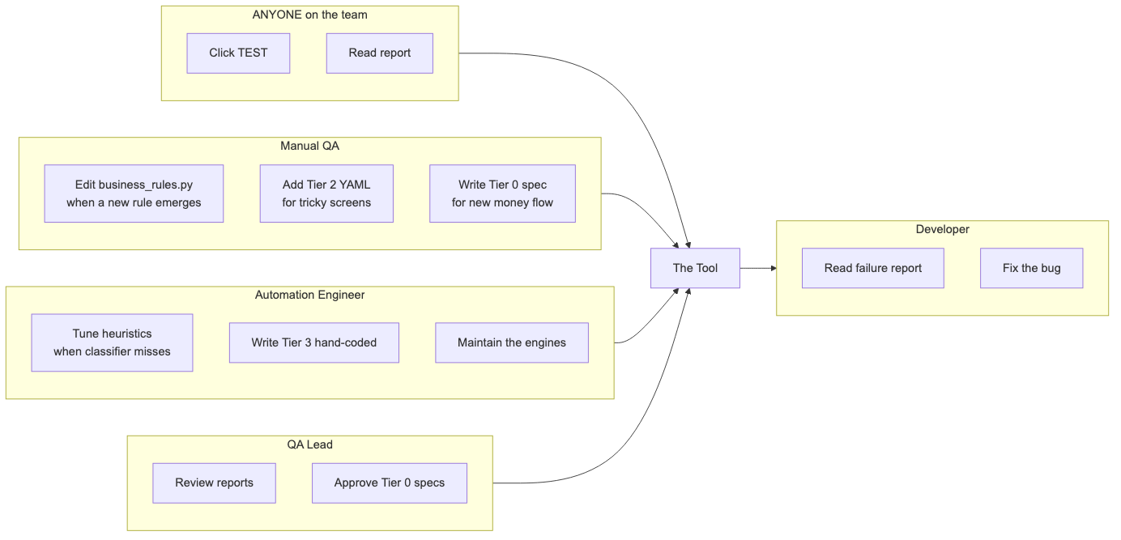
Diagram 8

Persona | Day-1 productivity | Touches
Manual QA | Hour 1 (click TEST) | business_rules.py, optionally YAML
QA Lead | Day 1 (read reports) | dashboard, Tier 0 approvals
Automation Eng | Week 2 | heuristics, Tier 3 Python
Developer | Hour 1 | nothing in the test framework
Anyone | Five minutes | the tool

16. Honest tradeoffs
If a vendor pitched you LLM-at-runtime testing without mentioning these, walk away.

LLM-at-runtime gives | Build-once gives | Worth the trade?
Auto-adapts to brand-new screen types we've never seen | Add a heuristic rule (5 min) when a genuinely new type ships | ✅ Yes — happens once a year, not daily
"Smart" edge case generation per screen | Generic edge cases per field type | ✅ Yes — generic catches 90%+ of bugs
Plain-English bug descriptions | Templated bug descriptions | ✅ Yes — templated is more consistent
Self-healing via vision | Multiple selector fallbacks (id → name → label) | ✅ Yes — works for 95% of breakage
No initial setup | One-time build (14 weeks) | ✅ Yes — pay once, save forever
$20-36k/year ongoing | $0/year ongoing | ✅ Always yes

The honest summary: we trade "infinitely flexible but expensive forever" for "very flexible and free forever." That's a great trade for an enterprise system that will run for years.

17. Cost model

Cost item | LLM-at-runtime | Build-once (this design)
One-time build | 8 wk × 2 eng | 14 wk × 2 eng
One-time AI consulting (rules generation) | — | ~$200 total
Per nightly run | $50-100 | $0
Per month | $1,500-3,000 | $0
Per year | $18,000-36,000 | $0
5-year ongoing total | $90,000-180,000 | $0
Tool maintenance | LLM API changes break tests | Code changes only when Stratus changes
If LLM provider goes down | Tests can't run | Tests run as normal
If budget gets cut | Tool stops working | Tool keeps working

Build-once costs +6 extra build weeks upfront and saves $90-180k over 5 years. Even at the lowest LLM pricing tier, the math is overwhelming.

18. Rollout plan
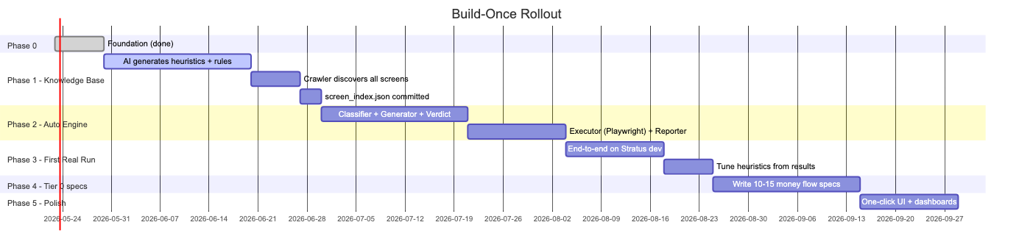
Diagram 9

Phase | Length | Deliverable
0 — Foundation | 1 wk | ✅ done
1 — Knowledge Base | ~4 wk | AI generates heuristics, rules, screen index. Committed to git. AI exits the project.
2 — Auto-Discovery Engine | ~5 wk | Six-step pipeline working end-to-end against a test app
3 — First Real Run | ~3 wk | Engine runs against Stratus dev, produces real report, heuristics tuned
4 — Tier 0 specs | ~3 wk | 10-15 money-flow specs written and green in CI
5 — Polish | ~2 wk | One-click UI, dashboards, alerting

Total: ~14 weeks with 2 engineers. End state: anyone on the team can test the entire BackOffice by pasting a URL and clicking a button, with zero ongoing cost for the lifetime of the tool.

19. Documentation strategy
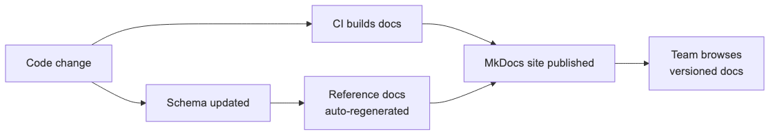
Diagram 10

Document | Audience | Format | Update trigger
Quickstart for QA | Day-1 hires | Markdown + screenshots | New CLI command
Architecture (this) | Leads, engineers | Markdown + Mermaid | Framework redesign
PITCH | Anyone explaining to non-technical people | Markdown | Major pitch refresh
Knowledge Base reference | Anyone updating heuristics or rules | Cookbook style | New rule pattern
Tier 0 spec reference | QA writing money flows | Schema reference | Spec format change
Cookbook | "How do I…?" recipes | Q&A format | New recipe added
Troubleshooting | When stuck | Symptom → fix table | Each known issue

Hosted via MkDocs with Material theme. Diagrams are Mermaid so they version with the code.

20. Why this approach

Alternative | Why we reject it
Manual regression only | Doesn't scale; humans miss things; weeks per release
Hand-coded Page Object per screen | 200 files of broken code as JSP changes
Pure YAML pattern engine (per-screen setup) | Adoption suffers — every new screen needs a QA to write a YAML
LLM at runtime | $20-36k/year ongoing. If we can afford the LLM, we could hire another QA.
Commercial AI tool (Mabl, testRigor, Reflect) | $30-100k/year + vendor lock-in
Pure computer-use agent | Slow, expensive, fragile on jQuery-heavy JSP screens
This — build-once with three tiers | Pay once, save forever. AI used for the durable artifact, not the recurring spend.

21. Risks and mitigations

Risk | Likelihood | Impact | Mitigation
Heuristics get a brand-new screen wrong | Medium | Low | Quick 5-minute rule addition to stratus_heuristics.py
Field rules miss a sneaky edge case | Medium | Medium | QA adds the case to field_test_rules.py — fix benefits all future screens
Knowledge Base becomes stale | Medium | Medium | Crawler re-runs nightly, flags screens whose classification changed
Self-healing selector picks wrong fallback | Low | Low | Every fallback choice logged + visible in report
Tests pollute DB with junk data | Medium | Medium | Each test in a transaction or uses unique-ID test data
Same bug found Tuesday, missed Wednesday | Low (deterministic) | Low | Tier 0/2 deterministic by design; Tier 1 also fully deterministic
Stratus is rewritten on a new framework | Low | High | Heuristics file gets rewritten once (~1 day) for the new framework
Tool breaks because Playwright API changes | Low | Medium | Pin Playwright version; upgrade once per quarter
Devs stop adding data-test attrs | High | Low | Heuristics work fine without them; selector fallbacks cover gaps

22. Glossary pointer
If any term in this document is unfamiliar, see Glossary (see glossary.docx). It explains every term in plain English — no prior knowledge assumed.

Appendix A

Mapping to Stratus' real architecture
How each tier interacts with Stratus' actual components:

Stratus piece | How it's tested
WebContent/login.jsp + UserAuthenticationServlet.do | Tier 1 crawler handles login; explicit test in tests/smoke/
StratusServlet (/stratus dispatcher) | Tier 1 discovers screenTypes by crawling; Tier 0 specs hit specific dispatchers for money flows
JSP + jQuery + Dust.js + jqGrid | Tier 1 inspects rendered DOM with stratus_heuristics.py; Tier 2 YAMLs supplement when jqGrid is brittle
Hibernate entities (Receipt, TradeCard, Sku, Customer, …) | DB verifier confirms persistence (Tier 0/1/2)
CrystalReportViewerHandler | Tier 3 hand-coded
TSYS / Shift4 card processors | Tier 0 specs with sandbox creds
Crystal Reports rendering | Tier 3 hand-coded

Appendix B

One-page exec summary
Problem: Stratus has hundreds of screens. Manual regression takes weeks per release; hand-coded automation grows to 200 unmaintainable Python files; LLM-at-runtime testing costs $20-36k/year forever and can be replaced by hiring another QA at the same price. Solution: A build-once testing tool. AI is used during the build phase (once) to generate a Knowledge Base — heuristics, rules, patterns — that gets committed to git. After build, the tool runs purely on local deterministic code. User pastes URL + credentials, clicks one button, reads a plain-English report. No API calls. No subscriptions. No ongoing cost. Safety nets: ~10-15 critical money flows (tender, payment, receipt) get explicit human-written specs. The 5% of weird screens (Crystal Reports, canvas) get hand-coded tests. Everything else — ~80% of the app — runs autonomously via the Knowledge Base. Build cost: ~14 weeks with 2 engineers. Operating cost: $0/year. Forever. 5-year savings vs LLM-at-runtime: $90-180k. Ongoing per-screen cost: Zero. New screens get tested the night they ship, no setup required. Who can use it: Anyone on the team who can paste a URL and click a button. No coding. No API keys. No subscriptions.

