Quickstart for Manual QA
Audience: manual QA team members who have never written code. If you can edit a Word document and an Excel spreadsheet, you can use this tool.
This guide walks you through adding one new screen to the automated test suite, end-to-end, in about 30 minutes.

The promise
By the end of this guide, you will:
- Pick a screen you want tested (e.g. "Tax Code List").
- Run one command that creates a starter file for you.
- Fill in the file in a text editor (just text — no programming).
- Drop your test cases in an Excel spreadsheet.
- Run one command to execute ~25 tests automatically.
- See a nice HTML report with screenshots.
You will never open a Python file. You will never write code.

Table of contents
- How the tool thinks about screens
- Before you start — one-time setup
- Step 1 — Pick the screen
- Step 2 — Create the YAML file
- Step 3 — Fill in the YAML
- Step 4 — Write your test cases in Excel
- Step 5 — Run the tests
- Step 6 — Read the report
- Common situations — recipes
- When something goes wrong
- Where to ask for help

1. How the tool thinks about screens
The tool understands five shapes of screen. Every screen you ever test falls into one of them:
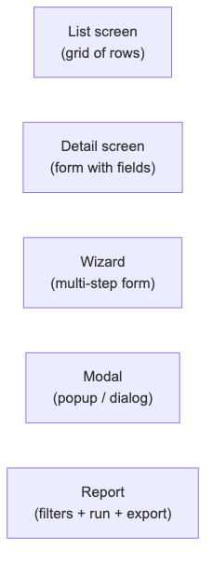
Diagram 1
Examples in Stratus:

Shape | Real Stratus screens
list | Customer List, SKU List, Receipt List, Tax Code List
detail | Customer Detail, SKU Detail, Employee Detail
wizard | Buy/Trade Intake, Consignment Intake, POS Checkout
modal | Login, Override Password, Lookup picker, "Are you sure?"
report | Sales report, Inventory report, Crystal Reports

Before you start, decide which shape your screen is. That's the single most important decision — the rest is mechanical.

2. Before you start
One-time setup. Skip this section if your laptop has already been set up by the automation team.
Open Terminal (Mac) or Command Prompt (Windows) and run:
BASH
cd /path/to/stratus_backoffice_develop/qa-automation
python3 -m venv .venv
source .venv/bin/activate # Windows: .venv\Scripts\activate
pip install -r requirements.txt
playwright install chromium
cp .env.example .env

Open .env in any text editor and fill in your DEV environment values:
INI
APP_BASE_URL=http://dev-stratus.example.com/backoffice
TEST_USER=qa_automation
TEST_PASSWORD=ChangeMe123
DB_HOST=dev-sql.example.com
DB_USER=sa
DB_PASSWORD=YourPassword
DB_NAME=stratus_dev

Now run the health check:
BASH
pytest -m smoke

If you see 3 green PASSED lines, you're set. If anything is red, see When something goes wrong.

3. Step 1 — Pick the screen
For this guide we'll use "Tax Code List" as our example. In your real work, pick any screen that doesn't have a YAML file yet.
Tip: check catalog/ to see which screens are already covered. Don't duplicate.
Open the screen in your browser, log in, and just look at it for a moment. Ask yourself:
- Is this a list (a grid)? → use the list pattern.
- Is this a form (boxes to fill in)? → use the detail pattern.
- Are there Next / Back buttons? → it's a wizard.
- Did it pop up over another screen? → it's a modal.
- Does it have a Run button and Export options? → it's a report.
Tax Code List has a grid + filters + Edit/Delete buttons per row. It's a list screen.

4. Step 2 — Create the YAML file
Run one command to create a starter YAML file:
BASH
stratus-qa new-screen --type list --id tax_code_list

This creates catalog/tax_code/tax_code_list.yaml pre-filled with a template. Open it in any text editor (Notepad, TextEdit, VS Code, or even Excel — it's just text).

5. Step 3 — Fill in the YAML
Here's the template you'll see, with comments explaining every line:
YAML
# WHAT screen is this?
screen:
id: tax_code_list # short name, same as filename
type: list # list / detail / wizard / modal / report
title: Tax Code List # human-readable name
url: /stratus?screenType=taxCodeList # the URL in the browser
api_screen: taxCodeList # ask a developer if unsure
db_table: TaxCode # the SQL Server table name

# WHAT does the LIST look like?
list:
grid_selector: "#taxCodeGrid" # right-click the grid → Inspect → copy the id
row_selector: ".jqgrow" # almost always ".jqgrow" in Stratus

# WHAT COLUMNS does the grid show?
columns:
- { name: taxCodeId, header: "Tax Code ID", db: tax_code_id }
- { name: description, header: "Description", db: description }
- { name: rate, header: "Rate (%)", db: tax_rate }
- { name: active, header: "Active", db: is_active }

# WHAT FILTERS does the page have?
filters:
- { name: storeId, control: dropdown, selector: "#filterStore" }
- { name: search, control: text, selector: "#filterSearch" }

# PAGINATION
pagination:
selector: ".ui-pg-input"
sizes: [10, 25, 50, 100]

# ROW ACTIONS — the buttons inside each row
row_actions:
- { name: view, selector: ".action-view", opens: tax_code_detail }
- { name: edit, selector: ".action-edit", opens: tax_code_detail }
- { name: delete, selector: ".action-delete", confirms: true }

# Pointer to your test data
test_data: data/tax_code_list_cases.xlsx

Where do selectors come from?
A selector is just a short string that tells the tool which thing on the page to click. The two most common kinds:

What you see | Selector
<div id="taxCodeGrid"> | #taxCodeGrid
<button class="action-edit"> | .action-edit

To find one:
- Open the screen in Chrome.
- Right-click the thing you care about → Inspect.
- Look at the highlighted line. If it has id="xyz", write #xyz. If
it has class="abc", write .abc.
If your screen has no IDs, ask a developer to add data-test="…" attributes. That's the single best thing they can do to help QA.

6. Step 4 — Write your test cases in Excel
The YAML says what the screen is. The Excel says which scenarios to test.
Create data/tax_code_list_cases.xlsx with these columns:

case_id | scenario | filter_storeId | filter_search | expected_min_rows | expected_max_rows
TC-01 | no filters — all rows |  |  | 1 | 1000
TC-02 | filter by store 001 | 001 |  | 1 | 100
TC-03 | search for "GST" |  | GST | 1 | 50
TC-04 | invalid store | 999 |  | 0 | 0
TC-05 | empty search |  | "" | 1 | 1000

Each row becomes one test. The column names match the field names in your YAML.
Tip: put one row per "thing you'd want a tester to check manually." If you can describe it in plain English, you can write it as a row.

7. Step 5 — Run the tests
BASH
pytest -k tax_code_list

You'll see something like:
tests/generated/test_tax_code_list.py::test_grid_renders PASSED
tests/generated/test_tax_code_list.py::test_columns_match[taxCodeId] PASSED
tests/generated/test_tax_code_list.py::test_columns_match[description] PASSED
tests/generated/test_tax_code_list.py::test_columns_match[rate] PASSED
tests/generated/test_tax_code_list.py::test_filter[storeId-001] PASSED
tests/generated/test_tax_code_list.py::test_pagination[10] PASSED
tests/generated/test_tax_code_list.py::test_pagination[25] PASSED
tests/generated/test_tax_code_list.py::test_row_action[edit] PASSED
tests/generated/test_tax_code_list.py::test_row_action[delete] PASSED
... (25 tests total)
============================ 25 passed in 1m 12s ============================

You wrote 0 lines of code. 25 tests just ran.

8. Step 6 — Read the report
Open reports/report.html in your browser. You'll see:
- ✅ Every test that passed
- ❌ Every test that failed, with:
  - The exact step it failed on
  - A screenshot of the screen at the moment of failure
  - A short video of the whole test (for UI tests)
  - The exact SQL query that ran (for DB tests)
  - A copy-pastable error message
For trend charts and history across multiple runs:
BASH
allure serve reports/allure-results

9. Common situations — recipes

Q: My screen has a dropdown that loads its options from the database
YAML
filters:
- name: department
control: dropdown
selector: "#filterDept"
source: dept_list # the framework loads options from this lookup

Q: A field is required only when another field is filled in
Drop down to two test data rows — one with the trigger field, one without — and adjust expected_result per row.

Q: My screen has tabs
Add a tabs: block to the detail YAML:
YAML
detail:
tabs:
- { id: general, selector: "#tab-general" }
- { id: addresses, selector: "#tab-addresses" }
- { id: history, selector: "#tab-history" }
fields:
general:
- { name: firstName, selector: "#firstName", type: text }
addresses:
- { name: street, selector: "#street", type: text }

Q: My test needs a specific customer to exist first
Add a setup: block — the framework will create the customer in the DB before the test runs:
YAML
setup:
- create_customer: { firstName: "Test", lastName: "User", storeId: "001" }

Q: My screen is weird and doesn't fit any pattern
That's fine — the escape hatch is for you. Ask the automation engineer to write a hand-coded test in tests/custom/. You give them the test scenarios in plain English; they write the Python.

10. When something goes wrong

What you see | What it means | What to do
playwright._impl._api_types.Error: Executable doesn't exist | Browser not installed | run playwright install chromium
ConnectionRefusedError | App is not running on the URL in .env | check APP_BASE_URL, start the app
pyodbc.InterfaceError | ODBC driver not installed | see Architecture doc, Appendix
TimeoutError: locator(...) waiting for selector | Selector in your YAML is wrong | open the screen, right-click → Inspect, fix the selector
AssertionError: expected_min_rows=1 got=0 | Your test data row found no results — either the data is wrong, or there really is a bug | check manually in the browser first
KeyError: 'taxCodeId' | Column name in Excel doesn't match a column in your YAML | typo somewhere; check spelling
Same test passes sometimes, fails sometimes | Flaky test — usually a timing problem | flag to automation engineer; they tune the wait

If you're stuck for more than 15 minutes, ask for help — don't burn the afternoon on it. See next section.

11. Where to ask for help

Question | Who to ask
"Which screenType does this screen use?" | A developer
"What does this selector do?" | The automation engineer
"Is this screen already covered?" | Search catalog/ for similar names; ask the QA lead
"My YAML won't validate" | Run stratus-qa validate catalog/your_file.yaml — the error message will tell you
"Is this test failure a real bug?" | Reproduce manually in the browser. If it fails there too, file a bug. If it passes there, file a flake report.
"I want to test something the YAML can't express" | Talk to the automation engineer — escape hatch territory

Appendix — The whole flow in one diagram
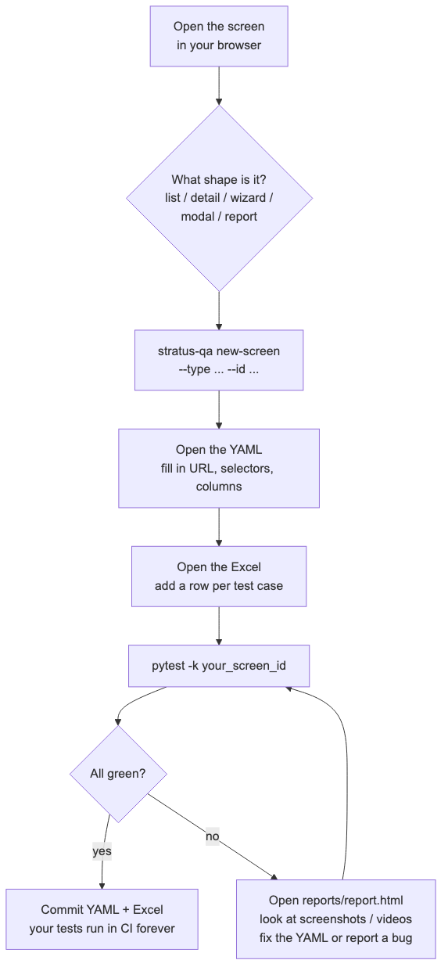
Diagram 2
That's it. Welcome to the team.

