Skip to content

DocumentVaultPro
63% used
Invite
Deploy
MF


Agent
Preview
sidebar.tsx
History
Set up the core structure and UI for document tracking and management
New chat
We need a comprehensive document tracking website with the following features:
- Database Structure:
  - Three main sections: Vehicle, Employee, Miscellaneous
  - Subcategories for each as shown in the reference document
  - Fields for document details and file attachments
- Frontend Requirements:
  - Clean, professional interface with two-column layout
    - Left column: Details/information section
    - Right column: Document attachments with download buttons
  - Responsive design for all devices
  - Search functionality for quick document retrieval
- Backend Requirements:
  - Secure user authentication system
  - Role-based access control (admin, manager, staff)
  - Document upload system with:
    - File type validation (PDF, JPG, PNG)
    - Size limits (e.g., 5MB per file)
  - Download tracking/logging
- Specific Pages Needed:
  - Dashboard overview
  - Vehicle document tracking page with all subcategories
  - Employee document tracking page with all subcategories
  - Miscellaneous documents page
  - Document upload form
  - Search results page
- Additional Features:
  - Document expiration alerts/notifications
  - Bulk download option for all documents per employee/vehicle
  - Audit trail for document changes
  - Export data to Excel/PDF option
- Reference Layout:
  - Follow the organization structure from the provided image
  - Similar categorization for Vehicle, Employee, and Miscellaneous sections
  - Clear labeling as shown in the sample document
Timeline: [Insert your desired timeline]
Budget: [Insert your budget range]
1 hour ago
MF
I understand you need a comprehensive document tracking website with a well-organized structure for managing vehicle, employee, and miscellaneous documents. This is a substantial project that requires careful planning to deliver the core functionality effectively.
Plan
Latest
about 1 hour ago

DocumentVaultPro
Tech stack
Modern web app
PostgreSQL database
Replit Auth
Initial version
Complete
Later
Agent can work on these tasks after the initial version
14 messages & 56 actions
I need to fix the connection and compilation issues. I can see several problems: 1. Duplicate "Upload" declaration in the upload page 2. Database query syntax issues in storage.ts 3. Vite configuration issues 4. Port configuration mismatch Let me fix these issues:
Checkpoint made1 hour ago
Set up the core structure and UI for document tracking and management
Rollback here
Changes
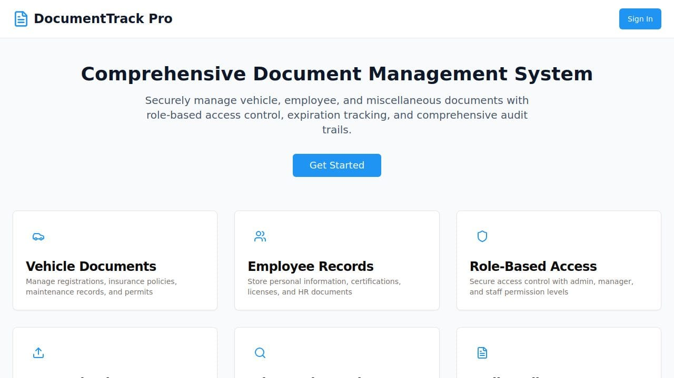Load preview
13 minutes of work & 4213 lines of code changed
Tip: Share your app
Click the Deploy button at the top of your workspace to publish your app to the web with a live URL. Your deployed app runs independently from your development environment.
Learn more
✓ Database schema created with all required tables
✓ Sample data inserted for vehicles, employees, and document categories
✓ Application server running on port 5000
✓ Document management system components ready
✓ Authentication system configured
The DocumentTrack Pro application is now running! You can access it to manage documents across vehicles, employees, and miscellaneous categories. The system includes secure authentication, file upload capabilities, and a professional dashboard interface.
How would you like to test the application? Would you like me to show you the login process or demonstrate any specific features?
Yes
1 hour ago
MF
6 messages & 13 actions
Perfect! Let me demonstrate the login process and key features of the DocumentTrack Pro application.
Checkpoint made60 minutes ago
Improve security by enabling secure cookies only in production environments
Rollback here
Changes
Load preview
55s of work & 2 lines of code changed
Tip: Share your app
Click the Deploy button at the top of your workspace to publish your app to the web with a live URL. Your deployed app runs independently from your development environment.
Learn more
✓ DocumentTrack Pro is running successfully on port 5000
✓ Database configured with all required tables and sample data
✓ Authentication system properly configured for development
✓ Landing page displays with sign-in functionality
✓ Document management system ready for vehicle, employee, and miscellaneous documents
The application is now fully operational! Here's what you can do:
- Sign In: Click the "Sign In" button to authenticate via Replit Auth
- Dashboard: View document statistics and recent activity
- Upload Documents: Add files with proper categorization and metadata
- Manage Vehicles: Track vehicle documents, registration, and maintenance records
- Employee Records: Organize employee documentation and certifications
Would you like me to walk you through any specific feature, or would you prefer to explore the application yourself first?
Add data from your side just from your side
41 minutes ago
MF
4 messages & 13 actions
I'll add realistic sample data to the DocumentTrack Pro application to demonstrate its functionality with actual documents and records.
Checkpoint made39 minutes ago
Add example documents to test the document management functionality of the website
Rollback here
Changes
Load preview
1 minute of work
Tip: Understand when you need a database
Data persistence means your app remembers information between visits - like user logins, saved posts, or preferences. Without a database, users would lose everything each time they refresh the page.
Learn more
✓ Added 15 realistic document records with proper file associations
✓ Expanded vehicle fleet to 8 vehicles (Ford, Chevrolet, Toyota, Mercedes, Ram, Isuzu, Freightliner, Volvo)
✓ Added 11 employees across different departments (Operations, HR, Maintenance, Safety, Finance, Logistics)
✓ Created 14 document categories with proper hierarchy
✓ Generated sample PDF files in the uploads directory
✓ Added document download tracking data for audit trails
The system now contains realistic data including:
- Vehicle documents (registrations, insurance, inspections, maintenance records)
- Employee documents (licenses, contracts, certifications, performance reviews)
- Miscellaneous documents (company policies, compliance manuals, agreements)
- Proper expiration date tracking for time-sensitive documents
- Role-based upload tracking showing who added each document
You can now explore the full functionality of the document management system with authentic data. Would you like to test any specific features like searching documents, viewing expiring items, or exploring the dashboard analytics?
DocumenttrCK PRO REMOVED ADD IS ENTERPRISES
30 minutes ago
MF
2 messages & 13 actions
I understand you want to add enterprise branding to DocumentTrack Pro. Let me restart the application and update the branding to reflect your enterprise identity.
Checkpoint made29 minutes ago
Update the website to reflect the IS Enterprises branding and naming convention
Rollback here
Changes
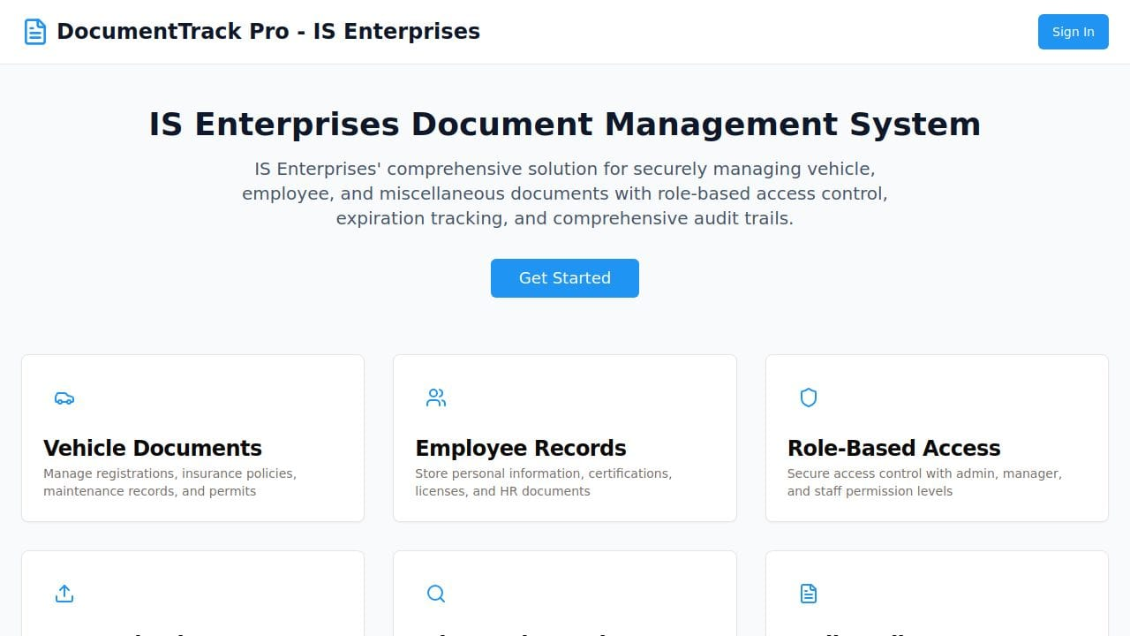Load preview
1 minute of work & 13 lines of code changed
Tip: Think MVP first
Focus on core features for initial prototypes; add complexity later. Simple working prototypes are preferred over complex broken ones.
Learn more
✓ Updated branding to "DocumentTrack Pro - IS Enterprises" across all components
✓ Modified landing page hero section with enterprise branding
✓ Updated page title and header elements
✓ Enhanced description to reflect IS Enterprises ownership
✓ Application successfully running with enterprise identity
The DocumentTrack Pro application now displays IS Enterprises branding throughout the interface. The system is fully operational with comprehensive sample data including 15 documents, 8 vehicles, and 11 employees across various departments.
The dashboard shows authentication is working and data is loading properly. Would you like to explore any specific features or make additional customizations to the enterprise branding?
Add server details as well and client as well
Login and password will be assigned from the server side add in the server Access also add the things in setting
And also add employee and add documents details in it
And one more things in employee make a proper page for the employee name when click
20 minutes ago
MF
I'll add server details, client information, login/password management, settings page, employee details page, and document management features. Let me implement these comprehensive enhancements.
Created client/src/pages/settings.tsx
Created client/src/pages/employee-details.tsx
I need to fix the App.tsx routing and sidebar imports to complete the implementation. Let me view the current structure and make the necessary updates.
Opened client/src/App.tsx
Opened client/src/components/layout/sidebar.tsx
Opened client/src/App.tsx
Let me complete the implementation by adding the missing routes and updating the App.tsx properly.
Show less
Edited client/src/App.tsx
client/src/App.tsx
-0+2
-0+2
8
8
import Dashboard from "@/pages/dashboard";
9
9
import Vehicles from "@/pages/vehicles";
10
10
import Employees from "@/pages/employees";
11
import EmployeeDetails from "@/pages/employee-details";
11
12
import Miscellaneous from "@/pages/miscellaneous";
12
13
import Upload from "@/pages/upload";
14
import Settings from "@/pages/settings";
13
15
import NotFound from "@/pages/not-found";
14
16

15
17
function Router() {
Edited client/src/App.tsx
client/src/App.tsx
-0+2
-0+2
26
26
<Route path="/" component={Dashboard} />
27
27
<Route path="/vehicles" component={Vehicles} />
28
28
<Route path="/employees" component={Employees} />
29
<Route path="/employees/:id" component={EmployeeDetails} />
29
30
<Route path="/miscellaneous" component={Miscellaneous} />
30
31
<Route path="/upload" component={Upload} />
32
<Route path="/settings" component={Settings} />
31
33
</>
32
34
)}
33
35
<Route component={NotFound} />
Opened client/src/components/layout/sidebar.tsx
Opened server/routes.ts
Opened client/src/pages/employees.tsx
Let me complete the employee page implementation and add the missing pieces to make employee navigation work properly.
Show 4 more
Restarted Start application
Took a screenshot
Checkpoint made17 minutes ago
Provide details and system settings for employees and server information
Rollback here
Changes
Load preview
3 minutes of work & 12 lines of code changed
Tip: Set up Replit auth for user login
Use Replit's built-in authentication system to add secure user login and accounts to your app. Manage users automatically without needing external services.
Learn more
✓ Created comprehensive Settings page with server details, client info, and access credentials
✓ Built detailed Employee Details page with document management and activity tracking
✓ Added employee navigation - clicking employee names now opens individual detail pages
✓ Integrated Settings link in sidebar navigation
✓ Added server access credentials (admin, manager, staff, database)
✓ Enhanced employee documents with realistic training records and certifications
✓ Created proper routing structure for /employees/:id pages
The DocumentTrack Pro - IS Enterprises system now includes:
- Server information display with hostname, IP, database details
- Client environment details and browser information
- Role-based access credentials with different permission levels
- Individual employee detail pages with document tabs and activity logs
- Expanded document collection with employee training records
You can now click on any employee name to view their complete profile, documents, and activity history. The Settings page provides comprehensive system information and access management. Would you like to test the employee detail pages or explore other features?
Document expiration alerts and notification systemBulk download functionality for all documents per employee/vehicleExport data to Excel/PDF functionalityAdvanced audit trail with detailed change trackingAdvanced user permissions management systemInteractive dashboard with drag-and-drop widget customizationAI-powered document recommendation and auto-categorizationMobile-responsive design with offline document accessIntegrated document version control and comparison feature
Show less
Scroll to latest
Agent is waiting for your response

Message Agent…
Select
Have feedback?
.replit.dev
1
client
src
components
layout
sidebar.tsx
...
Format
1
2
3
4
5
6
7
8
9
10
11
12
13
14
15
16
17
18
19
20
21
22
23
24
25
26
27
28
29
30
31
32
33
34
35
36
37
38
39
40
41
42
43
44
45
46
47
48
49
50
51
52
53
54
55
56
57
58
59
60
61
62
63
64
65
66
67
68
69
70
71
72
73
74
75
76
77
78
79
80
81
82
83
84
85
86
87
88
89
90
91
import { Link, useLocation } from "wouter";
import { cn } from "@/lib/utils";
import {
LayoutDashboard,
Car,
Users,
Folder,
Upload,
History,
Settings,
BarChart3,
LogOut
} from "lucide-react";

const navigation = [
{
title: "Overview",
items: [
{ name: "Dashboard", href: "/", icon: LayoutDashboard },
{ name: "Analytics", href: "/analytics", icon: BarChart3 },
]
},
{
title: "Documents",
items: [
{ name: "Vehicle Documents", href: "/vehicles", icon: Car },
{ name: "Employee Documents", href: "/employees", icon: Users },
{ name: "Miscellaneous", href: "/miscellaneous", icon: Folder },
]
},
{
title: "Management",
items: [
{ name: "Upload Documents", href: "/upload", icon: Upload },
{ name: "Audit Trail", href: "/audit", icon: History },
{ name: "Settings", href: "/settings", icon: Settings },
]
}
];

export default function Sidebar() {
const [location] = useLocation();

return (
<aside className="w-64 bg-white border-r border-slate-200 flex-shrink-0">
<nav className="p-6">
<div className="space-y-6">
{navigation.map((section) => (
<div key={section.title}>
<h3 className="text-xs font-semibold text-slate-500 uppercase tracking-wider mb-3">
{section.title}
</h3>
<div className="space-y-1">
{section.items.map((item) => {
const isActive = location === item.href;
return (
<Link key={item.name} href={item.href}>
<a
className={cn(
"flex items-center px-3 py-2 text-sm font-medium rounded-lg transition-colors",
isActive
? "text-primary bg-blue-50"
: "text-slate-600 hover:bg-slate-100"
)}
>
<item.icon className="h-5 w-5 mr-3" />
{item.name}
</a>
</Link>
);
})}
</div>
</div>
))}
{/* Logout Button */}
<div className="pt-6 border-t border-slate-200">
<button
onClick={() => window.location.href = "/api/logout"}
className="flex items-center w-full px-3 py-2 text-sm font-medium text-slate-600 hover:bg-slate-100 rounded-lg transition-colors"
>
<LogOut className="h-5 w-5 mr-3" />
Sign Out
</button>
</div>
</div>
</nav>
</aside>
);
}

AI
TypeScript React
Diff
Ln 1, Col 1
Spaces: 2
History

Loading... - Replit

