CryptoX

A Cryptocurrency website

**MINOR PROJECT (IT-457)**

## Bachelor of Technology

**Information Technology**



**UNIVERSITY SCHOOL OF INFORMATION AND COMMUNICATION TECHNOLOGY GURU GOBIND SINGH**

INDRAPRASTHA UNIVERSITY, NEW DELHI-110078

## Submitted to: Submitted by:

**MS. Priyanka Choudhary Farhan Saifi**

**Assistant Professor B. Tech IT 7th Semester**

**USICT, GGSIPU 03716401519**

**(2019-2023)**

**DECLARATION**

I, Farhan, a student of Information Technology, VIIth semester in University School of Information, Communication & Technology, Dwarka hereby declare that the project report entitled “CryptoX: Cryptocurrency features website” submitted by me to University School Of Information and Communication Technology, GGSIPU in partial fulfilment of the requirements or the Mid Term project to be submitted in-between the 7th semester is a record of bonafide project work carried out by me done under the guidance of MS. Priyanka Choudhary .I further declare that the work reported in this project has not been submitted and will not be submitted, either in part or in full, for the award of any other degree or diploma in this institute or any other institution or university.

(Signature with Date)

Farhan Saifi

03716401519 7th Semester

B. tech IT (2019-23)

**CERTIFICATE**

This is to certify that **Mr. Farhan Saifi** have developed the project titled **“CryptoX: A Cryptocurrency Features website”** in my supervision and guidance submitted to University School of Information and Communication Technology, GGSIPU in partial fulfilment of the requirements or the Mid Term project to be submitted in-between the 7th semester is a record of bonafide project work carried out by him. To the best of my knowledge the project work is original.

(Signature with Date)

MS. Priyanka Choudhary

Ass. Professor USICT, GGSIPU

**ACKNOWLEDGEMENT**

I sincerely express indebtedness to esteemed and revered guide **MS. Priyanka Choudhary** Professor USICT for his invaluable guidance, supervision, and encouragement throughout the work. Without his kind patronage and guidance, the synopsis would not have taken shape. Also, I thank him for providing the computer lab facility. I would like to express our sincere regards to him for advice and counseling from time to time.

Farhan Saifi

03716401519 7th Semester

B. tech IT (2019-23)

**Table of Content**

|  |  |  |
| --- | --- | --- |
| **S.NO** | **TITLE** | **Page No.** |
|  |  |  |
|  |  |  |
|  |  |  |
|  |  |  |
|  |  |  |
|  |  |  |
|  |  |  |
|  |  |  |
|  |  |  |
|  |  |  |
|  |  |  |
|  |  |  |
|  |  |  |
|  |  |  |
|  |  |  |

**ABSTRACT**

**INTRODUCTION**

**Cryptocurrency:**

The battle is finally over. For nearly two years the Indian courts have been fighting to lift the ban of cryptocurrency in India. It is remarkable that on March 4, 2020, The Supreme Court of India lifted the ban on cryptocurrency including the Bitcoins. The RBI’s circular of April 2018 has been declared unconstitutional. The RBI’s proposed ban has become a rallying point for multiple stakeholders in the crypto industry to come together and push for stronger regulation rather than shunning cryptocurrency for all its potential. The positive decision has taken the nation into a state of utter exuberance and hope for what is to come in the future for us. With this upliftment of the ban, India has an opportunity to draw on India’s huge population of over 300 million unbanked people. While India’s counterparts around the globe are moving into blockchain technology, we risked giving up the potential promised by co-opting crypto. The country is a sleeping giant with a population going up one billion. India has the power to change the global economy, all thanks to a positive decision by the Supreme court. The CEO of Pundi X, Zac Cheah said that India’s Apex Court removing the crypto ban just confirms the reality that cryptography and blockchain are emerging innovations. India is Pundi X’s second-largest blockchain wallet customer. Allowing cryptocurrency transfers will increase our customer base and put rising volumes of customers into the digital payments fold.

A cryptocurrency is a digital or virtual currency protected by cryptography which makes counterfeiting or doublespending almost impossible. Most cryptocurrencies are decentralized, blockchain-based networks — a public database operated by a dispersed computing network. One distinguishing characteristic of cryptocurrencies is that they are usually not distributed by any central agency, rendering them potentially resistant to intervention or abuse by the government. The term “crypto-currency” derives from the encryption methods used to protect the network. Cryptocurrencies attract scrutiny for a variety of reasons including their use for illicit activity, exchange rate fluctuations, and network flows that underlie them. They were also praised for their portability, accountability and divisibility. Cryptocurrencies are almost always intended to be free of government influence and regulation, but this core feature of the technology has come under fire as they have become more common. The currencies modelled after bitcoin are called altcoins collectively and have often attempted to present themselves as modified or improved versions of bitcoin. The first cryptocurrency based on blockchain was Bitcoin, which remains the most popular and valuable. Bitcoin was introduced in 2009 by a person or collective known as “Satoshi Nakamoto.” As of November 2019, more than 18 million bitcoins were in circulation with a cumulative market cap of about $146 billion. Bitcoin is one of the first digital currencies to use peer-to-peer technology to enable online transfers. Some of Bitcoin’s success spawned competing cryptocurrencies, known as “altcoins,” including Litecoin, Peercoin, and Namecoin as well as Ethereum, Cardano, and EOS. Today the aggregate value of all existing cryptocurrencies is around $214 billion — Bitcoin currently accounts for more than 68 per cent of the total value.

**The Top Cryptocurrency**

**Bitcoin:**

For Indians, Bitcoin is synonymous with cryptocurrency. And rightfully so, because this was the first and is the highest valued crypto in the market right now. After reaching an all-time high of about $65000 in April this year, the price started plummeting recently, thanks to Elon Musk’s tweet about Tesla not accepting Bitcoins anymore (initially, Tesla had decided to accept Bitcoins as a mode of payment). If you have the budget, now is the best time to buy Bitcoin as the price dropped by almost 30%.

**Ethereum:**

Ether, introduced in 2015, is presently the second-biggest digital currency by market value behind bitcoin, but it lags by a substantial margin behind the dominant cryptocurrency. Effective January 2020, the market value of ether is around 1/10 the size of bitcoins. Ethereum is focused on realistic smart contracts for the digitalisation of transactions used by several companies. Ethereum is a decentralized computing framework that enables the construction and running of Smart Contracts and Decentralized Applications without any third party interruption, theft, power or intervention. On Ethereum, the programs run on the platform-specific cryptographic token, ether.

**Ripple Coin:**

Launched in 2012, Ripple helps banks to real-time settle cross-border trades for end-to-end transparency and lower costs. With its new business model, Ripple has seen success; it remains one of the most appealing digital currencies 10 for mainstream financial institutions finding ways to revolutionize cross-border payments. This is also the world’s third-largest cryptocurrency by overall market value at this time. Ripple had a market cap of $9.2 billion as of January 8, 2020, and a stock of $0.21 per token.

**Binance Coin:**

As per market capitalization, Binance Coin is the third-largest cryptocurrency, the first two being Bitcoin and Ethereum. In 2017, Binance Coin was launched by one of the world’s largest cryptocurrency exchanges Binance, as a utility token. Hence, the pricing of this crypto coin depends on its utility on the Binance platform. In simple terms, if more people use Binance Coin to trade other cryptos, its value will increase. Experts predict that by the end of May 2021, the price of one Binance Coin will hit $505.

**Doge Coin:**

It is baffling how a crypto coin that started out as a meme is now a leading player in the market. Unofficially endorsed by the “Dogefather” Elon Musk, Dogecoin is a cheaply priced cryptocurrency with immense growth expectations. Though the market crash had stumped the price of Dogecoin, it is still the fourth-largest cryptocurrency as per the market cap.

**OBJECTIVE**

This is a web-based project designed & developed using solidity programming language and blockchain concepts. The features that are being used up in this project that will help the users to know more about cryptocurrencies are. Live rate of Cryptocurrency coins, Latest news related to cryptocurrency, Lottery organized game, Upcoming events,

**PROBLEM STATEMENT**

The website needs to be easy to access and has a unique design using CSS showcasing the theme and main objective of my project. Graph will be very easy to understand. User can easily track the price of crypto currency. To attract mass users, we have also added fun lottery game that can be very rewarding and very fun to play. Users also can exchange their crypto currencies by our decentralized exchange method. Users will have to register with an id and password to get login in website.

**TECHNOLOGY USED**

**HTML/CSS:**

As the name suggests, HTML works to build the structure while CSS provides the style, front end of the websites. That is why their pair is famous. It means both languages are the foundation to build custom websites, and you can’t move forward with having them in your hand.

Thus, these two are the necessity of every [Website](https://www.navicosoft.com/articles/lets-smash-jargons-with-web-development-vocabulary/) [Development](https://www.navicosoft.com/articles/lets-smash-jargons-with-web-development-vocabulary/) Company. Building the site infrastructure with these two, later, you can tweak your website the way you want. Also, both languages, HTML, and CSS are easy to learn and even master.

**JAVA SCRIPT:**

JavaScript, no doubt, is the most popular programming language for [development](https://www.navicosoft.com/articles/hire-web-development-company-with-bitcoin-for-your-startup/) [worldwide](https://www.navicosoft.com/articles/hire-web-development-company-with-bitcoin-for-your-startup/) and one of the principal technology that is the foundation of the World Wide Web. Basically, JavaScript is a “Front End” language, designing interactive front- end applications.

[JavaScript](https://www.navicosoft.com/articles/distinction-of-java-javascript-web-development/) has flexible syntax, is beginner-friendly, and works across all major browsers. Also, excellent frameworks and libraries, React.JS, [Node.JS](https://www.navicosoft.com/articles/node-js-vs-python-which-technology-is-better/), [AngularJS](https://www.navicosoft.com/articles/react-vs-angular-web-development-tools/), etc., have JavaScript behind the scenes.

**API:**

API stands for application programming interface, which is a set of definitions and protocols for building and integrating application software.

**How Does API Works:**

APIs let your product or service communicate with other products and services without having to know how they’re implemented. This can simplify app development, saving time and money. When you’re designing new tools and products—or managing existing ones—APIs give you flexibility; simplify design, administration, and use; and provide opportunities for innovation.

APIs are sometimes thought of as contracts, with documentation that represents an agreement between parties: If party 1 sends a remote request structured a particular way, this is how party 2’s software will respond.

Because APIs simplify how developers integrate new application components into an existing architecture, they help business and IT teams collaborate. Business needs often change quickly in response to ever shifting digital markets, where new competitors can change a whole industry with a new app. In order to stay competitive, it's important to support the rapid development and deployment of innovative services. Cloud-native application development is an identifiable way to increase development speed, and it relies on connecting a microservices application architecture through APIs.

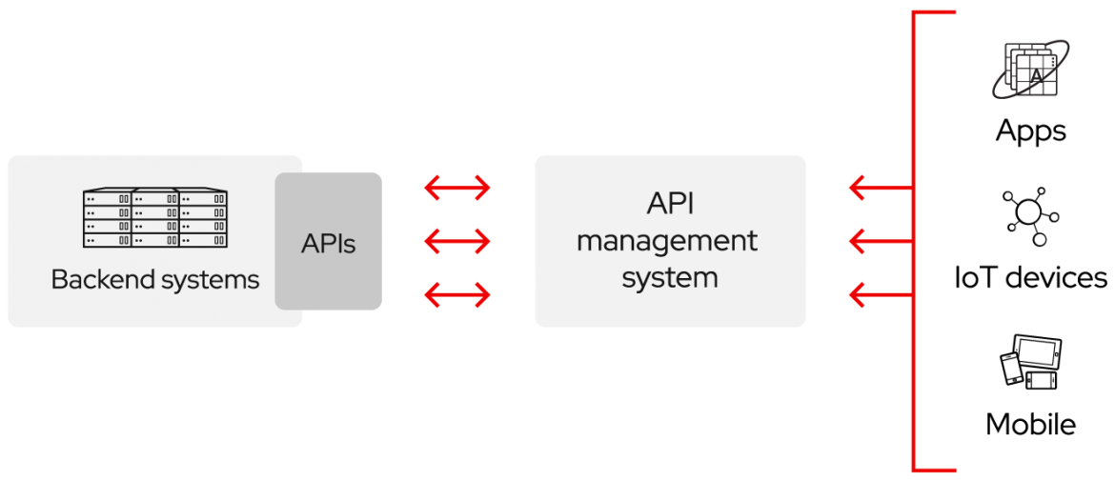

**SOLIDITY:**

Solidity is an object-oriented programming language for implementing smart contracts on various blockchain platforms, most notably, Ethereum. It was developed by Christian Reitwiessner, Alex Beregszaszi, and several former Ethereum core contributors. Programs in Solidity run on Ethereum Virtual Machine.

**WORKING OF API**

**CoinGecko:**

CoinGecko is the largest and one of the earliest cryptocurrency data aggregators. CoinGecko provides a detailed analysis of how the market is performing and how it has performed in the past. It is not a trading platform, it just provides data in the form of charts and graphs of all cryptocurrencies. This data helps users easily compare cryptocurrencies and enables them to trade without hassle.

**PROS**

* Easy to use and navigate.
* Its prices are very low.
* It can provide coin-specific information.
* There are no listing fees.

**CONS**

* It doesn’t offer an integration directly with cryptocurrencies.
* It doesn’t give information related to crypto lending interest rates.
* The free version is limited to 50 requests per minute.
* Even paid plan doesn’t support WebSockets.

## 

## How do I create an API key?

## Creating an API key generates a public and secret key to access the Exchange at the API level. The secret key is revealed when first created; however, upon refreshing the page or navigating elsewhere, the secret key will be hidden for security reasons. If you forget your secret key, you need to create a new one.

I chose CoinGecko’s API because the other major digital asset information site, CoinMarketCap, is notorious for publishing [fake volume data on coins](https://www.coindesk.com/for-15k-hell-fake-your-exchange-volume-youll-get-on-coinmarketcap).

**a.** Go to <https://www.coingecko.com/en/api> and scroll about halfway down. There, you’ll see the types of requests you can make. Since my application needs to bring in some data from CoinGecko, I want to make a GET request. That’s exactly what CoinGecko enables.

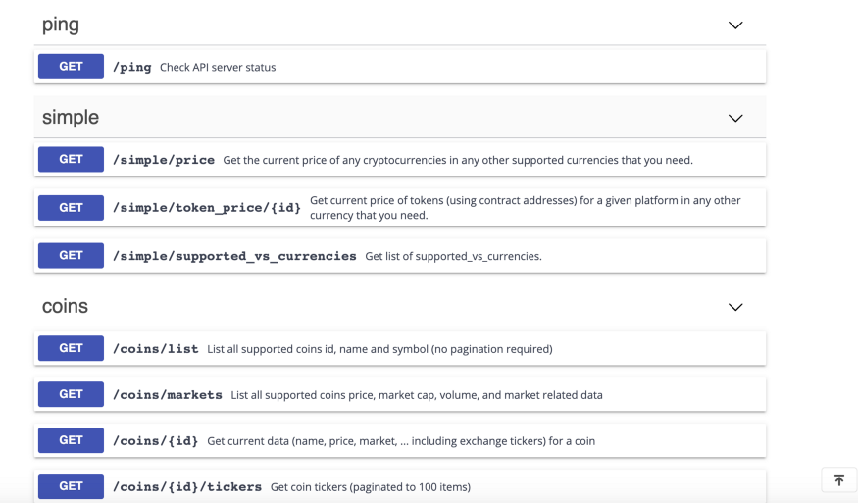

**b.** I will use **/simple/price**to get current market prices of coins X, Y, and Z**.** I will use**/coins/{id}/history**to get the price of a coin at some previous date.

2. Test how the data will be sent to your application. The testing environment on CoinGecko was excellent. It gives you an example of exactly how the information will pass to my application when I make a request. Let’s say I want to get the current market prices of [Bitcoin](https://blog.coincodecap.com/tag/bitcoin/) and Ether. I can input these parameters right in the browser. Be sure to separate the ids of coins only with a comma, and no spaces, or you will hit a problem.

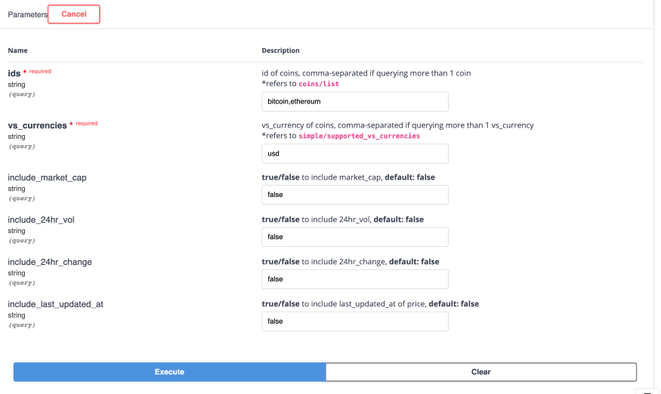

Click **execute.**

CoinGecko spits out the response it will send when your application makes this same request.

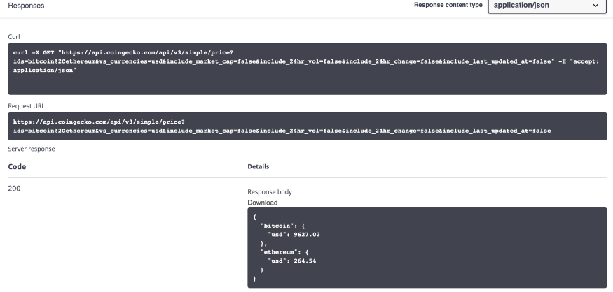

Great, so now we know that [bitcoin](https://blog.coincodecap.com/tag/bitcoin/" \t "_blank).usd will bring out 9627.02 as a number from this object. Check it out by going to the API, copying that data structure, pasting it in your console, and testing out how to get the information you need.

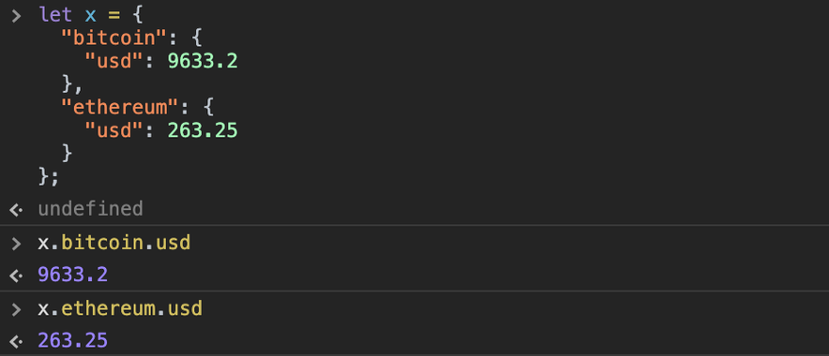

3. Import the dependencies in JavaScript

All you need is to run from the terminal:

npm install 'coingecko-api'

You may want to double check this lands in your package.json file like so:

"coingecko-api": "^1.0.10"

Nice and easy!

You only need the dependency to use the node.js wrapper, or else you can just hit the URL directly. (See the implementation below.)

4. Make your requests.

Lesson learned #1: If you need to get data for multiple coins, put them in an array when sending your fetch request to get the data.

Lesson learned #2: If the fetch request throws an error on historical queries, it may be because the data is only served from since the time CoinGecko started tracking that coin.

Lesson learned #3: Don’t forget that await functions (like this API query) must be conducted inside an async function. Here’s an implementation using the node.js wrapper inside a React class component:

5. Do what you want with the data!

**JAVASCRIPT CODE FOR API**

**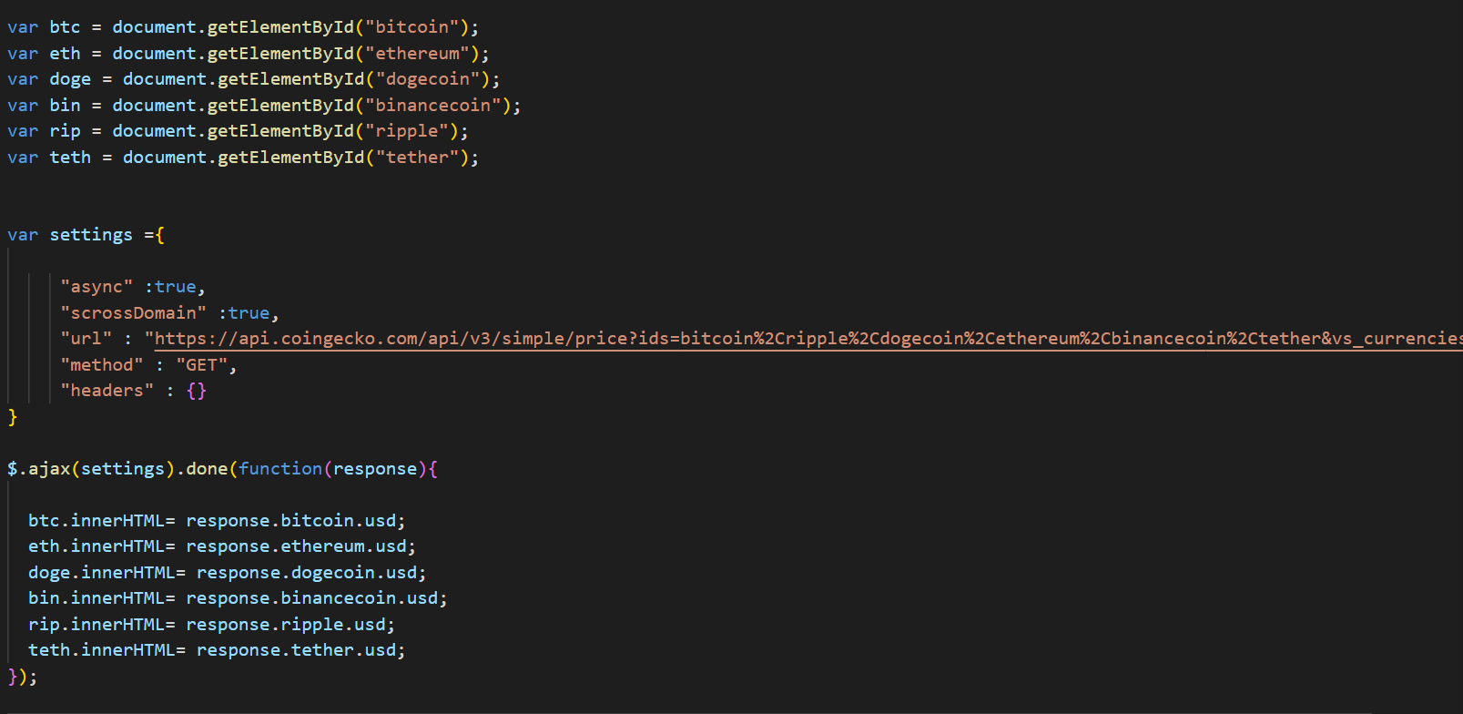**

**HARDWARE AND SOFTWARE**

**REQUIREMENTS**

**Web Browsers:**

Each web browser renders HTML and CSS in a different way, so we’ll need to make sure that our website displays and functions properly in each one. The four most popular web browsers, in order from most to least popular are:

* 1. Google Chrome
  2. Microsoft Edge
  3. Mozilla Firefox
  4. Opera

Every website needs HTML and CSS. However, depending on the type of website

you’re building, you may also need website scripting. Website scripting is what turns a static website into a dynamic website. It’s very likely that your website will need, or at least benefit from, scripting. Here are some examples of website scripting:

* 1. contact forms
  2. interactive buttons and controls
  3. website databases
  4. shared content between web pages

The following table lists the minimum and recommended hardware requirements for the web application.

**Table for hardware requirements**

|  |  |  |
| --- | --- | --- |
| **Component** | **Minimum** | **Recommended** |
| Processor | 1.9 gigahertz (GHz) x86- or x64-bit dual core processor with SSE2  instruction set | 3.3 gigahertz (GHz) or faster 64-bit dual core processor with SSE2  instruction set |
| Memory | 2-GB RAM | 4-GB RAM or more |
| Display | Super VGA with a resolution of 1024 x 768 | Super VGA with a resolution of 1024 x 768 |

**RESULTS**

**Home Section:**

**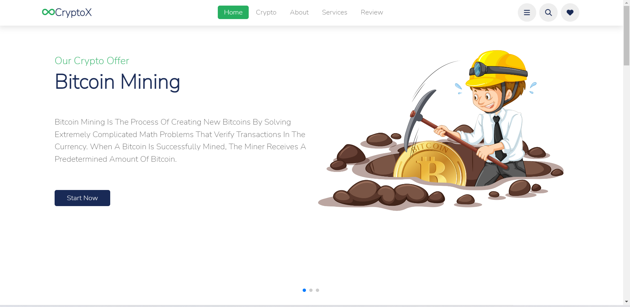**

**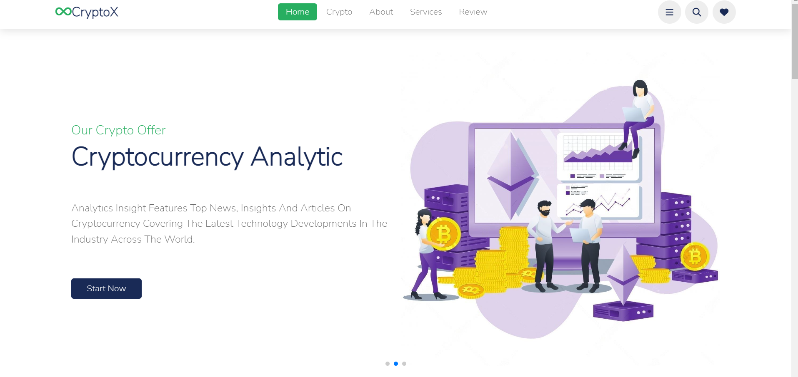**

**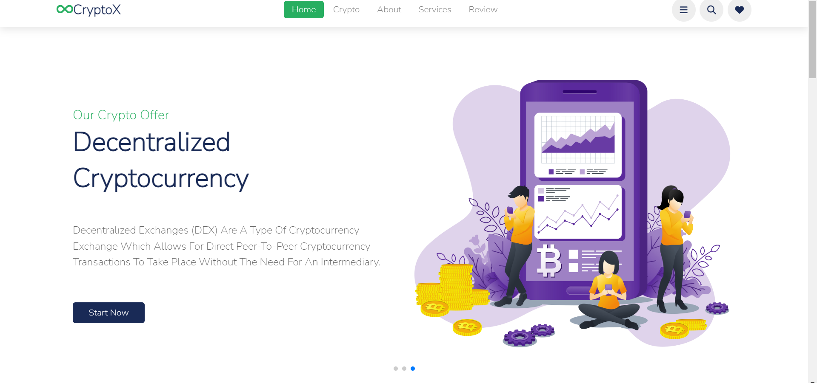**

**About Section:**

**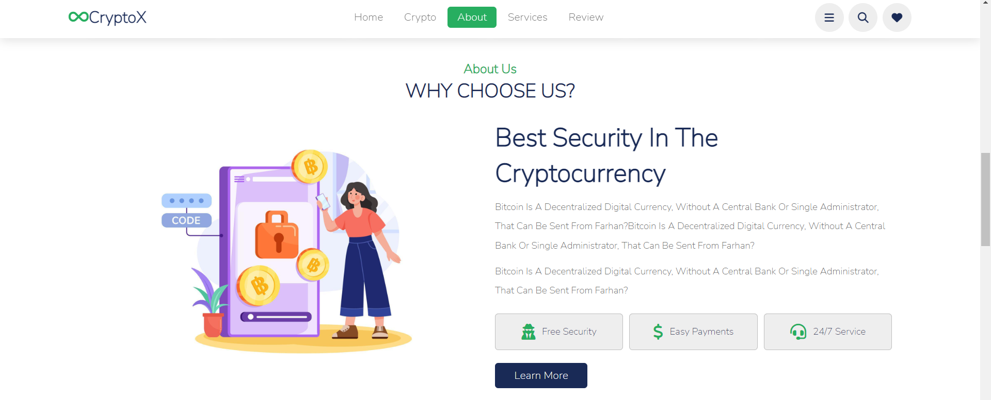**

**Review Section:**

**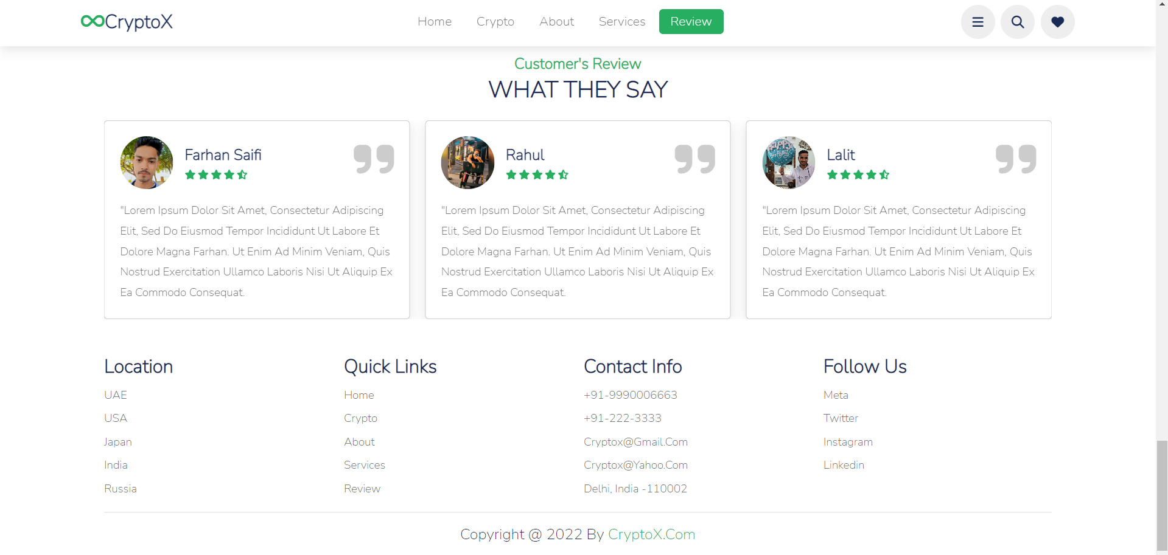**

**Service Section:**

**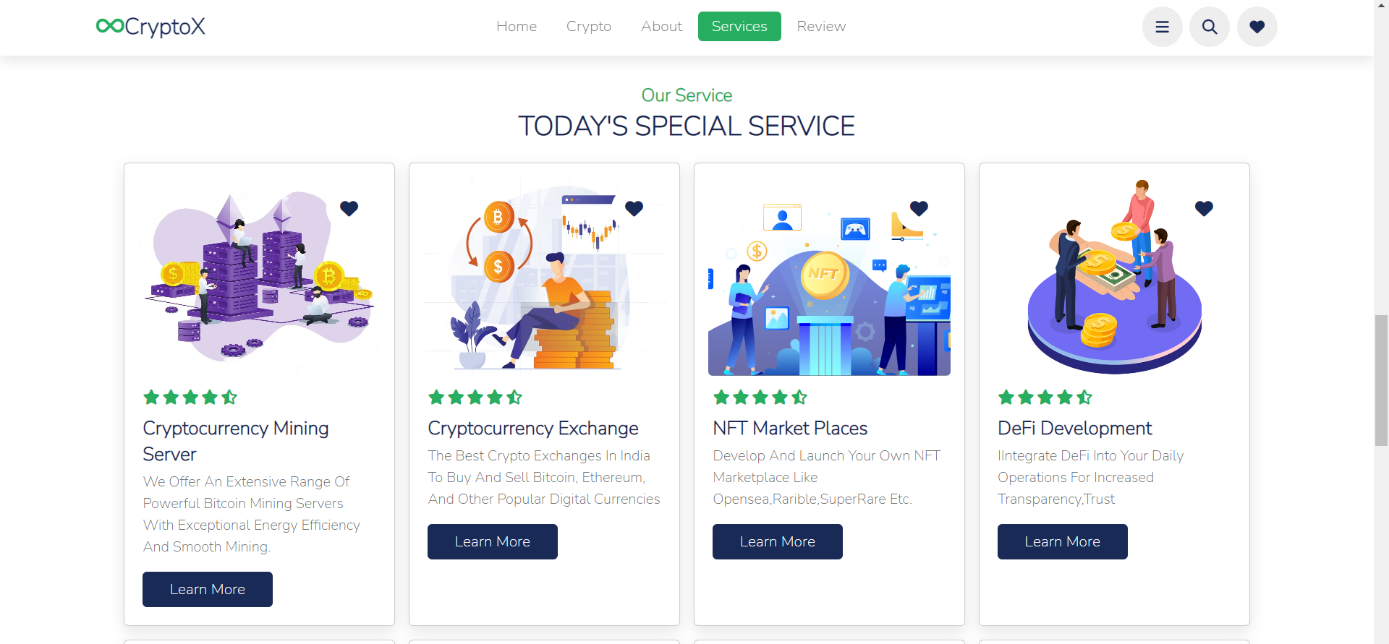**

**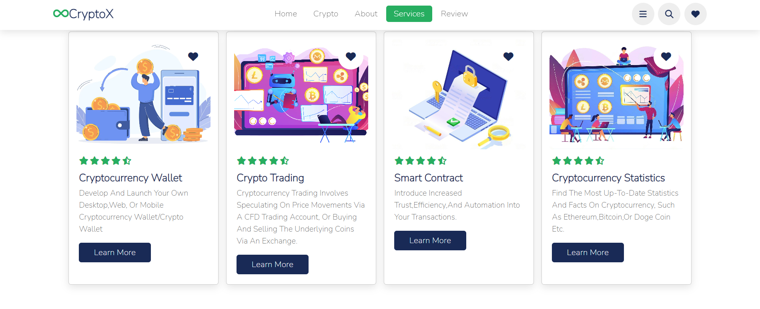**

**Live Cryptocurrency Price through API**

**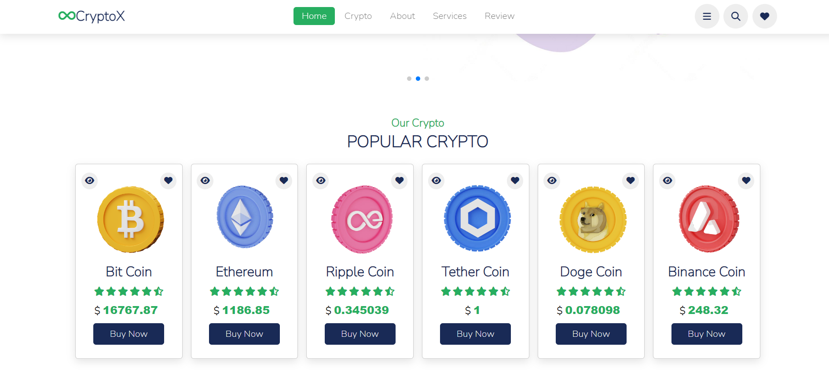**

**REFRENCES**

* <https://pixelplex.io/cryptocurrency-exchange-development>
* <https://www.studocu.com/in/home>
* <https://projectpeople.io/case-study/how-to-create-a-crypto-exchange-designing-an-online-platform-architecture-from-scratch/>
* <https://merehead.com/blog/build-blockchain-lottery-10-steps-success/>
* <https://www.softermii.com/blog/guide-to-building-your-own-cryptocurrency-exchange>
* <https://www.coingecko.com/en/api>
* Qin Liu, Guojun Wang, and Jie Wu“Efficient Sharing of Secure Cloud Storage Services” 2010 .10th IEEE International Conference on Computer and Information Technology (CIT - 2010).