Assignment 2

Sitemap: <https://www.jdacpa.com/>

Farhana Islam

Information Architecture and Content Strategy

Instructor: Sam Razaghi Kashani

Assignment Due Date: December 11, 2024

**Conduct Testing For:** <https://www.jdacpa.com/>

1. **Current Site map**

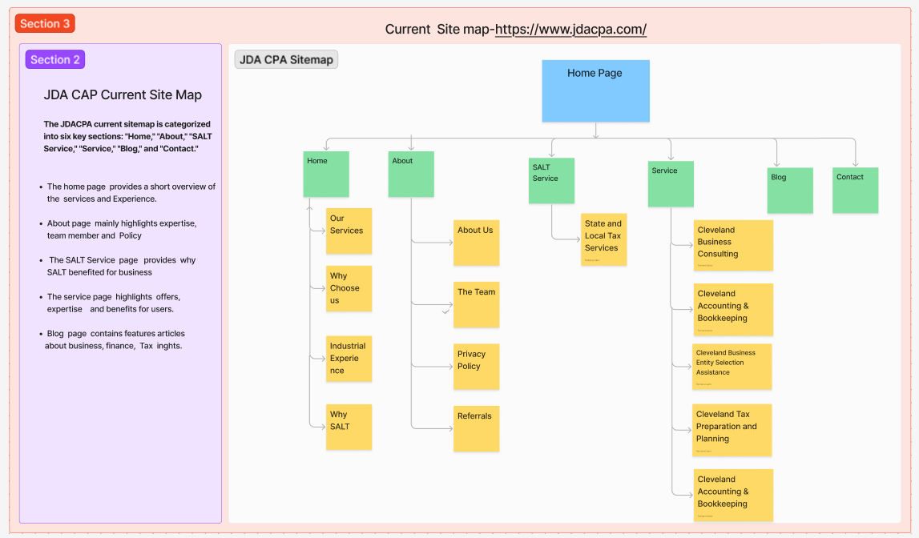

**Observation**: The site map is divided into main sections such as “Home”, “About”, “SALT Service”, “Services”, “Blog”, and “Contact”. There are child categories from “About”, “SALT Services” and Services. The website has some CTAs like "Contact Us”, "Get Free Tax and Business Updates”, “Secure Client Portal”, and “Track Your Refund”.

This website’s site design contains basic features and a user-friendly, simple design that makes for user smooth navigation and meets their basic needs. Regarding Competitive comparisons with other websites, JDA CPA needs to change the content hierarchy to a well-structured form for better engagement, and promoting the company brand. A few questions arise in new user's minds when they are looking for personalized services.: what about the company culture and value, why people choose their services, and why they are exceptional? What kinds of extra services do they provide? Who are their regular customers? What do customers say about their service? Who are their team members? How can they help users' personal needs?

**Inference:** I think adding more user-focused content and reorganizing some content hierarchy will answer all those questions that might have a user's mind. To boost the company's brand value, it needs to regularly update existing content, add new content reflecting on current market analysis, use engaging CTA’s that relate to user's pain points, and add new services to compete with the competitors.

1. **Assumption Site map**

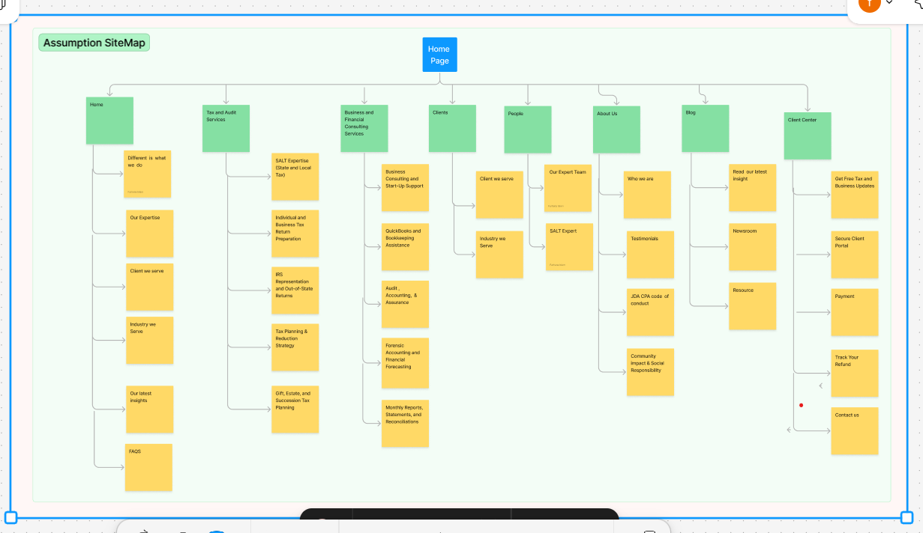

**Observation**: The Assumption Sitemap is a restructured design framework that focuses on showcasing the company, its key features, and services. The purpose is to highlight a few key contents that can provide a clear and engaging way for visitors to understand the company’s value and offerings. For example,

**The “Home”** page is a general overview of the company, why they are exceptional, key features, service, clients, new insights, and FAQ’s.

**The “About”** page provides more details about the company's values, mission, code of conduct, Testimonials from clients, and community and social involvements. The purpose is to add new content to the “About” page to better know the user about their journey, their client approach, and what clients think about the company and services to promote brand value.

**The “Service”** menu is categorized into two distinct menus: “Tax and Audit Services” and “Business and Financial Consulting Services.” The aim is to highlight the company’s few specialized services upfront to users to showcase expertise in different sectors and bring more user attraction.

**The “Clients”** menu is categorized into two distinct menus: “Client We Serve” and “Industry We Serve”. The reason is highlighting these two sectors is for users to know the company's name with their logo, clients with different professions, their testimonials, what kinds of services they took, and showcase their expertise that enhances the customer loyalty, and trustiness in the company.

**The “People”** menu is categorized into two distinct menus: “Our Team” and “SALT Expert”. The current system only highlights “Jeffrey” ‘s expertise. Users might be curious about the company’s other people’s expertise; it needs to highlight all team members' biography details to evidence their knowledge and expertise to address the client's pain points.

**The “Blog”** menu is categorized into three distinct menus: “Read our recent “Insights”, “Recourse”, and “Newsroom”. These key features make it more engaging to learn more about the current market strategy, and how they can have a proper solution from this company.

**The “Client Center”** menu is categorized into five distinct menus: “Get Free Tax and Business Updates” “Secure Client Portal”, “Payment”, “Track Your Refund”, and “Contact Us”. These key features will be more organized than the current system, avoiding duplicate content on all the pages. The new “Payment” will ensure both parties for sure transaction.

**Inference**:  I believe that the assumed content will not only enhance user engagement and satisfaction but also build a strong brand value. This structured approach can boost the business, help JDA CPA compete more effectively with its competitors, and increase user engagement by more than 15%.

1. **Close Card Sorting:**

Interviews: 3 interviews were conducted for the closed card sorting, one in person and two via Zoom.

Age: 35-41

Professions:

1. Investigator, AML, TD Bank
2. Software developer, Accenture
3. Business Owner, Scarborough

Video recorded: (with participant consent)

**Participant 1: Via Zoom**

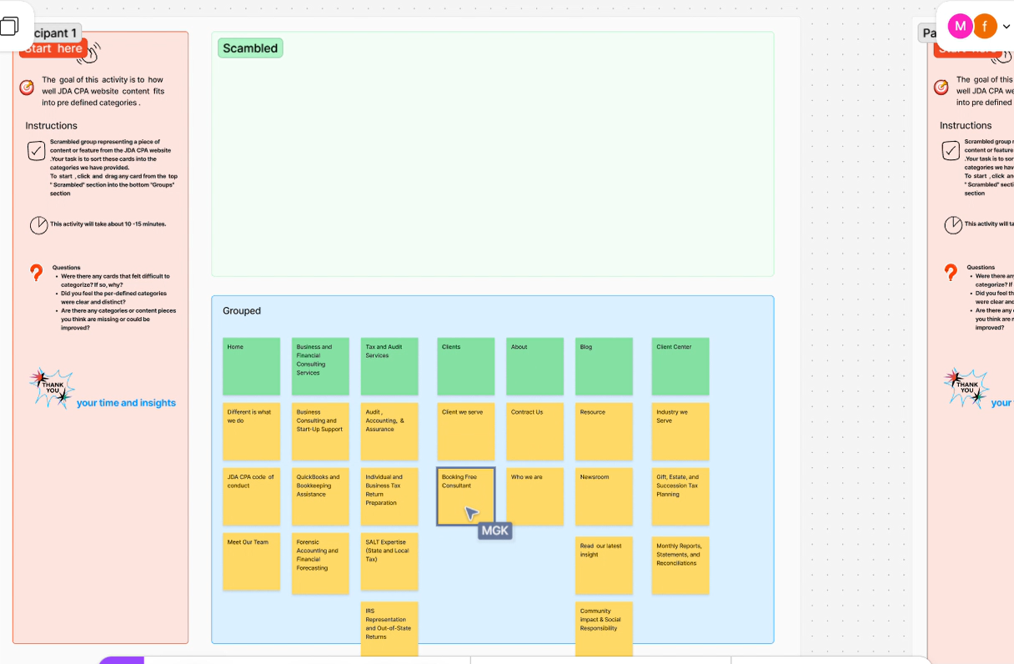

Client Feedback: A few submenus are confusing like “Client Center and Clients” those are kinds of similar to me.”

**Participant 2: In-person**

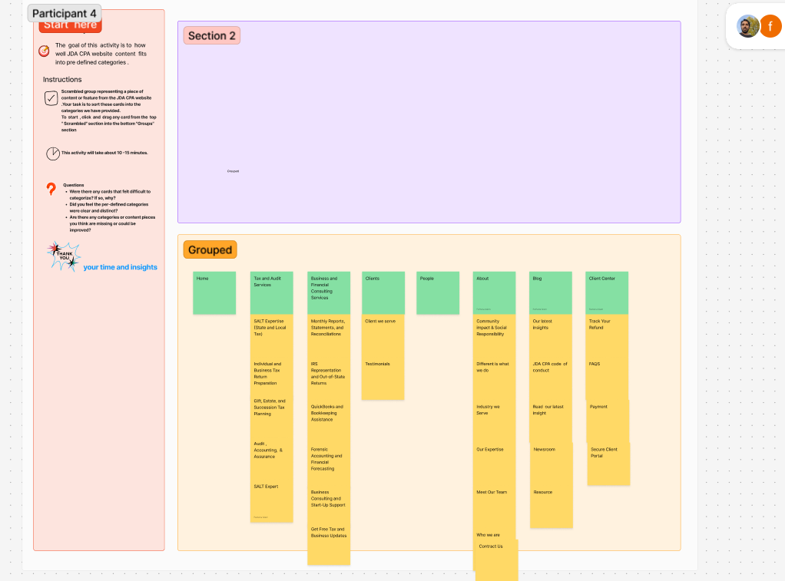

**Client Feedback:** I was not sure where to put the following sub menus: “CPA code of conduct”, “Secure Client Portal”, “Payment and Resources”. I chose the menu Client for few and Client Center for the rest.

**Participant 3: Via Zoom**

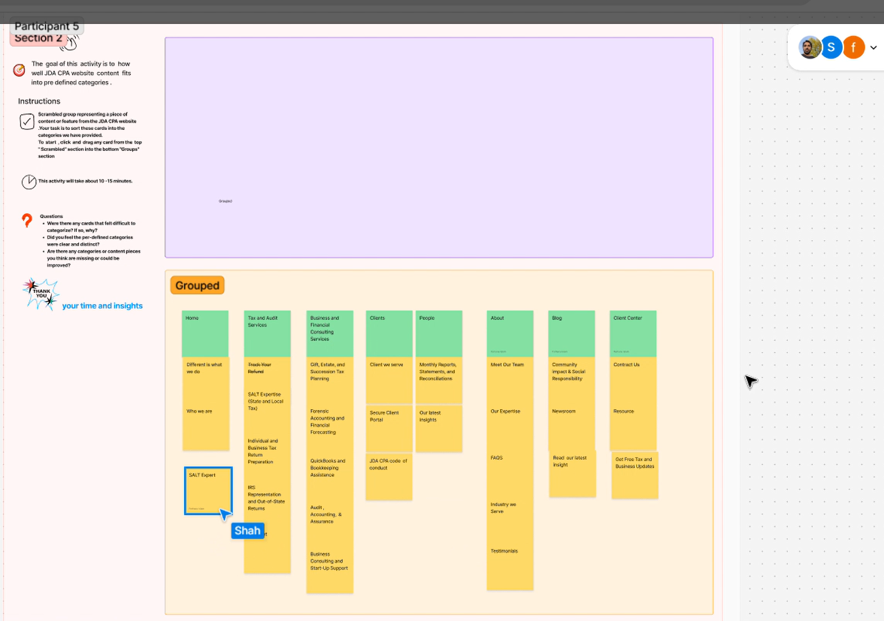

Client Feedback: “The Task was pity easy. I am not familiar the word what is “SALT”. It was confusing for me.”

**Observation**: During the card sorting exercise, participants chose a card and sorted it out which is mostly common. Participants might have faced confusion over where to put some of the sub-menus under the menus. Some items of the sub-menu were self-explanatory and easier to place under the related menu. However, some items were harder to put under a menu because the menus seemed similar. The participant also suggested the menus be similar to the other standard websites.

1. **Results from Card Sorting Site Map**

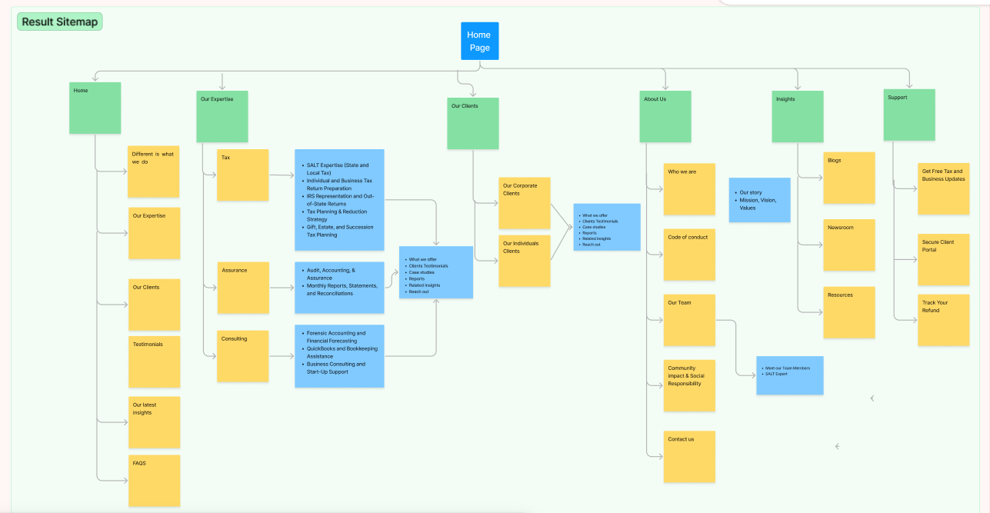

**Refined Sitemap: Observations and Improvements**

**Observation**: The Result Sitemap is a refined structure design after the “Close card Sorting exercise”. I believe, that now it is more simplified and logically categorized to ensure users can easily locate relevant keywords or services. for example,

For the “Homepage”, participants' card sorting results were similar to my assumed sitemap. However, “Clients We Serve”, and “Industry We Serve” these two elements caused confusion, so I made a change to “Our Clients”

I categorized it into two menus on my assumption site map: “Tax and Audit Services” and “Business and Financial Consulting Services.” That might have created confusion for all participants. Now, I have changed it into three simple categories: “Tax,” “Assurance,” and “Consulting.” All services are short in these three categories. I think that is much simpler than the Current and Assumption site map.

For the “Clients” page" participants had a little difficulty with “Client We Serve” and “Industry We Serve” I made a change to “Our Client” which could be doctors, Doctors, Employees, Investors, IT consultants, Retirees, and Self-employed. Here What the company offers, client testimonials, and case studies, help the users to build trust. For “Our Corporate Clients" " adding the company logo they served, what JDA CPA offers, and client testimonials will increase the company brands and user engagements

For the “People” page, participants had difficulty categorizing “Meet Our Expert Team.” I believe it would fit better under the “About” page. Regarding the SALT service, “SALT Expert” is a better fit under “Reach Out to SALT Expert.”

I think “Insights” is a better fit instead of “Blog.”  
Participants had difficulty understanding “Client Center,” so I changed it to “Support.”

**Inference**: I believe the “Result Sitemap” content will enhance website usability and user engagement by more than 15% because it properly categorizes compared to the existing sitemap. Additionally added new content will reduce users’ pain points and provide intuitive navigation. By boosting the overall user experience of browsing the website, the company will earn much-needed clients’ trust resulting in improved brand value over its competitors.