Q) construct SOM to cluster four given vectors [0, 0, 1, 1] [1, 0, 0, 0] [0, 1, 1, 0] and [0, 0, 0, 1]

No. of clusters to be formed is 2. Assume an initial learning rate of 0.5

Solution)

No. of input vectors n=4

No. of clusters m=2

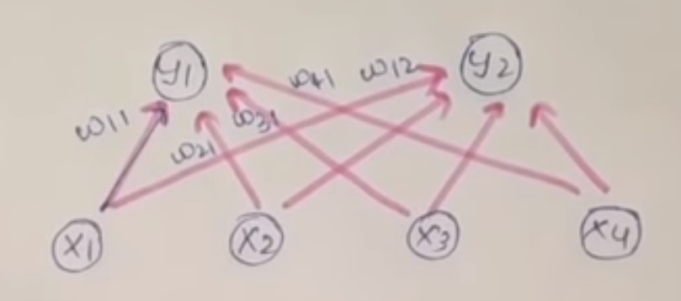

Initialize weights randomly between 0 and 1

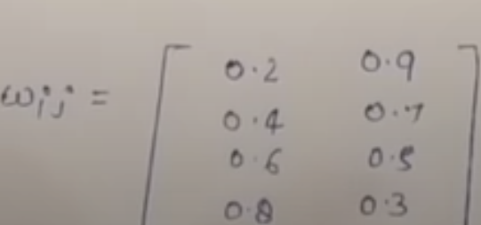

0.2 – 0.4 – 0.6 – 0.8 are the weights of X1, X2, X3 AND X4 connected with cluster Y1

First input vector

X1 = [0 0 1 1]

Here we calculate Eucledian distance between the first cluster and the input vector

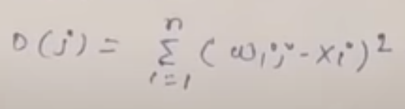

D(1) = (0.2 -0)^2 + (0.4 – 0)^2 + (0.6 – 1)^2 + (0.8 – 1)^2

D(1) = 0.04 + 0.16 + 0.16 + 0.04

D(1) = 0.4

Here we calculate Eucledian distance between the second cluster and the input vector

D(2) = (0.9-0)^2 + (0.9-0) ^2 + (0.9-1)^2 + (0.9-1)^2

D(2) = 0.81 + 0.49 + 0.25 + 0.49

D(2) = 2.04

Since D(1) < D(2) winning cluster is J =1 i.e Y1

Update weights on winning cluster J=1

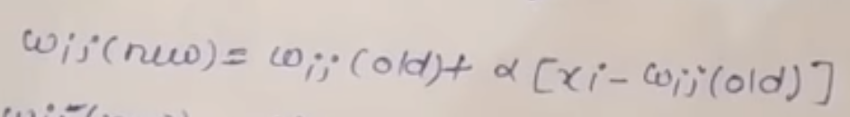

W11(n) = w11(old) + 0.5 [x1 – w11(old)]

= 0.2 + 0.5 [0 – 0.2]

= 0.1

W21 (n) = w21(old) + 0.5 [x2 – w21(old)]

= 0.2 + 0.5 [0 – 0.4]

= 0.2

W31 = w31(old) + 0.5[x3 – w31(old)]

= 0.4 + 0.5[1 – 0.4]

= 0.8

W41 = w41(old) + 0.5 [x4 – w41(old)]

=0.6 + 0.5[1 – 0.6]

=0.9

Updated weight matrix

Wij = 0.1 0.9

0.2 0.7

0.8 0.5

0.9 0.3

Second Input Vector [1 0 0 0]

Calculate Eucledian Distance

D(1) = 2.3

D(2) = 0.84

D(2) < D(1) J=2

Winning cluster unit is D2

Update weights on cluster 2

W12 = 0.95 w22 = 0.35 w32= 0.25 w42 = 0.15

Wij = 0.1 0.95

0.2 0.35

0.8 0.25

0.9 0.15

Third Input Vector [0 1 1 0]

D(1) = 1.5 D(2) = 1.91

Winning cluster is J1

W11=0.05 w21=0.6 w31=0.9 w41=0.45

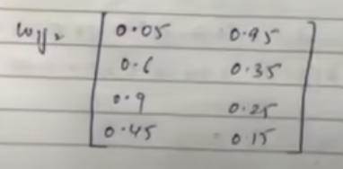

Forth Input vector [0 0 0 1]

D(1) = 1.475 D(2)=1.81

Winning cluster is J1

W11=0.025 w21=0.3 w31=0.45 w41=0.475

