**Exercise 2: Implementing the Factory Method Pattern**

**Scenario:**

You are developing a document management system that needs to create different types of documents (e.g., Word, PDF, Excel). Use the Factory Method Pattern to achieve this.

**Steps:**

1. **Create a New Java Project:**
   * Create a new Java project named **FactoryMethodPatternExample**.
2. **Define Document Classes:**
   * Create interfaces or abstract classes for different document types such as **WordDocument**, **PdfDocument**, and **ExcelDocument**.
3. **Create Concrete Document Classes:**
   * Implement concrete classes for each document type that implements or extends the above interfaces or abstract classes.
4. **Implement the Factory Method:**
   * Create an abstract class **DocumentFactory** with a method **createDocument()**.
   * Create concrete factory classes for each document type that extends DocumentFactory and implements the **createDocument()** method.
5. **Test the Factory Method Implementation:**
   * Create a test class to demonstrate the creation of different document types using the factory method.

**Solution:**

1. Created a Java project named “FactoryMethodPatternExample”
2. Created Interface IDocument
3. Created document classes
4. Created the factory class
5. Tested with Main Class

Source Code:

IDocument.java

package FactoryMethodPatternExample;

public interface IDocument {

void open();

}

Document Classes

WordDocument.java

package FactoryMethodPatternExample;

public class WordDocument implements IDocument {

public void open() {

System.***out***.println("Opening Word document.");

}

}

PdfDocument.java

package FactoryMethodPatternExample;

public class PdfDocument implements IDocument {

public void open() {

System.***out***.println("Opening PDF document.");

}

}

ExcelDocument.java

package FactoryMethodPatternExample;

public class ExcelDocument implements IDocument {

public void open() {

System.***out***.println("Opening Excel document.");

}

}

Document Factory Class

package FactoryMethodPatternExample;

public class DocumentFactory {

// Factory method

public static IDocument createDocument(String type) {

switch (type.toLowerCase()) {

case "word":

return new WordDocument();

case "pdf":

return new PdfDocument();

case "excel":

return new ExcelDocument();

default:

throw new IllegalArgumentException("Invalid document type: " + type);

}

}

}

Main.java

package FactoryMethodPatternExample;

public class Main {

public static void main(String[] args) {

IDocument doc1 = DocumentFactory.*createDocument*("word");

doc1.open();

IDocument doc2 = DocumentFactory.*createDocument*("pdf");

doc2.open();

IDocument doc3 = DocumentFactory.*createDocument*("excel");

doc3.open();

}

}

Output:

Opening Word document.

Opening PDF document.

Opening Excel document.

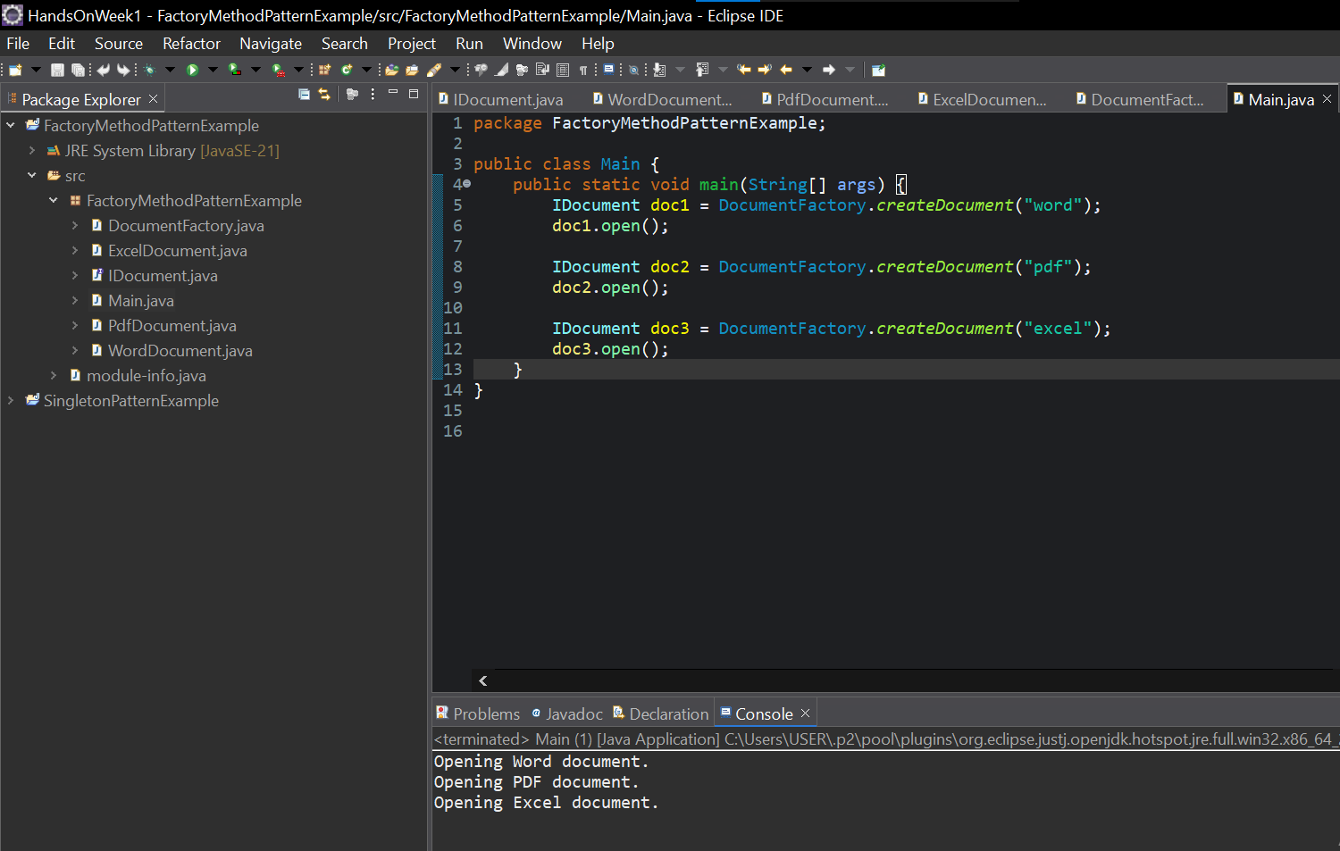Screenshot of Eclipse IDE Application