**a) Aim: To study the working of half wave rectifier using operational amplifier**.

**Components & Apparatus Required:**

Op-amp µA741, Diodes (IN 4007), Resistors, Signal generator, power supply & CRO

**Theory:**

The precision rectifier is a configuration obtained with an operational amplifier in order to have a circuit behaving like an ideal diode or rectifier. It can be useful for high-precision signal processing.

The use of op-amps can improve the performance of a wide variety of signal processing circuits. In rectifier circuits, the cut-in voltage drop that occurs with an ordinary semiconductor diode can be eliminated to give precision rectification.

**Procedure for Circuit Connection:**

1. Rig up the circuit as shown in the circuit diagram.
2. Using a signal generator apply the sinusoidal input waveform of peak-to-peak amplitude of 5V, frequency 1 KHz.
3. Keep the CRO in dual mode; apply input (Vin or V1) signal to the channel 1 and observe the output (Vo) on channel 2 which is as shown in the waveform below.
4. Note down the amplitude & time periods of Vo & VIN. Plot the waveform on the graph sheet.
5. Observe the transfer characteristics Vo Vs Vin.
6. For amplitude sensitivity, vary the amplitude of sinusoidal input signal. Note down the value of amplitude at which the output remains sinusoidal and not rectified output.
7. For Frequency sensitivity, vary the frequency of sinusoidal input signal. Note down the value of frequency at which the output remains sinusoidal and not rectified output.

**Circuit:**

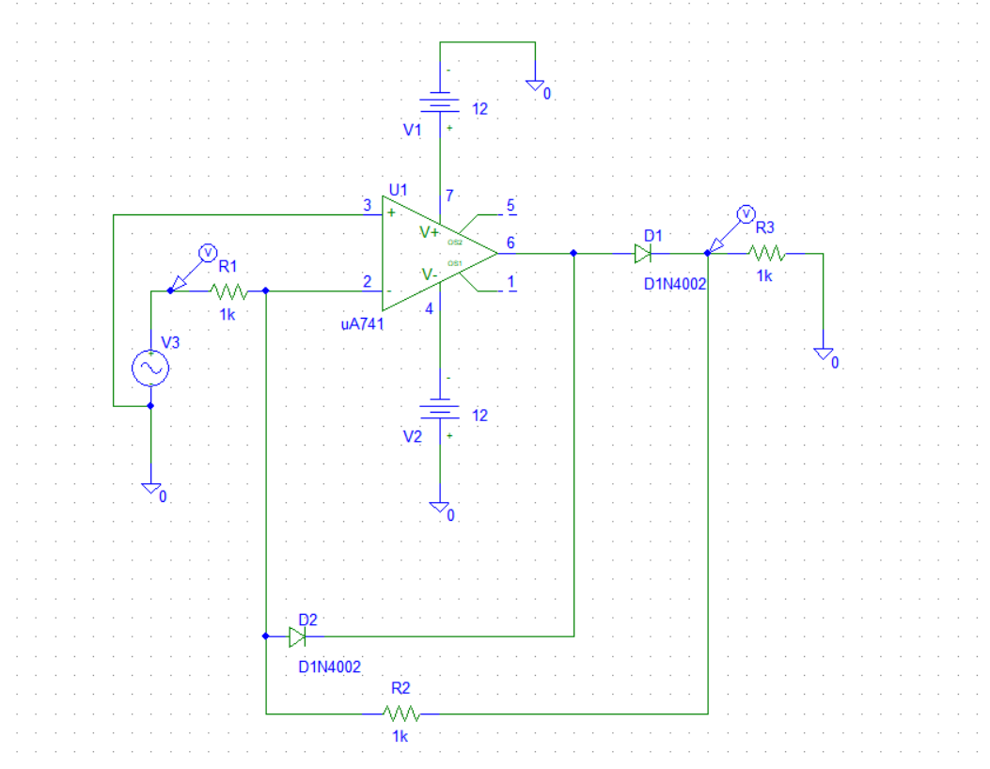

**Waveform:**

**Input:**

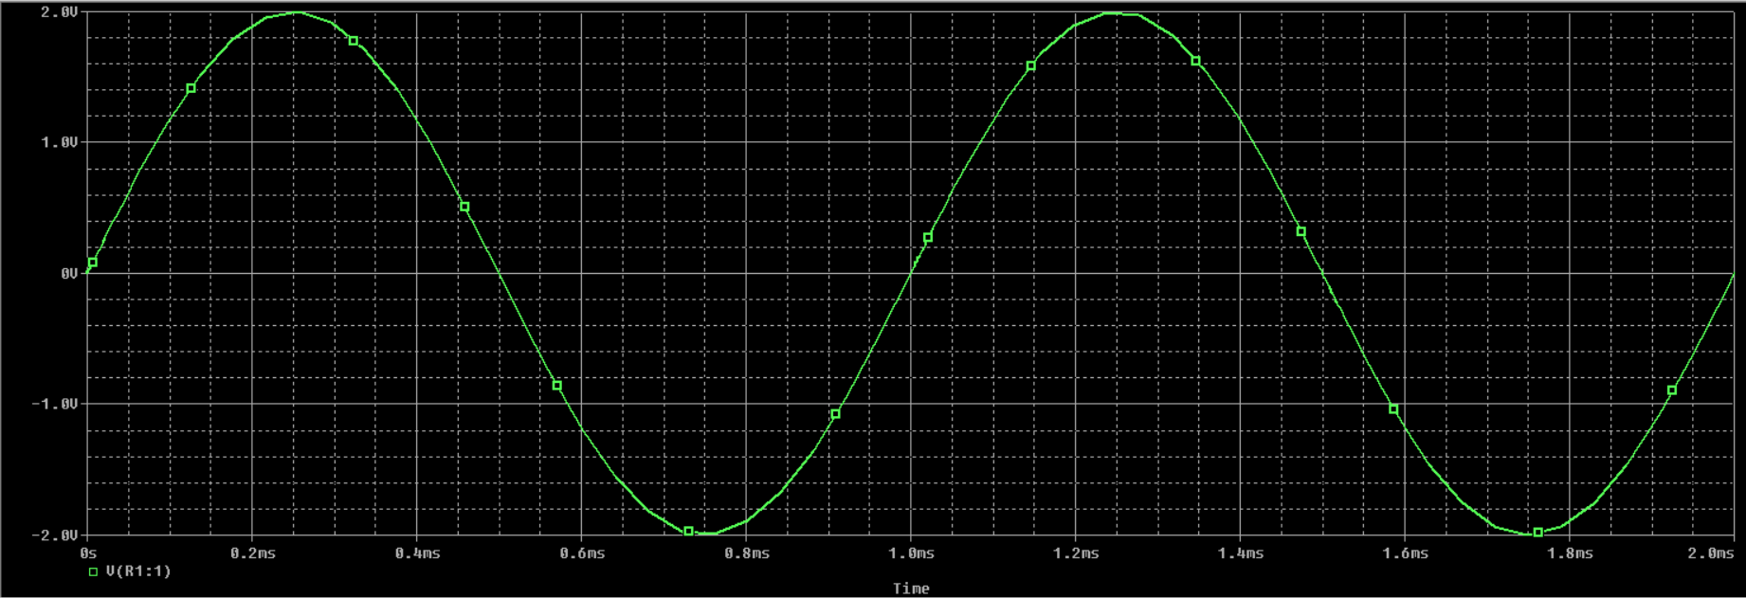

**Output:**

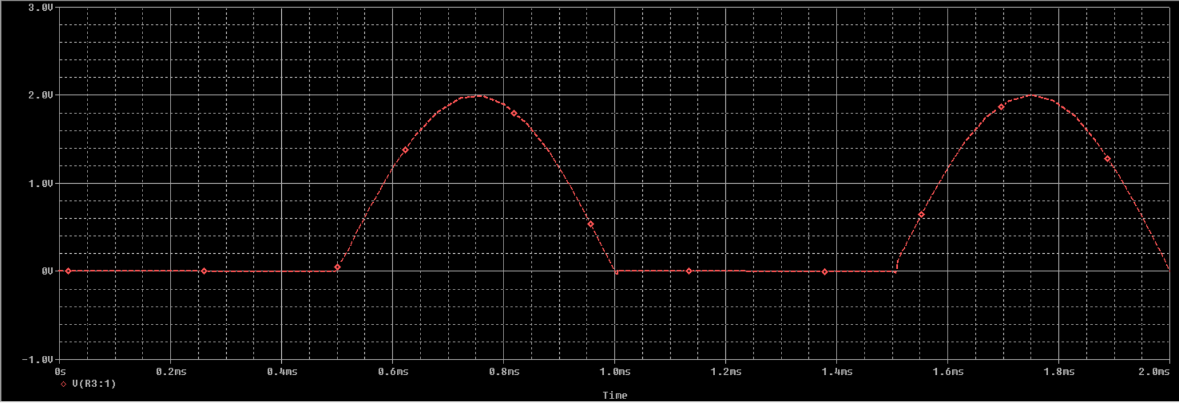

**Final:**

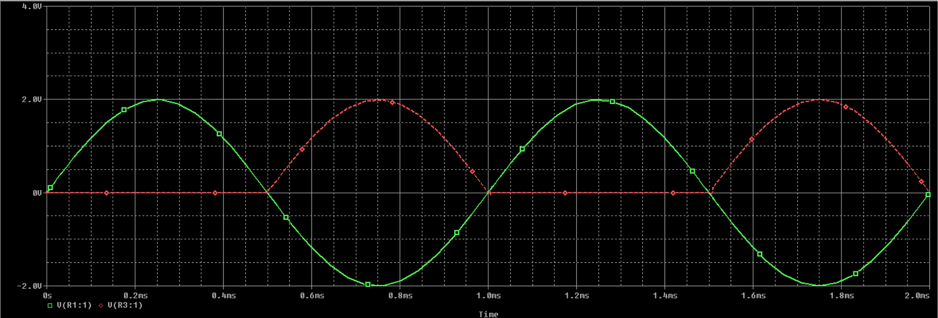

**Transfer Characteristics:**

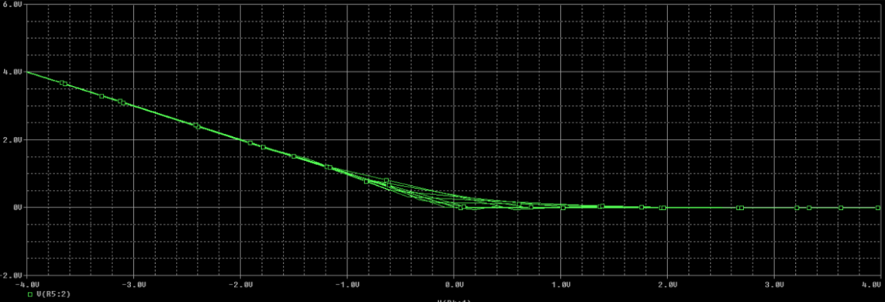

**b) Aim: To study the working of full wave rectifier using operational amplifier.**

**Components & Apparatus Required:**

Op-amp µA741, Diodes (IN 4002), Resistors, Signal generator, power supply & CRO.

**Procedure for Circuit Connection:**

1. Rig up the as shown in the circuit diagram.
2. Using a signal generator apply the sinusoidal input waveform of peak-to-peak amplitude of 5V, frequency 1 KHz.
3. Keep the CRO in dual mode; apply input (Vin or V1) signal to the channel 1 and observe the output (Vo) on channel 2 which is as shown in the waveform below.
4. Note down the amplitude & time periods of Vo & VIN. Plot the waveform on the graph sheet.
5. Observe the transfer characteristics Vo Vs Vin.
6. For amplitude sensitivity, vary the amplitude of sinusoidal input signal. Note down the value of amplitude at which the output remains sinusoidal and not rectified output.
7. For Frequency sensitivity, vary the frequency of sinusoidal input signal. Note down the value of frequency at which the output remains sinusoidal and not rectified output.

**Circuit:**

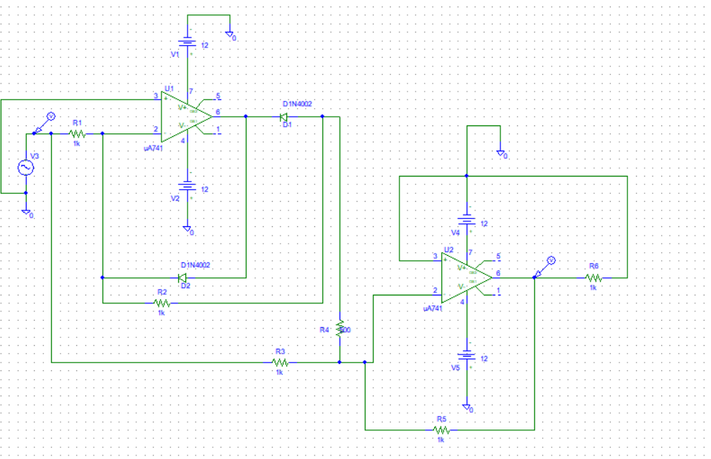

**Waveform:**

**Input:**

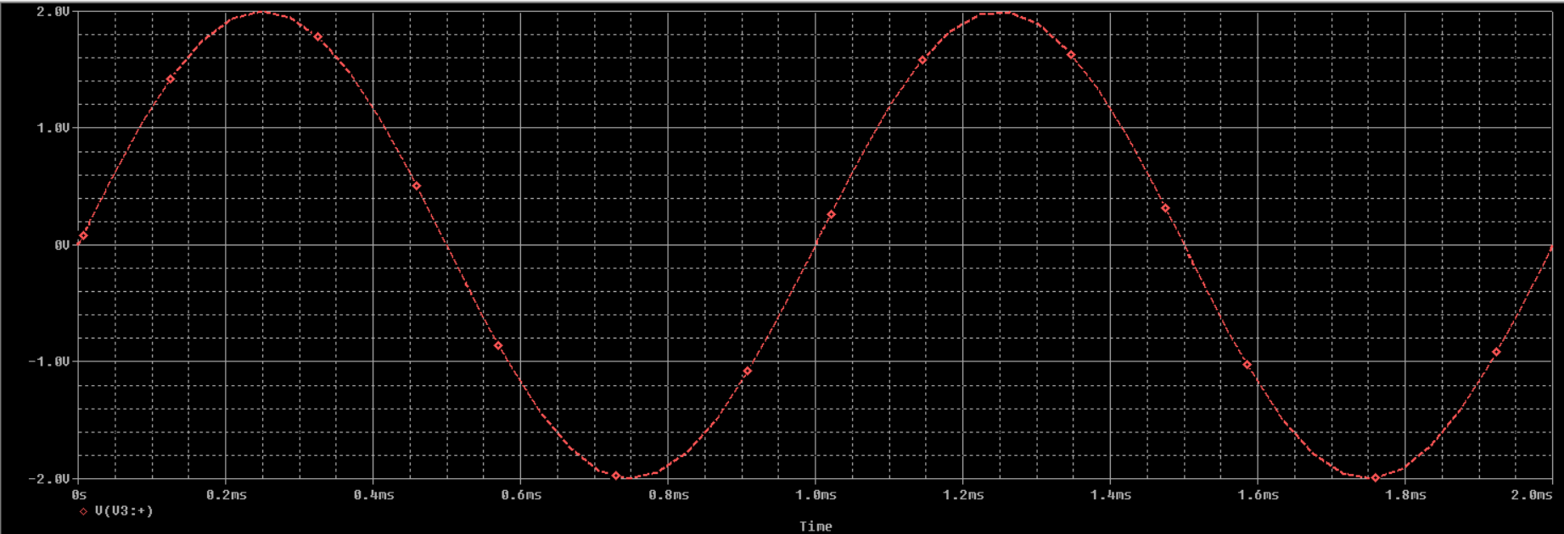

**Output:**

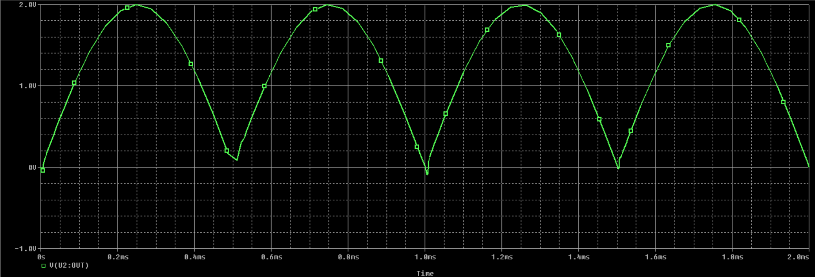

**Final:**

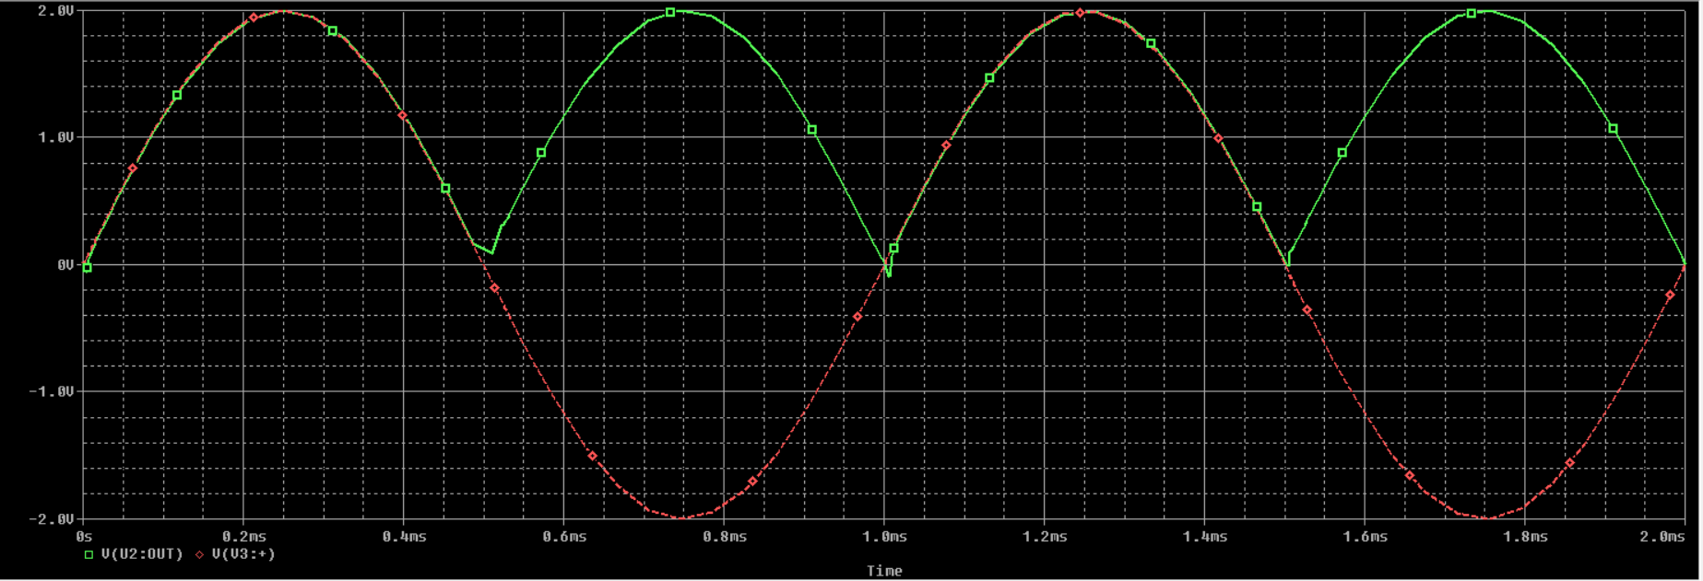

**Transfer Characteristics:**

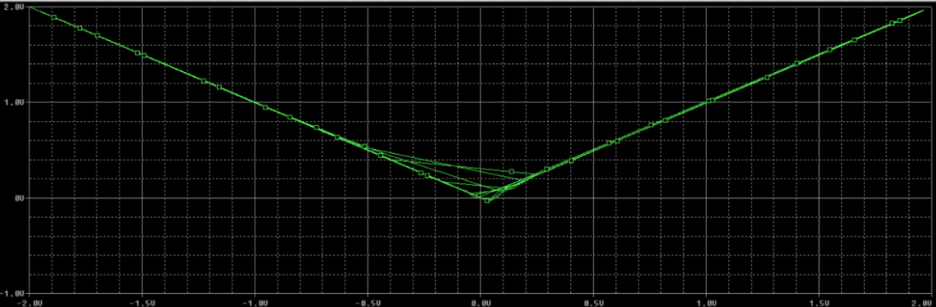

**Aim: To study the working of peak Detector using operational amplifier**.

**Components & Apparatus Required:**

Op-amp µA741, Diode (IN4007), Resistors, Signal generator, power supply & CRO

**Theory:** The basic precision rectifier with little modifications can be used also for detecting peak levels of signal. In the following circuit a capacitor keeps the peak voltage level of signal and switch can be used for resetting detected level

**Procedure for Circuit Connection:**

1. Rig up the circuit as shown in the circuit diagram.
2. Using a signal generator apply the sinusoidal input waveform of peak-to-peak amplitude of 1V, frequency 1 kHz.
3. Keep the CRO in dual mode; apply input (Vin or V1) signal to the channel 1 and observe the output (Vo) on channel 2 which is as shown in the waveform below.

Note down the amplitude & time periods of Vo & VIN. Plot the waveform on the graph sheet. Observe the transfer characteristics Vo Vs Vin

**Design:**

Let Vs = 1V at Freq. of 1 KHz, T = 1mSec

For proper circuit operation CRL>10T

Let RL = 10KΩ, C = 1µf

Therefore 1uf *10 k = 0.01

10 * T = 10 * 1ms = 0.01, CRL ≥10T

**Circuit:**

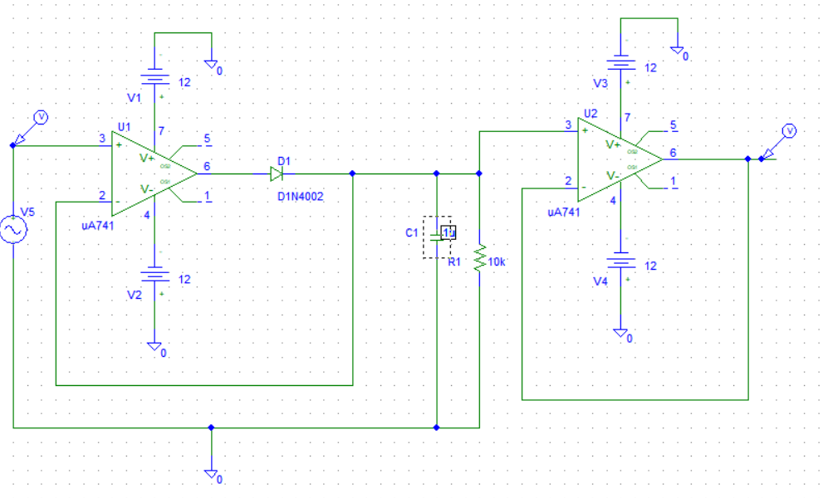

**Waveform:**

**Input:**

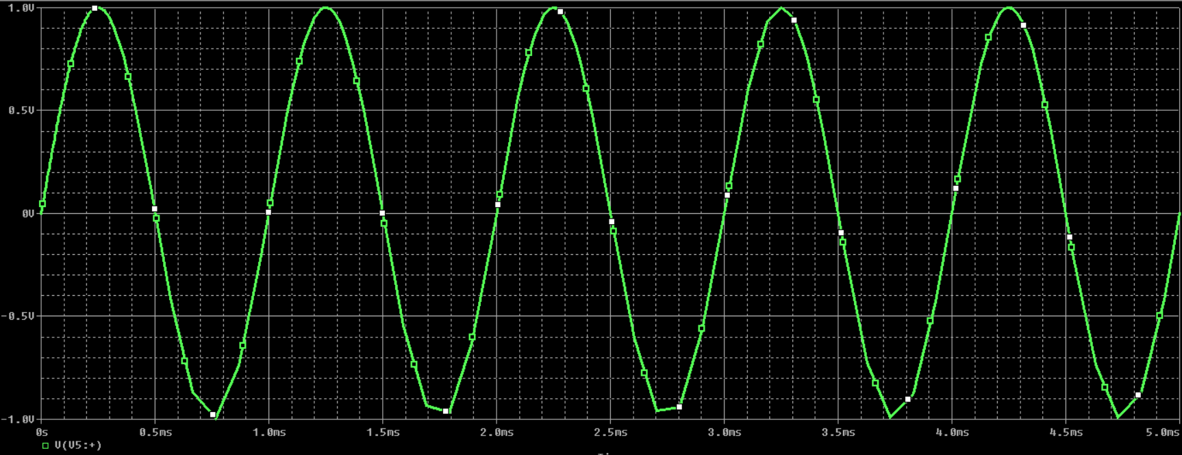

**Output:**

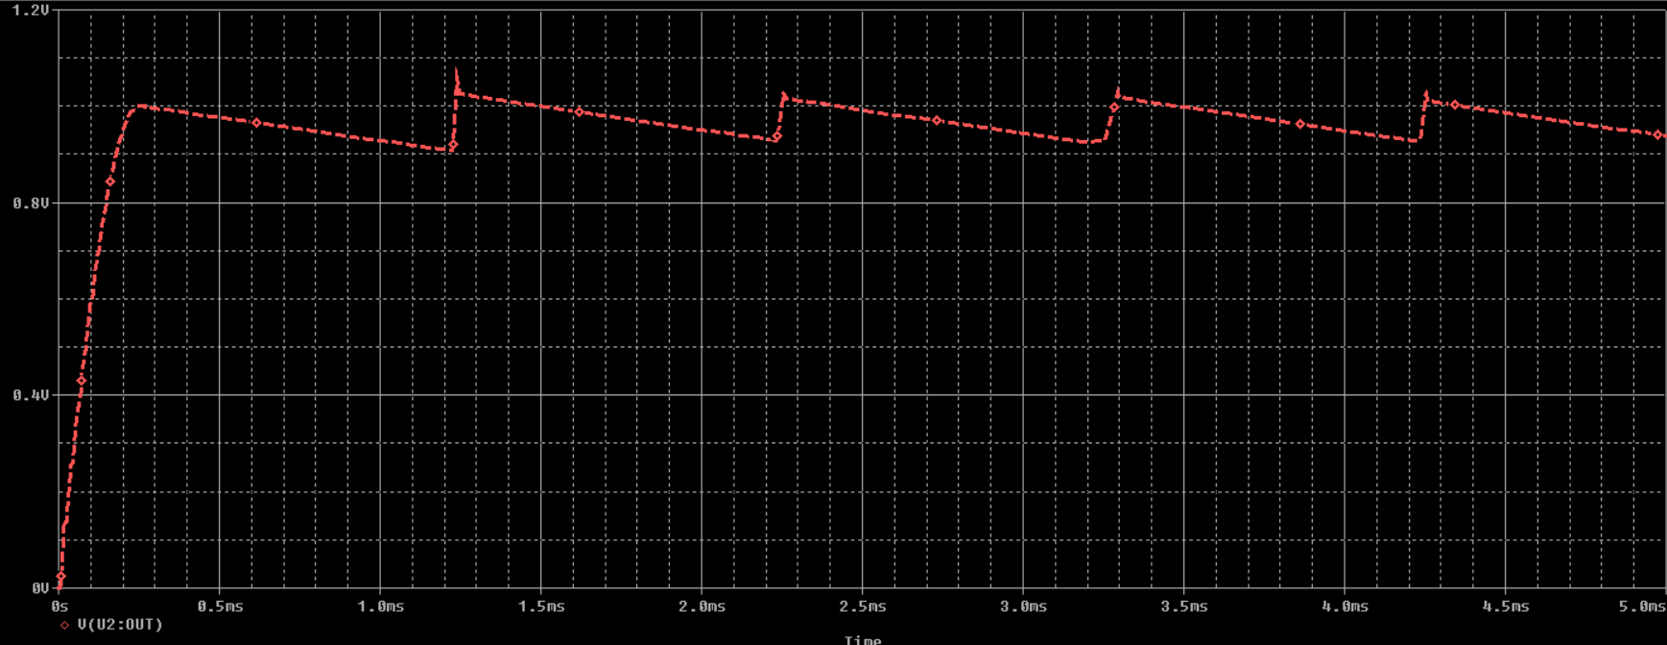

**Final:**

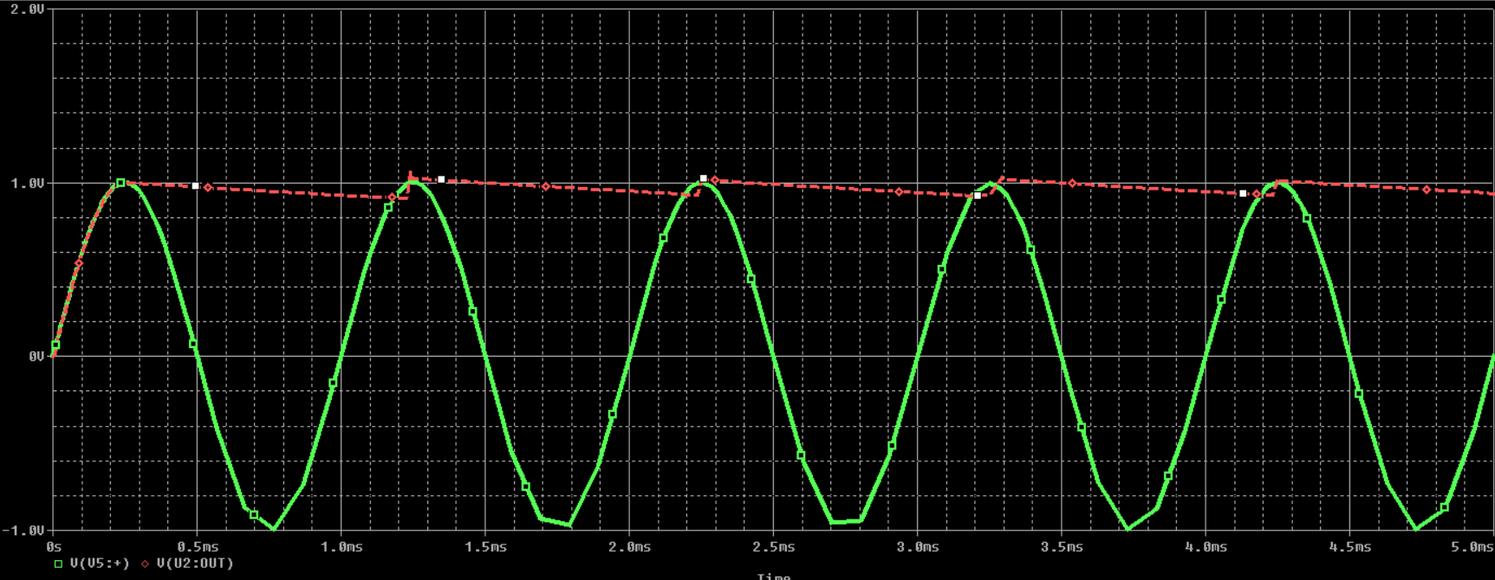

**Transfer Characteristics:**

