**AIM:** To design Schmitt triggers as per the given conditions.

**Case 1:** Design an inverting Schmitt trigger with reference voltage VUT=2V and VLT=-4V and |-Vsat|=Vsat=12V

**Case 2**: Design an inverting Schmitt trigger with reference voltage VUT=4V and VLT=2V and |-Vsat|=Vsat=12V

**Case 3**: Design an inverting Schmitt trigger with reference voltage VUT=-2V and VLT=-4V and |-Vsat|=Vsat=12V.

**APPARATUS AND COMPONENTS REQUIRED**:

Op-amp uA741, simulation software, resistors, DC input, AC input.

**THEORY:**

A Schmitt trigger is a comparator with hysteresis. It can be categorized into two types:

1. Inverting Schmitt trigger: In such Schmitt triggers, the input is applied through inverting terminal of opamp and the reference voltage is applied through non-inverting terminal.
2. Non-Inverting Schmitt trigger: In such Schmitt triggers, input is applied through non-inverting terminal of op-amp and the reference voltage is applied through non-inverting terminal.

**PROCEDURE:**

1. Carry out calculations as shown under calculations.
2. Rig up the circuit with the given values and calculated values.
3. Set the input parameters as shown.
4. Click on simulation and analyze the graph.

**Case1:**

**Circuit:**

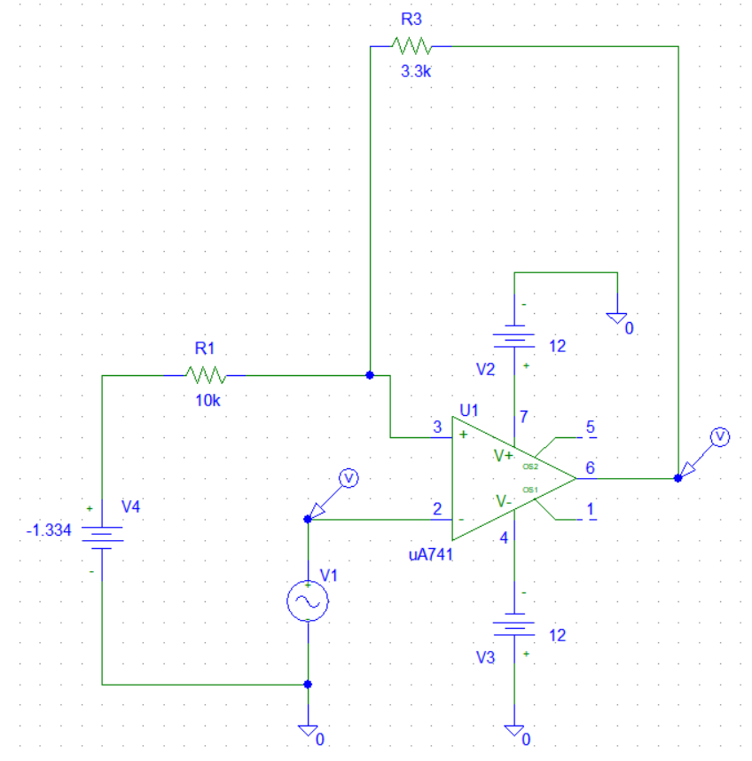

**Graph:**

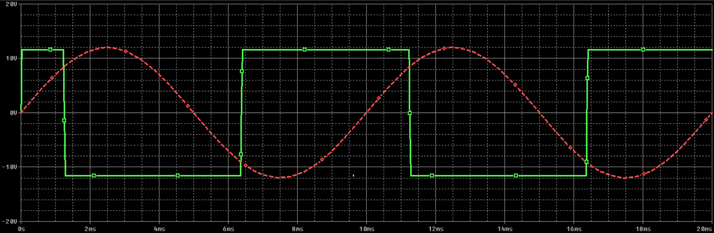

**Transfer Characteristics:**

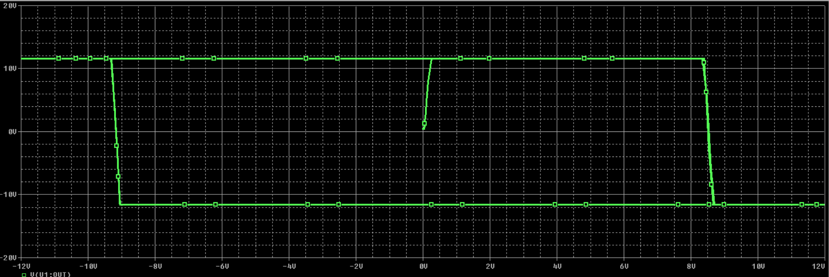

**Inference:**

UTP = 2 = Vsat*R2 / (R1+R2) + Vref *R1/ (R1+R2)

LTP = -4 = -Vsat*R2 / (R1+R2) + Vref *R1/ (R1+R2)

Substituting & calculating we get Vref= -1.334V, R1= 10KΩ, R2=3.3KΩ

**CASE 2:**

**Circuit:**

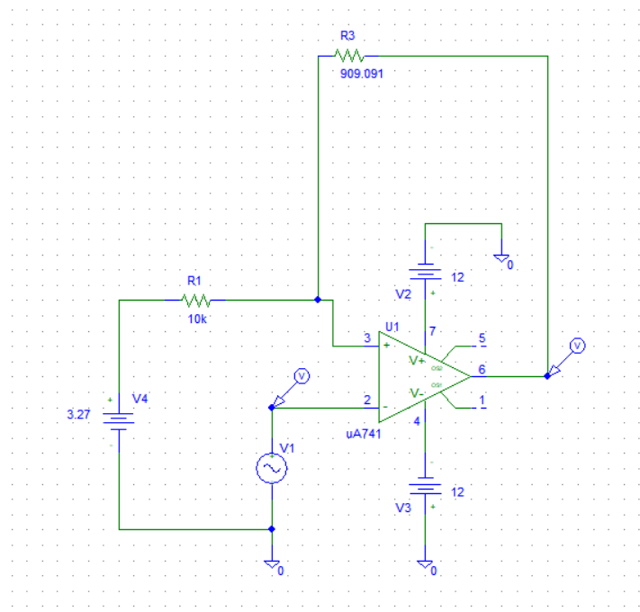

**Graph:**

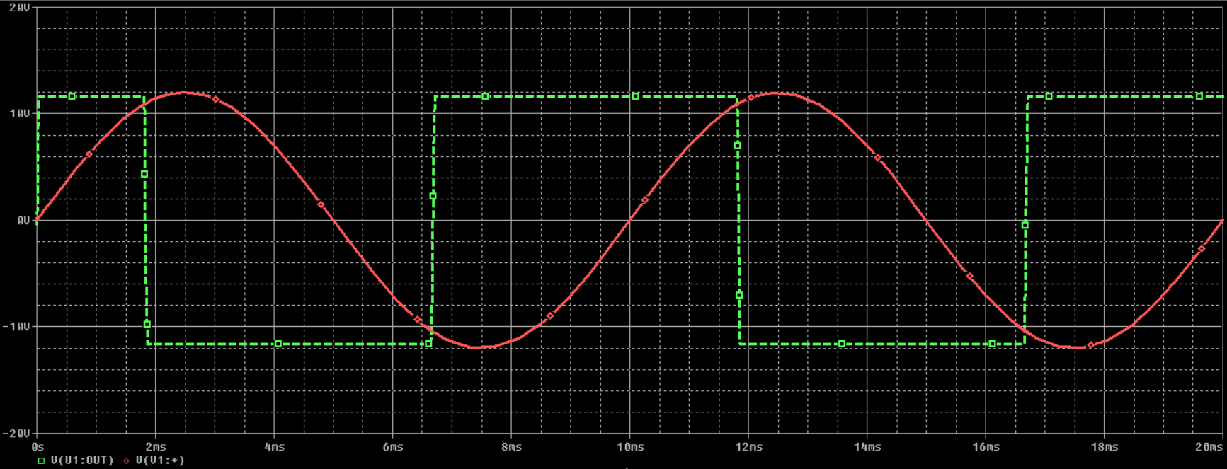

**Transfer Characteristics:**

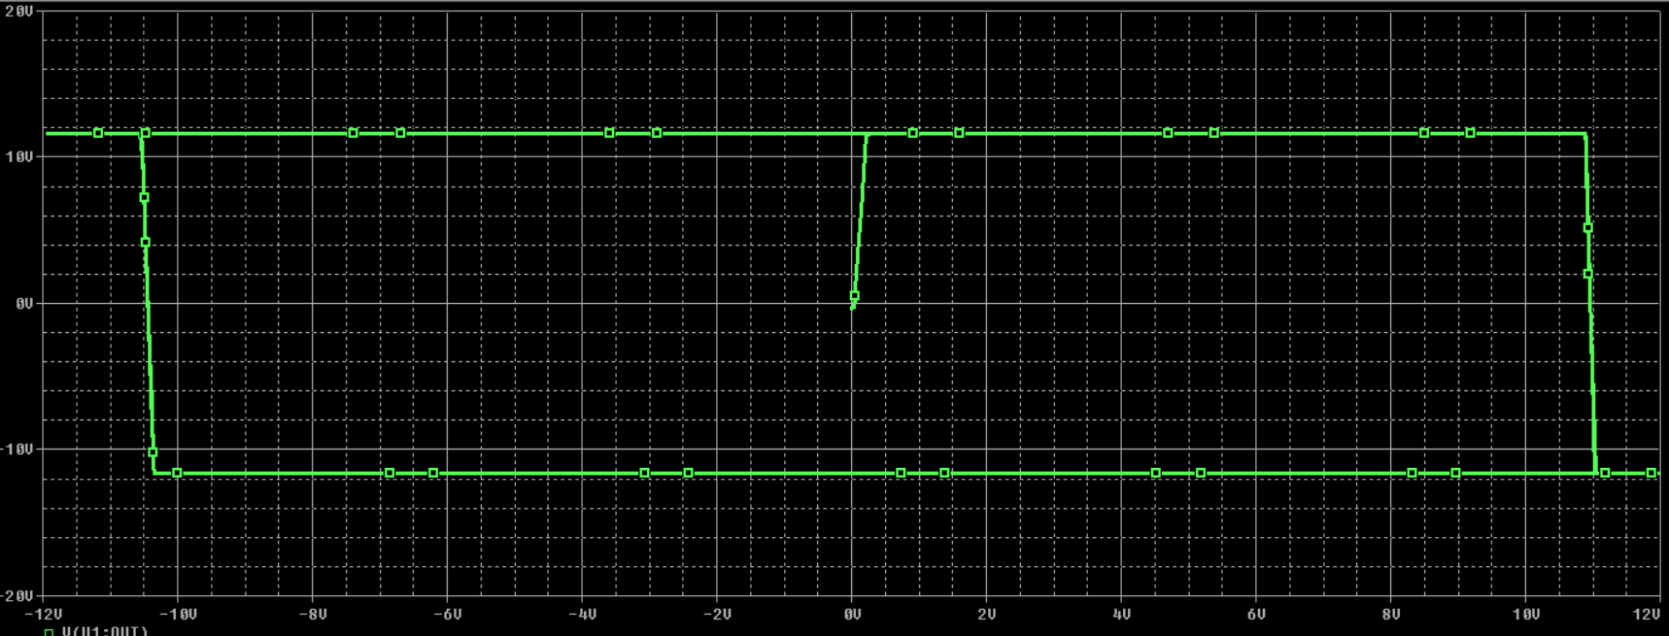

**Inference:**

UTP = 2 = Vsat*R2 / (R1+R2) + Vref *R1/ (R1+R2)

LTP = -4 = -Vsat*R2 / (R1+R2) + Vref *R1/ (R1+R2)

Substituting & calculating we get Vref= 3.27V, R1= 10KΩ, R2=909.091Ω

**CASE 3:**

**Circuit:**

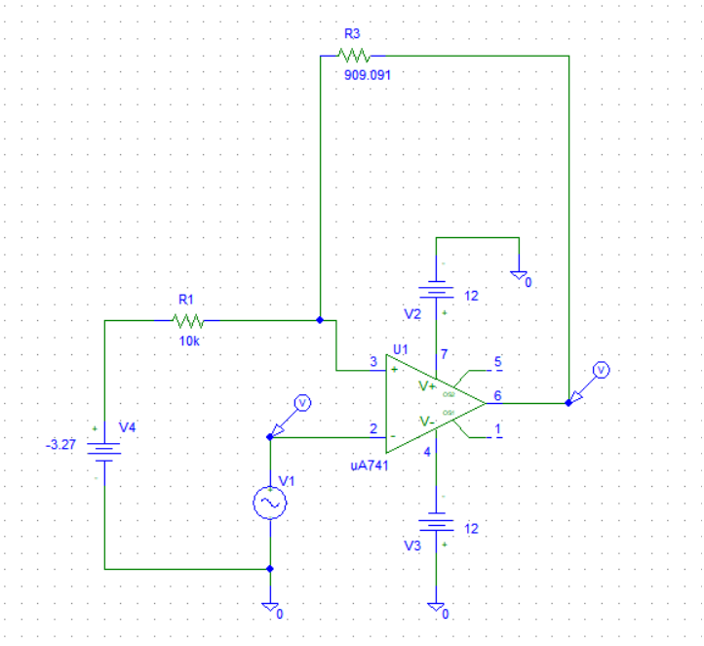

**Graph:**

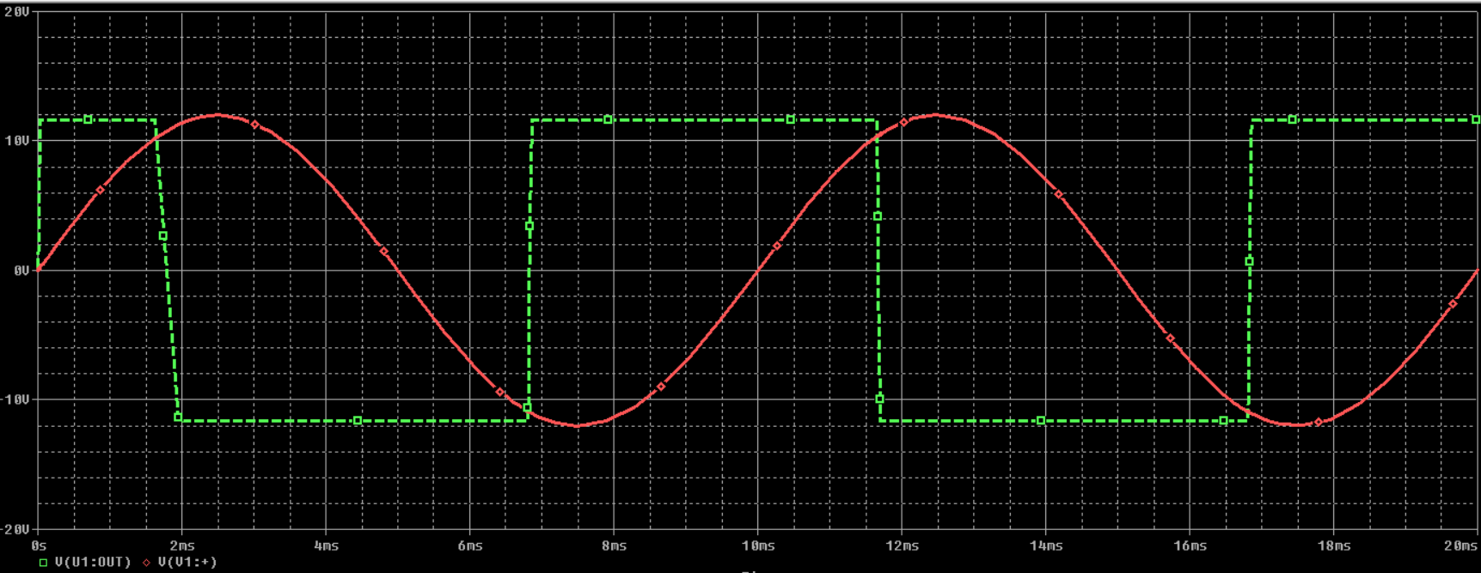

**Transfer Characteristics**:

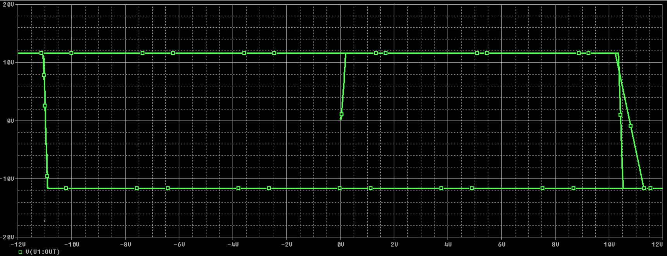

**Inference:**

UTP = 2 = Vsat*R2 / (R1+R2) + Vref *R1/ (R1+R2)

LTP = -4 = -Vsat*R2 / (R1+R2) + Vref *R1/ (R1+R2)

Substituting & calculating we get Vref= -3.27V, R1= 10KΩ, R2=909.091KΩ

**AIM**: To design various different wave generators as per the given conditions**.**

**CASE 1:** Design the sawtooth-wave generator shown so that fo =5kHz, Vth=5 V, and the circuit has a duty cycle of k =0.4. Assume Vsat =|-Vsat|= 12V.

**CASE 2:** Design the square-wave generator shown so that fo =4kHz. Assume Vsat =|-Vsat|= 14 V.

**CASE 3:** Design the triangular-wave generator shown so that fo =4 kHz, Vth=|-Vth|=5 V. Assume Vsat =|-Vsat|= 14 V

**APPARATUS AND COMPONENTS REQUIRED:**

Op-amp uA741, resistors, simulation software, DC input, AC input.

**THEORY:**

A linear, non-sinusoidal, triangular shape waveform represents a sawtooth waveform in which fall time and rise time are different

We can use a Schmitt trigger for the construction of a square wave generator.

Triangular waveform is a periodic, non-sinusoidal waveform. The important difference to note between triangular and saw tooth waveform is that triangular wave form has equal rise and fall time while saw tooth waveform has unequal rise and fall times.

**PROCEDURE:**

* 1. Carry out calculations as shown under calculations.
  2. Rig up the circuit with the given values and calculated values.
  3. Click on simulation and analyze the graph

**Case 1:**

**Circuit:**

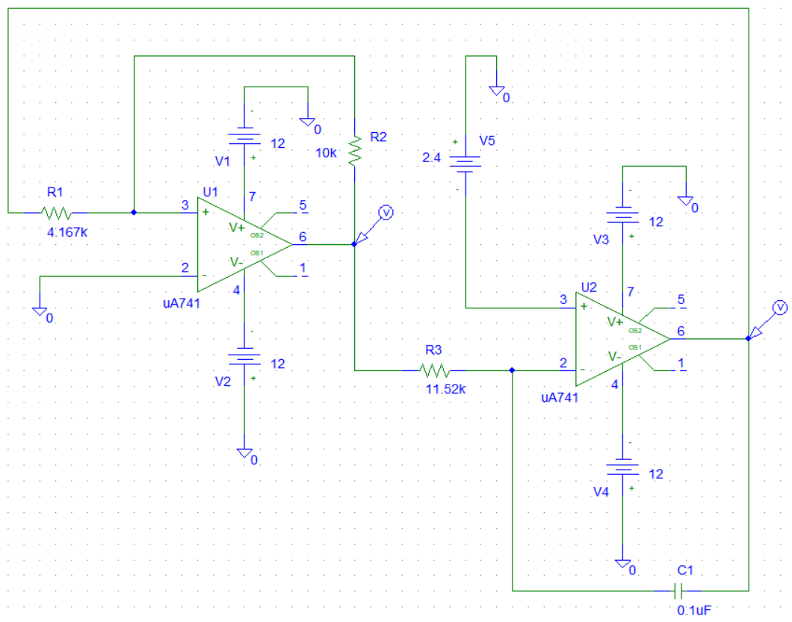

**Graph:**

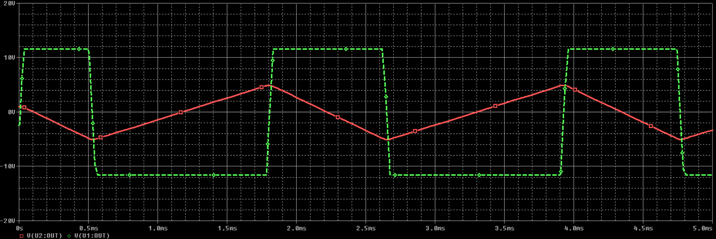

**Calculations:**

Vref= (0.8-1) *12= -2.4V

R1/Rf=Vth/Vsat=5/12

R1/10KΩ=5/12

We get,

R1=4.167KΩ

Assuming, C= 0.01µF

R= ((Vo^2) -(Vref^2))/(4fo*C*Vth*Vsat)

Substituting the values, we get,

R= 11.52KΩ

**CASE 2:**

**Circuit:**

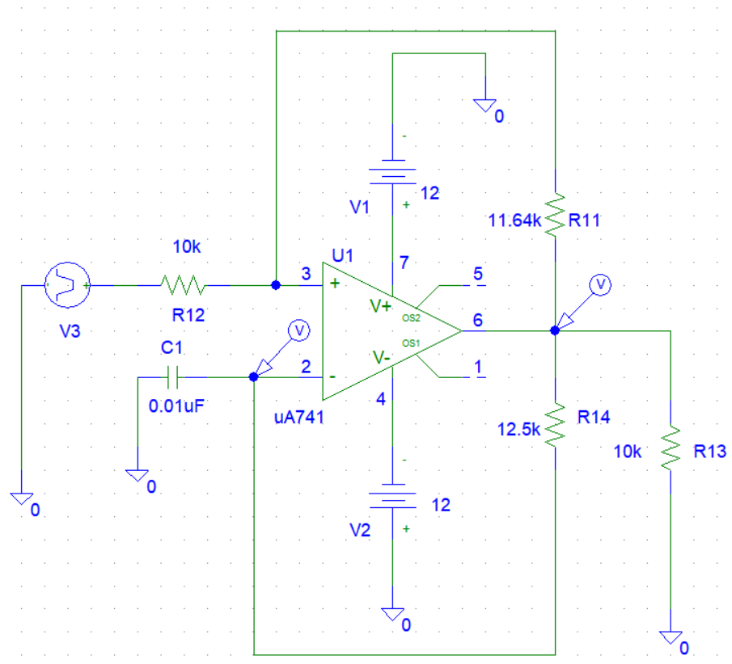

**Graph:**

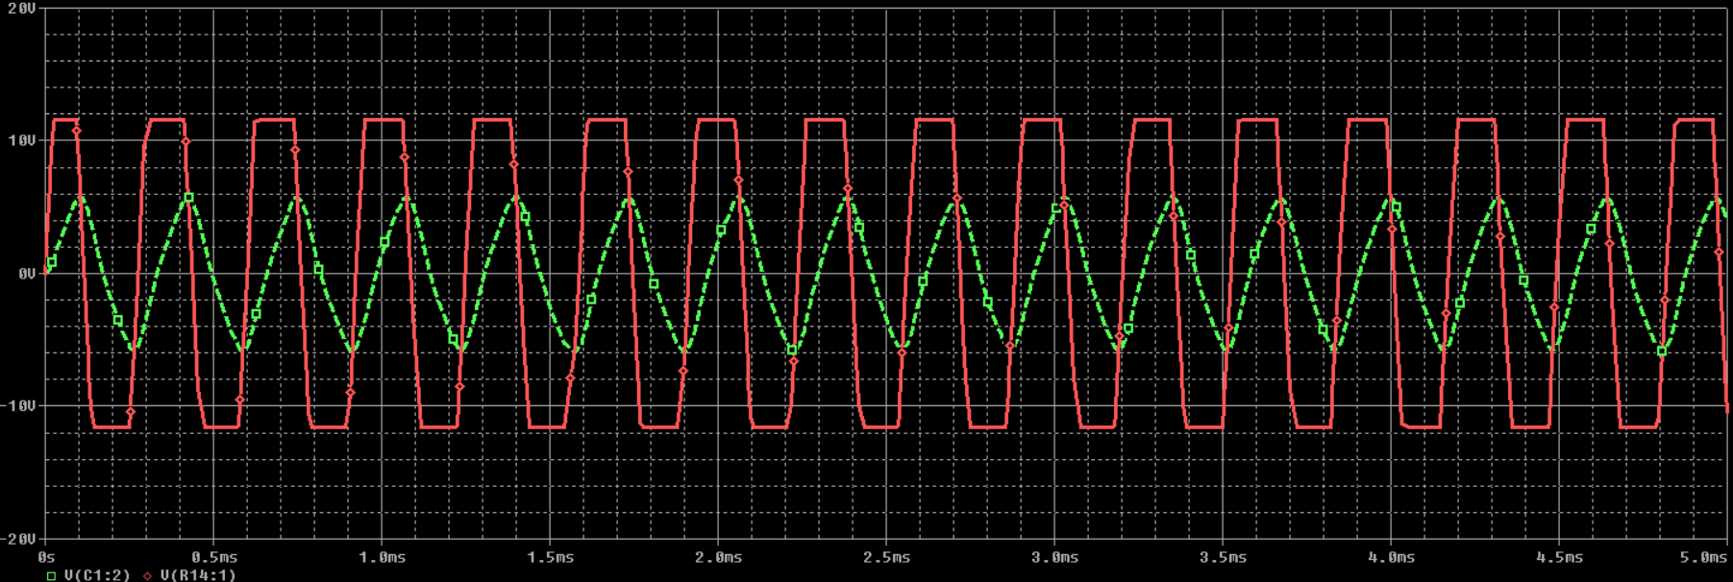

**Calculations:**

fo = 1/2πrc

Let C = 0.01µF

R = 1/2Cfo

= 1/ (2*0.01*(10^ (-6)) *4*(10^3))

= 12.5KΩ

Let R1 = 10KΩ

Therefore, Rt = 1.164*R1 = 11.64KΩ

**CASE 3:**

**Calculations**:

fo = 4KHz Vth = 5V Vsat = 14V

R1/R2 = Vth/Vsat = 5/14

If Rf = 10KΩ Then, R1 = 3.571 KΩ

R = Rf/(4*fo*C*R1)

Substituting the values, we get:

R= 17.502KΩ

**Circuit:**

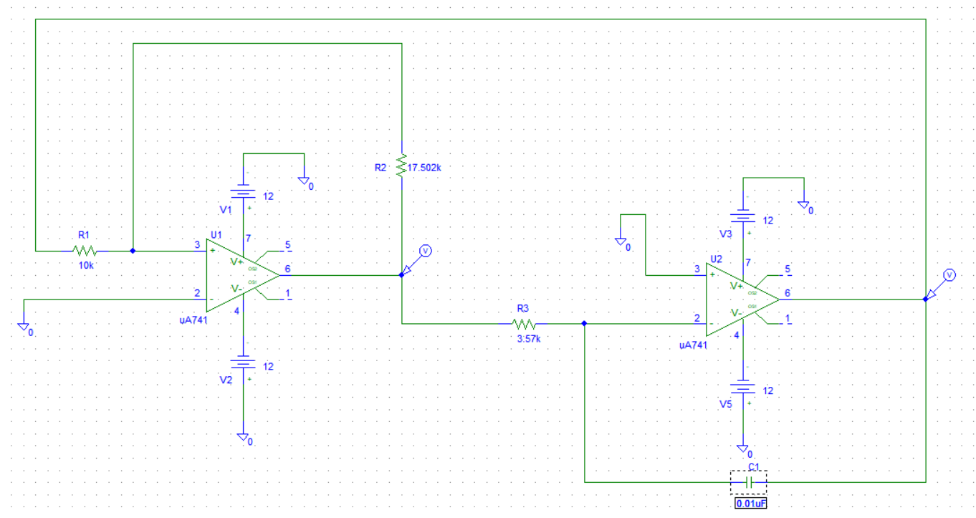

**Graph:**

