**Aim:** To design a 2nd order Modified Sallen-Key low pass filter for a given frequency using µA-741

**Components:**

1. µA-741 - 1
2. Resistors – (5 - 15.9 kΩ, 1 resistor - 25, 15.9, 10, 5.31kΩ)
3. Capacitors – (2 - 0.01 µF)
4. AC Voltage Supply

**Theory:**

**Second Order Filters,** which are also referred to as VCVS filters (as the op-amp is used as a Voltage Controlled Voltage Source amplifier), are another important type of active filter design because along with the active first order RC filters we looked at previously, Higher order filter circuits can be designed using them. Second order (two-pole) active filters whether low pass or high pass, are important in Electronics because we can use them to design much higher order filters with very steep roll-off’s and by cascading together first and second order filters, analogue filters with an nth order value, either odd or even can be constructed up to any value, within reason.

**Procedure**

1. Make the connections as shown in circuit diagram.
2. In setup analysis, select AC Sweep. Then select the start and end frequencies, with number of points.
3. Simulate the circuit, a graph of frequency response is obtained. Convert the graph to decibel (20*log (Vout)).

**Calculation:**

Given fC = 1 kHz, K = 4

We know: fC =

Let C = C2 = C3 = 0.01 µF. On solving, R = 15.91 kΩ

Let R2 = R3 = R4 = 15.91 kΩ

K = , Rf = 47.7 kΩ

**Let,** Q = 0.707

Q = , x = 0.39

x = , R5 = 24.87 kΩ

**Circuit:**

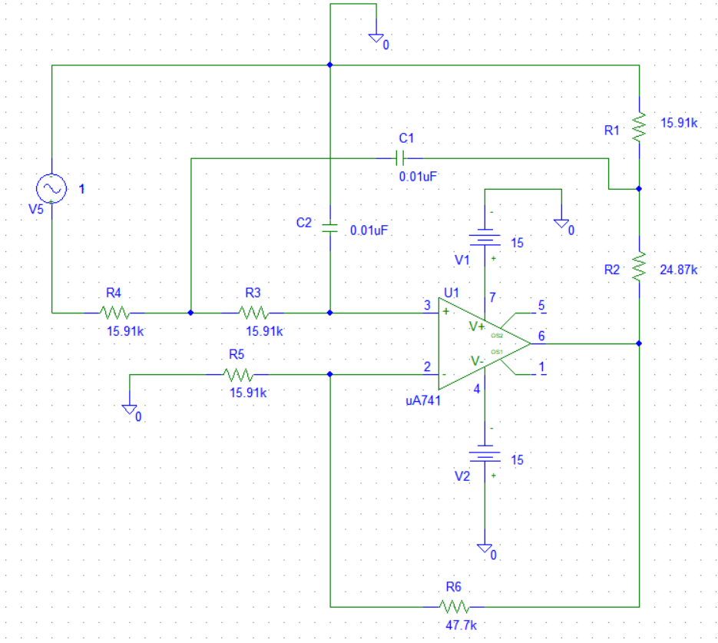

**Graph: (Q=0.707)**

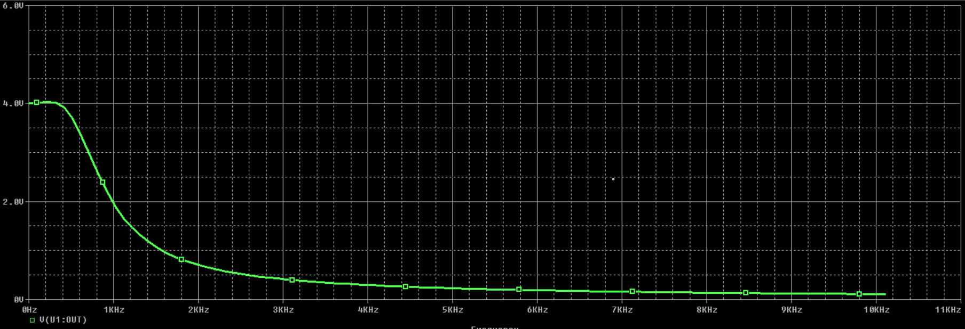

**Gain:**

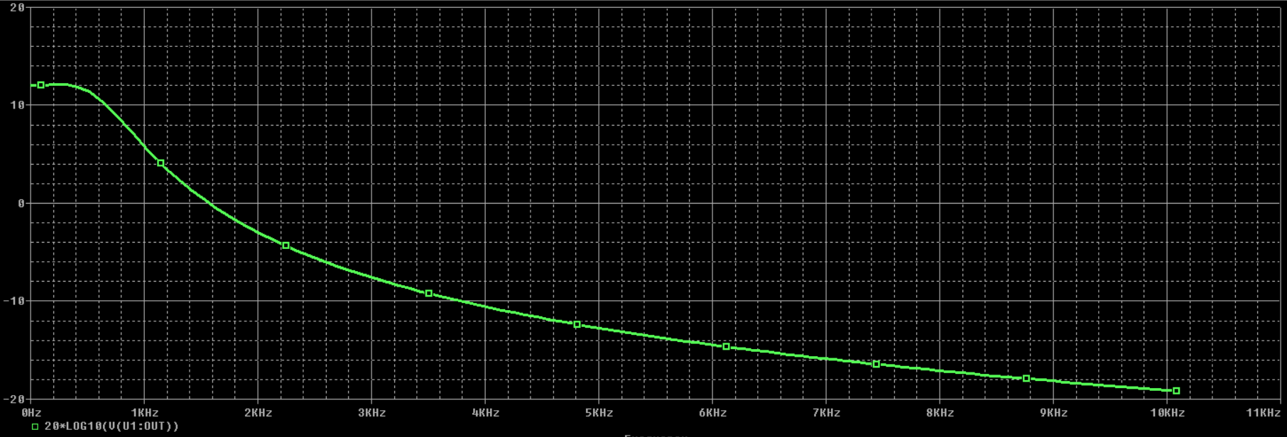

**Aim:** To design a 2nd order Sallen-Key high pass filter for a given frequency using µA-741

**Components:**

1. µA-741 - 1
2. Resistors – (5 - 15.9 kΩ, 1 resistor - 25, 15.9, 10, 5.31kΩ)
3. Capacitors – (2 - 0.01 µF)
4. AC Voltage Supply

**Theory:**

Higher order filters can be synthesized from these two basic types. Since the frequency scale of a Low pass filter is o to fL and that of high pass filter is fL to ∞, their frequency scales have a reciprocal relationship. By replacing R by C and C by R in the Lowpass filter will work as high pass filter. This filter passes all signals with frequencies higher than fL.

**Procedure**

1. Make the connections as shown in circuit diagram.
2. In setup analysis, select AC Sweep. Then select the start and end frequencies, with number of points.
3. Simulate the circuit, a graph of frequency response is obtained. Convert the graph to decibel (20*log(Vout)).

**Calculations:**

Given fC = 1 kHz, K = 4

We know: fC =

Let C = C2 = C3 = 0.01 µF. On solving, R = 15.916 kΩ

Let R2 = R3 = R4 = 15.916 kΩ

K = , Rf = 47.7 kΩ

**Let,** Q = 0.707

Q = , x = 0.39

x = , R5 = 24.87 kΩ

**Circuit:**

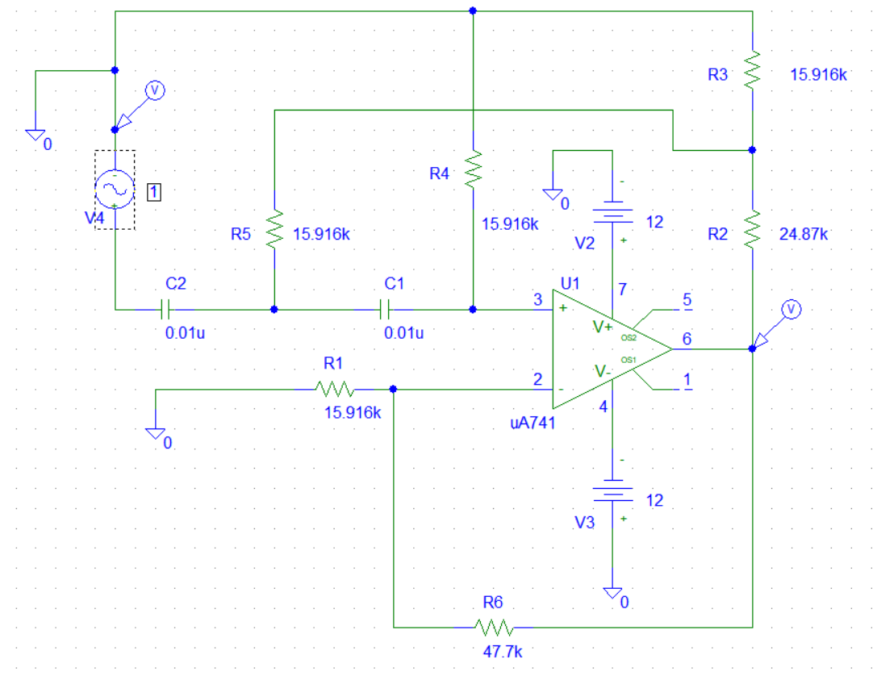

**Graph:**

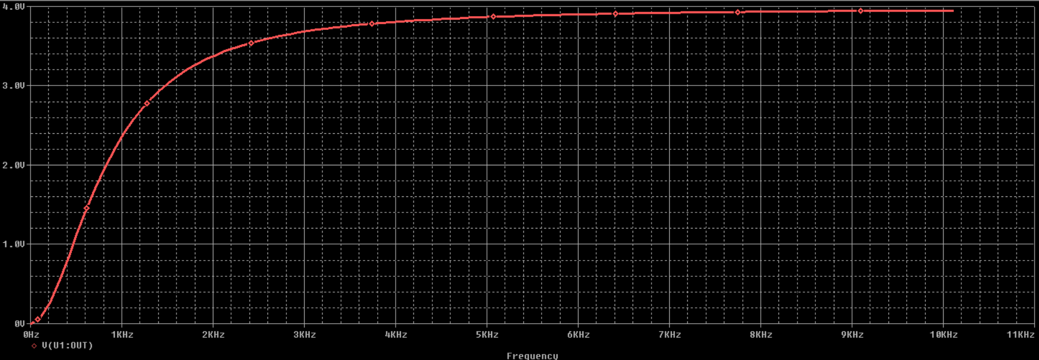

**Gain:**

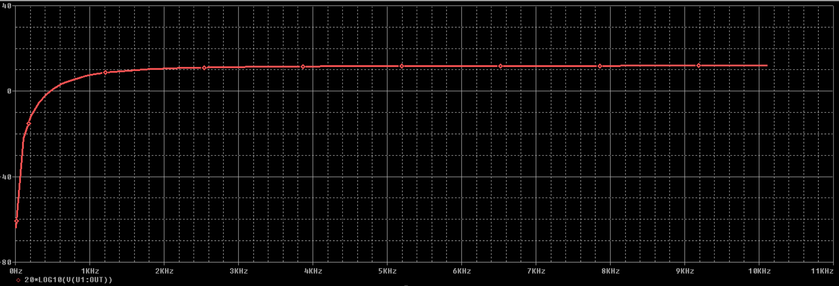

**Aim:** To design a 2nd order Butterworth low pass filter for a given frequency using µA-741

**Components:**

1. µA-741 - 1
2. Resistors – (4 - 15.9 kΩ, 1 resistor - 25, 15.9, 10, 5.31kΩ, 18k and 157k)
3. Capacitors – (2 - 0.01 µF)
4. AC Voltage Supply

**Theory:**

**Second Order Filters,** which are also referred to as VCVS filters (as the op-amp is used as a Voltage Controlled Voltage Source amplifier), are another important type of active filter design because along with the active first order RC filters we looked at previously, higher order filter circuits can be designed using them. Second order (two-pole) active filters whether low pass or high pass, are important in Electronics because we can use them to design much higher order filters with very steep roll-off’s and by cascading together first and second order filters, analogue filters with an nth order value, either odd or even can be constructed up to any value, within reason.

**Procedure:**

1. Make the connections as shown in circuit diagram.
2. In setup analysis, select AC Sweep. Then select the start and end frequencies, with number of points.
3. Simulate the circuit, a graph of frequency response is obtained. Convert the graph to decibel (20*log(Vout)).

**Circuit:**

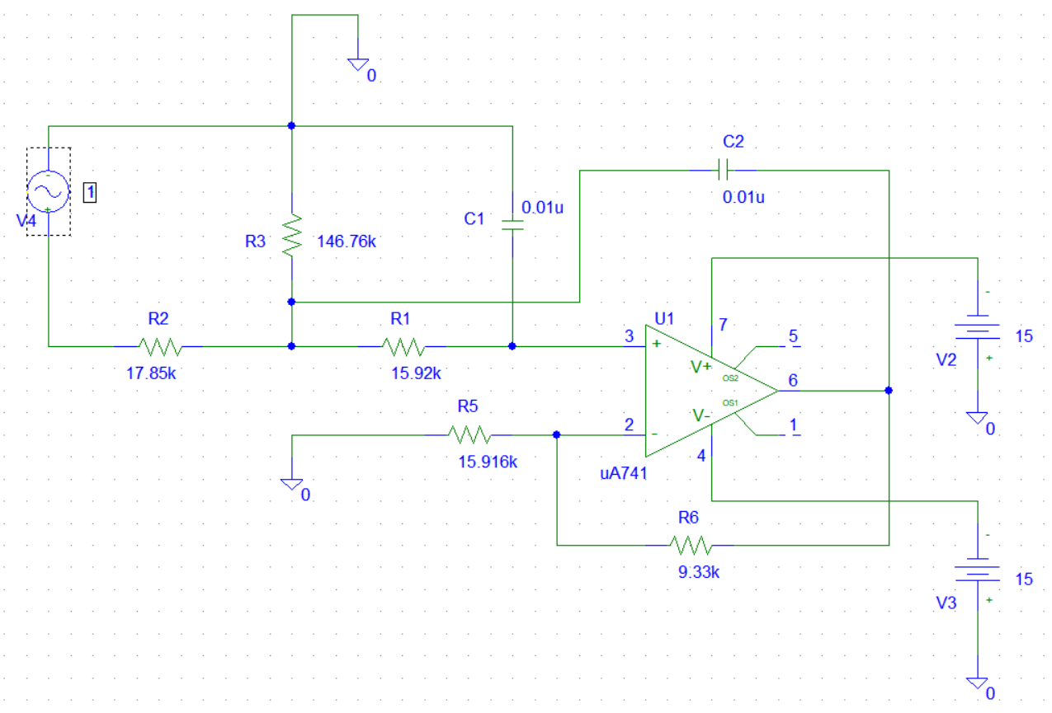

**Graph:**

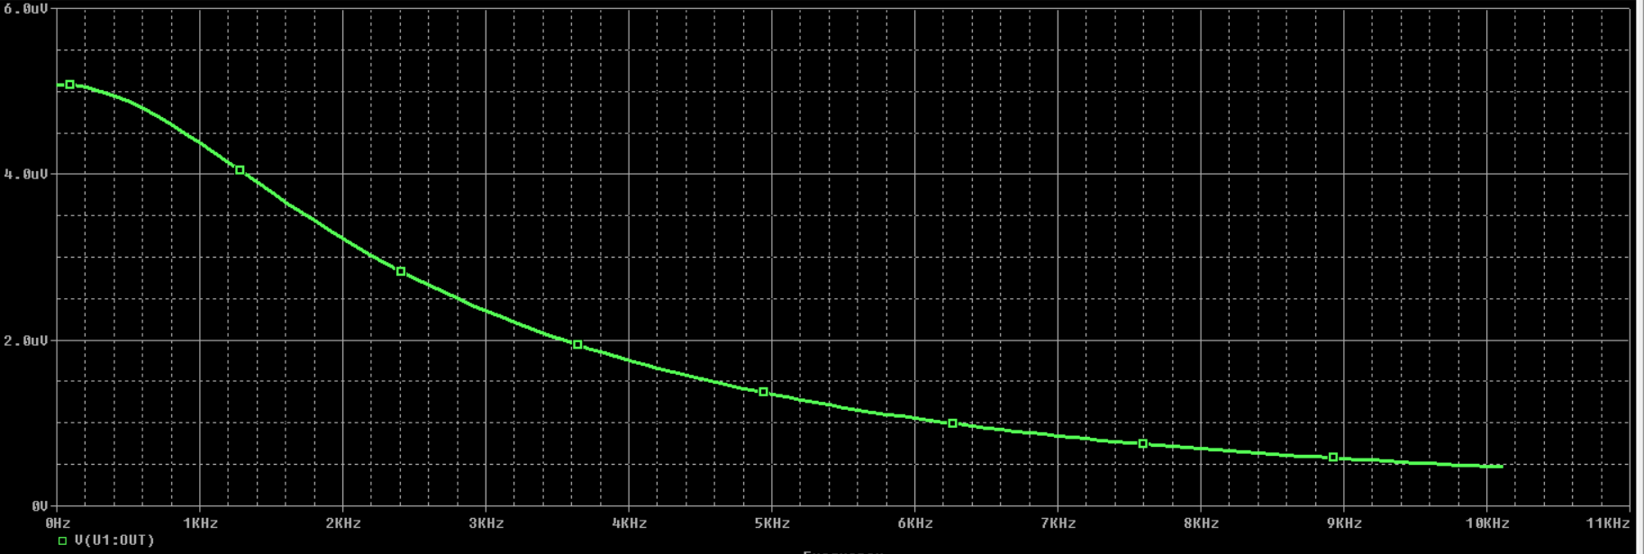

**Gain:**

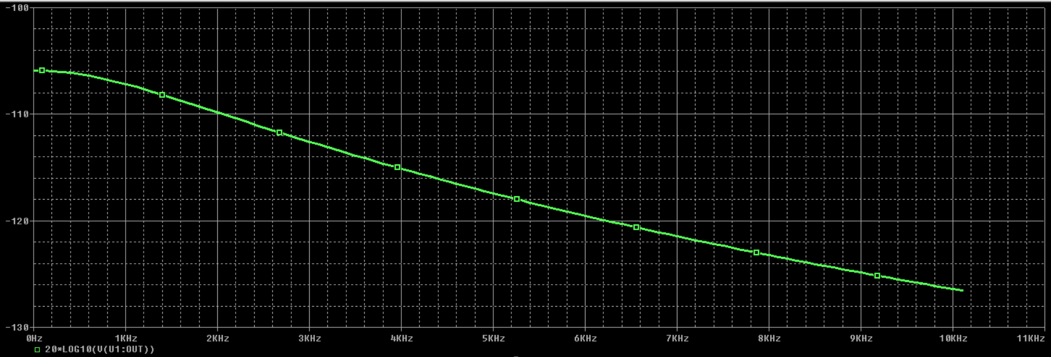

**Aim:** To design a 2nd order Butterworth high pass filter for a given frequency using µA-741

**Components:**

1. µA-741 - 1
2. Resistors – (4 - 15.9 kΩ, 1 resistor - 25, 15.9, 10, 5.31kΩ, 18k and 157k)
3. Capacitors – (2 - 0.01 µF)
4. AC Voltage Supply

**Theory:**

Higher order filters can be synthesized from these two basic types. Since the frequency scale of a Low pass filter is o to fL and that of high pass filter is fL to ∞, their frequency scales have a reciprocal relationship. By replacing R by C and C by R in the Lowpass filter will work as high pass filter. This filter passes all signals with frequencies higher than fL.

**Procedure:**

1. Make the connections as shown in circuit diagram.
2. In setup analysis, select AC Sweep. Then select the start and end frequencies, with number of points.
3. Simulate the circuit, a graph of frequency response is obtained. Convert the graph to decibel (20*log(Vout)).

**Design**:

For Q =0.707, we have C = 0.01uF and R = 15,916

K = 3 – 1 / Q

= 3 – 1 / 0.707 = 1.586

and RF = (K-1)R1 = (1.586 - 1) * 15,916 = 9327

Ca = C / K = 0.01uF/1.586 = 6.305nF

Cb = C * (K - 1) / K = {0.01uF * (1.586 - 1) }/ 1.586 = 3.695 nF

**Circuit:**

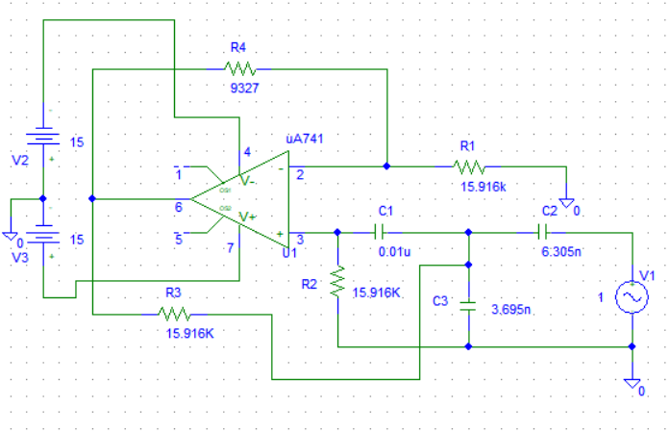

**Graph:**

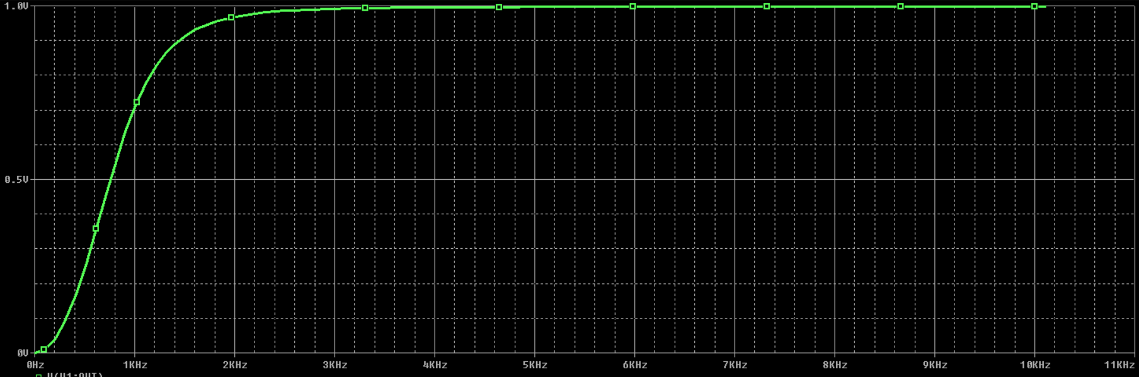

**Gain:**

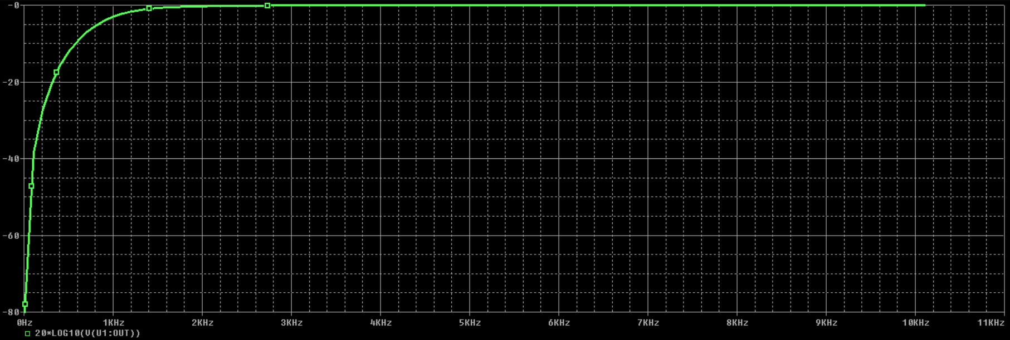

**Aim:** To design a 2nd order wide band pass filter for a given frequency using µA-741

**Components:**

1. µA-741 - 2
2. Resistors – 7
3. Capacitors - 5
4. AC Voltage Supply

**Theory:**

The arrangement here is to use two filters: one low-pass filter and one high-pass filter. The output is obtained by multiplying the low-frequency response by the high-frequency response, be implemented simply by cascading the first-order (or second-order) high-pass and low-pass sections. The order of the band-pass filter depends on the order of the high-pass and low-pass sections. This arrangement has the advantage that the falloff, rise, and midband gain can be set independently. However, it requires more op-amps and components

**Procedure:**

1. Make the connections as shown in circuit diagram.
2. In setup analysis, select AC Sweep. Then select the start and end frequencies, with number of points.
3. Simulate the circuit, a graph of frequency response is obtained. Convert the graph to decibel (20*log(Vout/Vin)).

**Calculation:**

Given fL = 10 kHz, fH = 1 MHz, KPB = 16

For **High Pass Section**,

fH = , KPB1 = 4

Let C = C2 = C3 = 0.01 µF. On solving, R = 15.9 kΩ

Let R2 = R3 = 15.9 Ω

Let R1 = 10 kΩ

K = , Rf = 30 kΩ

For **Low Pass Section**,

fH = , KPB2 = 4

Let C = C2` = C3` = 0.01 µF. On solving, R` = 15.9 kΩ

Let R2` = R3` = 15.9 kΩ

Let R1` = 10 kΩ

K = , Rf` = 30 kΩ

**Circuit:**

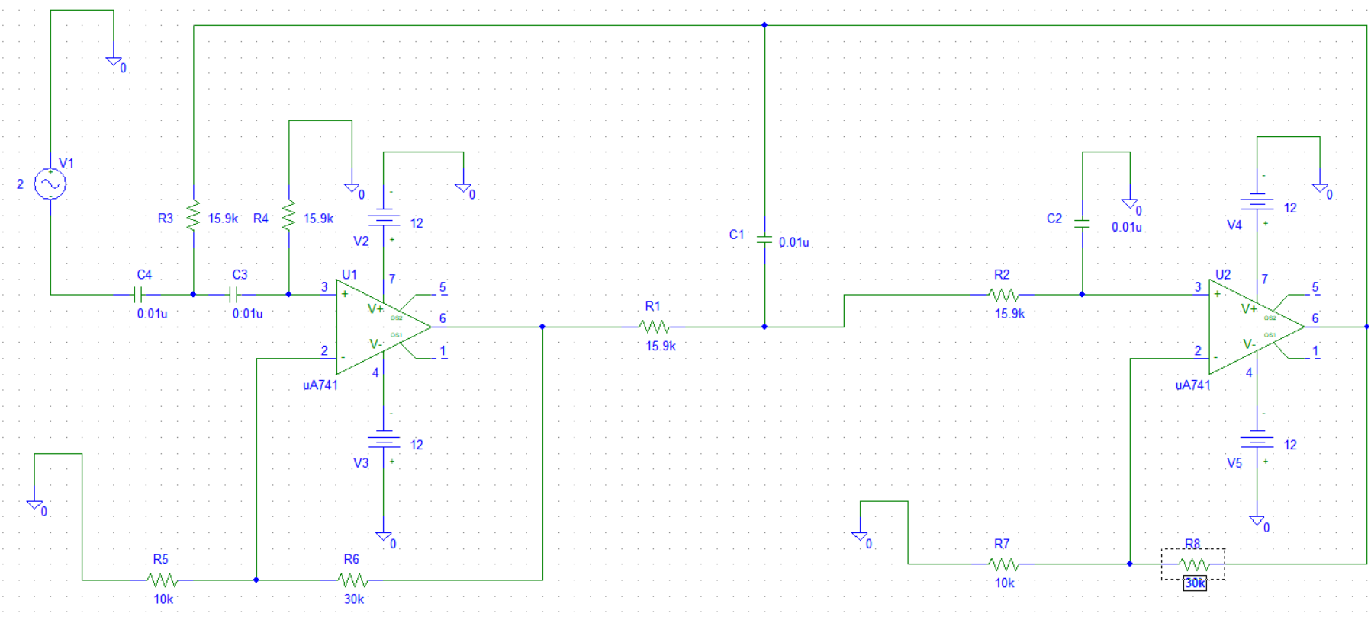

**Graph:**

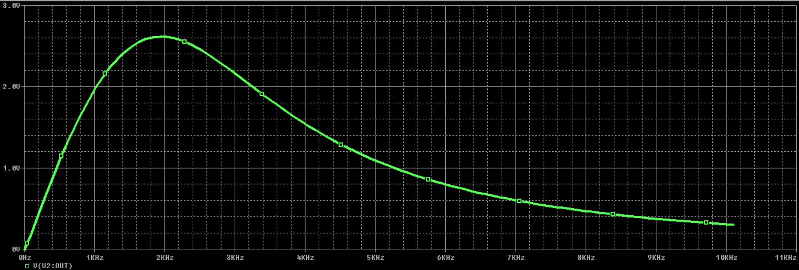

**Gain:**

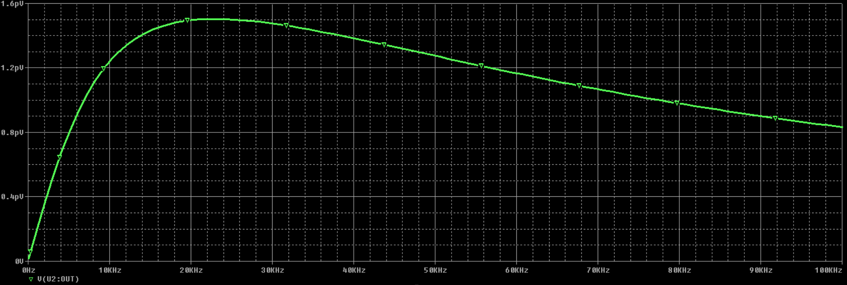

**Aim:** To design a 2nd order Butterworth Wide Band pass filter for a given frequency using µA-741

**Components:**

1. µA-741 - 2
2. Resistors – 7
3. Capacitors - 5
4. AC Voltage Supply

**Procedure**

1. Make the connections as shown in circuit diagram.
2. In setup analysis, select AC Sweep. Then select the start and end frequencies, with number of points.
3. Simulate the circuit, a graph of frequency response is obtained. Convert the graph to decibel (20*log(Vout)).

**Circuit:**

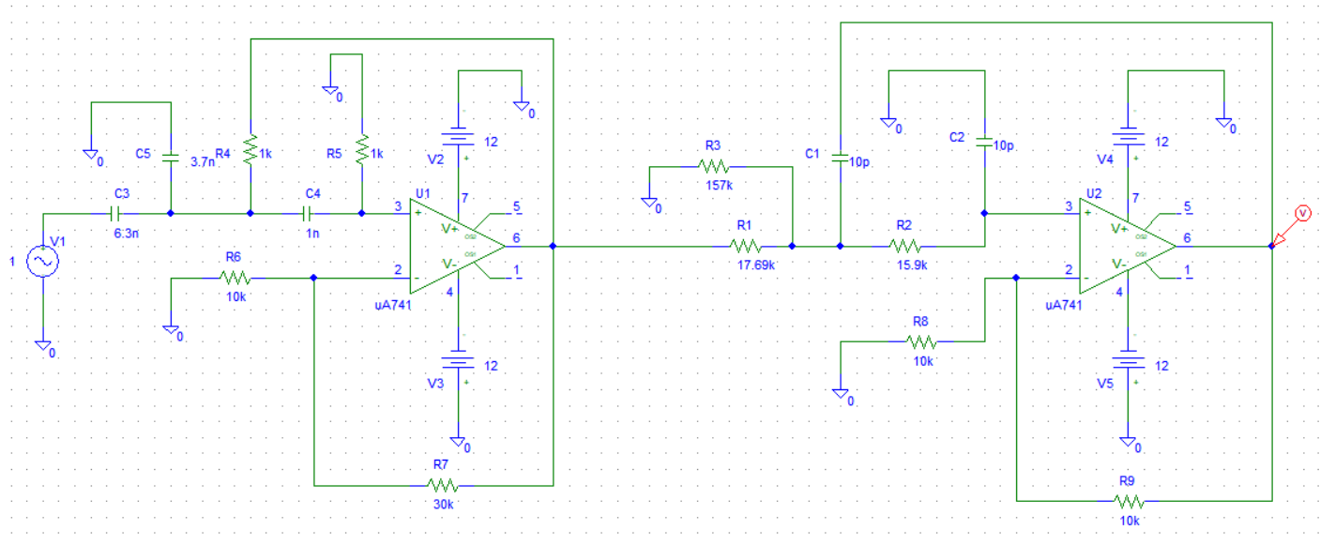

**Design:**

Let the gain of the high-pass section be KH = 4.

For the first-order high-pass section, fL = 10 kHz, we let C = 1 nF.

Then,

R = 1 / (2π * 10 kHz * 1 nF) = 15.915kΩ

and KH = 1+Rf/R1 = 4

Let R1 = 10kΩ, Then Rf = 30kΩ

For the first-order low-pass section, fH = 1 MHz and the desired gain is

KL = KPB/KH = 4

Let c’ = 10pF

R’ = 1 / (2π * 1MHz * 10pF) = 15.915k

KL = 1+ RF’/R1’ = 4

R1’ = 10K, Then RF’ = 30k

fC = (10 kHz * 1 MHz)^(1/2) = 100 kHz

BW = 1 MHz - 10 kHz = 990 kHz

Q = 100kHz / (1 MHz - 10 kHz) = 0.101

**Graph:**

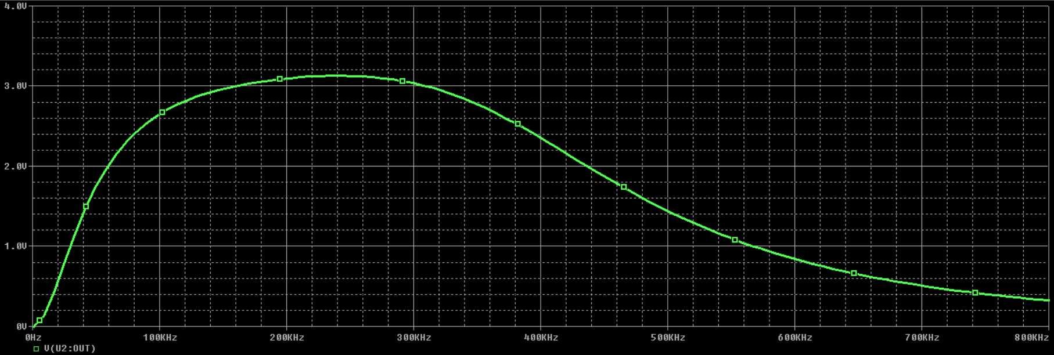

**Gain:**

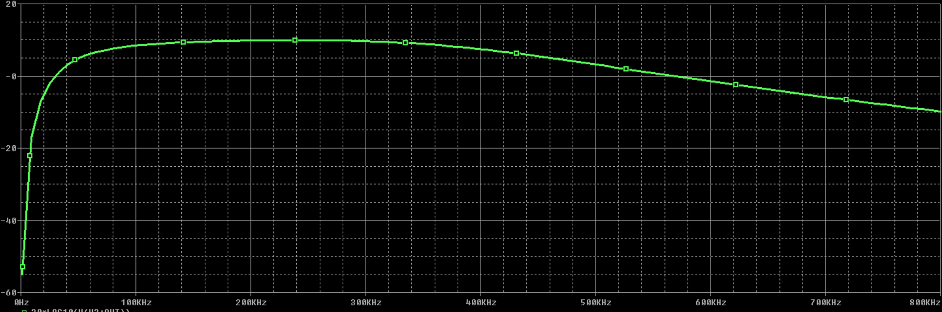

**Aim:** To design a 2nd order narrow band pass filter for a given frequency using µA-741

**Components:**

1. µA-741 - 1
2. Resistors – 3
3. Capacitors – 2
4. AC Voltage Supply

**Theory:**

This filter uses only one op-amp in the inverting mode. Because it has two feedback paths, it is also known as a multiple feedback filter. For a low Q-value, it can also exhibit the characteristic of a wide-band-pass filter. A narrow-band-pass filter is generally designed for specific values of fC and Q or fC and BW. The opamp, along with C2 and R2, can be regarded as an inverting differentiator such that Vo(s) = (-sC2R2) Vx(s)

**Procedure:**

1. Make the connections as shown in circuit diagram.
2. In setup analysis, select AC Sweep. Then select the start and end frequencies, with number of points.
3. Simulate the circuit, a graph of frequency response is obtained. Convert the graph to decibel (20*log (Vout)).

**Calculations:**

Given, f0 = 1 kHz, Q = 4, KPB = 8

Let C = 4.7 nF

R1 = Q/2πfCKpb = 16.93 kΩ π

R2 = Q/πfC = 270.9 kΩ

Rb = Q/(2πfC(2Q^2-Kpb)) = 5.63 kΩ

**Circuit:**

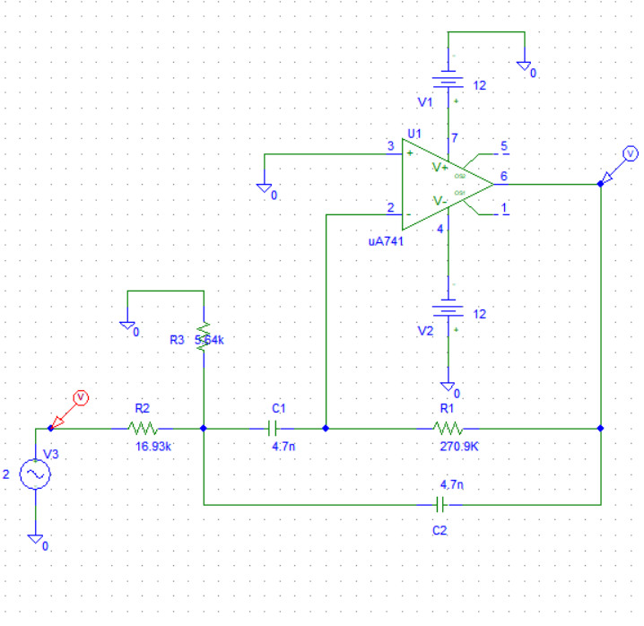

**Graph:**

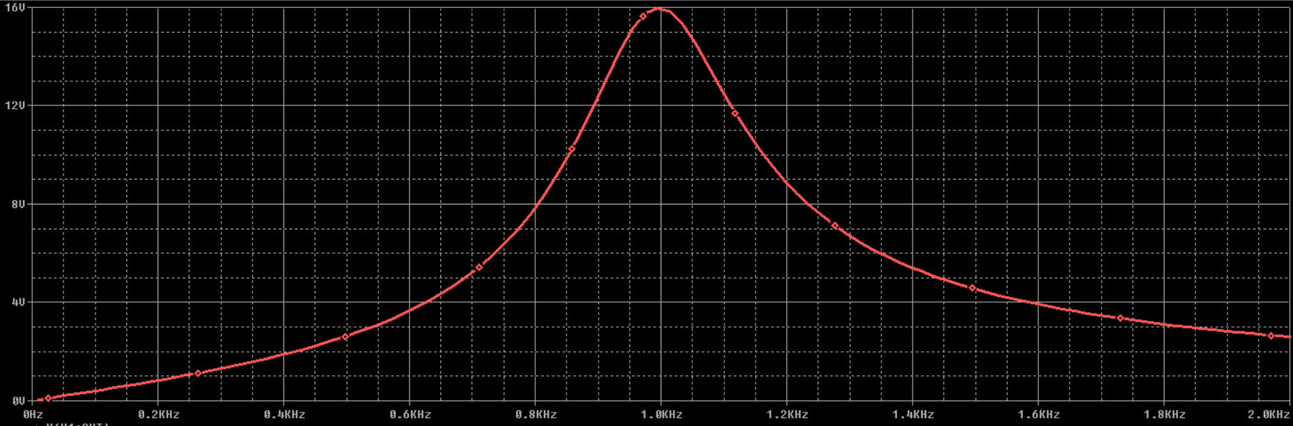

**Gain:**

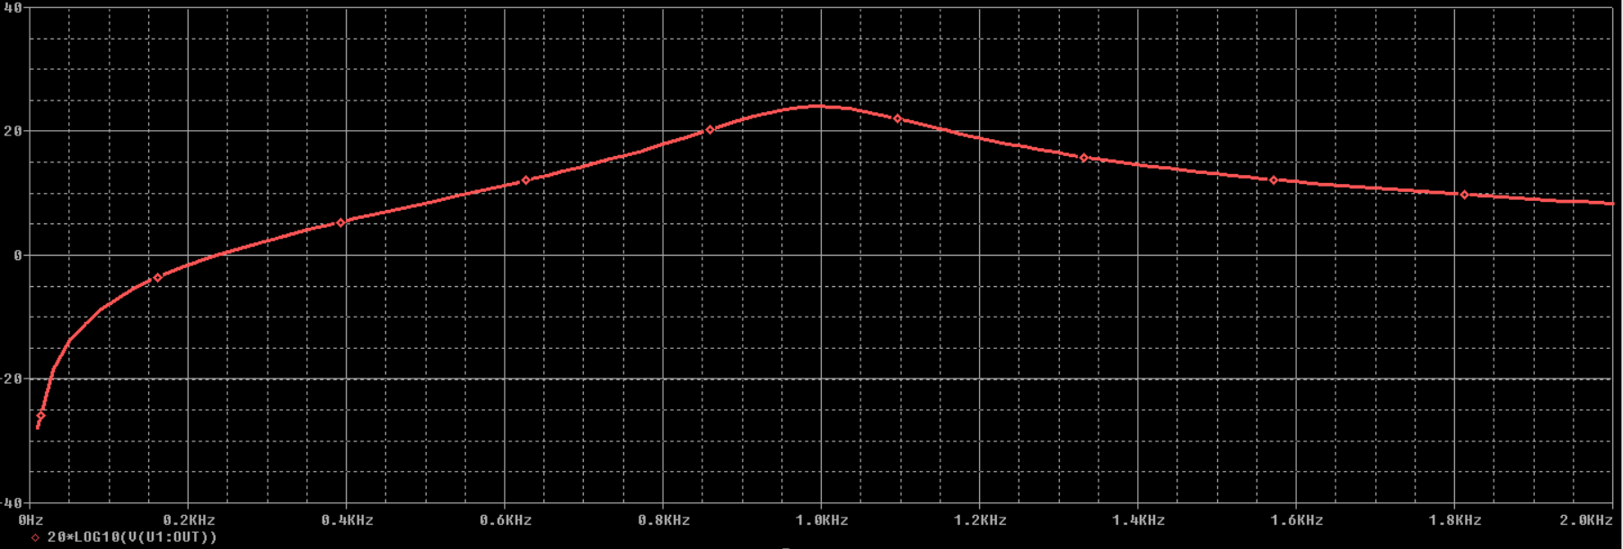

**Aim:** To design a 2nd order narrow band Reject (Notch) filter for a given frequency using µA-741

**Components:**

1. µA-741 - 1
2. Resistors – 3
3. Capacitors – 2
4. AC Voltage Supply

**Theory:**

This filter, often called a notch filter, is commonly used in communication and biomedical instruments to eliminate undesired frequencies such as the 60-Hz power line frequency hum. A twin-T network, which is composed of two T-shaped networks, is commonly used for a notch filter. One network is made up of two resistors and a capacitor; the other uses two capacitors and a resistor. To increase the Q of a twin-T network, it is used with a voltage follower.

**Procedure:**

1. Make the connections as shown in circuit diagram.
2. In setup analysis, select AC Sweep. Then select the start and end frequencies, with number of points.
3. Simulate the circuit, a graph of frequency response is obtained. Convert the graph to decibel (20*log (Vout)).

**Circuit:**

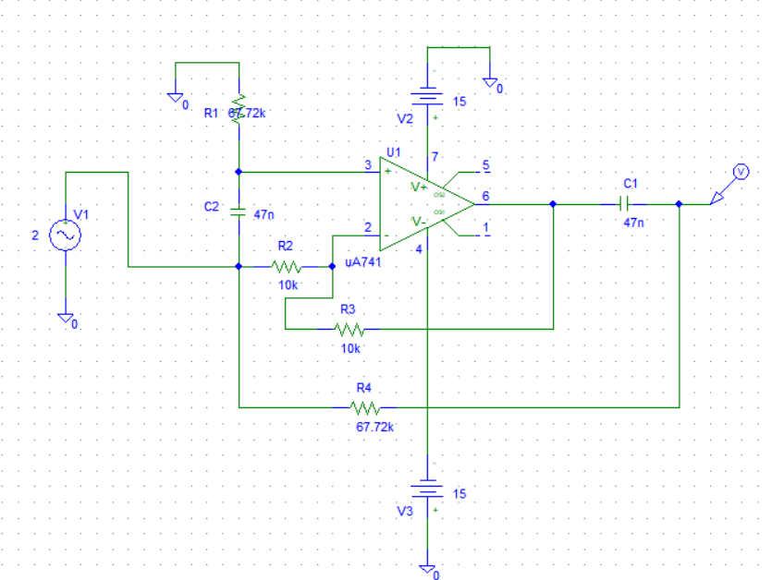

**Design:**

fn = 50 Hz. Choose a value of C less than or equal to 1uF: Let C = 0.047uF

R = 1/ (2*π*50*0.047uF) = 67.72k

R3 = R/2 = 33.86k

C3 = 2*C = 0.094uF

**Graph:**

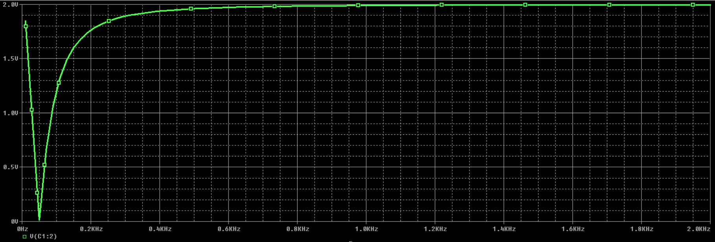

**Gain:**

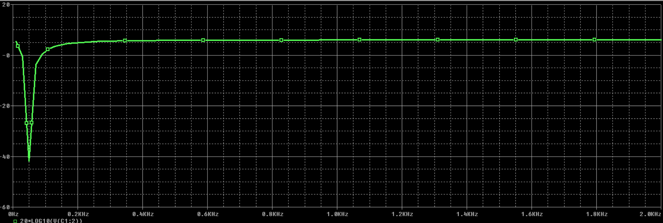

**Aim:** To design a 2nd order Wide band Reject filter for a given frequency using µA-741

**Components:**

1. µA-741 - 1
2. Resistors – 3
3. Capacitors – 2
4. AC Voltage Supply

**Theory:**

This characteristic can be obtained by adding a low-pass response to a high-pass response. The solution can be implemented by summing the responses of a first-order (or second-order) high-pass section and low-pass section through a summing amplifier. The order of the band-reject filter depends on the order of the high-pass and low-pass sections. For a band reject response to be realized, the cutoff frequency fL of the high-pass filter must be larger than the cutoff frequency fH of the low-pass filter. In addition, the pass-band gains of the high-pass and low-pass sections must be equal. With an inverting summer (A3), the output will be inverted

**Procedure:**

1. Make the connections as shown in circuit diagram.
2. In setup analysis, select AC Sweep. Then select the start and end frequencies, with number of points.
3. Simulate the circuit, a graph of frequency response is obtained. Convert the graph to decibel (20*log (Vout)).

**Design**:

We designed a wide-band-pass filter with fL = 10 kHz and fH = 1 MHz. In this, we have fL = 100 kHz and fH = 10 kHz; that is, fL > fH. However, we can follow the design steps of wide band pass to find the component values, provided that we interchange the high-pass and low-pass sections. Thus, for the high-pass section of fL = 100 kHz, C = 100 pF and R = 15.915 k, and for the low-pass section of

fH = 10 kHz, C’ = 1nF and R’=15.915k

For a pass-band gain of KPB = 4, use R1 =R1’ = 10k and RF = RF’ = 30k

For the summing amplifier, set a gain of 1. Choose R2 = R3 = R4 = 10 k

fC = (10 kHz * 100 KHz) ^ (1/2) = 31.623 kHz

BW = 100 KHz - 10 kHz = 90 kHz

Q = 31.623kHz / (100KHz - 10 kHz) = 0.351

**Circuit:**

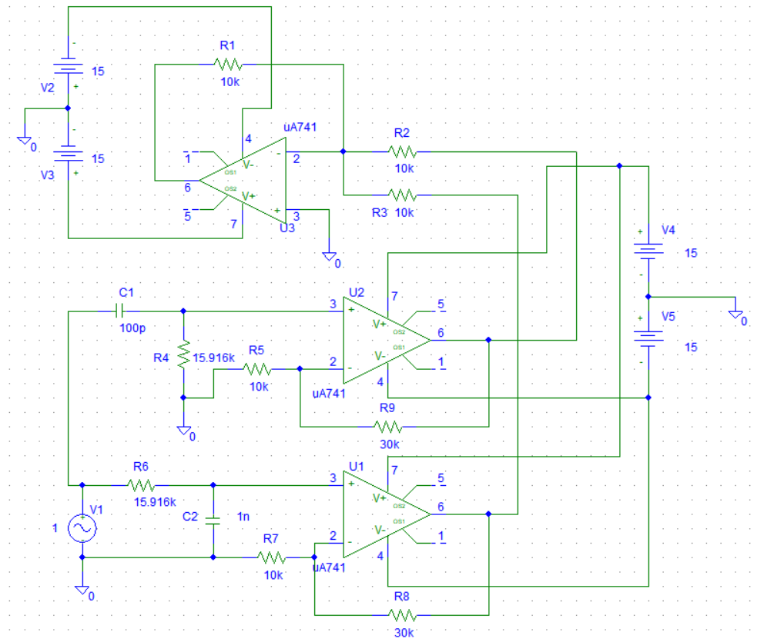

**Graph:**

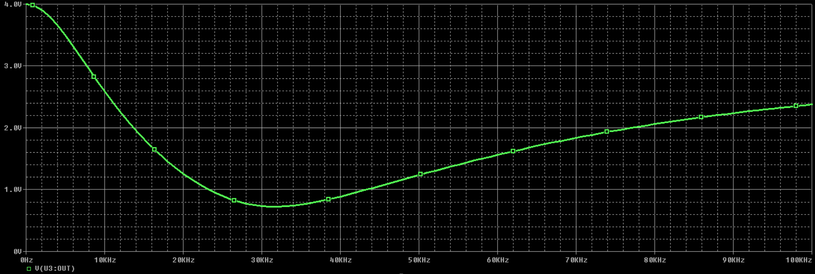

**Gain:**

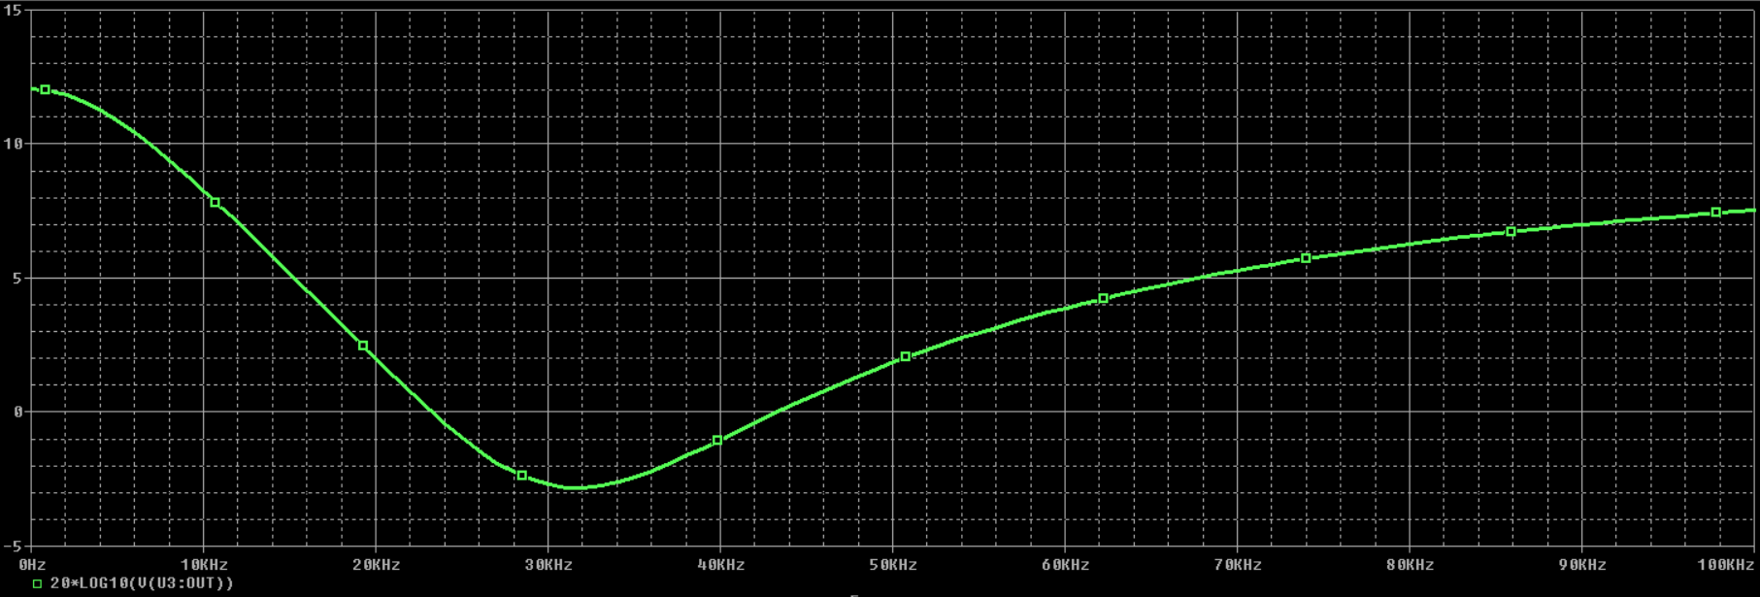

**Aim:** To design a 2nd order Butterworth Wide band Reject filter for a given frequency using µA-741

**Components:**

1. µA-741 - 1
2. Resistors – 3
3. Capacitors – 2
4. AC Voltage Supply

**Circuit:**

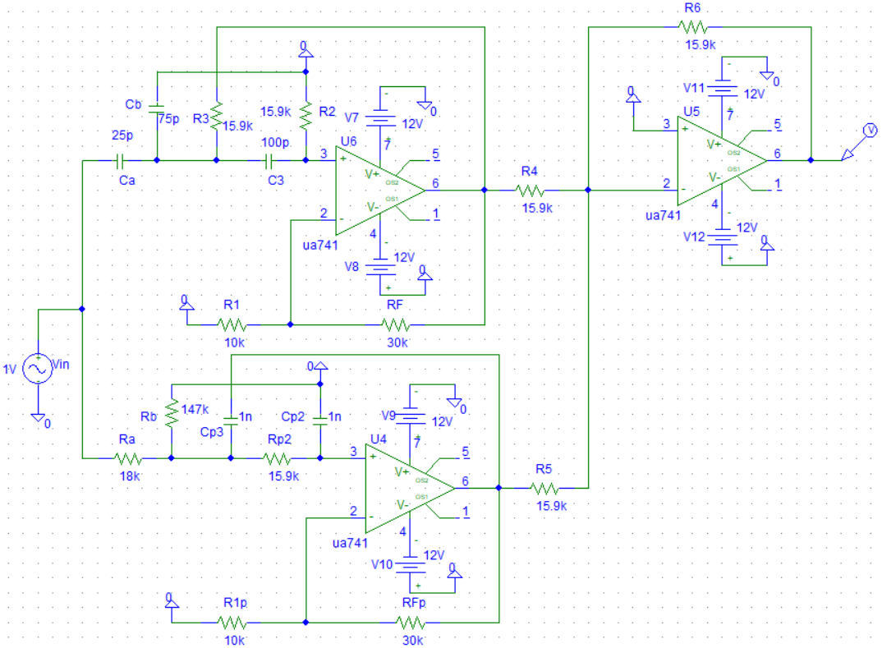

**Design:**

Given, fL = 100 kHz fH = 10 kHz, KPB = 16

**For High Pass Section**,

fL =

Let C = 100 pF. On solving, R = 15.9 kΩ

Let R1 = 10 kΩ , KPB1 = , RF = 30 kΩ

Ca = = 25 pF , Cb = C2 = 75 pF

**For Low Pass Section**,

fH =

Let C = 1 nF. On solving, R` = Rp = 15.9 kΩ

Let R1p = 10 kΩ , KPB2 = , RFp = 30 kΩ

Ra = * R2 = 18 kΩ , Rb = R2 = 147 kΩ

fC = = = 31.623 kHz , Bandwidth (BW) = 100 kHz – 10 kHz = 90 kHz

= 0.351

**Graph:**

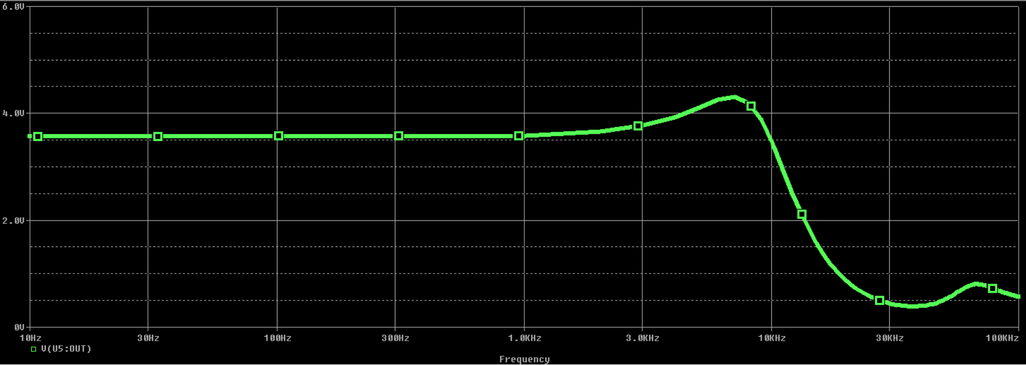

**Gain:**

