PROJECT DOCUMENTATION: AI-DRIVEN BUILDING ENERGY EFFICIENCY ANALYSIS & PREDICTION
1. PROBLEM UNDERSTANDING
1.1 Project Overview
This project analyzes how building structure affects heating energy consumption. Heat escapes through walls, roofs, and windows during winter, increasing electricity usage. Using the UCI Energy Efficiency dataset, we predict heating load based on structural features and identify which factors influence energy demand the most.
1.2 What Are We Predicting?
Target Variable: Heating Load (Y1)
Aspect | Description
What it is | The amount of energy needed to maintain indoor temperature when outside is cold
What it is NOT | Temperature reading, AC usage, or classification category
Format | Continuous numerical value (energy units)
Example | If Heating Load = 15.55, the building requires 15.55 units of energy to maintain warmth

Real-world analogy:
• Inside temperature = 22°C
• Outside temperature = 5°C
• Heat escapes through walls, windows, and roof
• Heater must replace lost heat continuously
• Heating Load = The energy required to maintain this balance
If higher Heating Load then more electricity used leads to higher costs means less efficient building
1.3 Why Are We Predicting It?
Benefit | Explanation
Design Comparison | Compare different building designs before construction
Identify Inefficiencies | Spot structural features that waste energy
Cost Estimation | Predict electricity costs for heating
Optimization | Recommend design changes to reduce energy demand

1.4 What Affects Heating Load?
Heating load depends on heat loss, which is influenced by:
• Surface exposure (how much contacts cold air)
• Shape efficiency (compact vs. spread out)
• Window area (glass loses heat faster than walls)
• Structural features (height, orientation, etc.)
more Heat Loss means heater works harder which increases heating Load
2. LITERATURE REVIEW
2.1 Dataset Source
Reference: UCI Machine Learning Repository. (2012). Energy Efficiency Dataset. University of Retrieved from https://archive.ics.uci.edu/dataset/242/energy+efficiency
2.2 Dataset Creation
• Simulation Software: Ecotect (building energy simulation)
• Building Shapes: 12 different base designs
• Total Samples: 768 building configurations
• Variations: Glazing area, glazing distribution, and orientation among other parameters
2.3 Feature Descriptions with Coded Values
X1 - Relative Compactness
Attribute | Details
Type | Continuous (0.62 to 0.98)
Meaning | Shape efficiency, how compact vs. spread out
High Value (~0.98) | Cube-like, efficient shape, less heat loss
Low Value (~0.62) | Elongated, irregular shape, more heat loss
Physical Principle | Compact shape = less surface area per unit volume = less heat escape

X2 - Surface Area
Attribute | Details
Type | Continuous (514.5 to 808.5)
Unit | Square meters (m²)
Formula | Surface Area = 2(L×W + L×H + W×H)
Meaning | Total outside skin touching cold air (walls + roof + floor)
Impact | More surface = more heat transfer paths = higher heating load

X3 - Wall Area
Attribute | Details
Type | Continuous (245.0 to 416.5)
Unit | Square meters (m²)
Meaning | Total vertical wall surface exposed to outside
Impact | Walls are primary heat loss surfaces; more wall area = more heat escape

X4 - Roof Area
Attribute | Details
Type | Continuous (110.25 to 220.5)
Unit | Square meters (m²)
Meaning | Top surface area exposed to cold sky
Impact | Heat rises and escapes through roof; stack effect increases with height

X5 - Overall Height
Attribute | Details
Type | Continuous (3.5 to 7.0)
Unit | Meters (m)
Meaning | Building height from ground to roof
Impact | Increases wall area and creates chimney effect (stronger air draft)

X6 - Orientation (Categorical)
Coded Value | Direction | Solar Exposure Impact
2 | North | Least sun exposure, higher heating load
3 | East | Morning sun, moderate benefit
4 | South | Maximum winter sun, lower heating load
5 | West | Afternoon sun, moderate benefit

Orientation has a smaller effect compared to surface area and glazing features.
X7 - Glazing Area
Attribute | Details
Type | Continuous (0.00 to 0.40)
Unit | Ratio (0 to 1, representing 0% to 40% of floor area)
Meaning | Total window area relative to floor space
Impact | Glass conducts heat 10x faster than insulated walls; major heat loss source
0.00 | No windows, minimal heat loss through glazing
0.40 | Maximum windows (40% of floor area), significant heat loss

X8 - Glazing Area Distribution (Categorical)
Coded Value | Distribution Pattern | Description
0 | No windows | No glazing area
1 | 25% on front only | Windows concentrated on one side
2 | 25% on front and back | Windows on opposite sides
3 | 25% distributed evenly | Windows on all four sides
4 | 40% on front only | High concentration on one side
5 | 40% distributed evenly | High amount, spread all around

Impact: Even distribution (codes 3, 5) may provide balanced daylight but different heat loss patterns than concentrated distribution (codes 1, 2, 4).
Y1 - Heating Load (Target Variable)
Attribute | Details
Type | Continuous (6.01 to 43.10)
Unit | Energy units (kWh or similar)
Meaning | Energy required to maintain indoor temperature during winter
Interpretation | Higher value = more electricity required = less efficient building
Range in Dataset | 6.01 (most efficient) to 43.10 (least efficient)

We are NOT predicting Y2 (Cooling Load) as this project focuses exclusively on heating energy demand.
3. DATA UNDERSTANDING
3.1 Dataset Structure
Property | Details
File Format | Excel (.xlsx)
File Size | 74.4 KB
Total Samples | 768 rows (building configurations)
Total Columns | 10 columns (8 features + 2 targets)
Missing Values | None
Data Quality | Clean, structured, simulation-generated

3.2 Excel File Structure
Sheet: energy_efficiency.xlsx
Column | Variable Name | Feature Code | Data Type | Description
A | Relative Compactness | X1 | Continuous | Shape efficiency ratio
B | Surface Area | X2 | Continuous | Total exterior surface (m²)
C | Wall Area | X3 | Continuous | Vertical wall surface (m²)
D | Roof Area | X4 | Continuous | Top surface area (m²)
E | Overall Height | X5 | Continuous | Building height (m)
F | Orientation | X6 | Integer (2-5) | Direction facing
G | Glazing Area | X7 | Continuous | Window area ratio (0-0.4)
H | Glazing Area Distribution | X8 | Integer (0-5) | Window placement pattern
I | Heating Load | Y1 | Continuous | Target: Heating energy
J | Cooling Load | Y2 | Continuous | Excluded from this project

3.3 Sample Data Rows
X1 | X2 | X3 | X4 | X5 | X6 | X7 | X8 | Y1 | Y2
0.98 | 514.5 | 294.0 | 110.25 | 7.0 | 2 | 0.10 | 1 | 15.55 | 21.33
0.98 | 514.5 | 294.0 | 110.25 | 7.0 | 3 | 0.10 | 1 | 15.55 | 21.33
0.98 | 514.5 | 294.0 | 110.25 | 7.0 | 4 | 0.10 | 1 | 15.55 | 21.33
0.98 | 514.5 | 294.0 | 110.25 | 7.0 | 5 | 0.10 | 1 | 15.55 | 21.33
0.90 | 563.5 | 318.5 | 122.50 | 7.0 | 2 | 0.10 | 1 | 20.84 | 28.28

Observation: The same building with different orientations (X6 = 2,3,4,5) has identical heating load (15.55), confirming orientation has minimal impact compared to other features.
3.4 Data Type Summary
Feature | Type | Range | Role
X1 | Continuous | 0.62 - 0.98 | Input
X2 | Continuous | 514.5 - 808.5 | Input
X3 | Continuous | 245.0 - 416.5 | Input
X4 | Continuous | 110.25 - 220.5 | Input
X5 | Continuous | 3.5 - 7.0 | Input
X6 | Integer (Categorical) | 2, 3, 4, 5 | Input
X7 | Continuous | 0.00 - 0.40 | Input
X8 | Integer (Categorical) | 0, 1, 2, 3, 4, 5 | Input
Y1 | Continuous | 6.01 - 43.10 | Target
Y2 | Continuous | 10.90 - 48.03 | Excluded

3.5 Data Quality Verification

Check | Status | Details
Missing Values | Pass | No null values in any column
Incorrect Formats | Pass | All numeric, proper data types
Consistent Ranges | Pass | All values within expected ranges
Target Availability | Pass | Y1 present for all 768 samples
Feature Suitability | Pass | All features suitable for regression

4. DATA CLEANING
4.1 Cleaning Steps Performed
Step | Action | Result
1 | Check for missing values | None found
2 | Verify data types | All numeric, correct formats
3 | Validate ranges | All within expected bounds
4 | Check for duplicates | 768 unique configurations
5 | Target selection | Isolated Y1, excluded Y2

4.2 Cleaning Outcome
The UCI Energy Efficiency dataset is simulation generated and pre cleaned, requiring minimal intervention. Verification confirms the dataset is reliable and ready for modeling.
5. INITIAL HYPOTHESES
Based on physical understanding and dataset inspection:
TableCopy
Hypothesis | Rationale | Expected Correlation
Larger surface area increases heating load | More exposure to cold air = more heat loss | Positive (X2 ↑ → Y1 ↑)
H2: Lower compactness increases heating load | Spread out shape = more surface per volume | Negative (X1 ↓ → Y1 ↑)
H3: Higher glazing area increases heating load | Glass insulates poorly than walls | Positive (X7 ↑ → Y1 ↑)
H4: Taller buildings have higher heating load | More wall area | Positive (X5 ↑ → Y1 ↑)
H5: Orientation has minimal effect | Dataset shows same load for different orientations | Weak correlation (X6 vs Y1)
H6: Glazing distribution affects heating load | Window placement changes heat loss patterns | Moderate correlation (X8 vs Y1)

6. OBJECTIVE OF STEP 1 SUMMARY
Upon completion of this phase, we have established:
Component | Status | Key Understanding
Problem Definition | Complete | Predict heating energy demand
Physical Meaning | Complete | Heat loss through building envelope
Feature Coding | Complete | X1-X8 meanings and value ranges
Dataset Structure | Complete | 768 samples, 8 features, target Y1
Data Quality | Complete | Clean, no missing values

Verifying rows, columns and datatypes and null values
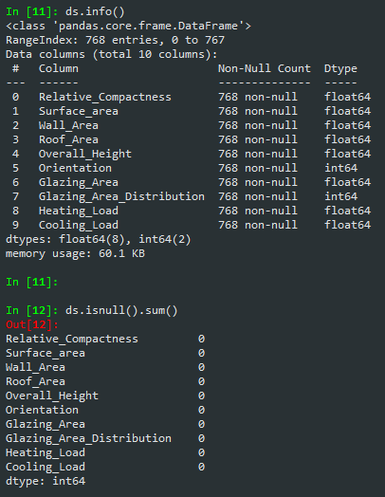
Checking any duplicate values
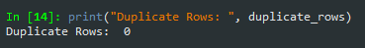

Statistical Analysis of data
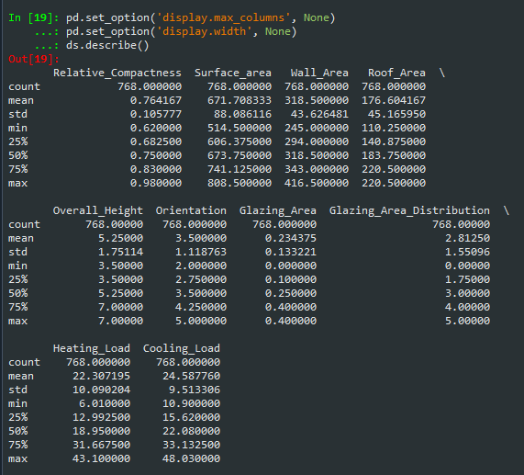

Deleting Cooling Load(Y2) column
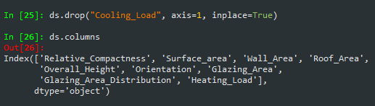

Heating Load Distribution
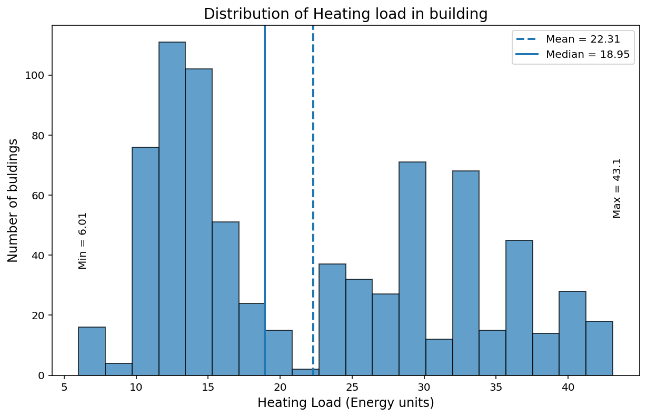

Relative Compactness vs Heating load
