The Islamia University of Bahawalpur
Department of Information Technology



SOFTWARE DESIGN DESCRIPTION
(SDD DOCUMENT)
for

<Fast food website >

Version 1.0

By
Farhan Altaf
F22BINFT1E02089
Supervisor
MISS Sara Fareed

Bachelor of Information Technology

Table of Contents
Introduction 1
Design methodology and software process model 1
System overview 1
Design models [along with descriptions] 1
Data design 2
Algorithm & Implementation 2
Software requirements traceability matrix 2
Human interface design 3
Appendix I 3

Revision History

Name | Date | Reason for changes | Version

Application Evaluation History

Comments (by committee)  *include the ones given at scope time both in doc and presentation | Action Taken

Supervised by
<Supervisor’s Name>

Signature

Introduction

This document outlines the design of a Fast Food Website aimed at streamlining online food ordering and restaurant management. The system includes modules for user authentication, menu management, order processing, secure payments, and customer feedback. Built using HTML, CSS ,JAVA Script React.js (frontend), Node.js (backend), and MySQL (database), the website emphasizes usability, scalability, and security. Key features include real-time order tracking, role-based access, and integration with payment gateways like Stripe/PayPal.

Design methodology and software process model

The project follows the Agile methodology for iterative development and continuous stakeholder feedback. Key design principles include:

Modularity: Separation of frontend, backend, and database layers.
Scalability: Microservices architecture to handle high traffic.
Security: Encryption for user data and payment transactions.

Tools and Technologies:

Frontend: React.js, HTML/CSS /javascript
Backend: Node.js,
Database: MySQL
APIs: Stripe/PayPal (payments)
Design: Figma (UI/UX mockups)

Overview of the systam

Objective
The Fast Food Ordering System is designed to streamline the online food ordering process, enhancing customer experience and improving restaurant operations. The system provides a platform for customers to browse menus, place orders, make secure payments, and track deliveries in real-time. For restaurant owners, it offers a system to manage orders, update menus, and interact with customers.

System overview
The Fast Food Website is a full-stack responsive web application that supports:
Functionality
User Management: Registration, login, and profile updates.

Menu Management: Add/edit/delete food items, categorize menus.

Order Processing: Cart management, order placement, and real-time tracking.

Payment Integration: Secure transactions via Stripe/PayPal.

Feedback System: Customer reviews and ratings.

Technologies include React.js (frontend), Node.js (backend), and MySQL (database). Payments are handled through Stripe/PayPal APIs.

Architectural design

The Fast Food Ordering System follows a multi-tier architecture:
- Frontend: A web-based application built using HTML, CSS, ReactJS, and Bootstrap for a responsive design. Customers interact with the interface to place orders, track deliveries, and make payments.
- Backend: The backend uses Node.js or PHP for server-side scripting, managing user requests, payments, and order processing.
- Database: MySQL for storing user information, order details, menus, and payment transactions.
- Payment Gateway Integration: Stripe and PayPal for secure transactions.
- Delivery Integration: Option for delivery/pickup based on the customer's location.
- Admin Dashboard: A comprehensive interface for restaurants to manage menus, orders, and customers.

Process flow/Representation

Browse Menu: User views available dishes, categories, and descriptions.
Add to Cart: Selects items, adjusts quantities, and saves choices.
Checkout: Enters delivery details, applies promo codes, and selects payment.
Payment Processed: Secure transaction via card/UPI/wallet; confirmation generated.
Order Confirmed: User receives email/SMS with order ID and estimated time.
Real-Time Tracking: Live updates on cooking, dispatch, and delivery status.
Admin Flow:
Manage Orders: Views incoming orders, assigns chefs, and tracks progress.
Update Menu: Edits dishes, prices, availability, and adds seasonal specials.
Review Feedback: Analyzes ratings, responds to reviews, and improves service.
.

Design models [along with descriptions]

The applicable models may include:
Class Diagram

User Registration & Login:
Sign-Up: User provides email, password, and role (default: customer).
Login: Authenticates using userId and password, redirects based on role.

User Browsing & Ordering:

Browse Menu: Fetches itemId, name, price, and category from the Menu.
Add to Cart: Stores selected items with quantities in session or database.
Checkout: Creates an orderId, maps userId, and sets initial status as "preparing".

Payment & Confirmation:

Payment Processed: Generates paymentId, links to orderId, and confirms amount.
Order Confirmed: Updates status and notifies user via email/SMS.

Real-Time Tracking:

Status Updates: Tracks orderId progress (preparing → out for delivery → delivered).
User Notification: Sends live updates via app/email on status changes.

Admin Management:

Manage Orders: Filters by status, updates preparation/delivery progress.
Update Menu: Adds/edits items (itemId, name, price, category).
Review Feedback: Views rating and comment from users, responds if needed.

Feedback System:

Submit Review: User adds rating and comment linked to their userId.
Admin Analysis: Checks trends in feedback to improve menu/service.

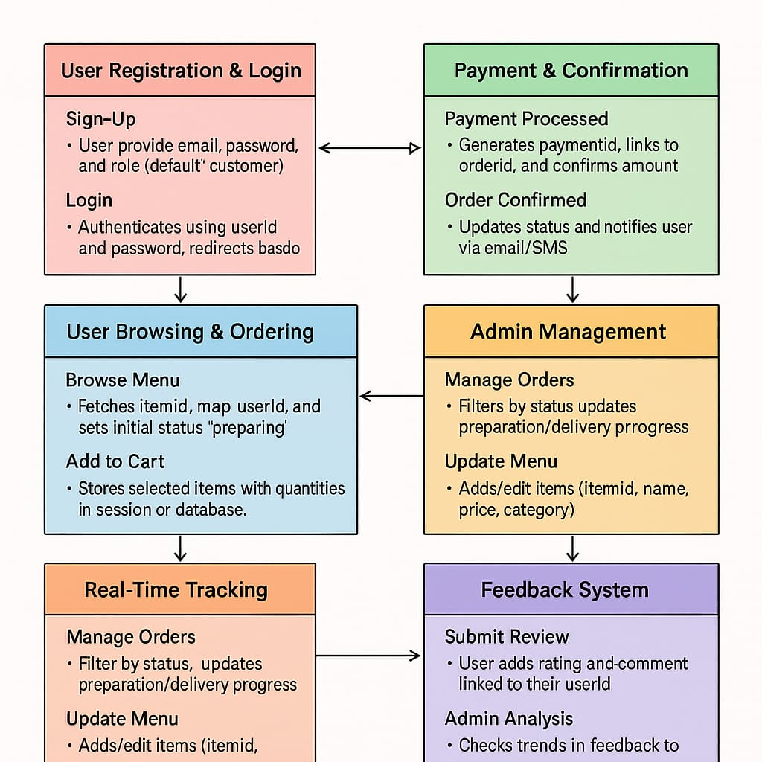

Sequence Diagram

Sequence Flow:

User → Frontend: Select Items → Add to Cart

User Interaction: User selects menu items, adjusts quantities, and clicks "Add to Cart."
Frontend Storage: Cart data (item IDs, quantities, price) is stored in local state or session.

Frontend → Backend: Send Order Details

Checkout Initiation: User clicks "Place Order," sending cart data, userId, and delivery info to the backend.
Request Handling: Backend validates data, checks item availability, and prepares order processing.

Backend → Database: Save Order

Order Creation: Backend generates an orderId, saves userId, items, and sets status as "preparing."
Database Update: Order details (items, total, address) are stored in the Orders table.

Backend → Payment API: Process Payment

Payment Request: Backend sends orderId, amount, and payment method to the Payment API.
Confirmation: On successful payment, API returns paymentId and updates status to "paid."

Backend → Frontend: Confirm Order & Trigger Tracking

Order Confirmation: Backend sends success response with orderId and estimated delivery time.
Real-Time Tracking: Frontend initiates live updates (e.g., "Preparing" → "Out for Delivery") via WebSocket/polling.
Additional Steps (Optional):

Notification Service: Backend triggers email/SMS alerts for order confirmation and status changes.
Admin Dashboard: Order details are pushed to the admin panel for real-time monitoring.

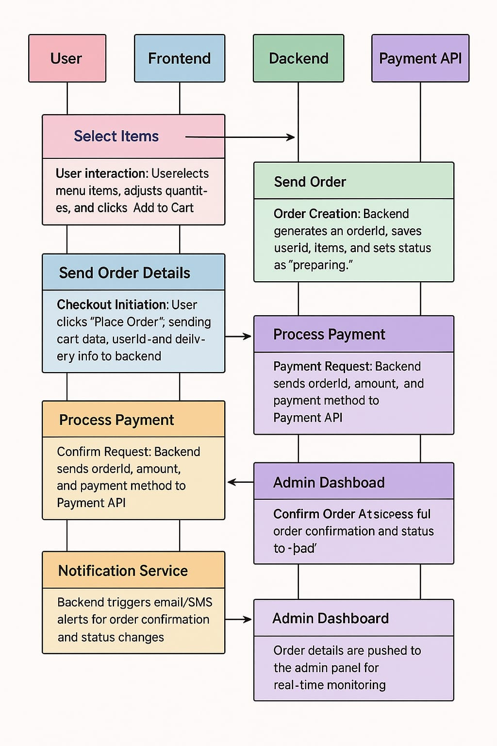

State Transition Diagram

Idle
The user has not interacted with the system yet.
The system waits for login or browsing activity.

Browsing
User explores menu categories and views item details.
They can filter, search, and add items to the cart.
Cart
User reviews selected items and makes modifications.
Options for quantity changes, item removal, or applying promo codes are available.

Payment
User selects a payment method and enters details.
The system validates and processes the transaction securely.

Order Placed
Payment is successful and order is saved in the database.
User receives a confirmation message and estimated delivery time.
Dispatched
The restaurant has prepared the order and handed it to delivery.
Tracking info and delivery agent details are updated in the system.

Delivered
Order has reached the customer’s location successfully.
User is prompted to provide feedback or rate their experience.

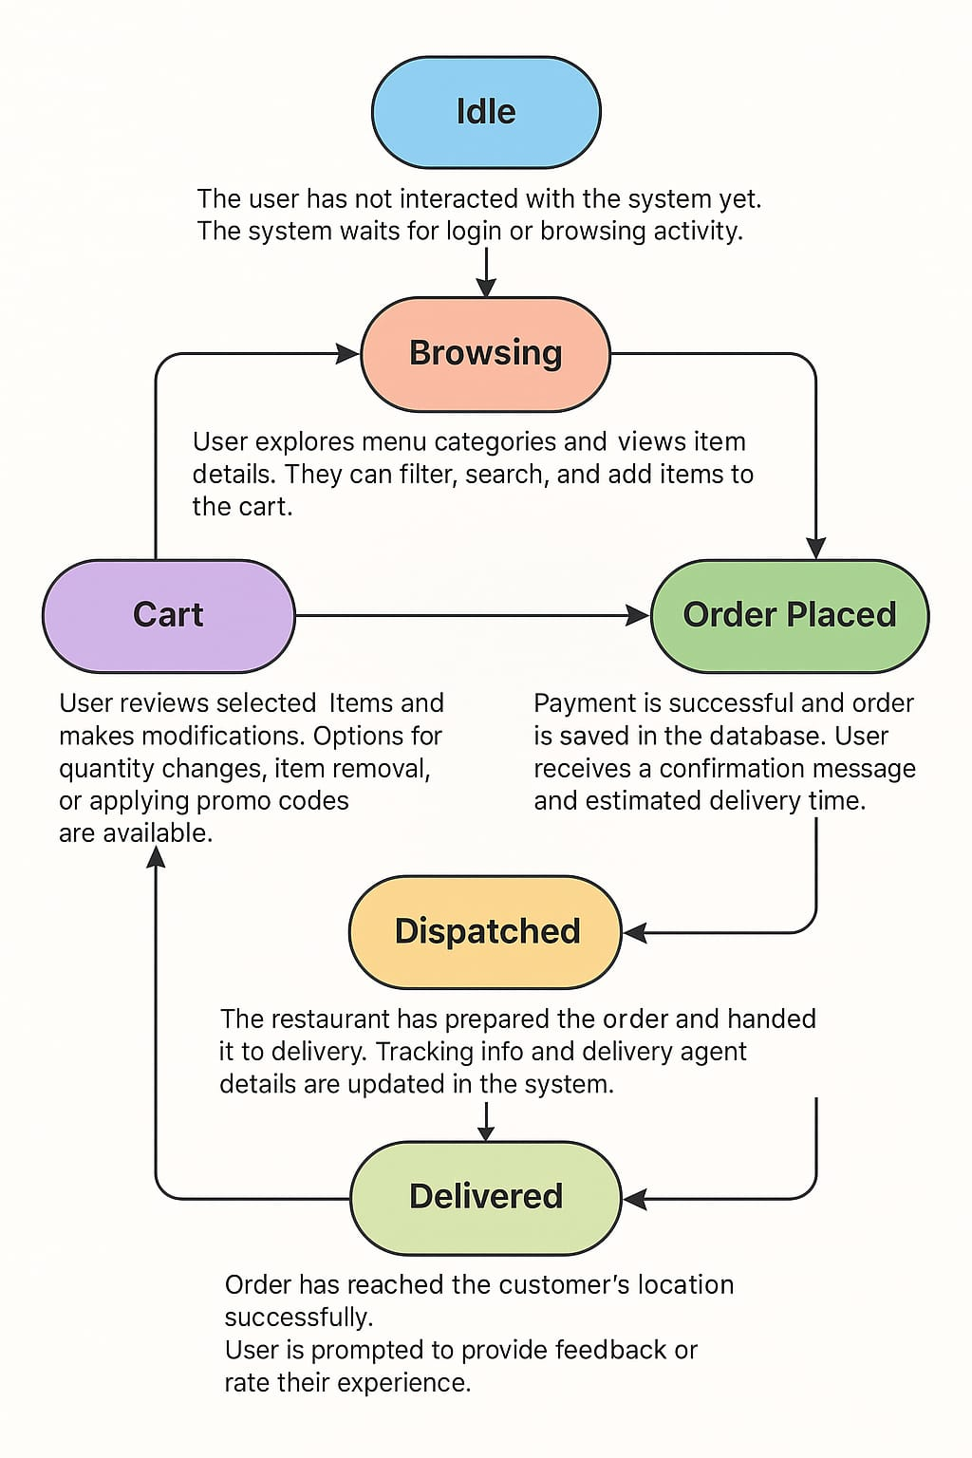

Data Flow Diagram

Level 0
External Entities:
Customer: Interacts with the system to place orders, make payments, and track deliveries.
Restaurant Admin: Manages menus, orders, and feedback.
Payment Gateway (Stripe/PayPal): Processes secure transactions.
Delivery Service: Handles order dispatch and delivery updates.
System Boundary: Fast Food Ordering System.
Key Data Flows:
Customer → System: Order details, payment info, feedback.
System → Customer: Order confirmation, real-time tracking.
Admin → System: Menu updates, order management.
System → Payment Gateway: Payment requests/confirmation.

Level 1 (Process Decomposition)

- Order Processing:
  - Input: Customer selects items → "Add to Cart."
  - Process: Validates item availability, calculates total.
  - Output: Cart summary sent to Checkout.
- Payment Processing:
  - Input: Payment details (card/UPI) → Stripe/PayPal API.
  - Process: Authenticates transaction.
  - Output: Payment confirmation → Order DB.
- Order Tracking:
  - Input: Order status updates (preparing → delivered).
  - Process: Pushes updates via WebSocket.
  - Output: Real-time notifications to customer.
- Menu Management:
  - Input: Admin edits menu (add/remove items).
  - Process: Updates MySQL database.
  - Output: Reflects changes on customer UI.

Key Data Stores:
- User DB: Stores customer profiles (email, password, order history).
- Order DB: Tracks order IDs, items, status, payment IDs.
- Menu DB: Holds food items, categories, prices.
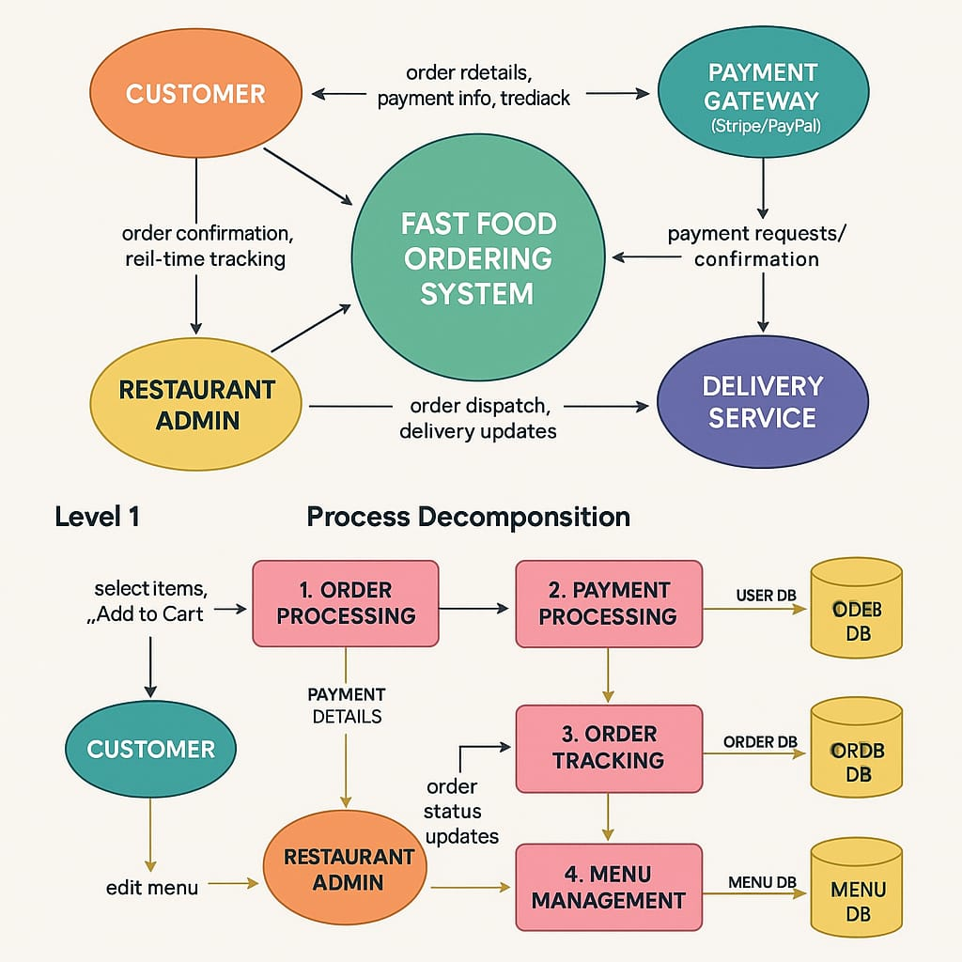

Data Design
Data Entities:
- User: Stores information such as username, password, email, order history.
- Order: Contains order details, customer data, items ordered, and delivery status.
- Menu Item: Descriptions, prices, and available modifications (e.g., toppings).
- Payment: Stores transaction details (payment method, amount, status).
- Feedback: Customer reviews and ratings for restaurant services.

Data Flow:

Customer selects items from the
Order data is processed and stored in the database.
Payment details are processed securely via a payment gateway.
Status updates "Preparing", "Dispatched" are sent to customers in real-time.

Algorithm & Implementation

Order Placement Algorithm:
- Customer browses the menu and selects items.
- The system validates items and checks for availability.
- The customer customizes the order (if applicable).
- Payment details are securely processed through Stripe or PayPal.
- The system stores the order and sends confirmation emails.
Feedback Algorithm:
- The customer rates the order.
- Feedback is processed and stored in the database for analytics.
Use Case:
Use Case ID: UC-1
Use Case Name: Place Order
Actors: Customer
Main Flow:
The customer selects items from the menu.
Proceeds to the cart, reviews the items, and checks out.
Chooses a payment method (e.g., credit card, PayPal).
The system confirms payment and processes the order.

Software requirements traceability matrix

Table 7 Requirements Traceability Matrix
Req. Number  FR01  FR02  FR03  FR04 | Ref. Item  User Authentication  Menu Customization  Secure Payments  Order Tracking | Design Component  User Management Module  Menu Management Module  Payment Module  Order Processing Module | Component Items  HTML, CSS React.js  MySQL, Node.js  Stripe API  WebSocket
NFR01 |  | System performance for 500 concurrent users | Performance & Scalability

Human interface design
Functional View:

Homepage: Featured menus, search bar, login/signup buttons.

User Dashboard: Order history, tracking status, profile settings.

Checkout Page: Cart summary, payment gateway integration.

Screen Objects & Actions:

Buttons: "Add to Cart" (triggers cart update), "Checkout" (redirects to payment).

Forms: Registration (collects email/password), Payment (card details).

Notifications: Real-time alerts for order status changes.

Interface Design

Customer Interface:
- Login/Signup: Provides options for new users to create an account and existing users to log in.
- Menu Page: Displays food items with categories, images, descriptions, and prices.
- Cart and Checkout: Allows users to review their selected items, apply discounts, and choose delivery/pickup options.
Admin Interface:
- Dashboard: Enables restaurant owners to add/edit menu items, track orders, and manage customer feedback.
- Order Management: Provides real-time updates on order statuses.

Appendix

Term | Definition
User Authentication | The process of verifying the identity of users through credentials such as email and password.
Menu Management | The system's ability to add, edit, or delete food items and categorize menus dynamically.
Order Processing | The workflow from cart creation to order placement, including payment and confirmation.
Payment Gateway | A service that processes online payments securely (e.g., Stripe, PayPal).
Real-Time Tracking | Live updates provided to users about their order status (e.g., preparing, dispatched).
Feedback System | A module for customers to submit ratings and reviews for orders.
Agile Methodology | An iterative development approach emphasizing collaboration and flexibility.
Microservices | An architectural style where the system is divided into small, independent services.
Responsive Design | UI/UX design that adapts to different screen sizes (mobile, desktop, etc.).
API Integration | Connecting third-party services (e.g., payment gateways) via Application Programming Interfaces.
Database Schema | The structure of the database, including tables for users, orders, and menus.
Session Management | Handling user sessions to maintain cart data and authentication state.

Acronyms

UI User Interface
UX User Experience
DB database
SDK Software Development Kit
HTML | HyperText Markup Language
CSS Cascading Style Sheets
JS Java script
API Application Programming Interface

TOOLS USED

Frontend: React.js, HTML5, CSS3, Bootstrap
Backend: Node.js ,React
Database: MySQl
Design: Figma (Mockups), Draw.io (UML)
APIs: Stripe, PayPal
Methodology: Agile

Refrences
Brown, L., & Johnson, M. (2021). E-Commerce and the Growth of Online Food Services. International Journal of Business and Technology,
Official Documentation of React.js and Node.js - https://react.dev/ & https://nodejs.org/
Stripe Payment API Documentation - https://stripe.com/docs
PayPal Developer Guide - https://developer.paypal.com/
UX/UI Best Practices for Food Delivery Apps - https://uxdesign.cc/best-practices-for-online-food-ordering-ui-design-3e21b5d1a4e6
- React.js Official Documentation: https://react.dev/
- Node.js Official Documentation: https://nodejs.org/

