**Comprehensive Orthodontic SmartPlan For**

Jhon Test

Orthobrain Report



# **Treating Doctor:** Dr. Test **Patient Name:**Jhon Test **Birth Date:** 02-09-1990 **Age:** 26 **Gender:**Mail **Chief Complaints:** Test **Medical History:** Test **Dental History:** Test **Orthodontic History:** Test **Family History:** Test **Treatment Goals:** Treatment Goals **Teeth # System:** 3

**Digital 3D Models Made (04-09-2017)**  
Gallery File  
  
  
  
**Digital Photos Made (04-09-2017)**  
PHOTO UPLOADS

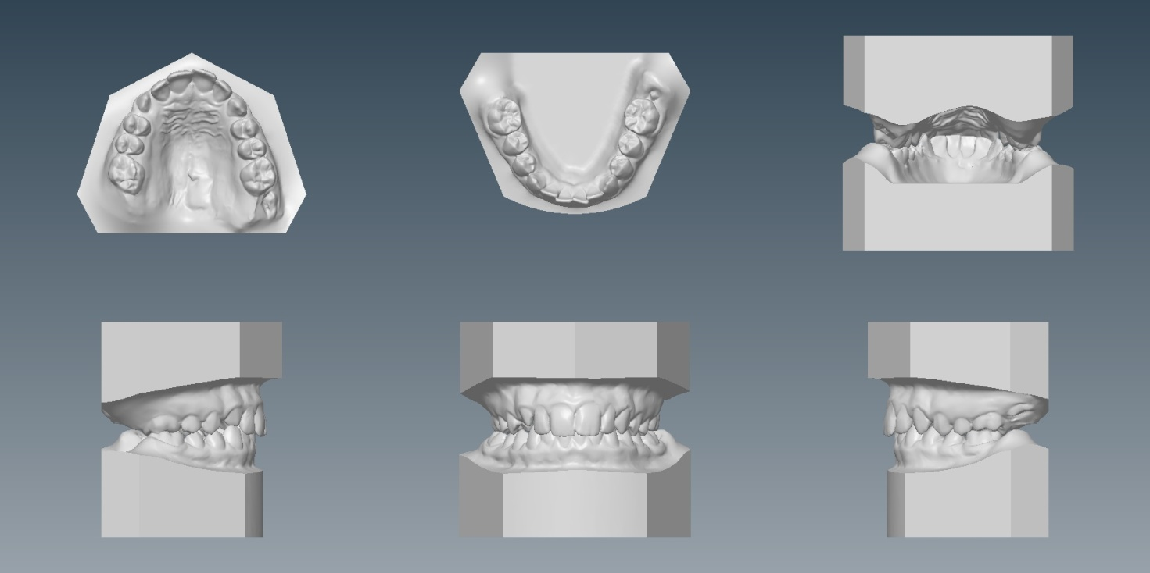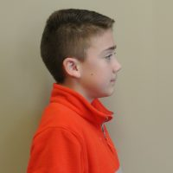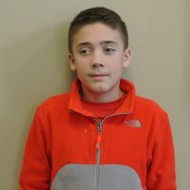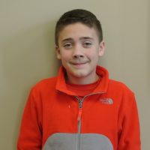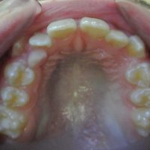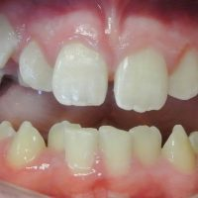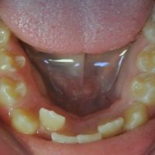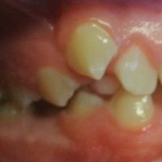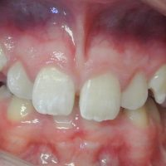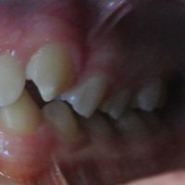

**Ceph Made (05-08-2017)**  
1**ST** X-RAY IMAGE  
  
  
  
**Image made (05-08-2017)**  
2**ND** X-RAY IMAGE  
  
  
  
**Image made (05-08-2017)**  
3**RD** X-RAY IMAGE

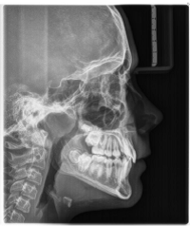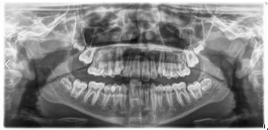

**SmartPlan Comprehensive Diagnostic Findings**

# **Facial**

## **Periodontal Perioral Evaluation**

# Smile Line: 15. Upper Incisal Display: 16. Upper Gingival Display: 17. Lips: 18. Symmetry: 19. Midlines: [UPPER, LOWER MIDLINE]. Profile: 21.

## Hygiene Practices: [ORAL HYGIENE]. Soft Tissue: [GINGIVAL TISSUE]. Frenal Attachments: [FRENAL ATTACHMENTS]. Hard Tissue: [HARD TISSUE]. Pathology: [PATHOLOGY].

### **Skeletal**

#### **Functional**

##### Symmetry:22. Horizontal: 23 Vertical: 24. Transverse: 25.

###### Tongue: [TONGUE]. Centric Relation to Centric Occlusion Shift: [CENTRIC RELATION]. Speech: [SPEECH]. Parafunction Habits: [HABITSPARA FUNCTION]. TMJ Masticatory System: [TMJ JOINT DYSFUNCTION] .

### **Dental**

#### **Airway Assessment**

##### Missing Teeth: 26. Ectopic Teeth: 27. Transverse: 28. Angle Classification: 29. Horizontal Overjet: [HORIZONTAL OVERJET] Vertical Overbite: 31. Archlength: 32. Enamel: [ENAMEL] Teeth Size or Shape: 34. Arch Form: 35.

###### Airway Issues:[AIRWAY ISSUES].

**3D Digital Model Made 04-09-2017**  
RIGHT SIDE, FRONTAL, LEFT SIDE VIEWS OF GALLERY VIEW  
  
  
  
**Abnormal Orthodontic Findings**  
we could eventually spec out what answers above are "abnormal" and have them make up this list



* Arch length deficiency
* Maxillary diastema
* Excess Overjet
* Missing #10
* Upper midline shifted to the left
* Possible airway problems to further investigate
* Gingival margin height discrepancy between 8 and 9

**Summary Orthodontic Treatment Goals & Prognosis**

|  |  |  |  |  |  |  |
| --- | --- | --- | --- | --- | --- | --- |
|  |  | **Poor Prognosis** |  | **Guarded Prognosis** |  | **Good Prognosis** |

Address Patient Chief Complaints: [CHIEF COMPLAINTS]

**[ALL BROUGHT DOWN FROM THE ABNORMAL LIST ABOVE]**

* Correct dentition to Class 1 occlusion
* Correct overjet to ideal
* Close diastema and correct arch length discrepancy
* Correct deep bite
* Correct midline shift
* Correct Gingival margin height discrepancy between 8 and 9 with perio surgery

**The chart below will need to be a "clean" version. Will this be live in the first drafts?**

