**Speech Translation SDK**

**User's Guide for**

**Sample Application**

**(iOS)**

Version 1.1

Table of Contents

1. About This Application 3

1.1. Overview 3

1.2. Functions 3

1.3. Released materials 3

2. Environments 4

2.1. Operating environment 4

2.2. Development environment 4

3. Screen View 5

3.1. Push-to-talk button 6

3.2. Result display area 6

4. Setting, Startup and Logs of Application 7

4.1. Setting of the server to communicate 7

4.2. Alerts at application startup 7

4.3. Logs 7

5. Screen Transition 8

5.1. Normal operation 8

5.2. Abnormal operation 10

Update History

|  |  |  |
| --- | --- | --- |
| Version | Release Date | Features |
| 1.0 | Dec. 20, 2013 | Released |
| 1.1 | Oct. 31, 2014 | Added ADPCM encoding for input speech and ADPCM decoding process for output speech |

# About This Application

This document is a tutorial to use the sample application of the open-source Speech Translation SDK (Software Development Kit) based on the MCML system.

## Overview

This application is a sample application for speech recognition, translation, and speech synthesis, based on the MCML system.

## Functions

The sample application has the following functions:

* The application transmits and receives MCML requests and responses of the MCML system (server) necessary for speech recognition, translation, and speech synthesis.
* The application performs a series of three processes, i.e., speech recognition, translation, and speech synthesis.
* The speech recognition function includes:
  + Speech recording via the microphone.
    - * Recording triggered by a proximity sensor is not supported.
  + Transmission of sound data in a linear data format and in an asynchronous transfer mode.
* The translation function includes:
  + Back translation to verify the accuracy of translation results.

※ Translation of input text is not supported.

* The speech synthesis function includes:
  + Playing the sound data received from the MCML system in a linear data format.

※ Speech synthesis of input text is not supported.

## Released materials

Released materials include the sample application and related documents as follows:

* Source codes
* User's Guide for Sample Application (iOS) (this document)
* API reference (Doxygen)

# Environments

## Operating environment

Operation of this application has been verified in the following environment.

|  |  |
| --- | --- |
| iOS | Version 6.1 |
| Terminal | iPhone 4S |

## Development environment

This application has been developed by utilizing the programming language, Objective-C.

* Recommended environment

|  |  |
| --- | --- |
| OS | Mac OS X 10.8.5 |
| Complier | Apple LLVM 4.2 |
| Development tool | Xcode 4.6.3 |

# Screen View

A screen view of the sample application is shown below.

Push-to-talk button

(for Japanese speech)

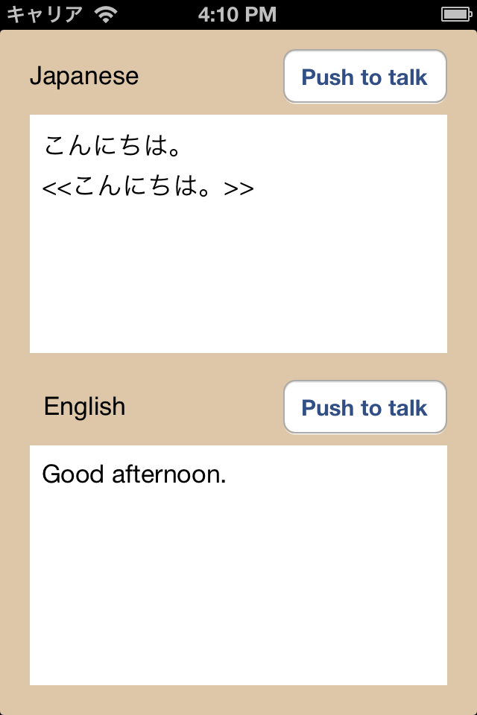

Push-to-talk button

(for English speech)

Result display area for English

Result display area for Japanese

## Push-to-talk button

* Recognition of speech

Speech is recorded while the Push-to-talk button is pressed.

To stop the recording and start speech recognition, release the button.

* Recognition of Japanese and translation to English

Press the Push-to-talk button for Japanese.

* Recognition of English and translation to Japanese

Press the Push-to-talk button for English.

## Result display area

* What appears in the display area
  + Speech recognition results

Speech recognition results in Japanese or English are displayed in the area.

* + Translation results

Translation results are also displayed in the area.

Back translations, enclosed in angle brackets << >>, are shown below the speech recognition results.

* + Processing status

The following messages appear to indicate the processing status.

* + - Recording…
    - Recognizing…
    - Translating…

# Setting, Startup and Logs of Application

## Setting of the server to communicate

Specify the address of the MCML system (server) in the source code.

* Source file

MCMLSampleApplication/Define.h

* Code to edit

#define MCML_SERVER @"**Insert the server's URL here** "

* Speech codec for input speech

#define MCML_RECORD_AUDIO @"raw PCM " or @"ADPCM "

* Speech codec for output speech

#define MCML_PLAYBACK_AUDIO @"raw PCM" or @"ADPCM "

Note: Use ‘Little Endian’ when ADPCM is selected.

#define MCML_PLAYBACK_ENDIAN @"Little"

## Alerts at application startup

The application is started by clicking the icon of the sample application on the screen of your iOS terminal. In case of failure to connect the server, an alert message will appear. If this happens, push the home button of your device to terminate the application.

## Logs

Operating status of the application is output as a log.

You will find it at the debugging console on Xcode.

* Example of output logs

2013-11-28 16:52:59.398 EnterpriseSample[894:617] DATA DELAYED

2013-11-28 16:52:59.398 EnterpriseSample[894:617] METHOD: -[CChunkedMultipartConnectionImpl sendString:]

2013-11-28 16:52:59.399 EnterpriseSample[894:617] SENT: --9FDC54D2C4F243A1A5B9

2013-11-28 16:52:59.412 EnterpriseSample[894:617] METHOD: -[CChunkedMultipartConnectionImpl stream:handleEvent:]

# Screen Transition

Screen transition through the course of speech recognition, translation, and speech synthesis is presented below.

## Normal operation

5.1.2.

5.1.3.

5.1.1.

Japanese Push to talk

English　 Push to talk

Pressing the button

Japanese Push to talk

English　 Push to talk

Recording…

Japanese Push to talk

English　 Push to talk

Recognizing…

Releasing the button

Recognition completed

Processing translation

5.1.5.

5.1.4.

5.1.6.

Japanese Push to talk

English　 Push to talk

本日は晴天なり

Today is fine day.

Japanese Push to talk

English Push to talk

本日は晴天なり

Translating..

Japanese Push to talk

English　 Push to talk

本日は晴天なり

<<今日は良い天気です>>

Today is fine day.

Back translation completed

Translation completed

Processing back translation

Processing speech synthesis

5.1.7.

Japanese Push to talk

English　 Push to talk

本日は晴天なり

<<今日は良い天気です>>

Today is fine day.

Speech synthesis completed

5.1.1. Before starting speech

When the application is started, the startup screen will appear.

Recording of speech is initiated by pressing the Push-to-talk button.

5.1.2. Recording speech

Recording is continued while the push-to-talk button is being pressed.

Text of messages being recorded will appear on the result display area of each language.

5.1.3. Processing speech recognition

If you release the Push-to-talk button, the recorded speech data is sent to the server and processed for speech recognition.

5.1.4. Speech recognition completed/Processing translation

Results of speech recognition returned from the server are shown in text on the result display area. The recognition results are automatically transmitted to the server for machine translation.

5.1.5. Translation completed/Processing back translation/Processing speech synthesis

Results of machine translation returned from the server are shown in text on the result display area. The translation results are automatically transmitted to the server for back translation and speech synthesis.

5.1.6. Back translation completed/Processing speech synthesis

Results of back translation returned from the server are shown on the result display area.

5.1.7. Speech synthesis completed

Results of speech synthesis are returned from the server, and the synthesized speech is played on your device.

## Abnormal operation

Japanese Push to talk

English　 Push to talk

本日は晴天なり

Translating..

Japanese Push to talk

English　 Push to talk

Recognizing…

Japanese Push to talk

English　 Push to talk

本日は晴天なり

<<There is no back

translation result.>>

Today is fine day.

Japanese Push to talk

English　 Push to talk

本日は晴天なり

<<今日は良い天気です>>

Today is fine day.

Japanese Push to talk

English　 Push to talk

本日は晴天なり

<<There is no back

translation result.>>

Today is fine day.

Translation completed

Processing back translation

Processing speech synthesis

Recognition completed

Processing translation

Japanese Push to talk

English Push to talk

本日は晴天なり

Today is fine day.

Recognition failed

Translation failed

Japanese Push to talk

English　 Push to talk

本日は晴天なり

<<There is no translation result.>>

Japanese Push to talk

English　 Push to talk

<<There is no recognition result.>>

Back translation failed

Synthesis successful

Back translation failed

Synthesis failed

Back translation successful

Synthesis failed

* + - * Messages displayed in case of process failure
        + Failure in recognition

Message in the result display area: << There is no recognition result.>>

* + - * + Failure in translation

Message in the result display area: <<There is no translation result.>>

* + - * + Failure in back translation

Message in the result display area: <<There is no back translation result.>>