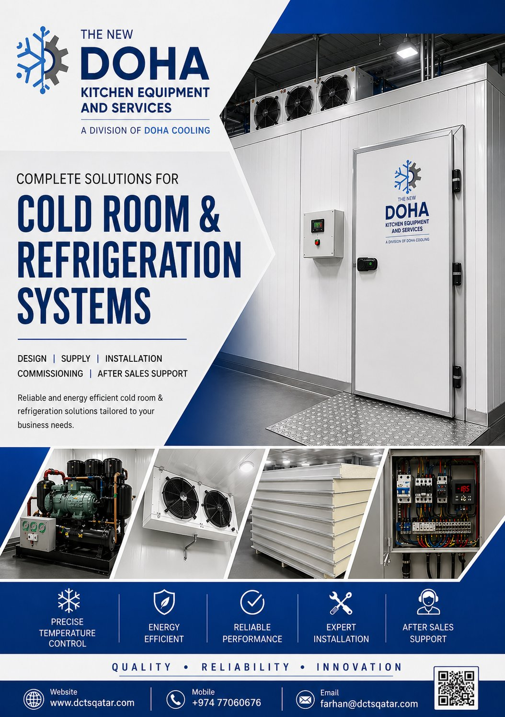

TNDK | The New Doha Kitchen  Equipment Services W.L.L.  P.O. Box 80247, Doha – Qatar  info@dkeqatar.com
QUOTATION
REFERENCE | DATE | VALIDITY
QUT/DCTS/SQ072/2026 | 05 August 2026 | 15 Days from quote date

TO | FROM
M/s. Marza Group of Companies  Doha, Qatar  Attn: Mr. Ashik | The New Doha Kitchen Equipment Services W.L.L.  P.O. Box 80247, Doha – Qatar  Email: farhan@dctsqatar.com  Prepared by: Farhan – Sales Engineer
Subject: Supply, Installation, Testing & Commissioning of cold room
Dear Sir, with reference to the above subject, we thank you for the opportunity to quote for your cold storage room project. Please find below our detailed technical and commercial offer for the supply, installation, testing and commissioning of inclusive of insulated flooring, refrigeration system and accessories.

Project description:
ROOM TYPE | QTY | TEMPERATURE | EXTERNAL DIMENSIONS | PANEL THICKNESS
CHILLER | 1 | 0°C to +8°C | 6.0 × 2.40 × 2.90 m | 100 mm

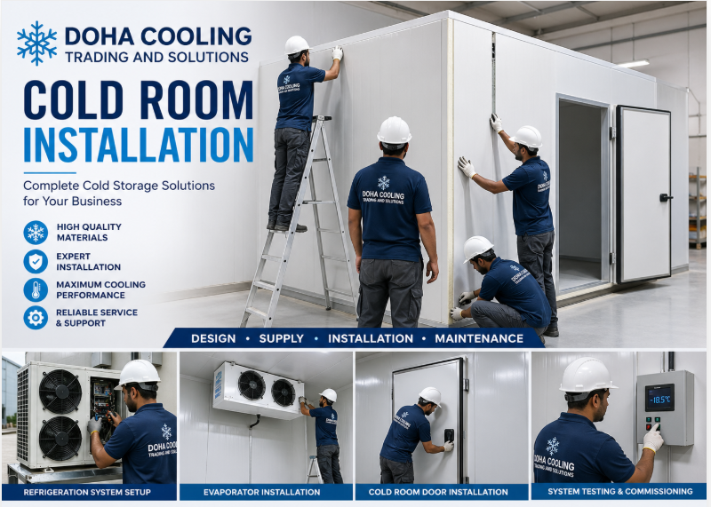

1. PANEL DETAILS
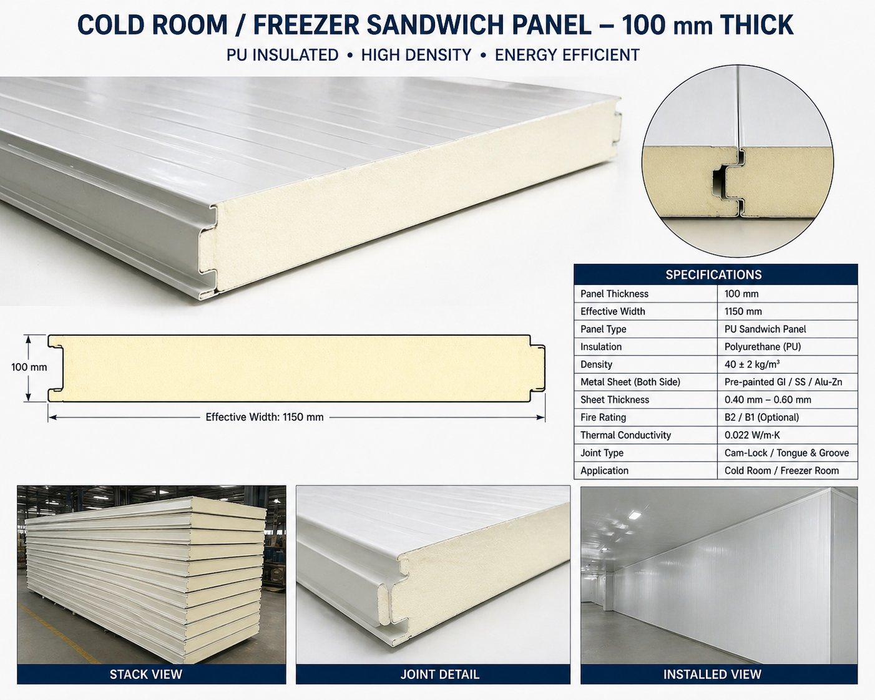
Panel Type | Pre-insulated Polyurethane (PUF) Sandwich Panel
Panel Thickness | 100 mm
Insulation Core | CFC-free injected polyurethane foam, density 40 ± 2 kg/m³
Skin Material | 0.5 mm pre-painted galvanized steel (PPGI), food-grade white
Locking System | Cam-lock / Hook-lock type for tight, leak-proof joints
Thermal Conductivity (k) | 0.022 W/m·K (typical)
Fire Rating | Class B / Self-extinguishing
Wall Coverage | 2 × (6.0 × 2.90) + 2 × (2.40 × 2.90) = 48.72 sqm
Ceiling Coverage | 6.0 × 2.40 = 14.40 sqm
Floor Coverage | 6.0 × 2.40 = 14.40 sqm
Total Panel Quantity | 77.52 sqm
2. DOOR DETAILS
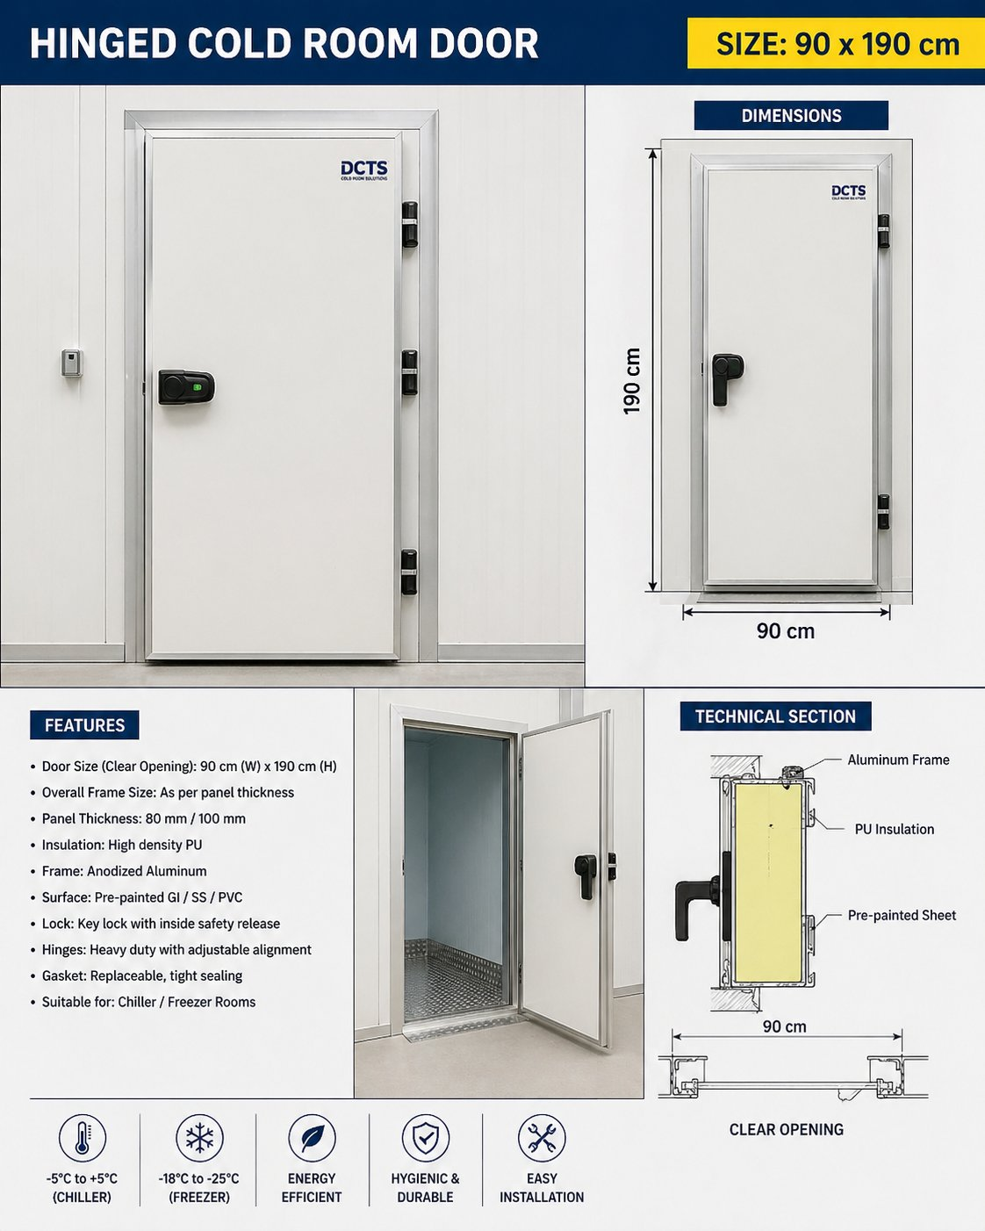
Door Type | Hinged Cold Room Door (single leaf)
Clear Opening Size | 900 mm (W) × 1900 mm (H)
Door Thickness | 100 mm — matching wall panel
Frame | Heated PVC/Aluminum anti-condensation frame
Hinges | Heavy-duty self-closing hinges (3 Nos.)
Handle / Lock | Safety latch handle with internal release (anti-trap)
Gasket | Magnetic / silicone double gasket, food-grade
Quantity | 1
3. ANGLES, SILICONE & ACCESSORIES
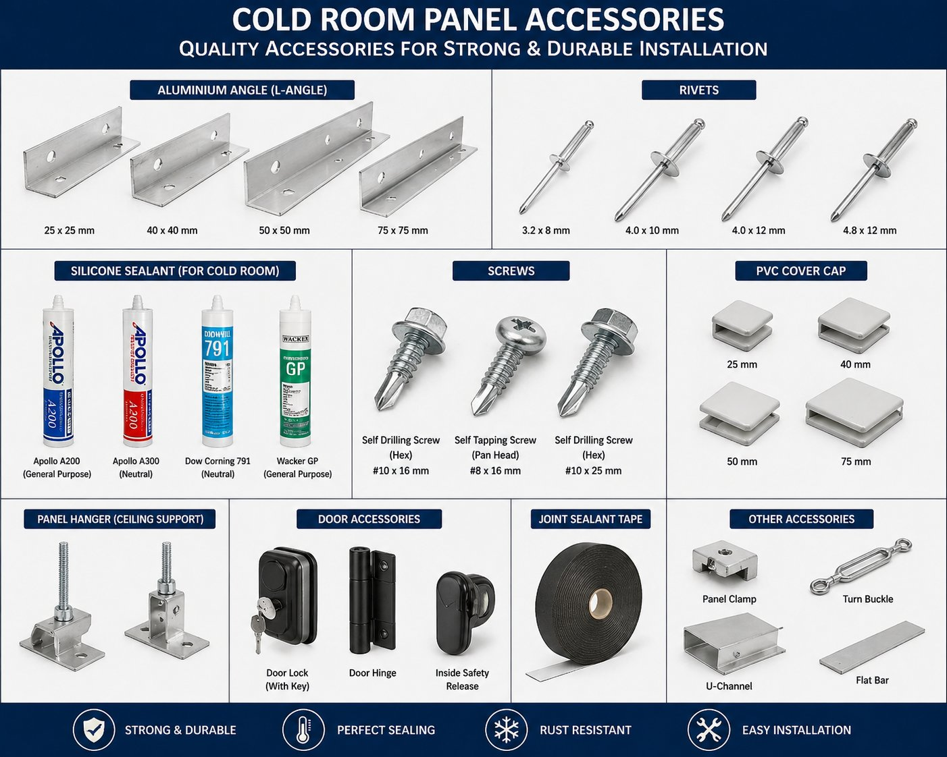
Internal Coving | Aluminum sanitary coving at all wall–floor and wall–ceiling joints
External Trim | Aluminum corner angles / capping at all external corners
Sealants | Food-grade neutral-cure silicone sealant at all panel joints, door frame and floor seam
PU Foam | Expanding polyurethane foam for joint backing
Fasteners | Stainless steel rivets, screws and washers
Vapor Sealing | Continuous vapor barrier at panel–floor interface
4. FLOORING DETAILS
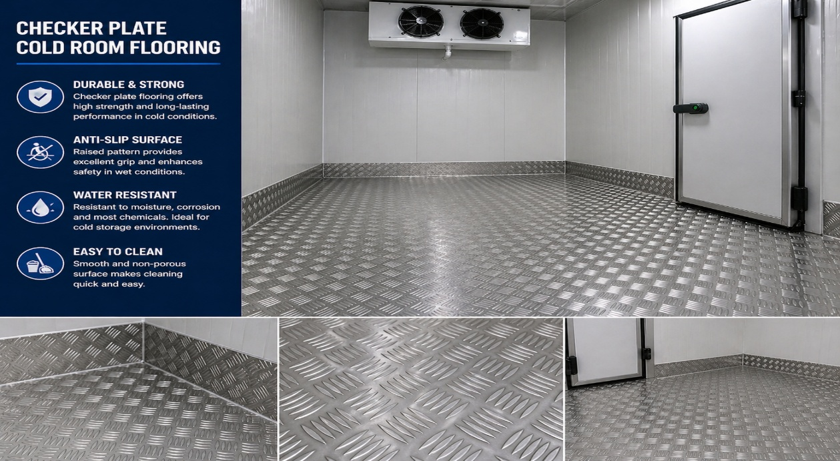
Insulated Floor Panel | 100 mm PUF panel, same specification as wall panels — 14.40 sqm
Plywood Layer | 18 mm Marine-grade plywood laid over the floor panel — 14.40 sqm
Top Finish | 3 mm Mild Steel Chequered (Checkered) Plate, slip-resistant — 14.40 sqm
Edge Sealing | Silicone seal between floor finish and wall panels
Load Suitability | Suitable for hand pallet / light trolley loading
5. REFRIGERATION MACHINE DETAILS
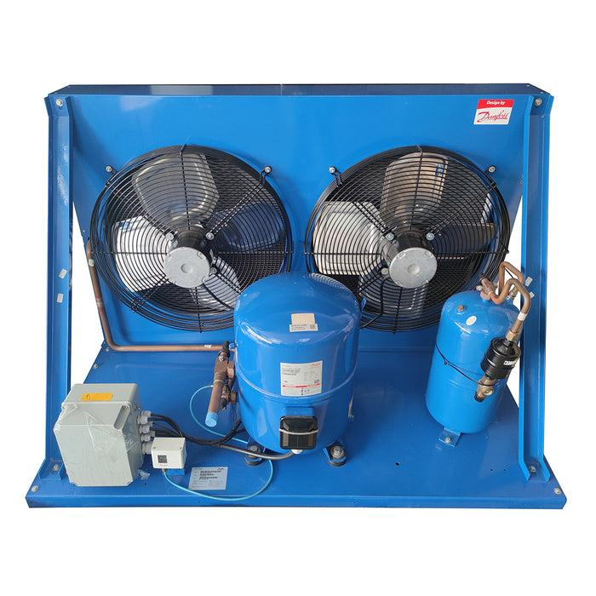  Condensing Unit (Outdoor) |  | 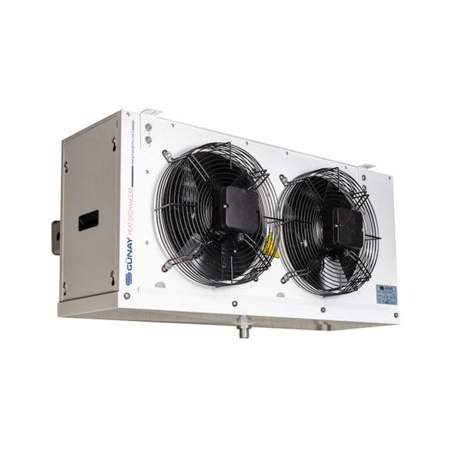  Evaporator / Air Cooler (Indoor)
System Type | Split-type refrigeration system (1 set)
Condensing Unit | BITZER LH64/2DES-3Y, semi-hermetic condensing unit, Germany
Compressor Brand | BITZER (Germany) — semi-hermetic compressor, model LH64/2DES-3Y
Refrigerant | R404A
Evaporator (Air Cooler) | HSE302-1DWEO evaporating unit, HC refrigerant compatible, South Africa
Mounting | Evaporator ceiling-suspended inside the room; condensing unit on outdoor pad
Operating Temperature | 0°C to +8°C (Chiller)
Defrost | Electric defrost with timer & termination thermostat
Drain Line | Insulated drain line with heating tape (where exposed)
6. MACHINE CAPACITY (HEAT LOAD)
Internal Volume | 6.0 × 2.40 × 2.90 = 41.76 m³
Design Ambient | +43°C (per BITZER selection, Doha ambient design)
Design Room Temp. | 0°C to +8°C (Chiller)
Estimated Heat Load | Cooling capacity 5.60 kW (per BITZER selection at −8°C SST / 43°C ambient)
Selected Capacity | BITZER LH64/2DES-3Y — 5.60 kW cooling capacity, 3.25 kW power input, 6.05 A @ 400V-3-50Hz
Run Time | Designed for ≤ 16 hours/day operation
Power Supply | 400V / 3-Phase / 50 Hz
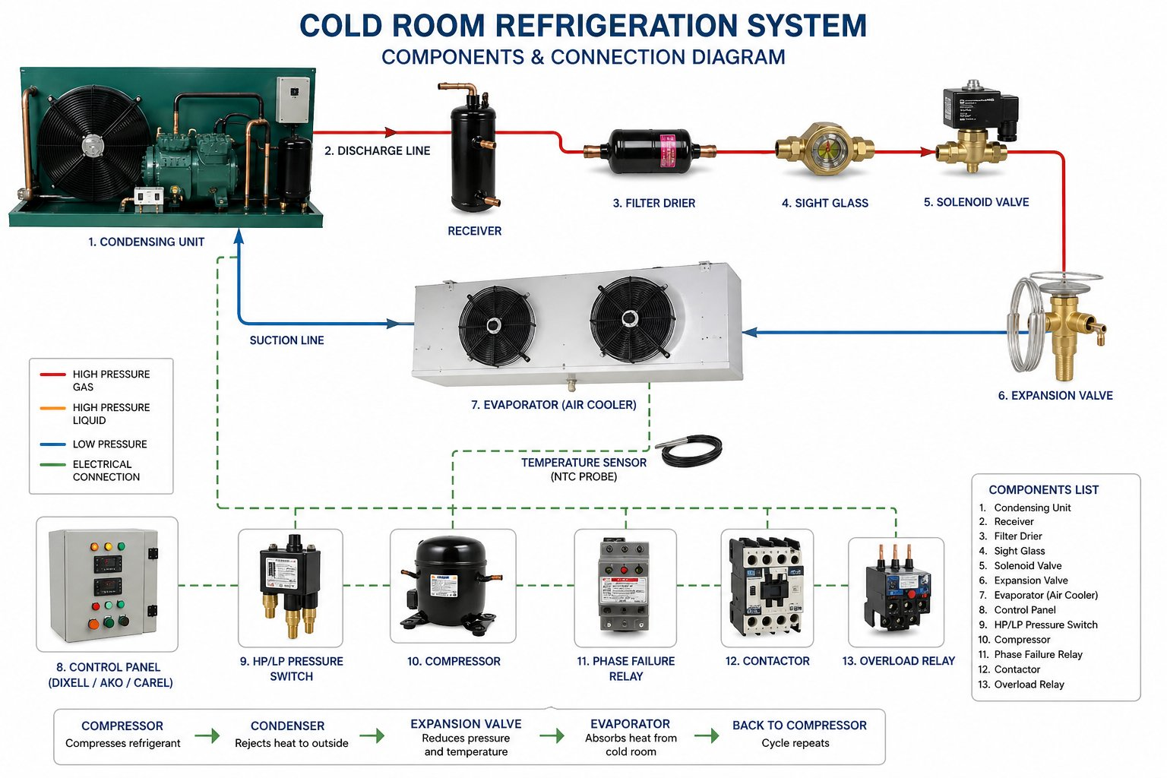
Refrigeration system components & connection schematic — for reference.
7. CONTROL PANEL DETAILS
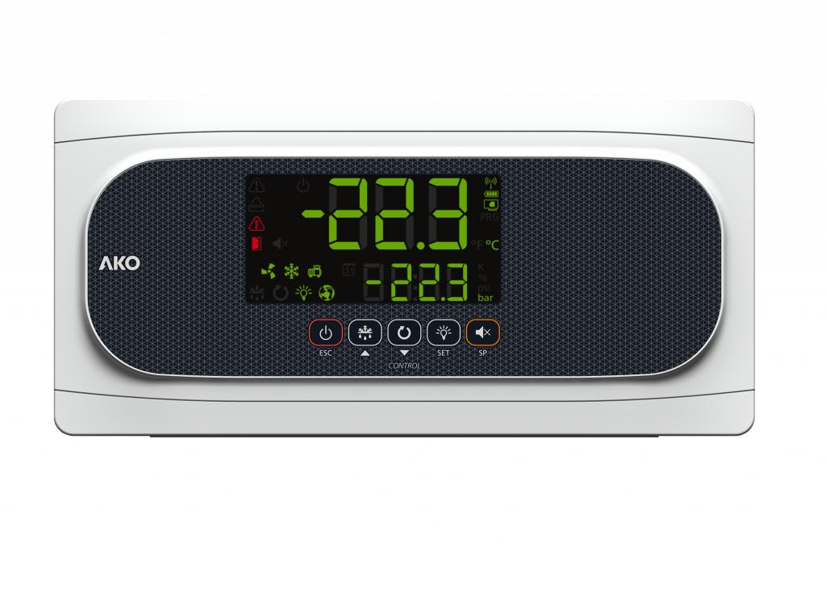  Digital Temperature Controller |  | 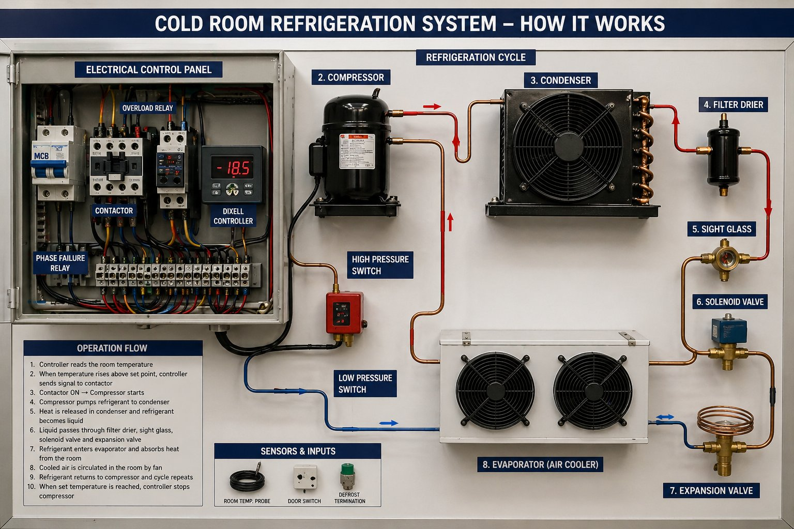  Typical Wiring Schematic
Controller | Eliwell / Dixell / Carel digital temperature controller
Display | Digital LED display showing set point and actual room temperature
Functions | Compressor ON/OFF, evaporator fan control, electric defrost timer, alarm output
Protections | Overload relay, phase-failure relay, HP/LP cut-out switches
Indicators | Power-ON, Compressor-ON, Defrost, Alarm pilot lamps
Safety | MCB, contactors and emergency stop in metallic enclosure (IP54)
Door Frame Heater | Anti-condensation heater wired through control panel
Internal Light | Vapor-proof LED light inside the room with ON/OFF switch outside
8. SCOPE OF WORK
- Site survey and confirmation of final room dimensions before fabrication.
- Supply of 100 mm PUF sandwich panels for walls, ceiling and floor (total 85 sqm).
- Supply and installation of one (1) No. hinged cold room door (900 × 1900 mm).
- Supply and installation of insulated floor system: 100 mm PUF floor panel + 18 mm marine plywood + 3 mm MS chequered plate.
- Supply and installation of condensing unit and matching evaporator (1 set).
- Refrigeration interconnecting copper piping, armaflex insulation and insulated drain line — Included in Item 1 above.
- Electrical works from the cold room control panel onward — including power, control wiring, internal LED light, door frame heater and emergency switch.
- Supply and mounting of digital control panel with all safeties.
- Aluminum coving, corner angles, silicone sealing and full vapor sealing.
- Pressure testing, vacuum, gas charging, testing and commissioning.
- Handover with operation training and as-built documentation.
9. EXCLUSIONS
- Civil works, foundation, leveling and any structural support.
- Power supply (Main DB), main cable run from MDB to cold room control panel.
- Any false ceiling removal, modifications or restoration of existing finishes.
- Drain piping beyond 3 m from the evaporator drain outlet.
- Backup power, UPS, generator or stabilizer.
- Telephone, CCTV, BMS or IoT integration (available on request — separately quoted).
- Any taxes, duties or municipality fees other than those explicitly mentioned.
- Lifting equipment / cranes if access requires more than standard manual handling.
- Working at heights above 3 m (additional scaffolding cost shall apply).
- Any item not specifically listed in the Scope of Work.
10. PRICING / BILL OF QUANTITIES
SL# | Description (Size & Quantity) | Amount (QAR)
1 | Supply, fabrication & installation of cold room — internal size 6.0 m (L) × 2.40 m (W) × 2.90 m (H) (41.76 m³), complete with 100 mm PUF sandwich panels for walls & ceiling (total panel area incl. floor: 77.52 sqm), all aluminum coving, corner angles, silicone sealing, fasteners and accessories.
2 | Supply & installation of one (1) No. hinged cold room door, clear opening size 900 × 1900 mm, 100 mm thick, with heavy-duty hinges, safety latch handle and inside release.
3 | Supply & installation of insulated floor system: 100 mm PUF floor panel + 18 mm marine plywood + 3 mm MS chequered plate (14.40 sqm).
4 | Supply & installation of refrigeration system: BITZER LH64/2DES-3Y semi-hermetic condensing unit (Germany) + HSE302-1DWEO evaporating unit (South Africa), R404A, cooling capacity 5.60 kW, including refrigeration copper piping, armaflex insulation and insulated drain line.
5 | Supply & installation of digital control panel with all safeties, internal LED light, door frame heater and complete electrical works from control panel onward.
6 | Testing, commissioning, transportation, mobilization, lifting at site and handover with operation training.

GRAND TOTAL (Lump Sum) | QAR 46,800.00
Amount in Words: Qatari Riyals Forty-Six Thousand Eight Hundred Only.

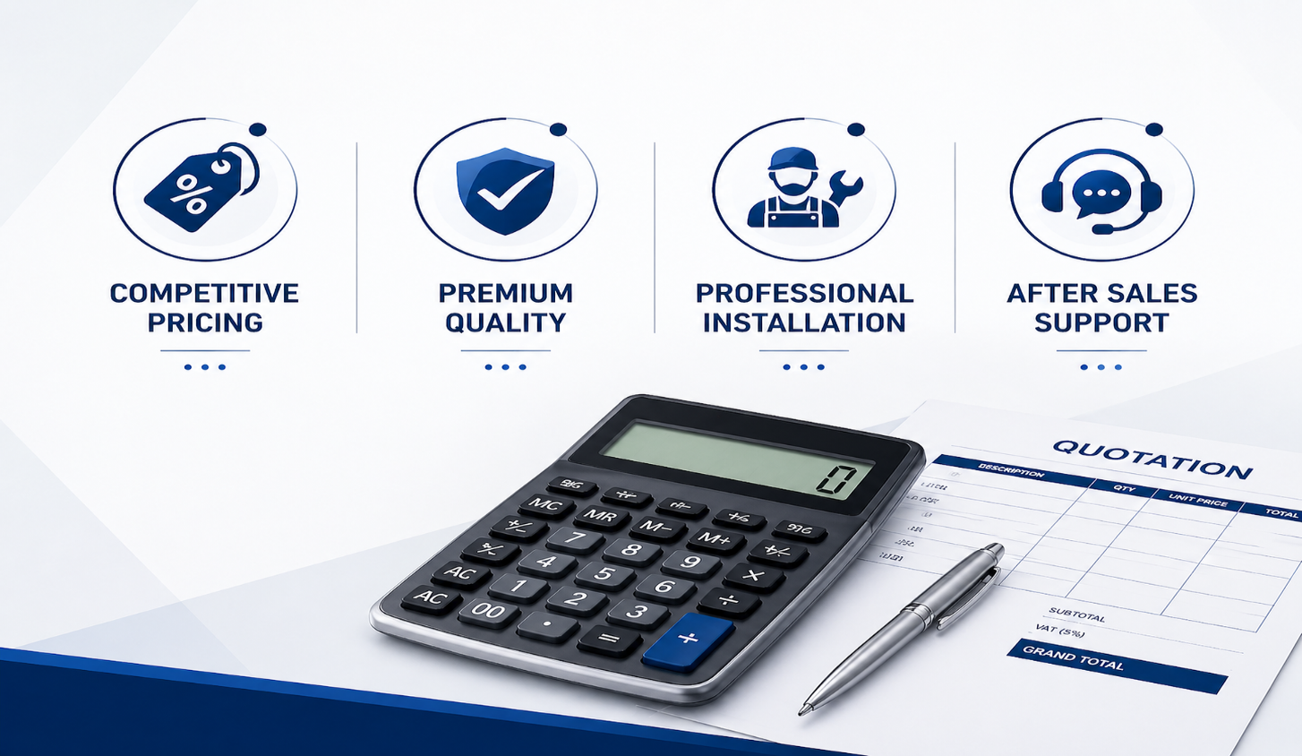

11. WARRANTY
Cold Room Panels & Door | 12 months from date of handover against manufacturing defects
Refrigeration Compressor | 12 months from date of commissioning (manufacturer warranty)
Evaporator & Condenser Coils | 12 months from date of commissioning
Electrical Components & Controls | 12 months from date of commissioning
Workmanship | 12 months from date of handover
Warranty Exclusions | Damage due to misuse, power surge, improper voltage, water ingress, unauthorized modification or absence of routine maintenance
12. DELIVERY & WORK COMPLETION
Material Delivery | 4 – 6 Days from date of LPO and approved advance payment
Site Mobilization | Within 3 working days of material arrival at site
Installation Period | 7 – 10 working days for civil-ready site
Testing & Commissioning | 1 – 2 working days after installation completion
Total Project Duration | Approx. 18-22 Days from LPO (subject to site readiness)
Working Hours | Standard working days, 08:00 – 17:00 (extended hours billed separately)
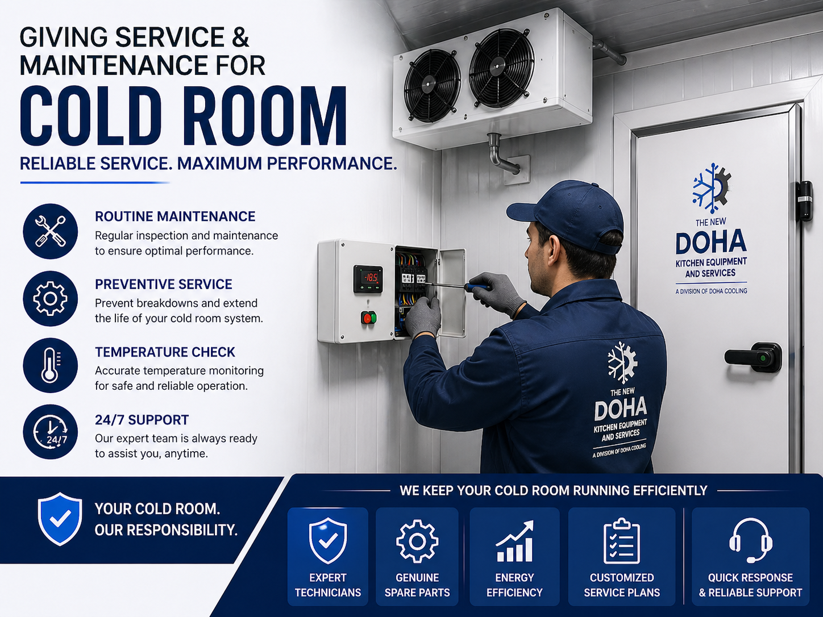
13. PAYMENT & COMMERCIAL TERMS
- 75% advance payment along with confirmed Local Purchase Order (LPO).
- 20% on delivery of materials at site.
- 5% balance after successful testing, commissioning and handover.
- Payment by cheque / bank transfer in favor of The New Doha Kitchen Equipment Services W.L.L.
- Prices are quoted in Qatari Riyals (QAR) and are exclusive of VAT, if applicable.
- This quotation is valid for 30 days from the date of issue.
We trust that the above offer meets your requirements and look forward to your favorable response. Should you require any further clarification or technical detail, please do not hesitate to contact us.
Thank you for the opportunity.
Best Regards,
Farhan
Sales Engineer
The New Doha Kitchen Equipment Services W.L.L & Doha Cooling Trading & Solutions W.L.L
Email: farhan@dctsqatar.com

