Proyek COSC6050003
Sistem Informasi EcoHub

Kelas : LB80 Kelompok : 6 Anggota :
Radja Triyasa / 2802482976
Farhan Yahya Hadil / 2802481531
Samuel Azriel Rachmat / 2802481494
M. Fadzli Nur Arrafi / 2802496470
Steven Lee Wijaya / 2802499661



BINUS UNIVERSITY
Jakarta
Ganjil 2025 / 2026
ERD:
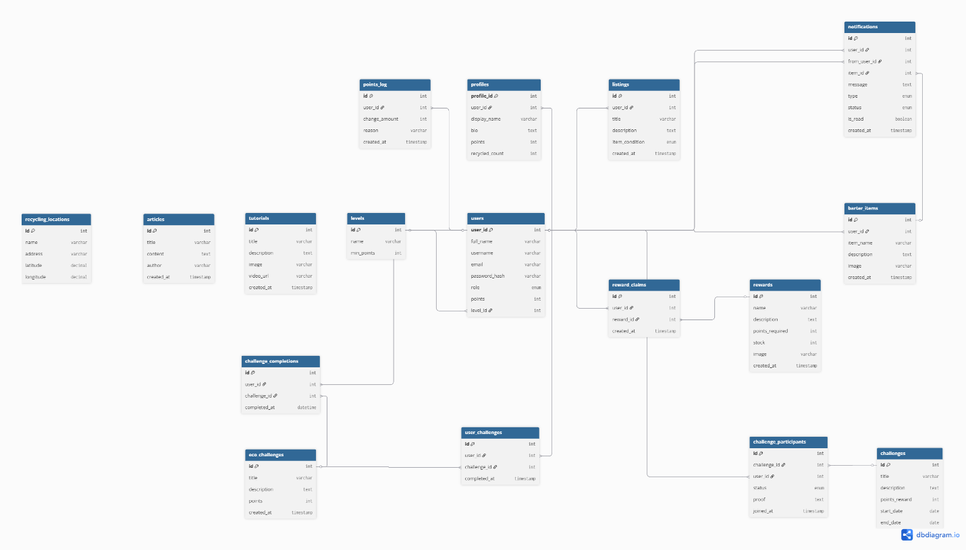

UI Design (Page Map)
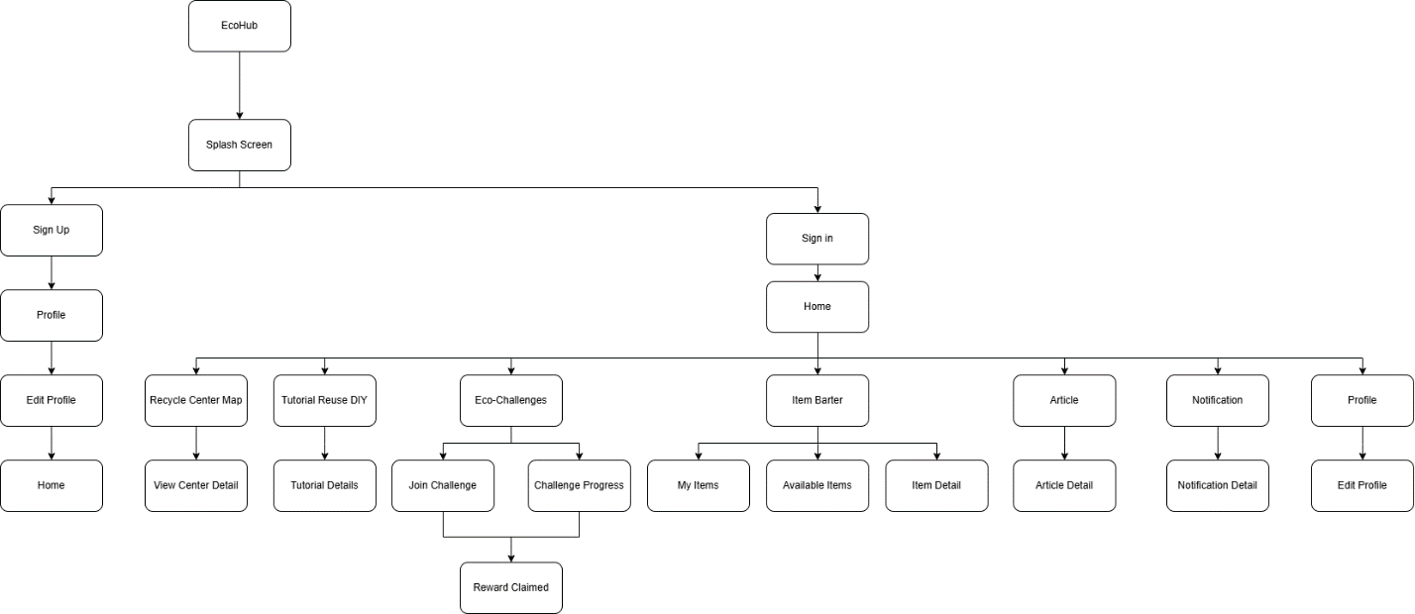

Documentation:
IMG:

Link: https://cms.ptgsi.id/uploads/blog/23080305424530108.jpg

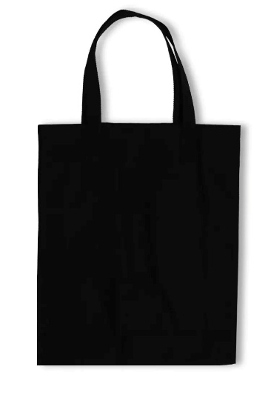
Link: https://www.zalora.co.id/p/third-day-amc77-totebag-aesthetic-kanvas-pria-wanita-hitam-black-art-face-4333379

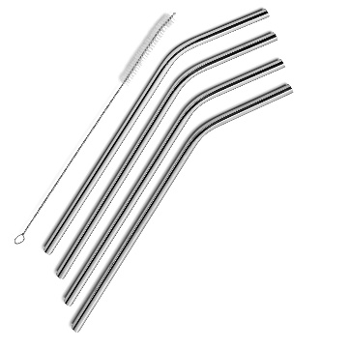
Link: https://m.media-amazon.com/images/I/81pZ71cKNnL.jpg
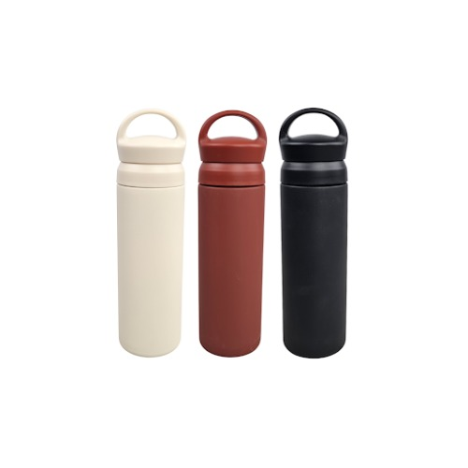
Link: https://encrypted-tbn0.gstatic.com/images?q=tbn:ANd9GcSTV2wt-Y9tCsyMzzIh8LAVS1HzPygUXFkmbQ&s

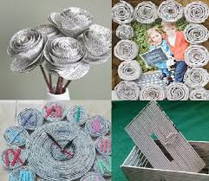
Link: https://udsregep.com/wp-content/uploads/2020/01/Kerajinan-dari-Kertas-Bekas-dalam-Beragam-Bentuk-yang-Mudah-Dibuat-1.jpg


Link: https://encrypted-tbn3.gstatic.com/images?q=tbn:ANd9GcT07vXh0iLdjZSVTq9qbJg16YQFZR95ry0dJKbvXMbwy88Q7YHA

