1. **Singapore TeBS Infrastructure training**
   1. **Office telephone management**
      1. Only HR admin and Infra telephone have the ability to allow for door access communication (such as communication and allow door access)
      2. In case of spam calls to office phones
         1. Take note of the calling number, to which number, date and time
         2. Refer to sample email
      3. Extension number master doc (refer to Telephone excel sheet)
      4. *How to rename telephone display name?*
         1. Find an empty telephone named “NA”
         2. Know the extension number first before proceeding
         3. Press Speaker btn > 800 > 282 (example of extension number)
         4. Type the user’s name, press hold, pick up the phone then put it down back
   2. **Door access management**
      1. Managed via web browser admin portal with Bill_Gates WiFi connected
         1. 192.168.1.27/#/login
         2. Admin account for me to be created in order to access the portal
         3. 2 types of users: HR and Admin (Infra)
         4. HR to submit new submission for door access and Infra to verify the submission (if any issues)
      2. Covered add and delete of users function
      3. In case of card expired to approach HR for help or Infra ia able to extend 1 year in the user’s profile
      4. In case of any issues of door access, restart door access via portal or by accessing the HKvision device at the entrance to restart
      5. Devices use for door access is out of warranty, if there is any technical issues that requires onsite visit (will require for payment) – inform Infra Manager before proceeding
   3. **Management of Infra devices**
      1. Office networks (TeBS-Guests & Bill_Gates)
      2. Printers – Secured print printer
         1. On rental plan and to seek for technical assistance, contact the hotline number and log a case and refer to the reference number pasted on the printer if support ask for it
      3. Servers
      4. Office lights
         1. Spare light bulbs are located at the ladder storage area)
         2. **Cool warm type of light bulb**
      5. CCTV
      6. Televisions in office (Pantry, meeting rooms)
      7. Projectors (in meeting rooms)
      8. Chairs (Do monthly physical inspection for any spoiled chairs)
      9. Shredder machine
   4. **Meeting room management**
      1. Each meeting room contains
         1. DoD (Definition of Done poster, Wi-Fi login, quality policy & quality objective)
         2. Telephone
         3. Projector + controller
            1. New projectors are in Bill Gates and Steve jobs and old projectors are in the rest of the rooms
            2. Simple troubleshooting training provided by Karthick
            3. Ensure projector is turned off when not in use
         4. Cabinet (in Bill Gates room and Larry Page)
            1. Project files are kept for ISO audits – Bill Gates
      2. In case of water leakage on the white card board, inform Jagdish to get prior approval and HR and then contact Building Management (+65 9325 6326)
      3. Ensure cable management are kept neat and tidy
   5. **Wi-Fi network**
      1. TeBS-Guest (Starhub, 6 child nodes + 1 parent node) and Bill Gates (SingTel, 1 note near Bill Gates room) Wi-Fi
      2. Simple troubleshooting for Mesh network routers
         1. To restart the child nodes if speed is slow
         2. Or to ask users to connect via LAN connection (when rebooting / slow)
   6. **Managed by building management**
      1. Air-conditioning office system (except for server’s room), monthly air maintenance (BM will check In with the company before coming down)
   7. **Fire Exit door to be locked at all times after accessing it** 
      1. Can be used if HR needed to bring stuff into office etc.
   8. **Main Power switch – contain the office power switches such as air-conditioner, access points. Located near the fire exit door**
      1. In case of circuit breaker happens, ensure the entire row is all off and then turn on one by one
      2. There is an annual electricity shutdown in the building, require Infra support team to comply and turn on Saturday after an annual shutdown
   9. **In case of emergency, entrance door is not working, use a door release key at Infra’s pedestal with the server room key drawer for main door fire exit**
   10. **Store room contains HR and Infra storage**
       1. Laptop chargers (Mostly Dell)
       2. LAN cables
       3. Mouse
       4. Desktop casings
   11. **Server room**
       1. Air-con managed by Infra
          1. Need to call for servicing every 6 months
          2. Monthly come into the room to do physical check
       2. Annual building electricity shutdown exercise
          1. Building management will inform TeBS via email of the exercise
          2. Need to turn off every power switch in server room
       3. Blackbox lights will be turned on when power is off
       4. M365 is not affected in the server room (it is situated in the cloud hosted by Microsoft)
       5. Contains 2 server racks
          1. Rear server rack – Mode, ISP, routers, switches, firewalls (White coloured is new, old firewalls is located below new one) and power switches
          2. Front server rack – Server, KVM, monitor
       6. WiFi troubleshooting
          1. Starhub is for Guest Wi-Fi (office Wi-Fi) and SingTel is hosting live servers (PROD, UAT, SIT) – Do not turn off SingTel router
          2. Turn off all the nodes, turn off main router and turn off the modem (power cycling)
          3. Singtel Modem and Router connection: ISP> ONR (Red Cable) > To Firewall > Router (Blue Cable)
       7. Network Switches
          1. Data and Voice
          2. D1-D144
          3. Colour coding
             1. Orange (Not working)
             2. Green (Working)
          4. Troubleshooting – unplug and plug back in
             1. Swap ethernet ports with a unused one
       8. Front server rack (nearer to Server room door entrance)
          1. 6 physical servers managed by KVM swtch
          2. Dell EMC servers - .230, .200 : major server development server
             1. .104 server some projects are residing in the server
             2. Infra support can only access .103, .104, .200, .230
       9. Procedure of powering on
          1. Ensure all appliances in rear server rack are powered on and then proceed to server rack 2 to be powered on
       10. NAS Backup device for the servers in front server rack - 64TB per slot*4= 256 TB
2. **Admin Support procedures**
   1. **Prioritisation of providing support**
      1. CEO, HR, Sales and Management (Sales, PMs and Practice Leads and Team Leads)
   2. **Infra Support’s Desk**
      1. Pedestals contains the following compartments
         1. IT tools (RAMs, hard drives (resignees backup etc.)
         2. Spare IT office equipments (Mouse etc.)
   3. **Assignment of Asset management in Asset Sheet for SG office**
      1. Update sheet under “Assigned to” column
      2. Sheet to maintained to be filtered for to only “Spare” and “Repair”
   4. **Movement of asset from SG office to BDC**
      1. inform Shafaiz from BDC office about asset movement and its asset details
         1. Extract from the entire row of that particular asset
   5. **Asset sheet/asset generic information**
      1. All Laptop asset have admin account called “Admin” and password is “TeBS” for Infra support activities
      2. To input any remarks under each asset (if any)
         1. Asset includes laptops, keyboard, mouse, mobile devices
      3. Fire extinguishers in the office are in the asset sheet
         1. Vendor: Safi equipment
         2. To take pictures of extinguishers of each and send via email
         3. To inform with Jagdish for any due extinguisher then email to vendor (Safi equipment) to ask for vendor to come down and test
         4. 2 dates for 2 types of test. Vendor will give temporary extinguishers while they do the tests
            1. Servicing test due date (check each fire extinguisher and set reminder)
            2. Hydrostatic test due date (check each fire extinguisher and set reminder)
   6. **Infra office equipment claims**
      1. Email every end of the month (for any Infra purchases)
      2. Claims can only be done by Infra Manager (Jagdish)
         1. Send via email using a claim template with scanned receipt of purchase
      3. Safekeeping of physical receipts
         1. Receipts are kept at the bottom drawer in a file
   7. **HR room cabinet**
      1. Office stationery are kept in the HR room near to HR Manager’s desk
      2. Master keys are kept (Glassdoor, 1 spare server key room
      3. ISO documents are kept for internal audit
      4. Resignees’ assets forms are kept in a file
      5. Pedestal master keys are in HR (not to give to user under any circumstances), Infra to unlock only if they left their keys at home etc.
      6. Sales team may ask for binding machine, machine is kept above HR Manager’s cabinet at the back of the room
   8. **Bringing own IT equipment**
      1. Users are to write an email in to Infra and Infra to acknowledge by saying that TeBS is not responsible for any damages incur during the time their equipment are in the office such as monitors etc.
      2. Infra to acknowledgement to user and input Infra Manager in the email CC loop for info
   9. **Infra cabinets**
      1. Infra 7: 2 Microsoft Surfaces (Usually for Sales team), 2 Spare laptop, 4 to be repair laptop
      2. Infra 5: All spoil laptops – to be use for spare parts
      3. Infra 6: Switches and other IT equipments
      4. Infra 4: User data hard drive, cable management, power cables
   10. **New Joinees & Resignees email**
       1. Every Friday, new J & R email will be sent to Infra from HR team
       2. Focus on the date of joining and decision of joining
       3. Name: Always first two then last name
       4. Uncheck require user to change password
       5. After completing account creation, email with generate account credentials is sent to TeBS Infra email
       6. Optional settings
          1. City – input SWD / SAT
       7. Save email attachment and email to HR and CC Jagdish
       8. Outlook account creation to be created on the Friday when the user is coming on Monday
       9. Sufficient lead time will be given for Infra to do the necessary new joinee checklist
       10. SWD – to prepare Outlook account and TeBS laptop
       11. SAT – to prepare only Outlook account (unless in the email it states to “TeBS”, to provide laptop)
       12. License plan
           1. SAT: Exchange online plan 1
           2. For PM, management, Sales, HR and Infra: E5 license
       13. For all other users to use E3 license
       14. To prep the laptop, outlook account and asset form
   11. **Sending of onboarding details email**
       1. Send to HR email, CC Jagdish and attach user account detail and created account creation
       2. Prep for new joinee
       3. Desk name plate (hr will need followup, we )
       4. Telephone number (by Infra)
       5. Drawer key: coordinate with HR if needed
       6. A serial number, asset form , remarks field, tag the number
       7. Find PM email in new joinee sheet and loop in CC for onboarding email
   12. **Creation of new Outlook account via M365 Admin Portal**
       1. Focus on add and deactivate users (depends on the circumstances)
   13. **Disposal List in Asset sheet**  
       ⁃ Keep the laptop 5 years old and ensure laptop is not usable  
       ⁃ Get approval for disposal from Jagdish  
       ⁃ Add to dispose list, recycle date put 1 year in between for audit (example, 2024-2025)
   14. **Resignee procedures**
       1. Check confirmation date, and ping HR  
          Infra to get user to fill up clearance form
       2. Check asset list if user is holding any client asset, and ask user to send confirmation email to PM if resignee is not holding to any
       3. Block sign in email at 6pm to 6.30pm and go user group and remove all user group
          1. Mail> email forwarding, copy paste to mail
       4. Take nameplate
       5. Once done send Resignee email to Jagdish and TeBS hr
       6. Exit clearance>tebs infra fill up
       7. Ensure resignee do not have any pending timesheet then return laptop
   15. **Went through the laptop preparation**
   16. **Printer setup and installation of driver**
       1. 12345 is Department ID for B&W print
       2. Different Department ID for Color print
   17. **Office 365 is to be install for those users with E3 license**
   18. **In case of change of laptop, Infra to issue a new asset form and update the asset sheet**
   19. **Covered introduction to SVN – 192.168.1.92 is a VM only used for SVN and creation of repositories**
   20. **Infra admin audit activities**
       1. Laptop & MS audit – Complete 5-10 users per day daily to complete total monthly
       2. Infra monthly meeting & New joinees (&resignees) 2024 excel – Complete monthly
   21. **New joinees (&resignees) 2024 excel**
       1. White row for joinees and coloured row for resignees
       2. Infra Issues summary - Shafaiz will do
       3. Summary sheet (first part), laptop procurement, laptop repair, monthly report for joinees and resignees, any extra activities in report
       4. Share the content to media team for monthly, send approval to to jagdish for approval (monthly security awareness)
   22. **Walkthrough on SVN and VPN login credentials**
       1. Get PM approval before assigning SVN and VPN and ask for project code from user
       2. VPN
          1. Creation of VPN account
          2. Add and removal of accounts

***Updated as of: 13/06/2024***

* ***Shahid***

**Phase 2 – 13/05/2024 – 13/06/2024**

**Admin Procedures notes for Joinee and Resignees**

1. HR will send weekly on Friday with email subject as example “New Joinee & Resignee - 31 May 2024”
2. Infra will prepare necessary assets for Joinees and conduct exit clearance for Resignees
3. Types of users, SWD and SAT
   1. SWD require Laptop + wireless mouse + charger and outlook email
   2. SAT require email only (due to user working for Client but under TeBS payroll)

**License types**

1. E5 (For HR, management, sales, PMs and Infra)
2. E3 (For other users)
3. Exchange online plan 1 (SAT)

**Infra Procedures for new Joinees**

1. Prepare the following assets
   1. Laptop + wireless mouse + charger + bag
      1. Laptop: To format, created local user account (assign with Admin rights) & install the software packages
      2. Software packages (Found in infra thumbdrive) consists of
         1. Office 365
         2. Bitdefender
         3. MS Teams
   2. New Joinee form (found in Jagdish’s OneDrive)
      1. To pre-fill second page with outlook email generated password, email address and local user login
   3. Creation of outlook email (on M365 Admin Portal) -
      1. New User > fill up the necessary fields, let auto generate for password, change the send password to Infra’s email and input City as “SWD” or “SAT” then assign necessary license as needed.
      2. Under Department, follow the employee’s Job Title. Examples:
         1. IT (for Infra)
         2. Human Resource (for HR)
         3. Development (for Developer)
         4. Sales & Pre-Sales (For Sales)
         5. Practice Lead (for Project Managers)
         6. Operations (for Operations)
2. On First Working Day (FWD)
   1. Infra will guide user to setup the necessary logins and OneDrive to point to the right directory and Intune Setup
   2. New Joinee page 1 to be kept by HR and page 2, user can keep it for own reference.

**Infra Procedures for Resignees**

1. Resignee need to print/send the Exit Clearance form to us with the first 8 points and point 13 and lastly sign under Employee box
2. Infra to check the returning assets, to ensure no damages/in good working condition
   1. Laptop + mouse + charger + bag
   2. VPN + SVN
   3. Client Assets – Ensure user return to the Client and acknowledge that user have returned the asset via email
   4. Any other assets (accessories, TeBS’ assets)
3. Once Infra cleared with user that user does not hold on to any assets relating to company or client Infra to proceed below checklist
   1. Reply to the HR email on user’s LWD and ask
      1. Informed HR that Infra have blocked the outlook email and ask PM whether to diverted the mailbox or delete the account
   2. Send email to Jagdish and CC HR, for every time there is a new resignee
      1. M365 : **Deactivated / Blocked**
      2. Vpn : **Removed / NA**
      3. Svn : **Removed / NA**
      4. Email backup : **YES / Pending**
      5. Local data backup : **YES / Pending**
      6. Door access remove by HR (verify by infra team) : **Done**
      7. Asset condition : **Good / Bad (specify)**
      8. Asset return : **Yes**
      9. Name plate removal : **Yes**
4. Update the necessary sheet as follows
   1. Master asset (laptop and others)
   2. VPN
   3. SVN
   4. New Joinees (and resignees)

**Daily Tasks**

1. Infra issue tracking sheet
2. Laptop Audit sheet
3. MS Audit sheet
4. New joinees (& resignees) sheet

**Monthly Tasks**

1. Security Awareness content creation email blast (Start of month and start of following month)
   1. Curate content
   2. Send to Media team for poster design
   3. Send to Jagdish for approval
   4. Blast out email
2. Meeting room checks (Start of month)
   1. Chairs
   2. Projectors
   3. TV (If applicable)
   4. 3 Posters
      1. DOD
      2. Quality Policy
      3. WiFi Password
   5. Server Room’s Air-Con
      1. Check if it is working fine
3. Infra monthly meeting sheet (End of month)
4. Infra claims sheet (End of month)
5. Download of CCTV, Door Access and Firewall Logs (Last day of the month)
   1. Firewall: /var/log/tebssyslog/hostname/logfile.log
      1. Download logs in WinSCP, restart and it will remove the logs by itself
6. Send client asset update email blast twice per month (Start and End of month)

**Ad-hoc Tasks**

1. Fire extinguisher (to set appointment and done 1 month before date of tests)
   1. Hydrostatic test
   2. Inspection test

**Printer Setup**

* Ensure connected to Bill Gates network or LAN/ethernet when setting up and sending for secured print



**Spam call reporting email template:**



**VPN Account Creation:** [VPN](https://192.168.1.1/login?redir=%2F)

SAT user requires fill up of NDA (refer to past emails)

SWD requires PM approval

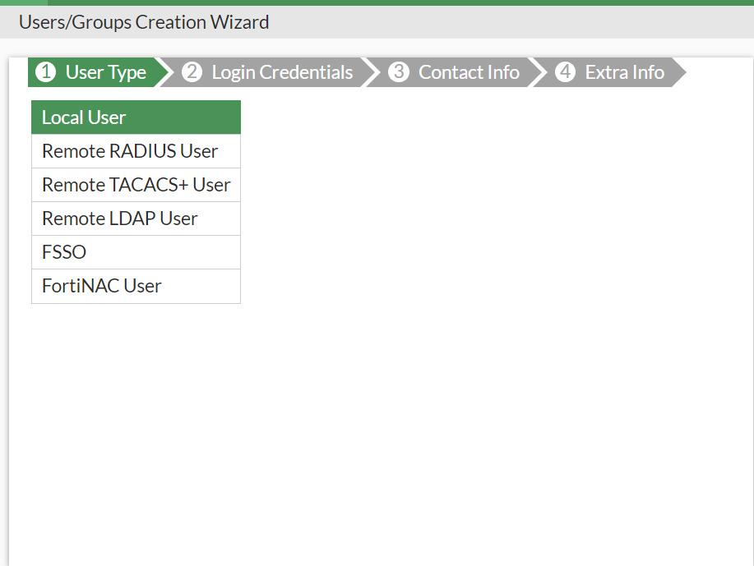

**Select “Local User”**

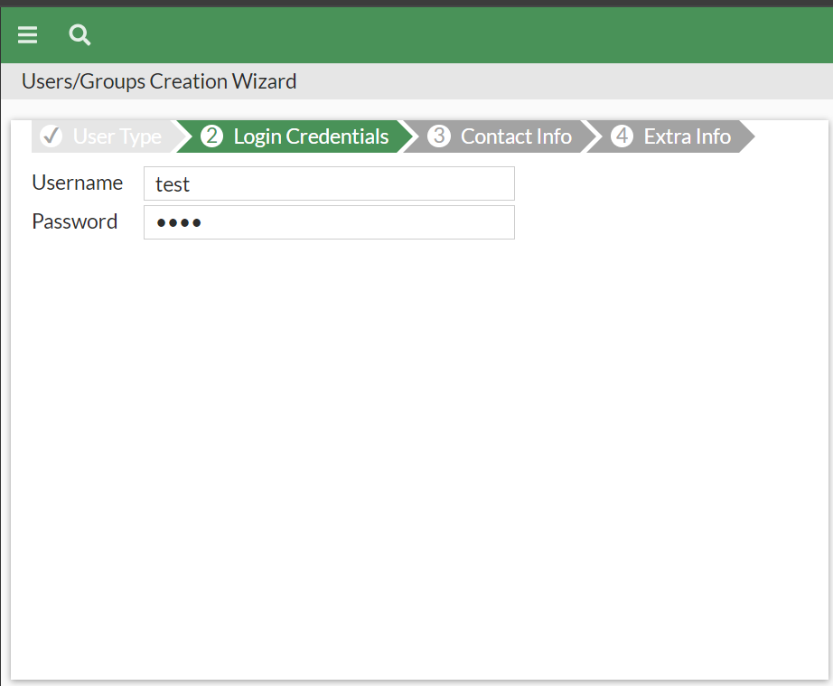

**Put Username as user’s front part of email address**

**Generate random password and input in “Password” field**

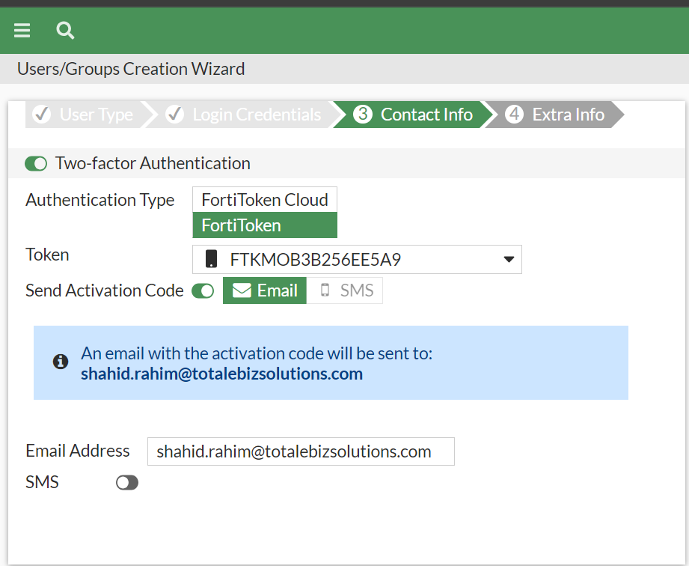

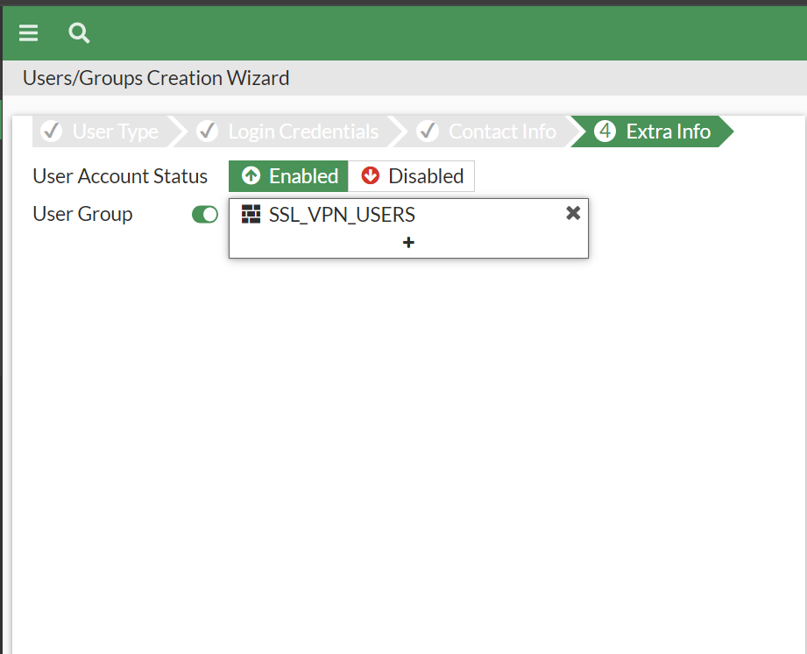

**VPN Client setup:**



**Creation of SVN on SVN server via RDP: 192.168.1.92**

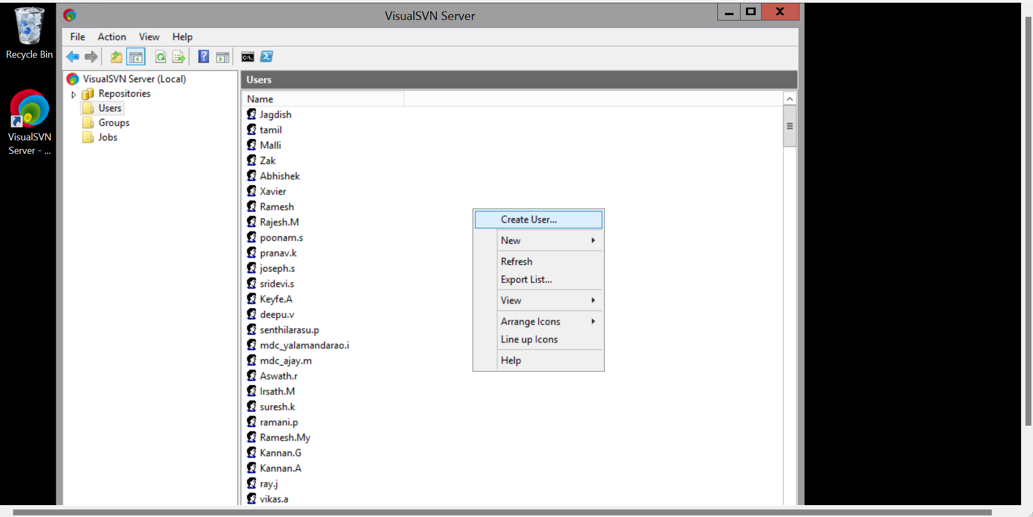

**Infra Tutorials**

How to block spam emails

[Call with Karthick and 1 other-20240610_095330-Meeting Recording.mp4 (sharepoint.com)](https://tebssingapore-my.sharepoint.com/personal/shafaiz_m_totalebizsolutions_com/_layouts/15/stream.aspx?id=%2Fpersonal%2Fshafaiz%5Fm%5Ftotalebizsolutions%5Fcom%2FDocuments%2FRecordings%2FCall%20with%20Karthick%20and%201%20other%2D20240610%5F095330%2DMeeting%20Recording%2Emp4&referrer=StreamWebApp%2EWeb&referrerScenario=AddressBarCopied%2Eview%2E7b4da933%2Df69b%2D419c%2Db099%2D47d542028efe&ga=1)

Creation of VPN

[Call with Shahid Bin Rahim-20240604_123445-Meeting Recording.mp4](https://tebssingapore-my.sharepoint.com/:v:/r/personal/shafaiz_m_totalebizsolutions_com/Documents/Recordings/Call%20with%20Shahid%20Bin%20Rahim-20240604_123445-Meeting%20Recording.mp4?csf=1&web=1&e=7doXKk&nav=eyJyZWZlcnJhbEluZm8iOnsicmVmZXJyYWxBcHAiOiJTdHJlYW1XZWJBcHAiLCJyZWZlcnJhbFZpZXciOiJTaGFyZURpYWxvZy1MaW5rIiwicmVmZXJyYWxBcHBQbGF0Zm9ybSI6IldlYiIsInJlZmVycmFsTW9kZSI6InZpZXcifX0%3D)

***Updated as of: 13/06/2024***

* ***Shahid***