Nama : Farhan Hasbi

Kelas : XII RPL 2

Controller





Route



View

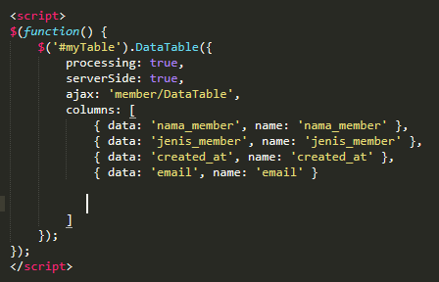

Pagination 1-10 data (Web)

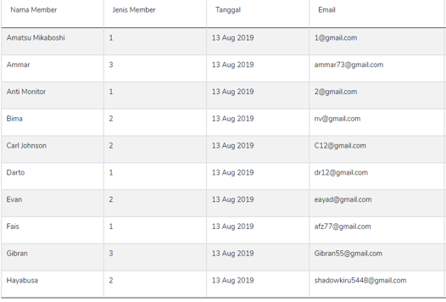

Pagination 11-20 data (Web)

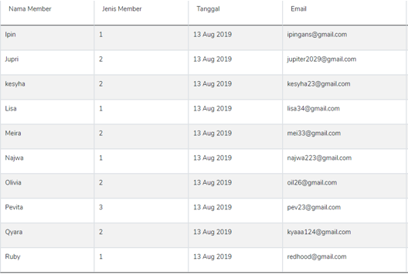

Pagination 21-30 data (Web)

