S.B.O.A.SCHOOL (CBSE), MADURAI-19

CLASS :IX MATHEMATICS WORKSHEET CH-12 “HERON'S FORMULA”
VERY SHORT ANSWER TYPE QUESTIONS

  - Find the length of each side of an equilateral triangle having an area of 9√3𝑐𝑚².
  - Find the area of an isosceles triangle having base 2 cm and the length of one of the equal sides 4 cm.

  - How many times area is changed, when sides of a triangle are doubled.

SHORT ANSWER TYPE QUESTIONS
  - If the perimeter of an isosceles triangle is 11 cm and its base is 5cm, its area is 5 √11𝑐𝑚². State true
4
or false and give reason.

  - If the area of an equilateral triangle is 16√3𝑐𝑚², then find the perimeter of the triangle.
  - The cost of levelling a ground in the form of a triangle having the sides 51m, 37m, and 20m at the rate of ` 3 per 𝑚² is ` 918. State whether the statement is true or false and justify your answer.
  - The perimeter of an isosceles triangle is 32 cm. The ratio of the equal side to its base is 3: 2. Find the area of the triangle.
  - The lengths of the sides of a triangle are 7 cm, 13 cm and 12 cm. Find the length of perpendicular from the opposite vertex to the side whose length is 12 cm.
LONG ANSWER TYPE QUESTIONS

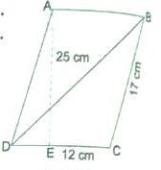
  - The lengths of two adjacent sides of a parallelogram are 17 cm and 12 cm. One of its diagonals is 25 cm long. Find the area of the parallelogram. Also find the length of altitude from vertex on the side of length 12 cm.

  - The perimeter of a triangle is 50 cm. One side of a triangle is 4 cm longer than the smaller side and the third side is 6 cm less than twice the smaller side. Find the area of the triangle.

Explore the depths of Heron's Formula, sharpen your math skills, and gain the knowledge needed to excel in your studies. Dive into the world of triangle areas with us today At JSUNIL TUTORIAL
Page 1 |Class IX | Maths

  - The area of a trapezium is 475 𝑐𝑚² and the height is 19 cm. Find the lengths of its parallel sides if one side is 4 cm greater than the other.
  - If each side of a triangle is doubled, then find the ratio of area of new triangle thus formed and the given triangle.
  - Find the area of quadrilateral ABCD in the given figure below:
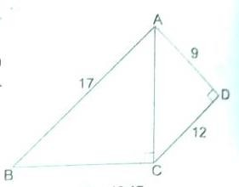
  - In the given figure, ∆𝐴𝐵𝐶 is equilateral triangle with side 10 cm and ∆𝐷𝐵𝐶 is right angled at D. If BD = 6 cm, find the area of the shaded region (√3 = 1.732).
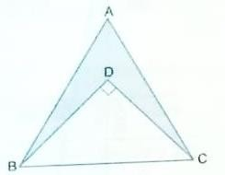

ANSWERS

1. a = 6 cm  3. Four times | 2. √15𝑐𝑚²  4. True
5. 24 cm | 6. True
7. 32√2𝑐𝑚² | 8. 4√3𝑐𝑚
9. 180𝑐𝑚², 15 𝑐𝑚 | 10. 109.6 𝑐𝑚²
11. 23 cm, 27 cm | 12. 4:1
13. 114 𝑐𝑚² | 14. 19.3 𝑐𝑚²

Page 2 |Class IX | Maths

