

American International University-Bangladesh (AIUB)

**Department of Computer Science & Engineering Faculty of Science & Technology (FST)**

Project Proposal, Fall 2023-24

|  |  |
| --- | --- |
| Course | SOFTWARE ENGINEERING [B] |

**Submitted By**

|  |  |  |
| --- | --- | --- |
| Student Name | Student ID | Section |
| ARNOB GHOSH | 21-45050-2 | B |
| MD. FARHAN ISTIAK PIASH | 21-45052-2 | B |
| MD AL AMIN MOLLA | 20-43231-1 | B |
| ABRAR ANAN RAIYAN | 21-45412-3 | B |

**Submitted To**

TONNY SHEKHA KAR

Lecturer, CS

**Project Title:**

**SMART HEALTHCARE SYSTEM**

**SMART HEALTHCARE SYSTEM**

**Prototype**

**Login:**

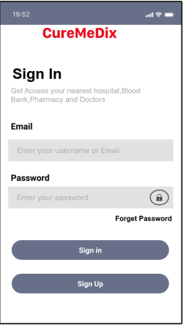

**Registration:**

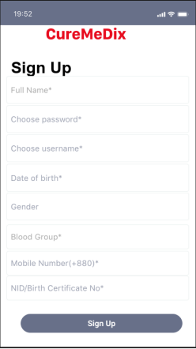

**Verification:**

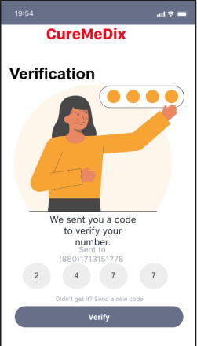

**Hospital (Doctors List):**

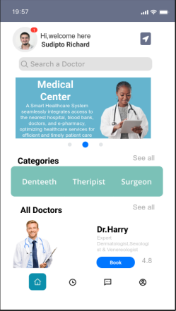

**Hospital (Doctors):**

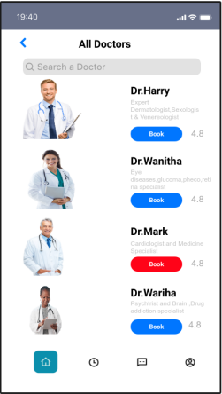

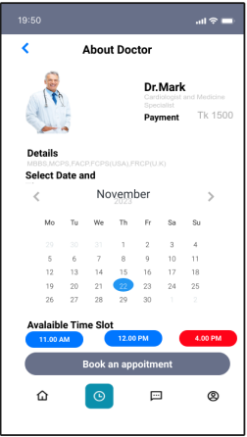

**Doctor’s Payment:**

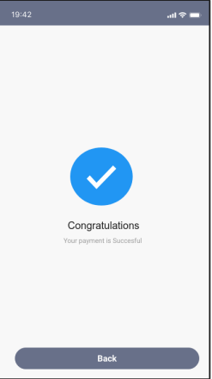

**Blood Bank:**

**E Pharmacy:**

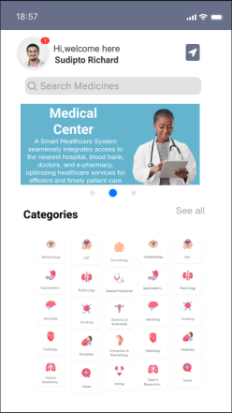

**E Pharmacy Payment:**

