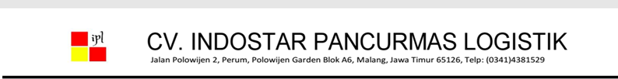${title}

(${periode})

|  |  |  |  |  |  |  |  |  |
| --- | --- | --- | --- | --- | --- | --- | --- | --- |
| **No** | **Tgl** | **Nopol** | **Nama Toko** | **Nama / No. Nota** | **Keterangan** | **Harga** | **Jumlah** | **Subtotal** |
| ${no} | ${tanggal} | ${nopol} | ${nama_toko} | ${nama_barang} / ${nomor_nota} | ${keterangan} | ${harga} | ${jumlah} | ${subtotal} |